1st February 2021

Year 10 Virtual Parents’ Evening – Thursday 11th February 2021

Dear Parent/Carer,

On Thursday 11th February 2021 from 4.30pm – 7pm, we will be holding our Year 10 Parents’ Evening as a virtual event. Appointments for this year’s evening will need to be made via our new parent booking platform Parents Bookings with timeslots available to book from today until Wednesday 10th February. Your appointments on the evening will take place via a one-to-one video meeting with your child’s teachers, rather than in-person at the Academy.

This is an extremely important event and we expect to have a high demand for appointments. As such we would encourage you to make your appointments via the platform as soon as possible.

Although you will be keen to speak to all of your child’s teachers, it may not be possible to meet with all of them on this evening, as some teachers are responsible for more than one Year 10 class. If you are unable to schedule an appointment with one of your child’s teachers but would like an update on their progress, then please email a request to parentsevenings@saintwilfrids.com

What do you need to do prior to the evening?
- Once you have read this letter carefully please login into your Firefly account.
- From here you can access the parent appointment booking platform by clicking on the ‘Parent Booking’ button at the top of the Firefly main parent dashboard. You may then need to click on the button to ‘authorize the app’ to allow you to access Parents Bookings.
- Please use the instructions on page 2 of this letter to select and confirm your appointments
- After you have made your appointments you can choose to either print or e-mail the confirmation which contains your full schedule for the evening.

How do you access your appointments on the evening?
On the day of your appointments please log into Firefly and click on the Parent Booking tab 15 minutes before your first appointment is due to start so that you are ready to join the video meeting room, where you can wait for your appointment(s).

Which devices and browsers are compatible?
You must use one of the devices named below and internet browser combinations for the video meeting technology to work:
• Apple iPhone/iPad (iOS 11+): Safari
• Android phone/tablet: Chrome or Firefox
• Linux computer: Chrome or Firefox
• Microsoft Surface: Chrome or Firefox
• Mac computer: Safari, Chrome or Firefox
• Windows computer: Chrome, Firefox or Edge (Chromium)

Troubleshooting and technical tips
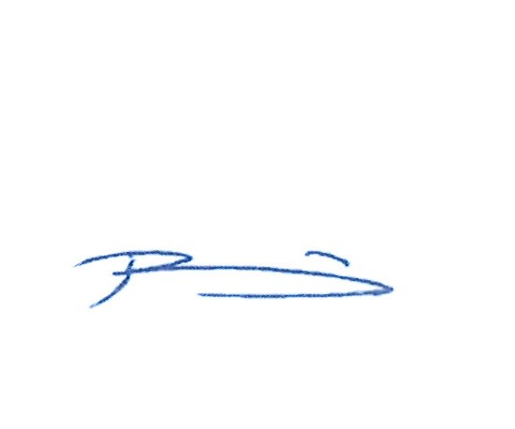
This is our first Year 10 virtual Parents’ Evening and as such we do ask for your patience if you are unable to log in or if the booking system does not initially work as intended. If you do have any technical issues or questions, please do not hesitate to contact the Academy either via parentsevenings@saintwilfrids.com or phone 01254 604000 prior to the evening.

Yours sincerely

Mr M Reeve Mr P Lewis
Year 10 Manager KS4 Assistant Principal

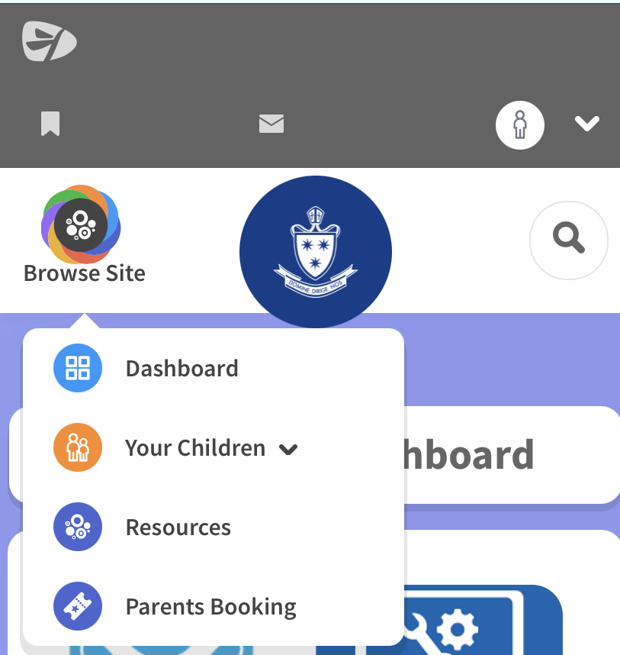
Step 1: Log into Firefly and click on the Parents Booking tab. It may look a little different on a smartphone; you should click on ‘Browse Site’ first.

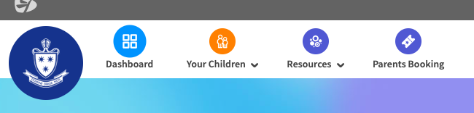
Year11 Parents’ Evening
Step 2: Select the Year 11 Parents’ Evening.
If you have more than one child at the
Academy you may need to click the button
below to view the evening…

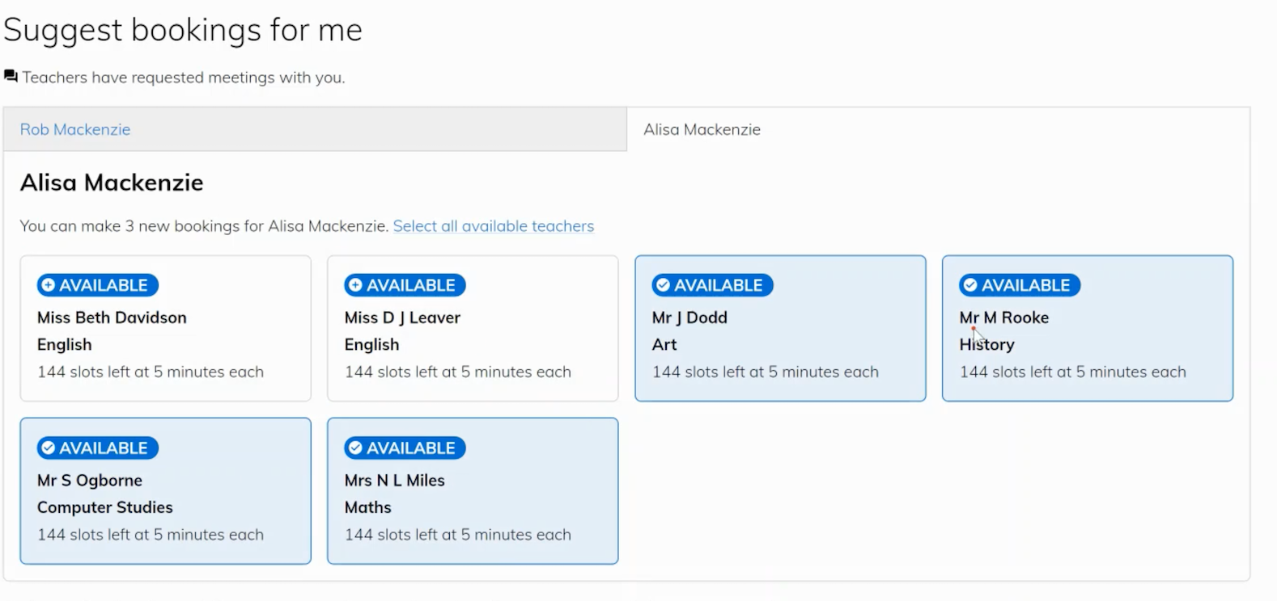
Step 3: You will now arrive at the suggested bookings screen.
Please choose the teachers you wish make an appointment with.

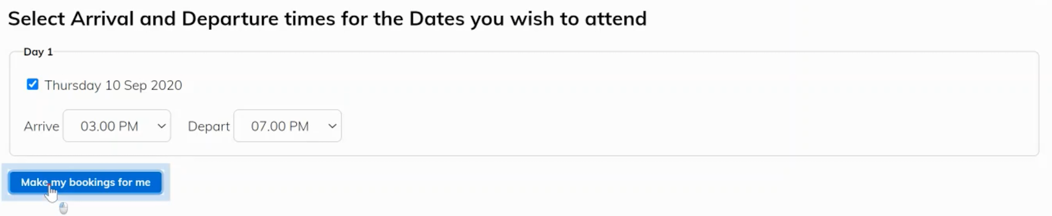
Step 4: Indicate the time you wish your appointments to start and end. Then click Make my bookings for me.

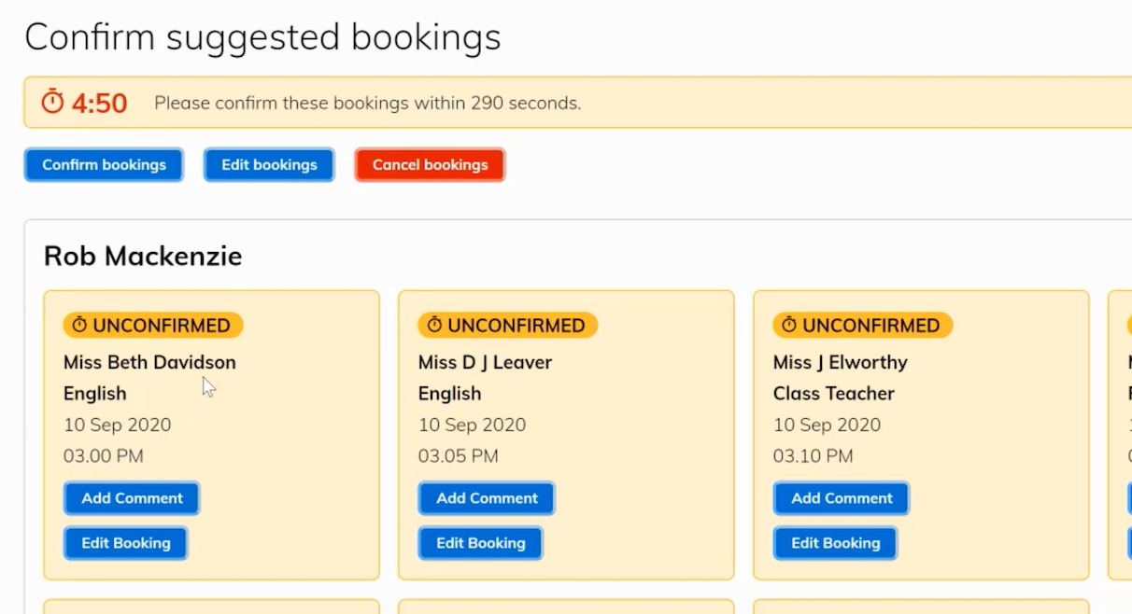
Step 5: Check you are happy with your bookings and then click on the Confirm bookings button.

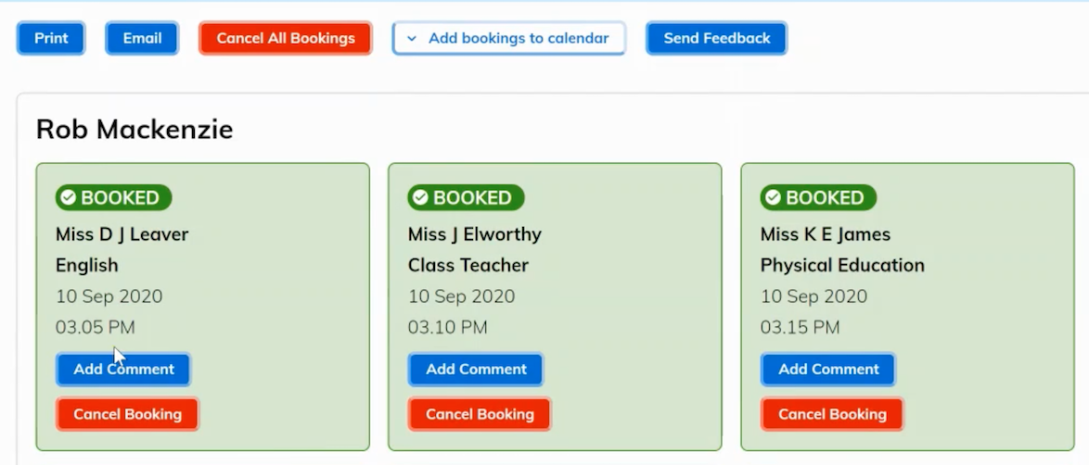
Step 6: Your bookings will now turn green to show they are booked and confirmed. From this screen, you can also either Print or Email your appointment schedule for your records.

