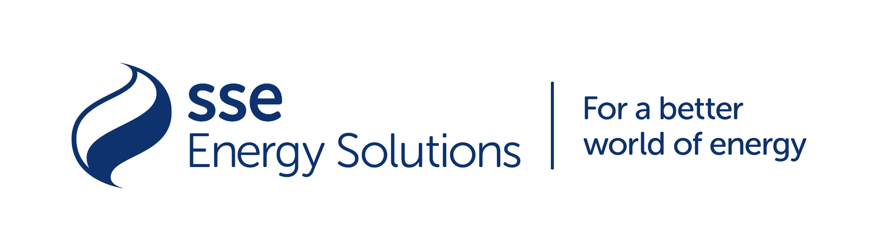

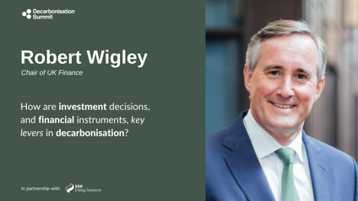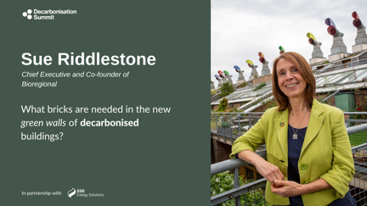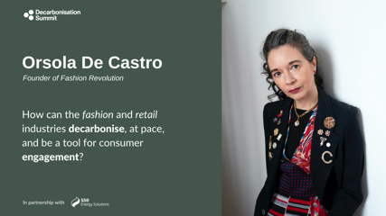

Trio of Top Speakers Confirmed for the Decarbonisation Summit

24 September 2021

Green.TV Media and SSE Energy Solutions announce three of the most prominent figures in the fields of finance, fashion & retail, and architecture will speak at the inaugural Decarbonisation Summit, to be held on 9th/10th November, during COP26.

Anybody interested in hearing from speakers from a range of industries, organisations and backgrounds debating actionable solutions and in depth debates around the topics of all things sustainability are able to watch the online panels for free.

Speakers from across the worlds of industry, government, academia and non-government organisations (NGOs) will include three headline speakers:

- Investor, author and entrepreneur Bob Wigley, the Chairman of UK Finance, Vesta Global Holdings and Bink Ltd, who brings his 25 years sector experience to lead the Finance & Investment panel; one of ten panels being held at the Decarbonisation Summit.
Bob was also Chairman of Victoria Beckham Ltd during 2016 and 2017, developing a growth plan and securing an equity investment of £30m to fund it, demonstrating his expertise in the fashion and retail sector – another dedicated panel of the Summit that will be chaired by Orsola De Castro.

- Orsola De Castro, internationally recognised opinion leader in sustainable fashion and upcycling and is the co-founder and creative director of Fashion Revolution, a global movement towards sustainable fashion that has participation in over 90 countries. Orsola will speak on how the fashion and retail industries can decarbonise at pace whilst also being a tool for consumer engagement as chair the Fashion & Retail panel at the Summiy.

- Sue Riddlestone OBE, Chief Executive and Co-Founder of Bioregional, a highly regarded specialist in the field of sustainable development. Sue has been reinventing how the population can live in zero-carbon, affordable homes and communities for 25 years, following Bioregional’s initiation of the iconic BedZED eco-village in London in 1997. Sue will chair the Summit panel on Buildings & Architecture that will consider ‘what bricks are needed in the new green walls of decarbonised buildings?’.

The Decarbonisation Summit will address other key sectors in the race to zero emissions including: Energy, Food and Agriculture, Automotive, Air Travel, Shipping, Policy, Science and Innovation as well as Gender & Decarbonisation which focuses on the role of women in the delivery and education of decarbonisation.

The Decarbonisation Summit will take place in-person, at the Glasgow headquarters of SSE, and virtually as part of COP26. Speakers will be on stage, in a set piece digital studio whilst international speakers will join the Decarbonisation Summit, virtually.

Ade Thomas, Founder of Green.TV Media, the force behind the Decarbonisation Summit, World EV Day, and the EV Summit, said: “The Decarbonisation Summit will drive conversations and enable connections between people across the globe, that I’m confident will result in real change in the field of sustainability. With the UK hosting COP26, we are really in the spotlight and well placed to lead industries towards a greener future for all with decarbonisation across industry sectors.”

Nathan Sanders, Managing Director of SSE Distributed Energy, said: “SSE is delighted to be hosting the first Decarbonisation Summit at our head office in Glasgow, complementing our principal partner status for COP26 next month. Our focus is on net zero and we are committed to enabling both organisations and businesses to decarbonise their energy, heat and transport with solutions that lead the way in developing low-carbon assets and an infrastructure to support us reaching our collective goals for the UK to reach zero emissions by 2050.”

Free online attendance at the Decarbonisation Summit is available for each panel, with in-person tickets having already sold out. Virtual attendance tickets include full access to the Decarbonisation Summit and panel discussions via the Green.TV Media virtual platform.

To book your free online place at the Decarbonisation Summit, visit: https://www.eventbrite.co.uk/e/the-decarbonisation-summit-2021-tickets-165111174969

The Decarbonisation Summit’s speaker video content will be available live and on-demand across the website, and via social media channels.

- https://www.decarbonisationsummit.com/
- https://twitter.com/Decarbon_Summit
- https://www.facebook.com/DecarbonisationSummit/

- ENDS -

NOTES TO EDITORS

Press contacts:

Catherine Dhanjal
Morledge & Co. Communications & PR
Phone: 0794 166 9925
Email: catherine@morledgeandco.com

To request a press pass to the Decarbonisation Summit, interviews or images, please contact: catherine@morledgeandco.com

About Green.TV Media

Green.TV Media is a multi-channel publishing network and digital platform that specialises in telling and propelling sustainability stories that connect people with purpose. With a vision of ‘for change, for good, for all’, the Oxford-based company creates content and channels, both digital and live, to bring audiences across the globe closer to messages with the purpose of creating a better and decarbonised future.

Green.TV Media created World EV Day, the EV Summit and the Ebike Summit and their ElectricDrives Facebook channel is the largest emobility channel, outside the automotive industry, with over 250,000 followers.
https://www.green.tv

Green.TV Communications Lead:
Dean Prosser
Head of Communications
Phone: +44 7493700902
Email: Dean.Prosser@green.tv

About SSE

SSE’s distributed energy business offers a full range of services, which contribute to development of smart cities and smart places, in both public and private sectors:

- Electric vehicle infrastructure for public mass transportation and vehicle fleets
- Electricity networks including building, owning and adopting private HV networks
- Distributed energy systems including renewable and low-carbon generation, energy storage and demand management services
- Energy solutions optimising building energy consumption through intelligent systems

SSE has been confirmed as a major partner for COP26 as it gears up for a year of climate action ahead of the flagship summit in Glasgow, where world leaders will be seeking a more ambitious climate change agreement. The news comes as SSE continues to deliver its £7.5bn investment programme, leading the way in developing the low-carbon assets and infrastructure required for the UK to reach its target of net zero emissions by 2050.

