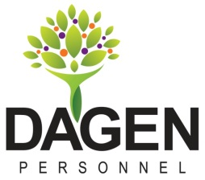

Direct Deposit Agreement Form
Dagen Personnel, LLC

Authorization Agreement

I hereby authorize Dagen Personnel, LLC to initiate automatic deposits to my account at the financial institution named below. I also authorize Dagen Personnel, LLC. to make withdrawals from this account in the event that a credit entry is made in error.

Further, I agree not to hold Dagen Personnel, LLC responsible for any delay or loss of funds due to incorrect or incomplete information supplied by me or by my financial institution or due to an error on the part of my financial institution in depositing funds to my account.

This agreement will remain in effect until Dagen Personnel, LLC receives a written notice of cancellation from me or my financial institution, or until I submit a new direct deposit form to the Payroll Department.

Account Information

Name of Financial Institution:

Routing Number:

Account Number:

Checking Savings

Signature

Authorized Signature (Primary): Date:

Authorized Signature (Joint): Date:

Phone #___________________________________________

Please attach a voided check NOT A DEPOSIT SLIP
and return this form to the Payroll Department.

