Change Management Framework

Participant Guide

Table of Contents

The Change Management Framework Overview 5

Step 1: Plan & Manage Organizational Change 7

Change Scope 8

Change Strategy 8

Workplan, Roles & Metrics 9

Project Health Snapshot 9

Step 2: Engage Sponsors and Influencers 10

Sponsor Influence Plan 11

Engage Sponsors 11

Engage Key Influencers 12

Step 3: Communication with Stakeholders 13

Stakeholder Analysis 14

Communication Plan 14

Communication Standards 15

Implement Communications 15

Step 4: Manage Change Risk and Readiness 16

Change Impacts 17

Change Readiness 17

Readiness Activities 18

Step 5: Align Organization 19

Business Process Changes 20

Change Impact Summary 20

Change Plan 21

Transition Plan/Guide 21

Step 6: Train Stakeholders 22

Training Plan 23

Training Development 23

Training Delivery 24

Evaluate Training 24

Step 7: Sustain the Change 25

Change Agent Network 26

Reward and Recognition 26

After Action Review 27

APPENDIX 28

Change 28

Change Management 29

Step 1: 30

Change Navigation 30

Sponsorship 35

Step 2 Analyze Impacts 43

Change Navigation 44

Sponsorship 58

Stakeholder Management 59

Project Management 64

Communication in Change Management 66

Training 69

Communication 75

Training 78

Change Navigation 79

Sponsorship 86

Project Management 87

Stakeholder Management 88

Step 4: Implement and Transition 93

Benefits of Change Management 95

The Framework 96

Activity: Positively and Negatively Perceived Change 98

Managing Change 102

Step 5: Accelerate and Sustain 103

103

Guest Speaker 104

The Framework 105

What’s next? 107

Reflections 108

### Course Information

For participants to become change practitioners and be able to plan and implement a small to medium sized change project using  *Change Management Framework*.

* Give you an understanding of individual’s progression through change.
* Become familiar with Change Management processes, tools, and tactics.
* Help you to be effective on your ‘real life’ project.
* Introduce you to the change community.

# The Change Management Framework Overview

The Change Management Framework is a collection of recommended tools and templates. It should complement your project management activities by engaging leaders, influencers, and stakeholders –and preparing them to help you make your project more effective.

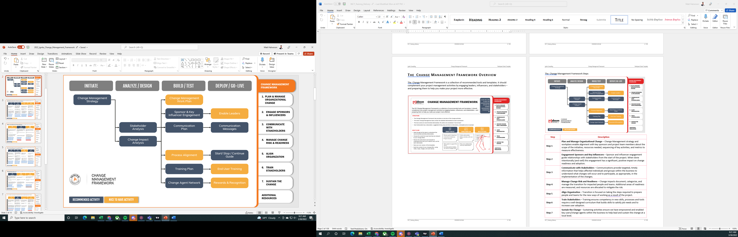

The Change Management Framework Steps

|  |  |
| --- | --- |
| **Step** | **Description** |
| **Step 1** | **Plan and Manage Organizational Change** – Change Management strategy and workplans enable alignment with key sponsors and project team members about the scope of the initiative, resources needed, sequencing of key activities, and metrics to measure effectiveness. |
| **Step 2** | **Engagement Sponsors and Key Influencers** – Sponsor and influencer engagement guide relationships with stakeholders from the start of the project. When done intentionally (and well) this engagement has a significant, positive impact on change readiness and adoption. |
| **Step 3** | **Communicate with Stakeholders** – Communications provide targeted, timely information that helps affected individuals and groups within the business to understand what changes will occur and to participate, as appropriate, in the implementation of the changes. |
| **Step 4** | **Manage Change Risk and Readiness** – Change impacts document, categorize, and manage the transition for impacted people and teams. Additional areas of readiness are measured, and resources are allocated to mitigate the risk. |
| **Step 5** | **Align Organization** – Transition is focused on taking the steps required to prepare people and teams for the new ways of working as a result of the project. |
| **Step 6** | **Train Stakeholders** – Training ensures competency in new skills, processes and tools require a well-designed curriculum that builds skills to satisfy job needs and to increase user adoption. |
| **Step 7** | **Sustain the Change** – Sustaining activities ensure we have empowered and enabled key users/change agents within the business to help lead and sustain the change at a local level. |

# Step 1: Plan & Manage Organizational Change

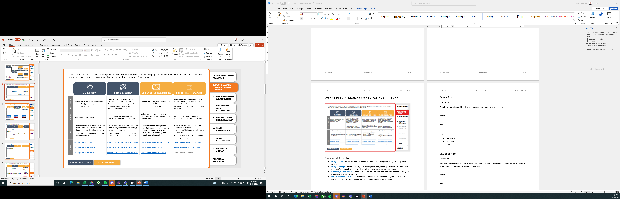

Topics covered in this section:

* Change Scope – details the items to consider when approaching your change management project.
* Change Strategy – identifies the high level “people strategy” for a specific project. Serves as a roadmap for project leaders to guide stakeholders through needed transitions.
* Workplan, Roles & Metrics – defines the tasks, deliverables, and resources needed to carry out the change management strategy.
* Project Health Snapshot – identifies main roles needed for a change program, as well as the metrics that will be useful to measure the project milestones and progress.

## Change Scope

### Description

Details the items to consider when approaching your change management project.

### Timing

### Tips

### Links

* Instructions
* Template
* Example

## Change Strategy

### Description

Identifies the high level “people strategy” for a specific project. Serves as a roadmap for project leaders to guide stakeholders through needed transitions.

### Timing

### Tips

### Links

* Instructions
* Template
* Example

## Workplan, Roles & Metrics

### Description

Defines the tasks, deliverables, and resources needed to carry out the change management strategy.

### Timing

### Tips

### Links

* Instructions
* Template
* Example

## Project Health Snapshot

### Description

Identifies main roles needed for a change program, as well as the metrics that will be useful to measure the project milestones and progress.

### Timing

### Tips

### Links

* Instructions
* Template
* Example

# Step 2: Engage Sponsors and Influencers

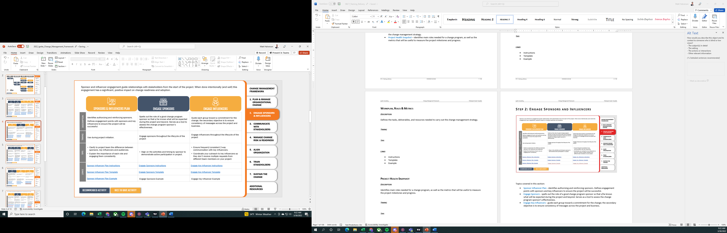

Topics covered in this section:

* Sponsor Influencer Plan - identifies authorizing and reinforcing sponsors. Defines engagement points with sponsors and key influencers to ensure the project will be successful.
* Engage Sponsors - spells out the role of a good change program sponsor so that s/he knows what will be expected during the project and beyond. Serves as a tool to assess the change program sponsor’s effectiveness.
* Engage Key Influencers - guide each group toward a commitment for the change; the secondary objective is to ensure consistency of messages across the project and business.

## Sponsor Influence Plan

### Description

Identifies authorizing and reinforcing sponsors. Defines engagement points with sponsors and key influencers to ensure the project will be successful.

### Timing

### Tips

### Links

* Instructions
* Template
* Example

## Engage Sponsors

### Description

Spells out the role of a good change program sponsor so that s/he knows what will be expected during the project and beyond. Serves as a tool to assess the change program sponsor’s effectiveness.

### Timing

### Tips

### Links

* Instructions
* Template
* Example

## Engage Key Influencers

### Description

Guide each group toward a commitment for the change; the secondary objective is to ensure consistency of messages across the project and business.

### Timing

### Tips

### Links

* Instructions
* Template
* Example

# Step 3: Communication with Stakeholders

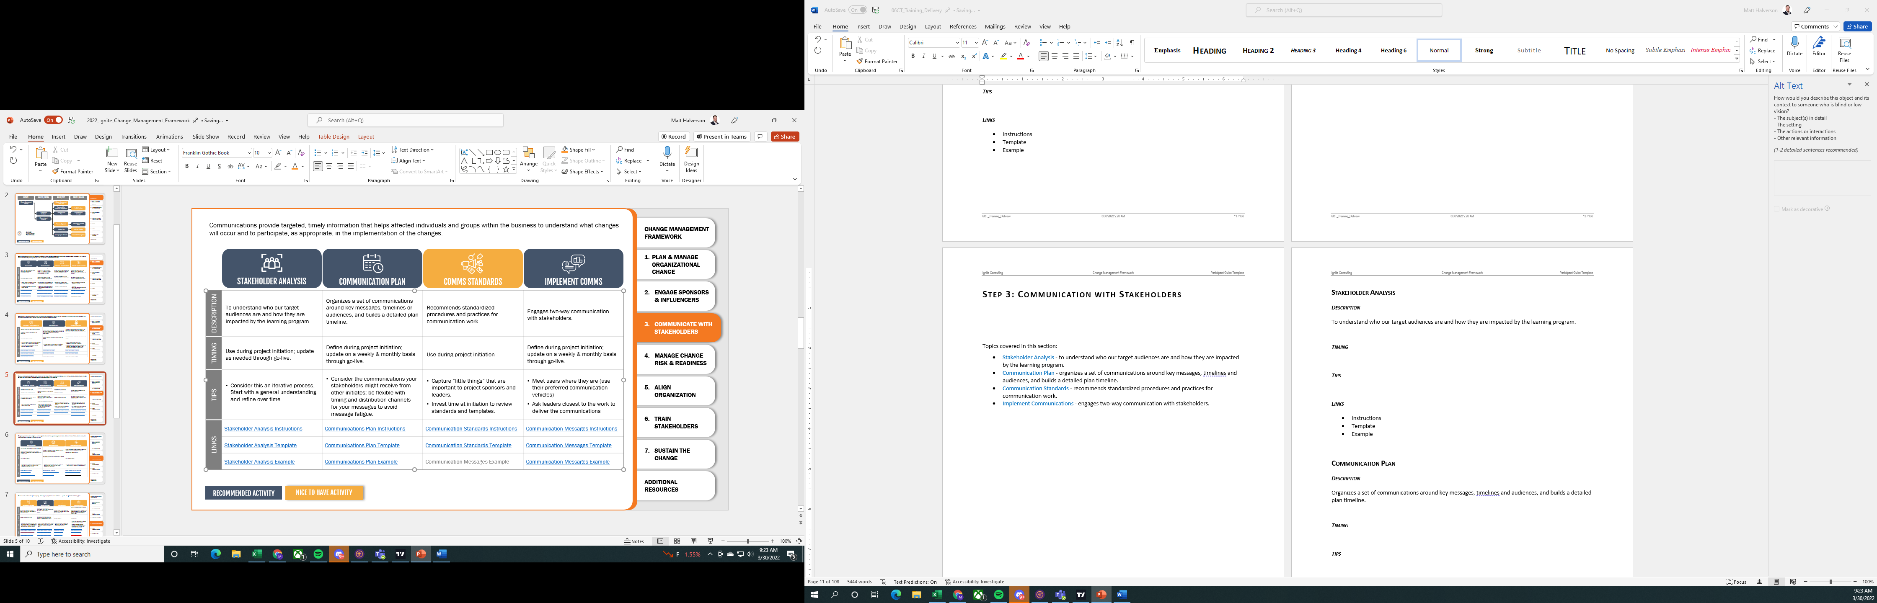

Topics covered in this section:

* Stakeholder Analysis - to understand who our target audiences are and how they are impacted by the learning program.
* Communication Plan - organizes a set of communications around key messages, timelines and audiences, and builds a detailed plan timeline.
* Communication Standards - recommends standardized procedures and practices for communication work.
* Implement Communications - engages two-way communication with stakeholders.

## Stakeholder Analysis

### Description

To understand who our target audiences are and how they are impacted by the learning program.

### Timing

### Tips

### Links

* Instructions
* Template
* Example

## Communication Plan

### Description

Organizes a set of communications around key messages, timelines and audiences, and builds a detailed plan timeline.

### Timing

### Tips

### Links

* Instructions
* Template
* Example

## Communication Standards

### Description

Recommends standardized procedures and practices for communication work.

### Timing

### Tips

### Links

* Instructions
* Template
* Example

## Implement Communications

### Description

Engages two-way communication with stakeholders.

### Timing

### Tips

### Links

* Instructions
* Template
* Example

# Step 4: Manage Change Risk and Readiness

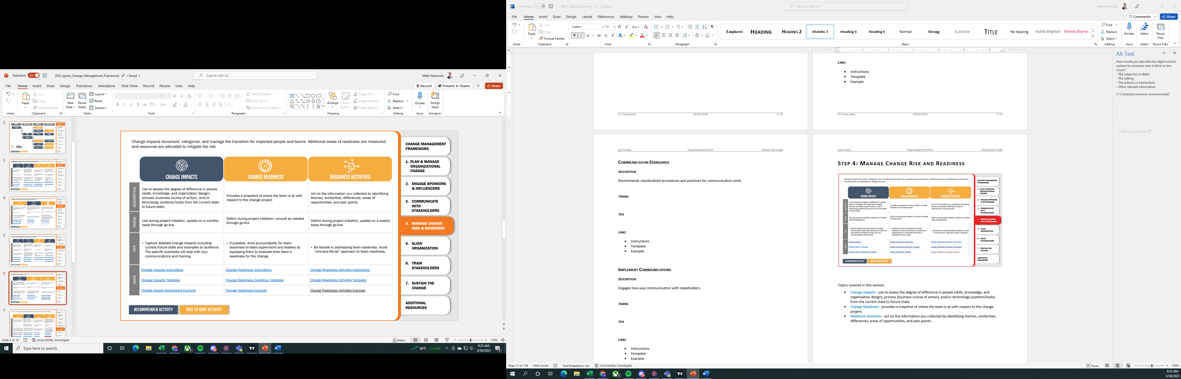

Topics covered in this section:

* Change Impacts - use to assess the degree of difference in people (skills, knowledge, and organization design), process (business course of action), and/or technology (systems/tools) from the current state to future state.
* Change Readiness - provides a snapshot of where the team is at with respect to the change project.
* Readiness Activities - act on the information you collected by identifying themes, similarities, differences, areas of opportunities, and pain points.

## Change Impacts

### Description

Use to assess the degree of difference in people (skills, knowledge, and organization design), process (business course of action), and/or technology (systems/tools) from the current state to future state.

### Timing

### Tips

### Links

* Instructions
* Template
* Example

## Change Readiness

### Description

Provides a snapshot of where the team is at with respect to the change project.

### Timing

### Tips

### Links

* Instructions
* Template
* Example

## Readiness Activities

### Description

Act on the information you collected by identifying themes, similarities, differences, areas of opportunities, and pain points.

### Timing

### Tips

### Links

* Instructions
* Template
* Example

# Step 5: Align Organization

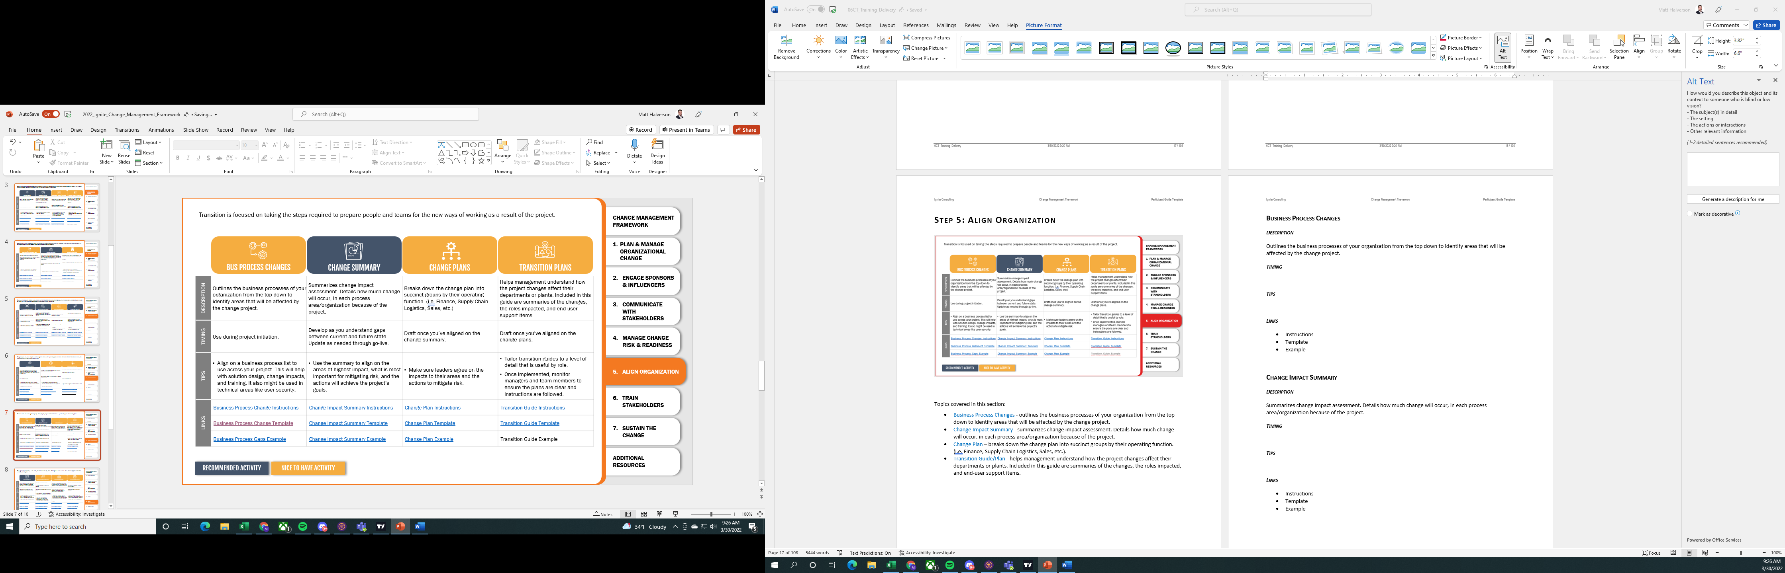

Topics covered in this section:

* Business Process Changes - outlines the business processes of your organization from the top down to identify areas that will be affected by the change project.
* Change Impact Summary - summarizes change impact assessment. Details how much change will occur, in each process area/organization because of the project.
* Change Plan – breaks down the change plan into succinct groups by their operating function. (i.e. Finance, Supply Chain Logistics, Sales, etc.).
* Transition Guide/Plan - helps management understand how the project changes affect their departments or plants. Included in this guide are summaries of the changes, the roles impacted, and end-user support items.

## Business Process Changes

### Description

Outlines the business processes of your organization from the top down to identify areas that will be affected by the change project.

### Timing

### Tips

### Links

* Instructions
* Template
* Example

## Change Impact Summary

### Description

Summarizes change impact assessment. Details how much change will occur, in each process area/organization because of the project.

### Timing

### Tips

### Links

* Instructions
* Template
* Example

## Change Plan

### Description

Breaks down the change plan into succinct groups by their operating function. (i.e. Finance, Supply Chain Logistics, Sales, etc.).

### Timing

### Tips

### Links

* Instructions
* Template
* Example

## Transition Plan/Guide

### Description

Helps management understand how the project changes affect their departments or plants. Included in this guide are summaries of the changes, the roles impacted, and end-user support items.

### Timing

### Tips

### Links

* Instructions
* Template
* Example

# Step 6: Train Stakeholders

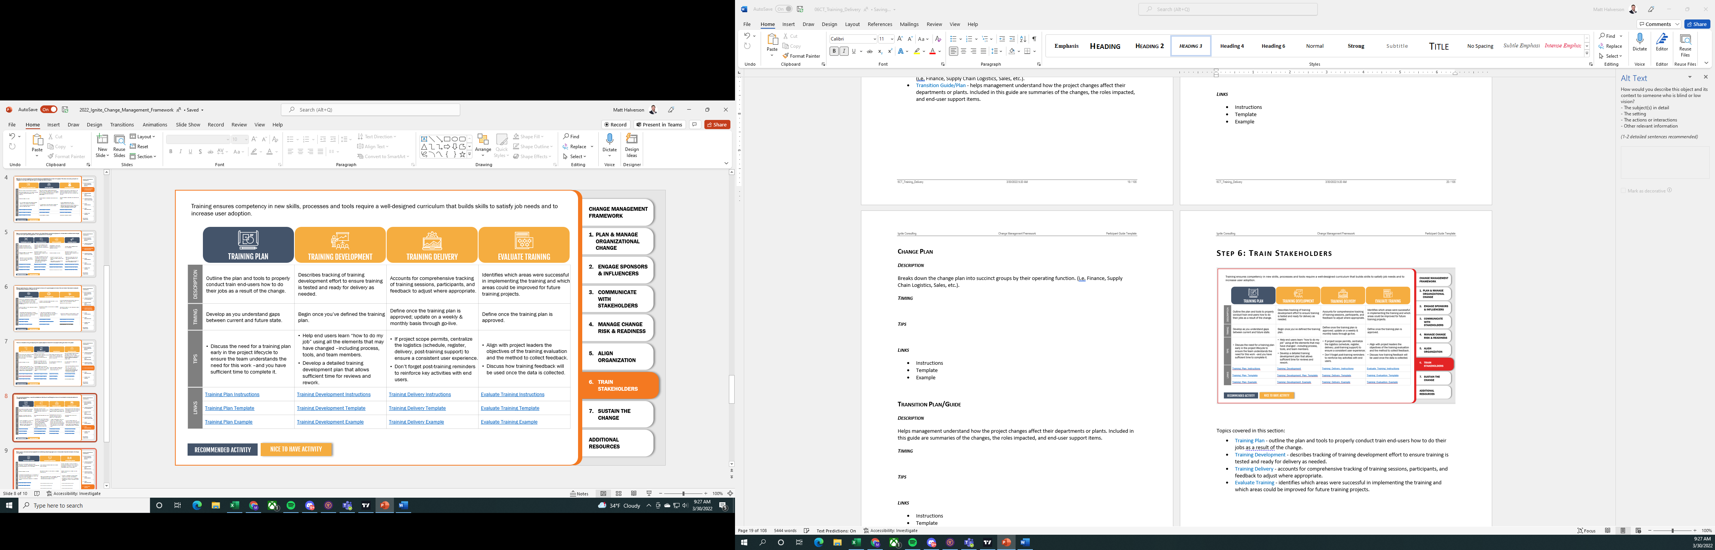

Topics covered in this section:

* Training Plan - outline the plan and tools to properly conduct train end-users how to do their jobs as a result of the change.
* Training Development - describes tracking of training development effort to ensure training is tested and ready for delivery as needed.
* Training Delivery - accounts for comprehensive tracking of training sessions, participants, and feedback to adjust where appropriate.
* Evaluate Training - identifies which areas were successful in implementing the training and which areas could be improved for future training projects.

## Training Plan

### Description

Outline the plan and tools to properly conduct train end-users how to do their jobs as a result of the change.

### Timing

### Tips

### Links

* Instructions
* Template
* Example

## Training Development

### Description

Describes tracking of training development effort to ensure training is tested and ready for delivery as needed.

### Timing

### Tips

### Links

* Instructions
* Template
* Example

## Training Delivery

### Description

Accounts for comprehensive tracking of training sessions, participants, and feedback to adjust where appropriate.

### Timing

### Tips

### Links

* Instructions
* Template
* Example

## Evaluate Training

### Description

Identifies which areas were successful in implementing the training and which areas could be improved for future training projects.

### Timing

### Tips

### Links

* Instructions
* Template
* Example

# Step 7: Sustain the Change

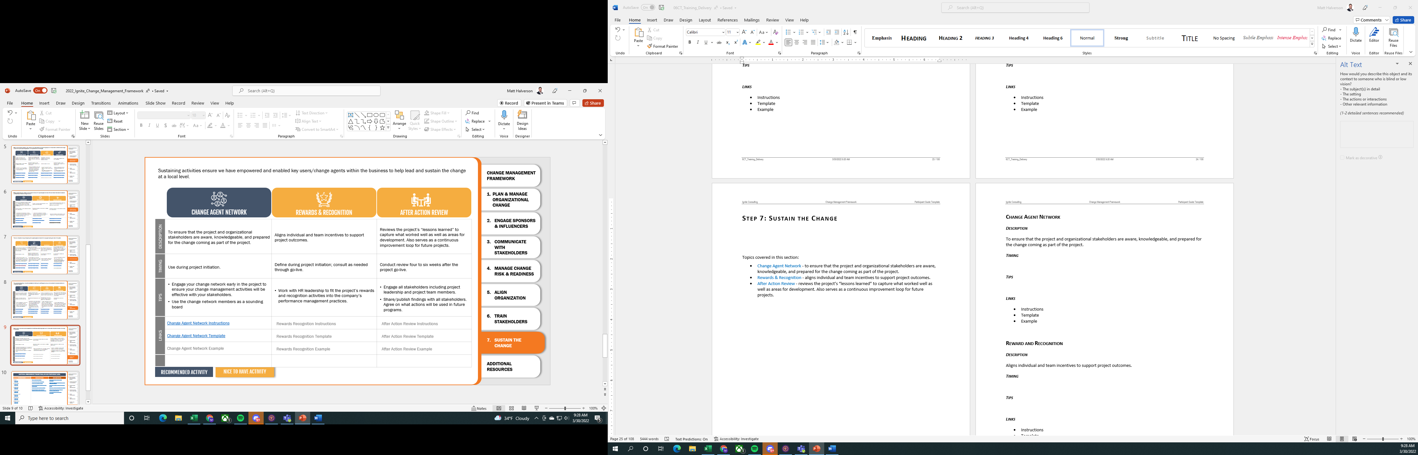

Topics covered in this section:

* Change Agent Network - to ensure that the project and organizational stakeholders are aware, knowledgeable, and prepared for the change coming as part of the project.
* Rewards & Recognition - aligns individual and team incentives to support project outcomes.
* After Action Review - reviews the project’s “lessons learned” to capture what worked well as well as areas for development. Also serves as a continuous improvement loop for future projects.

## Change Agent Network

### Description

To ensure that the project and organizational stakeholders are aware, knowledgeable, and prepared for the change coming as part of the project.

### Timing

### Tips

### Links

* Instructions
* Template
* Example

## Reward and Recognition

### Description

Aligns individual and team incentives to support project outcomes.

### Timing

### Tips

### Links

* Instructions
* Template
* Example

## After Action Review

### Description

Reviews the project’s “lessons learned” to capture what worked well as well as areas for development. Also serves as a continuous improvement loop for future projects.

### Timing

### Tips

### Links

* Instructions
* Template
* Example

# APPENDIX

## Change

### Purpose of Change

|  |
| --- |
|  |
|  |
|  |
|  |
|  |

### Nature of Change

|  |
| --- |
|  |
|  |
|  |
|  |
|  |

### Adoption of Change

* Innovator
* Change Promoter
* Pragmatist
* Skeptic
* Traditionalist

### Activity: Adoption of Change

#### Factors in Change Adoption

|  |
| --- |
|  |
|  |
|  |
|  |
|  |
|  |
|  |
|  |
|  |
|  |
|  |
|  |

## Change Management

### Definition of Change Management

* Engaged executive sponsorship.
* Clear understanding of the current and future state.
* Understanding of required skills and knowledge to support the change.
* Targeted and ongoing communications.
* Defined roles and responsibilities for all involved in the change.
* Defined plans to implement change strategies.

### Benefits of Using Change Management

|  |
| --- |
|  |
|  |
|  |
|  |
|  |
|  |
|  |
|  |
|  |
|  |

### The Role of Change Practitioners

* Work with the Sponsor to create and deploy and change plan
* Coach Sponsor(s), designated Change Agents and those effected by the change on Change Management
* Measure the change for adoption and effectiveness

|  |
| --- |
|  |
|  |
|  |

# Step 1:

## Change Navigation

### Business Case

* Sets the foundation for the project
* Justifies in terms of costs and benefits
* Addresses the business need that the project seeks to resolve

### Change Definition

Defines the high-level gap

Change Definition Questions:

* Who is changing?
* Who must change?
* When will the change take place?
* Where will the change take place?
* Why are the changes necessary?

### Change Definition for Case Study

What work process(s) will change?

What is the current level of performance?

What is the desired level of performance?

Why must these processes change?

How will these processes change?

When will the change take place?

Where will the change take place?

### The Commitment Curve

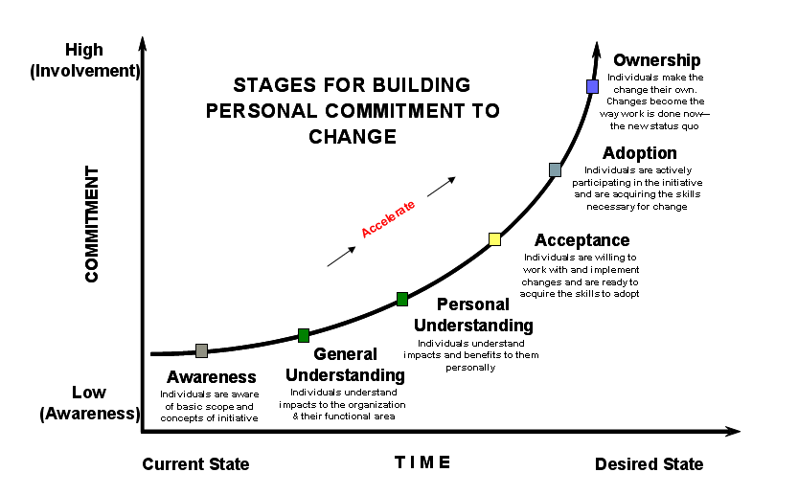

**Awareness** – Individual are aware of the basic scope and concepts of the initiative.

**General Understanding** – Individual understand the impacts to the organization & their functional area

**Personal Understanding** – Individuals understand the impact and benefits to them personally

**Acceptance** – Individuals are willing to work with and implement the change and are ready to acquire the skill they’ll need

**Adoption** – Individuals are actively participating in the initiative and are acquiring the skill necessary for the change

**Ownership** – Individuals make the change their own. The change becomes the way work is done now – the new status quo

## Sponsorship

### Sponsors

* Decide which changes will happen
* Commit the resources required to execute the change
* Communicate the new priorities to the organization
* Provide the reinforcement required to ensure success

### Authorizing Sponsor

* Legitimize the change project
* Crucial to any change project as they ‘get the ball rolling’
* Have the organization power to sanction subsequent action

### Activity: Prepare for a Sponsor Meeting

**Purpose:** Practice planning a initial meeting with an Authorizing Sponsor (AS).

**Directions:**

You are meeting with Fritz. Develop a list of questions you will you to:

* Determine his point of view
* Identify his needs
* Assess his commitment
* Assess his understanding of the magnitude of the change on the organization

### Conducting a Sponsor Meeting

* What happened?
  + What were the most challenging parts of this activity, and what strategies were used to overcome these challenges?
  + What tactics worked well?
  + What tactics did not work well?
  + What might you have done differently?
* What did you learn about the sponsor?
  + How committed is the sponsor to the change?
  + Does Fritz know what personal behaviors he needs to demonstrate in order to make sure the organization adopts this change?
  + What would be the repercussions if you identified the wrong person to interview?
  + Does Fritz have a clear vision of the desired state?
  + What does success look like to Fritz?
  + What concerns does Fritz have with this change?
  + Are people ready for a change? Is the willingness to change different at different levels?
* What issues did you identify?
* What do we do with the information we just obtained?

### Your Project – Sponsor’s Commitment Level

Where is your sponsor on the Commitment Curve?

What challenges are you going to have with the sponsor?

### Reinforcing Sponsors

Reinforcing Sponsors actively support and help sustain the change effort al lower levels of the organization. Other key responsibilities include:

* Make sure communication surrounding the change is continuous and accurate.
* Help move people through the change intervention and gage their commitment level.
* Demonstrate commitment to outcomes
* Allocate resources and support and provide project guidance
* Publicly support and validate the change effort
* Support and coach Change Agents

### Northern Oil’s Reinforcing Sponsors

|  |
| --- |
|  |
|  |
|  |
|  |
|  |
|  |
|  |
|  |
|  |
|  |

### Sponsor Development

**The Communication Plan** - will give sponsors communication- related action items.

**The Leadership Action Plan** – outlines upcoming events and actions the sponsor must complete in order to address and barrier to the change program.

**Sponsor Development - Fritz’s**

* Where is Fritz on the Commitment Curve?
* What kinds of issues do you see with Fritz?
* How is he doing with Sponsorship?

What can we do with Fritz to bring him along the curve?

### Activity: Develop Reinforcing Sponsor

* Identify the sponsor’s current and desired commitment levels on the commitment curve
* Identify areas of resistance for the assigned reinforcing sponsor
* Determine the sponsor’s motivation
* Determine what might happen if the issues are not addressed
* Determine how the authorizing sponsor can bring up the reinforcing sponsor’s level of commitment

### Maintaining Your Sponsor Relationship

* During initial meetings:
* Reiterate the Sponsor’s role and responsibilities
* Decide on the frequency of ongoing status meetings with the Sponsor
* Decide what documents will be reviewed and discussed at your regular status meetings.
* Ongoing status meetings:
* Review documents

### Dealing Effectively with Sponsors

|  |
| --- |
|  |
|  |
|  |
|  |
|  |
|  |
|  |

### Your Project: Reinforcing Sponsors

|  |
| --- |
|  |
|  |
|  |
|  |
|  |
|  |

# Step 2 Analyze Impacts



**Topics covered in this section:**



## Change Navigation

### Current State Analysis and Desired State Planning Teach Back

**Directions:** Using the materials provided on the following pages, create a 5 minute presentation on your assigned topic.

#### Current State Analysis instructions

Project Phase:

* Planning

Purpose:

* Identifies “**where are we now**?”
* Documents the qualitative case and **reasons for making change**.
* Determines the **people, processes and technologies** that **exist** in the **Current State**.

Potential Inputs:

* Existing process or procedural documentation
* Current job descriptions and training plans for roles involved
* Current organizational charts
* Current reports
* Current Job Aids
* Current training manuals and operating procedures
* Summarized results from annual company-wide surveys, if applicable (employee surveys, customer surveys, etc.)
* Interviews with key stakeholders

Directions:

1. To begin this discovery process, review the “Potential Inputs” above to complete the listed questions.
2. As problems and weaknesses are discovered, gather thoughts and ideas on what might be the root causes for these issues.
3. Complete the people, process and technology description for the Current State as best as possible.
4. Include a variety of key stakeholders to gather information, including project manager and process members of project team.
5. For larger projects, a planning meeting should also be held with representatives from across the organization to confirm that your findings accurately describe the Current State.
6. Later, use the information collected for the Current State to help create the Master Change Plan.

Helpful Hints:

* Whenever possible, collect both qualitative (comments), and quantitative (data and statistics) information. Often, data is readily available from reports (sales, processing/lead time, turnover, etc.). It may also be useful to show how these statistics have changed over time.
* Make observations on where there may be quick-win items that could be easily implemented to start to build positive momentum.
* Use the tool to determine what people are actually doing and how that may differ to what is currently documented for their role. This will help you when it comes time to analyze the gaps between actual current state and desired state.
* Neglecting to recognize the involvement of certain groups in the discovery process is a common pitfall. Failure to gain a comprehensive understanding of the issues will make it more difficult to identify true root causes and possible solutions. When meeting with stakeholders, ask who would be impacted most by possible changes to the Current State. This help to surface additional information. If an organization chart is available, that will help you think through all possible departments that should be approached. If a current org chart is unavailable, you can review a list of each and every department in the company directory on the intranet.
* Another means to analyze and summarize your findings of the Current State into an Executive Summary format is to create a “SWOT Analysis.” SWOT stands for “Strengths”, “Weaknesses”, “Opportunities”, and “Threats.” This is often a one to four page document that gives a big-picture view of the Current State. Here are some questions to consider for each of the four components:

*Strengths*

* What advantages does our company have?
* What do we do better than anyone else?
* What unique or low-cost resources do we have access to?
* What do customers/suppliers/employees see as our strengths?

*Weaknesses*

* Where could we improve?
* What should we avoid?
* What are customers/suppliers/employees likely to see as weaknesses?
* What are we criticized for or receive complaints about?
* Where are we especially vulnerable?

*Opportunities*

* Where are some favorable opportunities facing us?
* What are emerging trends that we may be able to take advantage of?

*Threats*

* What obstacles do we face?
* What is our competition doing?
* Is changing technology threatening our position?
* Do we have exposure due to debt or cash-flow problems?
* Could any of our weaknesses seriously threaten our business?

#### Desired State Planning Instructions

Project Phase:

* Planning

Purpose:

* Helps clearly articulate “**where we want to be**”
* Identifies:
  + - a **“picture”** of what the **Desired State** looks like;
    - an estimate of **the amount of time it will take to get there**; and
    - **indicators** to show **how the organization will know it has reached** the **Desired State**
* Describes the **people, processes and technologies** that will be necessary in the **Desired State**

Potential Inputs:

* Current State Analysis *(what is the current situation?)*
* Mission Statement *(who are we? what do we do? for whom do we do it? why do we do it?)*
* Vision Statement *(the conceptual image of the desired future)*
* Guiding Principles *(the core values and philosophies that describe how we conduct ourselves in carrying out our mission)*
* Business Strategy *(objectives and plans developed to carry out the Strategic Plan of the company)*

Directions:

1. Complete probing questions to determine key elements of the Desired State.
2. Describe the people, processes and technologies that will be necessary to achieve the Desired State.
3. Evaluate the Desired State to determine if it is in alignment with the Mission, Vision, and Guiding Principles. Refine as necessary.
4. Determine the impact on Business Strategies. Will new Business Strategies need to be developed, or can existing Business Strategies be revised?
5. Later, use the information collected for the Desired State to help create the Master Change Plan.

Helpful Hints:

* + Reflect on whether the Desired State would mean incremental or radical change. Does it go far enough in addressing the issues uncovered in the Current State?
  + It is extremely important to obtain alignment among the sponsors when completing this tool. All sponsors must be aware of what the Desired State will look like and how their people, processes and technology will change.
  + Encourage sponsors to illustrate their vision of the Desired State using stories or pictures instead of just using words. This will help them articulate the true Desired State and help you and others clearly understand their vision.
* Successful transformation rests on "a picture of the future” that is relatively easy to communicate and appeals to customers, stockholders, and employees.

### Activity: Northern Oil Gap Analysis

*Directions: Complete the Current State and Desired State Analysis on the following pages then answer the following questions:*

* Where is the population right now, in relation to the change?
* What will be different in the desired state in terms of process, people, and technology?
* What are the gaps that need to be filled?

**Current State Assessment**

What is not work well today?

What are the indicators in the Current State that tell us change is necessary?

Who knows there is a need to change?

Why didn’t we do this earlier?

What if our attempt at change fails?

How much longer can we stay in the Current State?

**Current State Assessment – Description of Elements**

|  |  |  |  |  |
| --- | --- | --- | --- | --- |
| **Strategy and Vision:** | | Reinventing the way we work | | |
| **Structure**  *(Authority, Relationships, and Roles)* | **People**  *(Talent Selection, Development & Retention)* | **Process & Technology**  *(Flow of Decisions, Information & Work)* | **Culture**  *(Values, behaviors and beliefs)* | **Metrics and Rewards**  *(Measurement, Scorecards, & Incentives)* |
|  |  |  |  |  |

**Desired State Planning**

What will the Desired State look like?

How does the change fill into the overall Business Strategy?

What elements of the Desired State (if any) are/are not negotiable during the implementation?

How stable will the Desired State Be?

How will the organization know when it has reached the Desired State?

How long will it take to reach the Desired State?

**Desired State Planning – Description of Elements**

|  |  |  |  |  |
| --- | --- | --- | --- | --- |
| **Strategy and Vision:** | | Reinventing the way we work | | |
| **Structure**  *(Authority, Relationships, and Roles)* | **People**  *(Talent Selection, Development & Retention)* | **Process & Technology**  *(Flow of Decisions, Information & Work)* | **Culture**  *(Values, behaviors and beliefs)* | **Metrics and Rewards**  *(Measurement, Scorecards, & Incentives)* |
|  |  |  |  |  |

### Your Project – Gap Analysis

* Where is the population right now, in relation to the change?
* What will be different in the desired state in terms of process, people, and technology?
* What are the gaps that need to be filled?

## Sponsorship

### Assess Sponsor Commitment

Informal collection of information of sponsors to evaluate if they are where they need to be in order for the change to succeed.

What do you do if……

* Your AS has not communicated his/her vision?
* Your AS is not managing the RSs?
* The AS is not communicating enough?
* The AS is not visible and out in front of the change?

## Stakeholder Management

* Identifies all groups involved or impacted
* Objective is to guide each group to commitment
  + Assess current mindset
  + Information will contribute to the Communication Plan
* Stakeholder management occurs during:
  + Analyze Impacts (initial creation)
  + Develop Solutions (revisit and revise)
  + Implement and Transition (revisit and revise)
  + Accelerate and Sustain   
    (review and use input in   
    After Action Review)

### Stakeholder Assessment

Determining where each group affected by the change is on the commitment curve.

What do you want to know about each group?

|  |
| --- |
|  |
|  |
|  |
|  |
|  |
|  |
|  |
|  |
|  |

### Activity: Northern Oil Stakeholder Assessment

For your stakeholder group, complete the stakeholder assessment tool. (Handout)

* How they feel about the change?
* What concerns they have?
* What is their motivation to make the change?
* Where are they on the Commitment Curve?

Provide a rationale for your answers.

### Your Project: Identifying Stakeholders

|  |  |
| --- | --- |
| **Stakeholder** | **Rationale for selection** |
|  |  |
|  |  |
|  |  |
|  |  |
|  |  |
|  |  |
|  |  |
|  |  |
|  |  |
|  |  |
|  |  |
|  |  |

### Impact Analysis

**Purpose: Provides more detail….(than Gap Analysis)…**

* Who is affected by the change
* To what degree they are impacted
* What they have to gain or lose

**Information is captured in workshops, focus groups, interviews, etc.**

**Information is used in:**

* Communication planning
* Training
* Rewards and recognition
* Job design
* Change Readiness

### Activity: Impact Analysis for Northern Oil

**Work in your groups to prepare for an Impact Analysis Workshop for your functional area:**

* Read through the material we have given you, also use your business case, gap analysis etc.
* Think about the changes in terms of work processes, technology used and people
* Complete the worksheet
* Compile a list of changes your group will need to make
* If you need additional information, compile some questions to get the information you need

## Project Management

### Issue and Risk Management

Risk –

Issue –

### Best Practices in Risk and Issue Management

* Actively monitor each risk and issue status
* Call attention to risks and issues during status reporting
* Review risks and issues on a weekly basis
* Communicate with appropriate stakeholders on changes to risk and issue status and new risks and issues

## Communication in Change Management

### Communication: Purpose

* Ensures that stakeholders understand the desired vision, values, and strategy of the project
* Moves people through the stages of change
* Focuses on building a widespread acceptance and responsibility for change in the organization

### Communication Keys

* Communication is critical in reducing resistance and accelerating change.
* Must be clear, concise, honest, ongoing, and relevant to your audience
* Most leaders and managers do not communicate enough
* Can bring valuable perspective to the change effort and points out potential risks and pitfalls

### Communication Strategy:

* Key messages
* Target audiences
* Vehicles for communicating

Delineates:

* + What messages do you want to communicate?
  + When will you communicate your messages?
  + How will you establish two-way communication?
  + How will you measure the effectiveness of your communication? At what intervals?

### Activity: Communication strategy

**Directions:**

Create a Communication Strategy for your functional group in the Northern Oil case study. Be sure to cover:

* What messages do you want to communicate?
* When will you communicate your messages?
* How will you establish two-way communication?
* How will you measure the effectiveness of your communication? At what intervals?

### Your Project: Communication Strategy

* What messages do you want to communicate?
* When will you communicate your messages?
* How will you establish two-way communication?
* How will you measure the effectiveness of your communication? At what intervals?

## Training

### Training Strategy

* Engage the <CLIENT> Learning Center (GLC) during the Analyze Impacts step.
* Contact the HRG of the affected area
* Contact the GLC representative of the affected area

Training Possibilities

|  |
| --- |
|  |
|  |
|  |
|  |
|  |
|  |
|  |
|  |
|  |
|  |

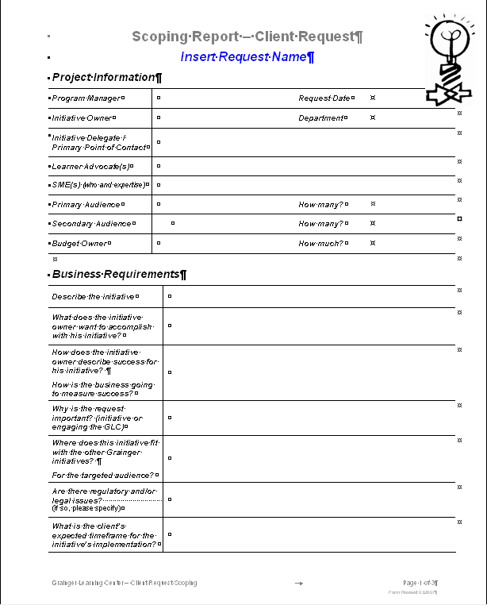

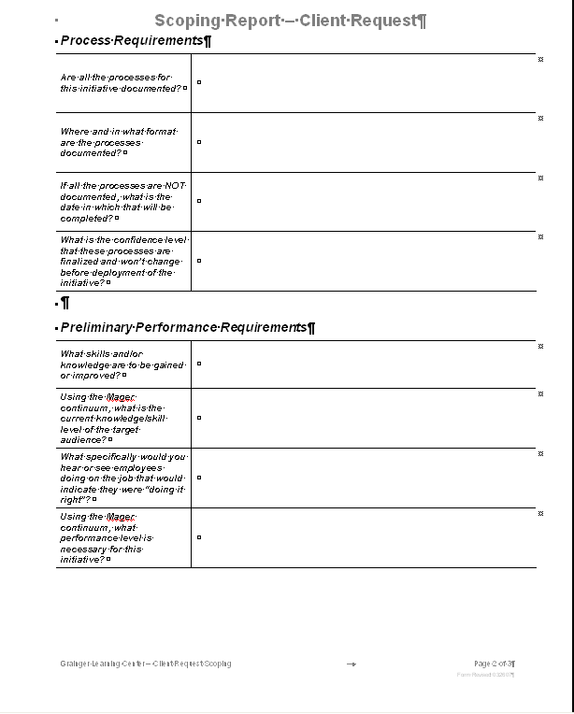

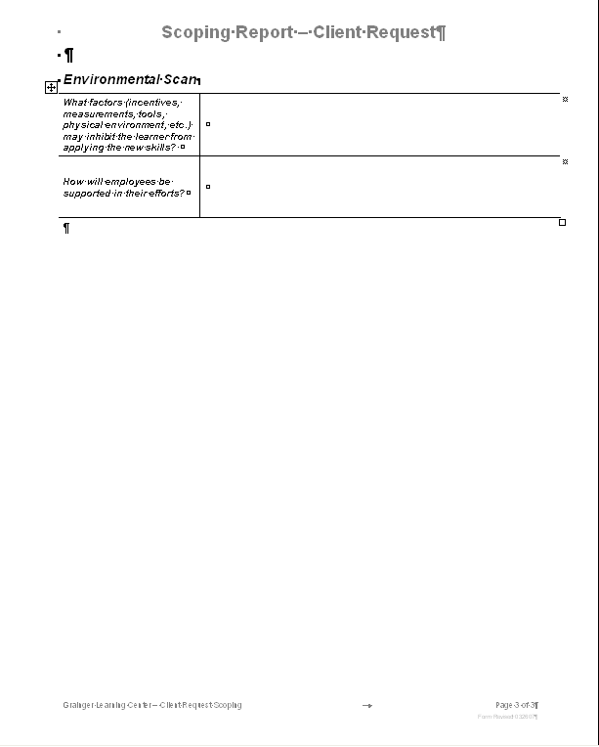 Step 3: Develop Solutions



**Topics Covered in this section:**



## Communication

### Communication Plan

* **Outlines the communications sent throughout the project**
* **Tracks the details of the communication**
  + - Audience
    - Message
    - Timing
    - Frequency
    - Medium
    - Sender

### Activity: Case Study: Corporate-wide Communication for Northern Oil

**Directions:**

Build an outline for the presentation Fritz will make at the All Employee Meeting introducing the change.

* Determine the points you want to make
* Sequence the points
* Construct the outline
  + Be sure to include the main topics and the key messages in each topic

### Activity: Communication Plan – Functional Area Northern Oil

Communication from the Change Team to your Audience:

* What do you wish to communicate?
* Who will deliver the message?
* What medium will be used to deliver the message?
* Who will craft the communication?
* How will the communication be delivered?
* When will the communication be delivered?

Communication from your Audience to the Change Team:

* What have you included to get feedback from your audience?

## Training

Continue your relationship with the GLC and work to:

* Identify detailed training needs per audience
* Develop Training courses
* Deliver Training courses

## Change Navigation

### Master Change Plan

* It is a culmination of all work performed in the Defining the Change, Analyzing Impacts and part of the Developing Solutions steps.
* It identifies audiences impacted and how they are impacted
* It is used to educate sponsors and key stakeholders about the change and to solicit their assistance.
* It drives rapid adoption of change.

### Master Change Plan Contents

* Burning Platform - Why this change is urgent and important?
* Context for Change
  + Current State Analysis - What is the current situation?
  + Desired State Planning - What the new situation will be like?
  + Impact Analysis - Who will be affected by the change? How will they be impacted by the change?
* Organizational Change Components
  + Sponsor Alignment - What actions will sponsors need to take?
  + Stakeholder management -
  + Training - How will targets be reskilled?
  + Communication - Who will need to be communicated to and the key messages
  + *Process Design*
  + *Organization Design & Staffing*
  + *Rewards & Recognition*
  + *Project Assessment*
* *Timeline*
* *Risks*

### Activity Master Change Plan

**Part1: Ideas and Questions for the panel**

|  |
| --- |
|  |
|  |
|  |
|  |
|  |
|  |
|  |
|  |
|  |
|  |

**Part 2: Panel Discussion Notes:**

|  |
| --- |
|  |
|  |
|  |
|  |
|  |
|  |
|  |
|  |
|  |
|  |
|  |
|  |
|  |
|  |
|  |
|  |
|  |
|  |
|  |
|  |
|  |
|  |
|  |
|  |
|  |
|  |
|  |
|  |
|  |
|  |
|  |
|  |
|  |
|  |
|  |
|  |
|  |
|  |
|  |
|  |
|  |
|  |
|  |
|  |
|  |
|  |

**Part 3: Your Change Plan for Northern Oil**

Complete the following sections:

* Burning Platform
* Context for the Change (Current State, Desired State, Impact)
* Communications

|  |
| --- |
|  |
|  |
|  |
|  |
|  |
|  |
|  |
|  |
|  |
|  |
|  |
|  |
|  |
|  |
|  |
|  |
|  |
|  |
|  |
|  |
|  |
|  |
|  |
|  |
|  |
|  |
|  |
|  |
|  |
|  |
|  |
|  |
|  |
|  |
|  |
|  |
|  |
|  |
|  |
|  |
|  |
|  |
|  |
|  |
|  |
|  |
|  |
|  |
|  |
|  |
|  |
|  |
|  |

### Change Readiness

Purpose

* Shows if change agents & targets are assimilating the change
* Offers key questions to ask for assessing readiness
* Outlines areas of the change framework that will be impacted
* Provides valuable information to Sponsors on problems and corrective action needed.

Done with Surveys, direct observation, focus groups, interviews (telephone or face-to-face)

Used as information to update any plans.

### Change Readiness Assessment

* Shows if change agents & targets are assimilating the change
* Offers key questions to ask for assessing readiness
* Outlines areas of the change framework that will be impacted
* Provides valuable information to Sponsors on problems and corrective action needed

|  |
| --- |
|  |
|  |
|  |
|  |
|  |
|  |
|  |
|  |
|  |
|  |
|  |

**Change Readiness Assessment Questions**

|  |
| --- |
|  |
|  |
|  |
|  |
|  |
|  |
|  |
|  |
|  |
|  |
|  |
|  |
|  |
|  |
|  |
|  |
|  |
|  |

## Sponsorship

###### What do you do if…..

## Project Management

### Work Plans

## Stakeholder Management

### Change Network:

A “critical mass” of employees who work with the projects to support the implementation of change

### Benefits of a network

* Creates ownership among impacted employees
* Increases effectiveness and trustworthiness of communications
* Reduces change resistance
* Supplements communications coming directly from Business Unit management
* Provides feedback back to the project team
* Builds change leadership for the future

### Roles in a Change Network

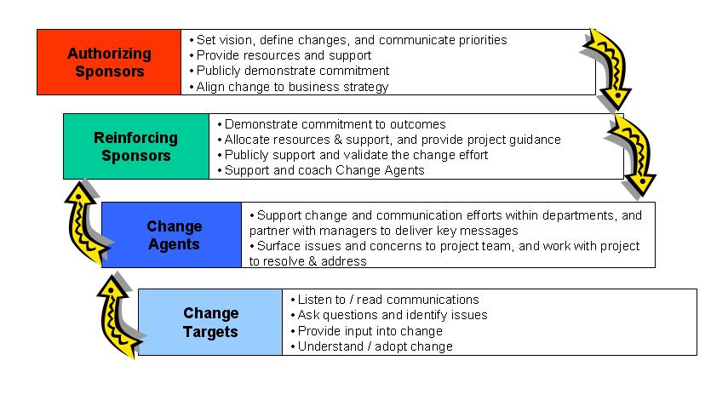

### Structure of the Change Network

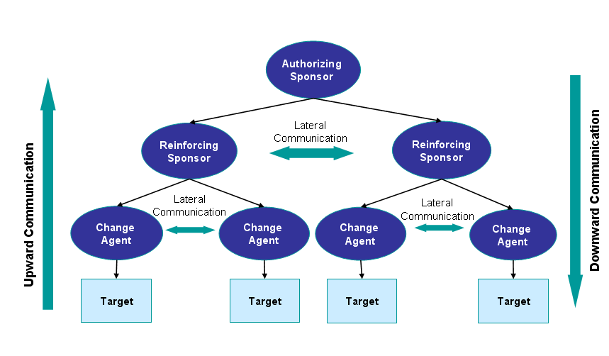

|  |
| --- |
|  |
|  |
|  |
|  |
|  |
|  |
|  |
|  |
|  |
|  |
|  |
|  |

### Change Agents:

**Change Agent Competencies and Characteristics**

|  |  |
| --- | --- |
| Like to see | Don’t want to see |
|  |  |

### Activity: Selecting Change Agents

**Purpose:** To select change agents and to create an onboarding agenda to educate the change agents on their role.

**Directions:**

Select a change agent (CA) for each department in the profiles document.

Create an agenda for a presentation educating the CA to their role.

Change Agents

|  |  |  |
| --- | --- | --- |
| Department | Change Agent | Rationale for selection |
|  |  |  |
|  |  |  |
|  |  |  |
|  |  |  |
|  |  |  |
|  |  |  |

Presentation Topics

|  |
| --- |
|  |
|  |
|  |
|  |
|  |
|  |
|  |
|  |
|  |
|  |
|  |
|  |
|  |
|  |
|  |
|  |

# Step 4: Implement and Transition



**Topics in the section**

* The Benefits of Change Management
* The Framework
* Positively Received Change
* Negatively Received Change
* Managing Change

## Benefits of Change Management

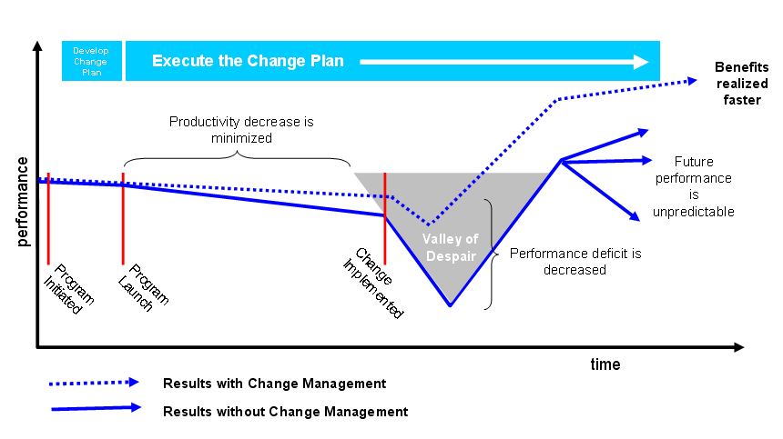

|  |
| --- |
|  |
|  |
|  |
|  |
|  |
|  |
|  |
|  |
|  |
|  |
|  |
|  |
|  |
|  |
|  |
|  |

## The Framework

What is happening now in each part of the Framework?

Change Navigation

|  |
| --- |
|  |
|  |
|  |

Sponsorship

|  |
| --- |
|  |
|  |
|  |

Stakeholder Management

|  |
| --- |
|  |
|  |
|  |

Project management

|  |
| --- |
|  |
|  |
|  |

Communications

|  |
| --- |
|  |
|  |
|  |

Training

|  |
| --- |
|  |
|  |
|  |

## Activity: Positively and Negatively Perceived Change

#### Positively Perceived Change

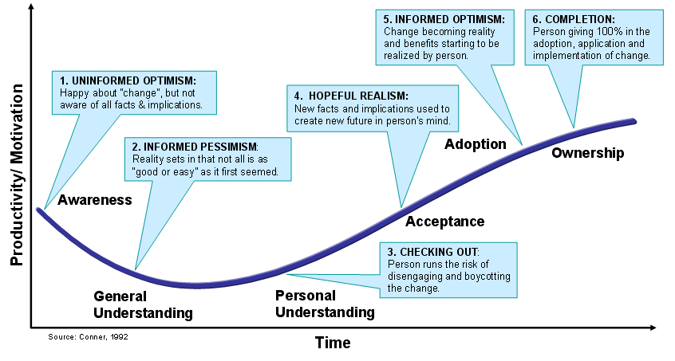

|  |
| --- |
|  |
|  |
|  |
|  |
|  |
|  |
|  |
|  |
|  |
|  |
|  |
|  |
|  |
|  |

#### Negatively Perceived Change

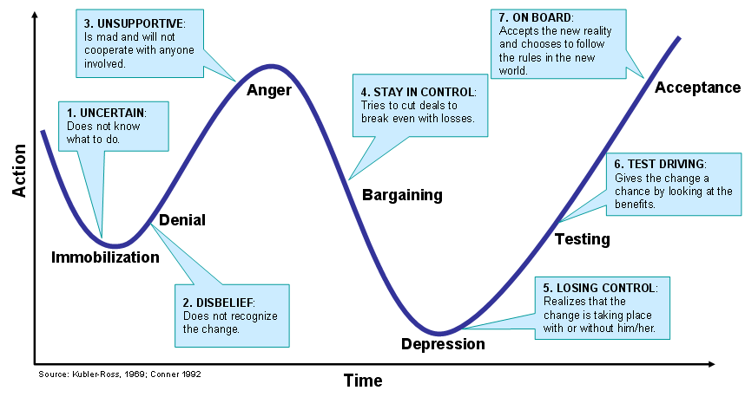

|  |
| --- |
|  |
|  |
|  |
|  |
|  |
|  |
|  |
|  |
|  |
|  |
|  |
|  |
|  |
|  |

### Activity: Negatively Perceived Change

|  |  |  |
| --- | --- | --- |
| **Stage** | **Behaviors you will notice** | **Suggestions of what to do** |
| **Immobilization** |  |  |
| **Denial** |  |  |
| **Anger** |  |  |
| **Bargaining** |  |  |
| **Depression** |  |  |
| **Testing** |  |  |
| **Acceptance** |  |  |

## Managing Change

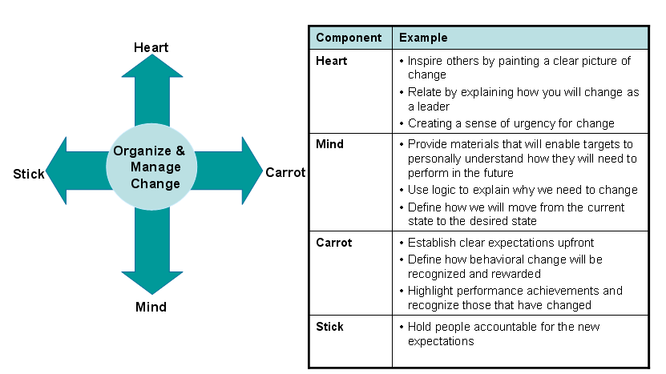

|  |
| --- |
|  |
|  |
|  |
|  |
|  |
|  |
|  |
|  |
|  |
|  |
|  |
|  |
|  |
|  |

# Step 5: Accelerate and Sustain

# 

**Topics in this section:**

* Guest Speaker
* The Framework

## Guest Speaker

|  |
| --- |
|  |
|  |
|  |
|  |
|  |
|  |
|  |
|  |
|  |
|  |
|  |
|  |
|  |
|  |
|  |
|  |
|  |
|  |
|  |
|  |
|  |
|  |
|  |
|  |
|  |
|  |
|  |
|  |

## The Framework

What is happening now in each part of the Framework?

Change Navigation

|  |
| --- |
|  |
|  |
|  |

Sponsorship

|  |
| --- |
|  |
|  |
|  |

Stakeholder Management

|  |
| --- |
|  |
|  |
|  |

Project management

|  |
| --- |
|  |
|  |
|  |

Communications

|  |
| --- |
|  |
|  |
|  |

Training

|  |
| --- |
|  |
|  |
|  |

# What’s next?

|  |
| --- |
|  |
|  |
|  |
|  |
|  |
|  |
|  |
|  |
|  |
|  |
|  |
|  |
|  |
|  |

## Reflections

|  |
| --- |
|  |
|  |
|  |
|  |
|  |
|  |
|  |
|  |
|  |
|  |
|  |
|  |
|  |
|  |