Description
The Training Evaluation Template measures if the project learning objective and criteria for success defined in the Training Plan have been accomplished. The training process's evaluation and feedback phase provide information about overall training effectiveness, quality of learning materials, user ability to grasp and apply new knowledge, facilitators' ability to deliver precise and engaging training, and opportunities for improvement.

Instructions
- Use the Training Evaluation Template to determine what questions you want to ask. We recommend you reduce the number of questions to the absolute minimum.
- Create assessment
- Implement assessment
- Analyze data
- Share results

Kirkpatrick Training Evaluation Model
Kirkpatrick's model provides a framework for understanding the levels of evaluation. This model describes the impact of the training on the trainee in three areas: reaction to the learning, knowledge attained by the learning, and impact on–the–job behaviors. Additionally, the impact and results on the organization are measured at the fourth level.
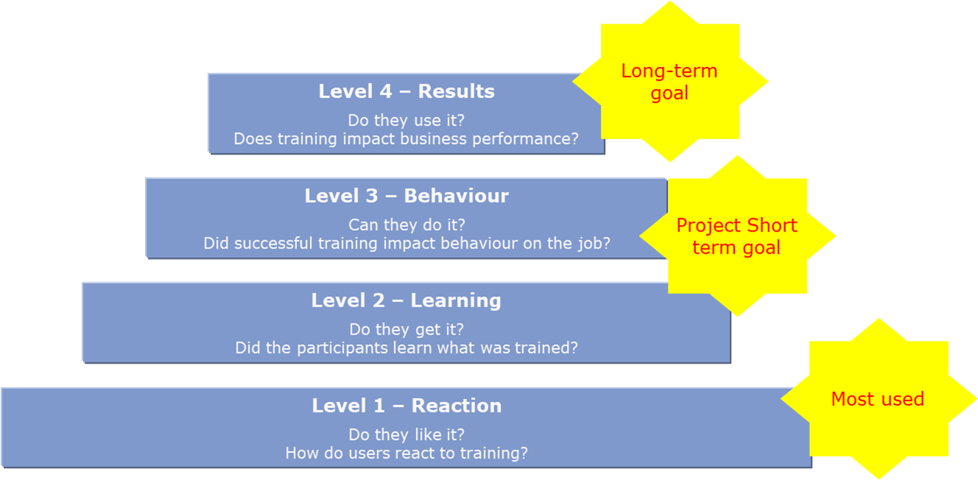

Applying the Kirkpatrick model

 | LEVEL 1: REACTION | LEVEL 2: LEARNING | LEVEL 3: BEHAVIOR | LEVEL 4: RESULTS
CHARACTERISTICS | Measures how participants felt about training.  Used to establish if the participant liked the training. | Measures to what degree participants learned what they were trained.  Used to establish if the participant understood the concepts, facts, and techniques that were presented. | Measures whether the training program has effectively transferred new knowledge and skills to the workplace.  Used to determine whether the participant demonstrates the behavior and performance they exhibited in training. | Measures the impact of the training program on the organization's performance (KPIs).  Used to determine the effect that the trainee's acquired knowledge has on the business.
 | 96% of organizations evaluate at this level. | 37% of organizations evaluate at this level. | 13% of organizations evaluate at this level. | 3% of organizations evaluate at this level.
TACTICS | Evaluated by distributing questionnaires to participants after training, asking them to rate aspects of the course.  The questions may measure content, delivery, instructors, materials, media used, and facilities. | Typically evaluated during the training session using pre and post–training assessments.  Training assessments can include hands on exercises, written tests and instructor observation. | Evaluated using subtle and ongoing observation, surveys, or on the job performance assessments.  Assessments are typically conducted by line managers or supervisors. | Evaluated using indicators including productivity, profitability, employee turn over and costs.  This level of evaluation is usually difficult to quantify.
VALUE | Identifies more immediate opportunities to enhance training delivery and content. | Ensures that training participants are learning the training content. Clearly indicates the technical knowledge and skills learned at the individual level as a result of the training. | Ensures that training is aligned with business requirements. Shifts the focus of assessments. Evaluates how effectively training prepares participants for their job duties rather than how effectively participants learn the training. | Organization would see an overall increase in productivity and a decrease in error rates.
COMMON PRACTICES | Course evaluation forms are given to participants at the close of each training session, which assess the training module and facilitator. | Tests/quizzes are administered in the training sessions to measure the participant's comprehension of the training materials  Inconsistencies exist in the administration of tests and follow through on test results | The impact of the training program on the employee's on–the–job behavior is not currently being measured. Currently, managers may request the Learning and Development Team conduct ad–hoc training sessions to determine that skills gaps exist in certain areas. | The impact of the training program on organizational results is not currently being measured.

