Engage Sponsor Description
This document provides a mechanism early in the project that allows key sponsors to offer valuable insight to the project team and influence the development and implementation of change management activities. It also spells out the role of a good change program sponsor so that s/he knows what will be expected during the project and beyond.
We recommend the project team uses this document with the Authorizing and Reinforcing Sponsors.

Instructions
- Review this document in preparation for your meeting with the Sponsor.
- Identify Authorizing Sponsors and Reinforcing Sponsors and their corresponding areas of responsibility.
- Walkthrough the items below, so the Sponsor understands the project team’s recommendation (needs) of their role
  - Sponsor Overview
  - Sponsor Background
  - Sponsor Interview
  - Sponsor Responsibilities
  - Best Practices
  - Sponsor Self-Evaluation
- Create an action plan for each Sponsor.

A. Sponsor Overview
The project team seeks your insight into the project’s objectives to develop the change management strategy. We also want to share our experience with the role of a good change program sponsor so you know what you can do to support the project.

B. Sponsor Background
Try to understand the Sponsors’ history with and change initiatives. This knowledge may also influence the approach that you will take in developing the Change Plan.
- Contact information (email, work phone, cell phone)
- Sponsor’s background with
- Years of service
- Their experience with change projects outside the company
- Their experience with change projects at
- How have they managed resistance to change efforts in the past?
- At a high level, what do they see as the greatest risks and obstacles for this project (people, process, technology)?
- How are they perceived by others in the company? What is their reputation?

C. Sponsor Interview
- How would you define the problem we are planning to tackle as it relates to Project X?
- What is the impact of the problem on your area of responsibility?
- What success measures would you use for Project X?
- What goals or objectives do you have, or will you have related to Project X?
- What ideas do you have in terms of what could be contributing to the problem?
- What concerns or anticipated obstacles do you have related to achieving the desired state?
- What suggestions do you have for overcoming those concerns/obstacles?
- What are the other key initiatives in your area currently underway or planned that might compete for time/attention?
- In terms of significance, where does Project X fall in your list of key initiatives?
- How would you like to receive updates on the progress of this project?
- If appropriate, ask the Sponsor who to consult if you receive confusing or conflicting information

D. Sponsor Responsibilities

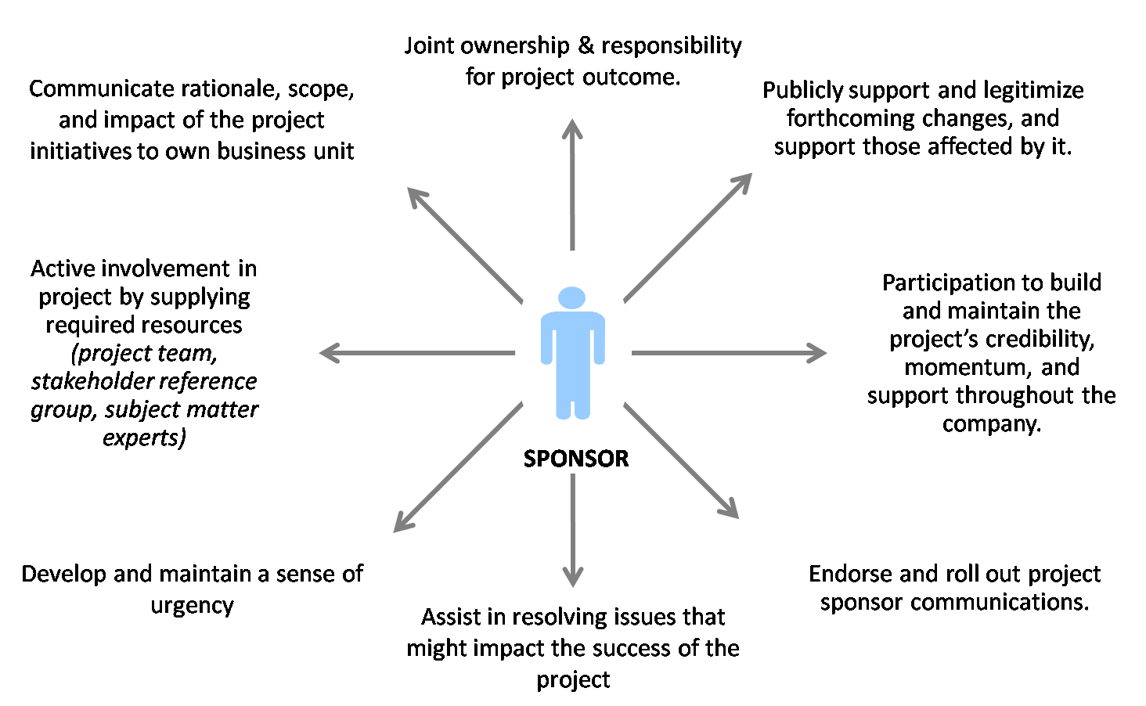

- Communicate rationale, scope, and impact
The Sponsor must openly and repeatedly communicate the “why” behind the change initiative and let people know how they will be impacted and what’s in it for them.
- Supply required resources
The Sponsor must supply people access to information and an adequate materials budget to the change program team to ensure success.
- Endorse and/or rollout project communications
The Sponsor must actively support and participate in project communication efforts.
- Support change agents
Those in the field who are responsible for ultimately making the change happen are the change agents. They need to know the Sponsor is behind them or they may check out of the process.
- Regularly review progress
Any change program that is truly a top priority of a sponsor should have his/her appropriate attention. Typically, this means at least a weekly update regarding the program’s progress so that successes can be publicly celebrated and new barriers can be identified and removed.
- Actively support impacted staff
Just like the change agents, those who are most impacted by the change need to see support from the top and need to know what’s in it for them if they support the change.
- Develop and maintain a sense of urgency
People look to the project sponsor to communicate the priority of the change effort. Unless the Sponsor clearly communicates the urgency of the initiative, people will assume it is not of high priority, and your efforts will be wasted.
- Publicly legitimize and support the change
By publicly celebrating successes and removing barriers, the Sponsor will send a clear message that this program is here to stay and not just another flavor of the month.
- Acknowledge and endorse the pain required for the change to be successful
The Sponsor must recognize that the change will bring pain to the organization and be willing to make tough decisions at crucial moments. It is best to anticipate these decisions and proactively plan the response to increase the likelihood of success.
- Identify and resolve issues that might impact the success of the project
By clearing the path for the change to happen, the Sponsor stands a better chance of building positive momentum that will carry the organization forward toward the new way of doing business.

E. Best Practices
- Change Process
  - Conflicting or confusing goals among departments will be worked out at the lowest possible level.
  - Resource constraints will be accepted as a normal part of the change process.
  - Decisions made regarding action steps will keep the two-fold goal of making major changes and supporting the on-going business as the framework.
- Communication
  - Use every opportunity, formal and informal, to express support for the changes.
  - Express all concerns regarding the changes objectively, constructively, and in reference to the project, not to individuals.
  - Ensure that communication about the change sent down throughout the organization is accurate and consistent.
  - Actively solicit feedback on the issues and concerns of the people who work for you (Targets).
- Learning
  - Demand the skills, knowledge, and behaviors that support the change throughout the company.
  - Understand and accept the hit on short term goals caused by the learning time and effort.
  - Support the training efforts by being at the beginning and/or end of every training session to tell people why they are there and what is expected of them.
  - Help team adapt project team goals to ’s performance appraisal process, if appropriate.

F. Sponsor Self-Evaluation
The following items are important when evaluating a project’s sponsorship. Share a few (or all) items with your Sponsor so they may understand what activities may need additional attention.
sponsor  responsibility | rating |  |  |  | comments
 | 1  Strongly Disagree | 2  Somewhat Disagree | 3  Somewhat Agree | 4  Strongly Agree
Communicates the “why” behind the change program, in addition to its scope and anticipated impacts
Supplies required resources to make the change program successful (e.g., people, dollars, facilities, etc.)
Endorses and/or personally delivers change program communications in a timely manner
Supports change agents and other key stakeholders critical to the success of the change program
Regularly reviews the change program’s progress and ensures objectives are being met
Supports the workforce most impacted by the change program
Develops and maintains a sense of urgency with those needed to keep the change program moving
Publicly legitimizes and supports the change program
Recognizes and is willing to “pay the price” needed for the change program to be successful
Identifies and helps resolve potential obstacles to the change program’s success

Authorizing Sponsor Plan

Name / Title
Project point of contact
Type of updates, frequency
Key people to engage

CONCERNS | ACTION | TIMING

Reinforcing (BU) Sponsor Plan

Name / Title
Project point of contact
Type of updates, frequency
Key people to engage

CONCERNS | ACTION | TIMING

Sponsor Coaching Tips (for the change practitioner)
Use the tips below to prepare for your sessions with your Sponsor.
- Use questions to help the Sponsor arrive at his / her own conclusions and plans of action.
  - For example, instead of saying “you should meet with the VP of Supply Chain to make sure she’s on-board with the new system,” try “do you think it would be a good idea to meet with the VP of Supply Chain before our next stakeholder meeting so that we can understand any objections she may have to the new system?”
  - Using questions instead of statements helps people to form their own thoughts and take more ownership over the action plan.
- Appropriately challenge your sponsors’ thinking and help them to think through possible (and sometimes unintended) consequences of their decisions, actions, and words.
- You may need to remind your sponsors that they are likely much further “up the change curve” than those who are being impacted by the change.
  - This is because they may have generated the change idea and have been “living with it” for much longer than those who are on the front lines.
  - Patience will be required to take the right actions, and one of your jobs is to serve as that gentle reminder.
- In your role as a change management professional, you must be comfortable reporting facts about the projects and stakeholders.
  - At times, you may have to deliver difficult messages to your sponsors.
  - While this can be a stressful conversation, reporting facts can help sponsors see situations from new angles/points of view and result in new courses of action.

