Communication Standards
We recommend several elements to improve stakeholder communications
- Project overview presentation (updated monthly)
- Project information site
- Shared project mailbox
- Project email template

It is helpful to have project templates (PowerPoint, word, excel) that include:
- Header: Company Name, Project Name, Document Name
- Footer: File name, Date/time, page number / total pages
- Project image/graphic (on PowerPoint presentation)
- We suggest the documents be formatted to print to a standard size (e.g., Letter), in black and white.

Project overview presentation (updated monthly)
- Also known as Standard Presentation or Monthly Big Picture
- Contents:
  - Elevator speech
  - Timeline (overall)
  - 90-day timeline
  - Key accomplishments (last 30 days)
  - Upcoming activities (30 days)
  - Upcoming activities (90 days)
  - Conversation topics with Key Stakeholders
    - Key themes
    - Key decisions
  - Where to get more information or provide feedback

Project information site
Suggested contents:
- Shared folders (by workstream or project phase)
- Project timeline
- Project plan
- Project status reports
- Project issue reporting
- Project roster & OOO calendar
- Standard presentation (see above)
- Project overview (elevator speech)
- Frequently asked questions
- Feedback/questions

Shared project mailbox
A shared inbox offers you a single, streamlined platform to address all your collaboration needs. By using a shared inbox, you will be able to manage both project and stakeholder communication to:
- Monitor and send email from a centralized account
- Respond to stakeholder questions/comments faster
- Share Outlook calendar information

Email Urgency Labels
Urgency labels can be used in the subject line to clarify the type of action you want the recipient to take.

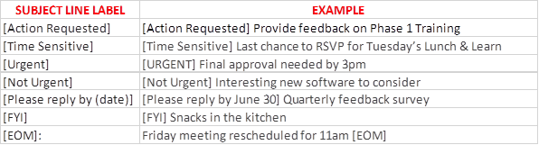

Project email template
Please see the sample below:
- The table set up will center on the viewer’s screen and format the message to a specific width.
- If the project team has a SharePoint site, it helps to link the message to a PDF that opens in a web browser.
- “Action requested” call out – helps users focus on the action you want them to take.

click here to view this message in a web browser
Sent by the <project team name>
ACTION REQUESTED
<greeting>
<text>
<signature>
COMPANY CONFIDENTIAL
 please consider the environment before printing this email

Project Glossary
- Our project is related to the Change Management Framework (not change management methodology or change management approach)
- Refer to employees as “team members”
- When to use Ordinal Numbers - April 22, 2020 -or- April 22nd, 2020
  - Use ordinal numbers (a number with the suffix –th, –eth, –nd, –rd, or –st) if the number appears in a date before the month or if the date stands alone.
  - Examples:
    - I will retire January 29, 2021.
    - I will retire on the 29th of January in 2021.
    - I will retire on the 29th.

Project Coordination & Consistency
- Powerpoint
  - Use project PowerPoint template
  - Make sure you use standard (4:3) slide size (avoid using widescreen 16:9 slide size)
- Coordinate outreach to leaders via change management or project management team
- Drive toward consistency in messaging about the project by using the monthly project update presentation

