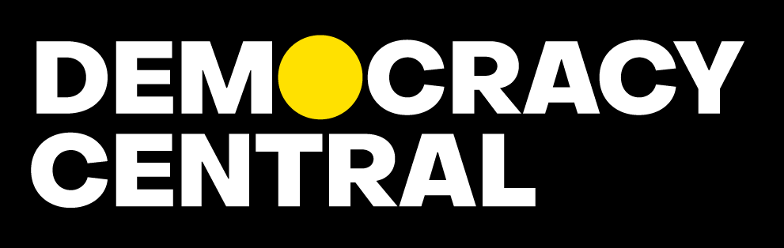

Project Proposal: Democracy Central
Grants Programme
Publication date: April 20, 2023

REQUEST FOR FUNDING
 | Project code: | (Leave this field blank)

Applicant
Name of the media organisation / media outlet
Legal business entity under which media outlet is officially registered in public records
Name of the project
Link to website
Links to social media | YouTube
 | Facebook
 | Instagram
 | Twitter
 | Other
 | Other
Location (country, region, city)
Address
Date of establishment of the outlet
Ownership of the media outlet
(If owned by a legal entity, provide ownership information for that entity, and any further entities until ultimate beneficiaries are identified.)
Registered legal representative | Name, Surname
 | E-mail
 | Phone
Requested funding
General aim / purpose of the requested funding
(Explain briefly why you need the requested funding.)
Country of implementation
Duration of the support
(Maximum 12 months)
Start date (dd/mm/yyyy)
End date (dd/mm/yyyy)
Requested grant amount (EUR)
Contact information
Responsible person for the project
Name, surname (as in passport)
Position
(e.g., Director, Project coordinator, etc.)
Email
Phone
Contact person
Name, surname (as in passport)
(If different from the responsible person)
Email
Phone

PROFILE OF THE ORGANISATION
- Organisation

  - Describe the management structure of your organisation. Please attach an organisational chart.

  - How many people work for your media organisation (on any type of contract) and on what basis (full time, part-time)? What is the proportion of men/women?
Position | Full-time | Part-time | Percentage of women
Journalists and editors
Management
Support (admin, technical, marketing, maintenance…)
TOTAL

Add lines if needed.

- Editorial orientation and market positioning
  - Briefly explain the editorial policy of your media outlet.
  - Please describe mechanisms put in place to ensure editorial independence from owners and other external interests and influences.

  - How does your media outlet differentiate itself from its competitors in terms of its content, style, and presentation? What niche in the media market do you occupy?

  - What are the main publication formats that you use?

  - Please list, if relevant, 5 examples of referrals, quotations to your publications that have been made in other major media outlets in the last 12 months. Please describe if, how, and to whom you syndicate your content.

  - Share with us 3 examples of publications from the last 12 months that best illustrate the level of the quality of your work. Provide us with examples that have been the most popular and / or that resulted in concrete change or significantly contributed to the public debate (for each example provide a web link and a short explanation).

EXAMPLE 1
Title:
Date of publishing:
Short description:
Link:
EXAMPLE 2
Title:
Date of publishing:
Short description:
Link:
EXAMPLE 3
Title:
Date of publishing:
Short description:
Link:

- Strategic vision

  - What is the long-term vision for your organisation? Where do you see your organisation in 3 to 5 years regarding its relevance as an independent media outlet, its market share, and its organisational capacities and resources?
  - What are the main priorities/objectives for the next 12 months for your media organisation?

- Audience

  - Who is the target audience of your media outlet, and what are their interests and preferences? Be as detailed as possible.

  - Provide quantitative information about your current audience for each channel/platform that you are using, such as: social media, radio, TV, print, newsletter, apps, etc. (Please provide the data for the previous month, i.e., March 2023 or the latest month for which you have the most complete information and indicate basic trends in increase/decrease in comparison to a year ago. If you use Google Analytics, please attach screenshots)

Channel/Platform  (add or delete as appropriate for your media outlet) | Relevant audience data (e.g.: reach, page views, unique visitors, engagement, subscribers, followers, sold copies, distributed free copies, viewers, etc.) | Trend: increase or decrease compared to a year ago. (Explain any major changes and provide an indicator of change in percentages.)
TV channel
Radio channel
Printed publication
Website
Podcasts
YouTube channel
Facebook
Instagram
Twitter
TikTok
Newsletter
Apps
(…)
Add or delete channels/platforms according to the profile of your media organisation.

4.3 What is your plan for expanding existing audiences, deepening relationships with your audience, and reaching new audiences in the next 3 to 5 years?

- Innovations

  - What are some notable examples of innovative content, formats, technologies, business models, or processes your media outlet has launched in the past few years? Please name those that you find the most important and explain briefly what happened and how such innovations impacted your organisation.

  - What are the immediate plans and longer-term strategy of your media organisation for staying ahead of emerging trends and technologies in the media industry?

- Financial sustainability

  - What is your current revenue model and how diversified are your revenue streams? Indicate revenues for each revenue type in the following table:

Type and sources of income | 2021 (EUR) | 2022 (EUR)
Income from private individuals
(subscriptions, sales, microdonations / crowdfunding)
Income from private businesses (subscriptions, sales, advertising, sponsorship, donations, other…)
Income from government, public institutions, and state-owned companies
(subscriptions, sales, advertising, sponsorship, donations, grants, direct transfers, any other…)
Income from donors
(grants and donations from international donors and local private non-profit organisations)
Other types of income
(please specify here)
Total

6.2 If you have received grants from international donors (including grants administered by local non-profit organisations) in the past 2 years, please list the donors and briefly explain how the support was used.
Donors | 2022 (EUR) | 2023 (EUR) | Brief explanation
1
2
3
4
…
Add or delete rows as needed.

6.3 How has your media outlet performed financially over the past 2 years (2021 and 2022)? (Briefly summarise and explain key indicators of financial performance. Provide financial statements for 2021 and 2022 in the attachment to this form with English version)

6.4 What is your plan for retaining or increasing revenue and ensuring financial sustainability in the next 3 to 5 years, and what challenges and opportunities does it foresee in the market?

C. DESIGN OF THE PROJECT

In this section of the form you will provide information about the planned project for which you are requesting funding.

1. The Problem / Opportunity
- What is an organisational challenge/problem you want to address or an opportunity you want to exploit with this project? Provide relevant details and background information to explain why is that an important challenge/problem or a good opportunity for your media organisation?

2. The Goal (long-term overall goal)
- Explain what is the overall, strategic goal you want to achieve regarding the identified problem or an opportunity from the previous section (section C.1., above)?

3. Objectives (specific, planned results of the project, what you want to achieve with the project)
- Identify concrete objectives that this project will be able to achieve within its timeline, and that contribute towards the achievement of the long-term goal (from the previous section C.2, above). (The project can have several objectives that are logically related to, and contribute towards the achievement of the overall goal. Maximum number of objecives is six)

Objective 1
What will be the concrete result of this project?
How do you measure it?
Explain and provide indicators of success.
How reaching this objective contributes to the overall, strategic project’s Goal? (defined in Section C.2. above)? Explain the logical link between this objective and the long-term goal.

Objective 2
What will be the concrete result of this project?
How do you measure it?
Explain and provide indicators of success.
How reaching this objective contributes to the overall, strategic project’s Goal? (defined in Section C.2. above)? Explain the logical link between this objective and the long-term goal.

Objective 3
What will be the concrete result of this project?
How do you measure it?
Explain and provide indicators of success.
How reaching this objective contributes to the overall, strategic project’s Goal? (defined in Section C.2. above)? Explain the logical link between this objective and the long-term goal.
Add additional objectives if needed. Maximum number of project objectives should be six.

4. Activities of the project

- In the following table please insert the specific project objectivs / planned results from the previous section, and for each objective list all activities that must be undertaken in order to achieve the planned objective. For each activity provide the timeline.

Project objectives / planned results  (General direction of the project. Add as many objectives as needed.) | Activities  (Detailed list of specific activities to be implemented in order to reach each objective/planned result. Add as many activities as needed, but try not to have more than 15 for each objective.) | Start date  dd/mm/yy | End date  dd/mm/yy
1. | 1.1.
 | 1.2.
 | 1.3.
 | 1.4.
 | 1.5
 | 1.6
2. | 2.1.
 | 2.2.
 | 2.3.
 | 2.4.
 | 2.5
 | 2.6
3 | 3.1.
 | 3.2.
 | 3.3.
 | 3.4.
 | 3.5
 | 3.6
Add or delete rows if necessary.

5. Project team
- Describe who will be the members of the project team. For each team member briefly explain who they are, and what are their roles and responsibilities within the project.

6. Sustainability of the project results
- Explain if and how this project will contribute to the sustainability of your institution and its strategic orientation within the next 3 years? Explain how the successful completion of the project will impact, in a longer-term perspective, at least one of the aspects of your work listed in the following table:

Aspects of your work: | Expected contribution of this project to each aspect within next 3 years:
Revenue streams and financial sustainability
Audience reach and community building
Offerings of products and services
Brand/reputation
Organisational capacities, processes, and structures
Market share and market differentiation
Other (specify):
Аdd or delete rows, if necessary

7. Risks
7. What are the main risks of this intervention and how do you plan to mitigate them? What is the likelihood that the risk will occur and what is the level of its impact on your organisation?

D. LIST OF DOCUMENTS TO BE ATTACHED
Please make sure that all of the following documents are provided in addition to this form:

- Project Budget
- A copy(copies) of court/official registration document(s) stating the founding entities/persons and ownership structure
- Organisational chart
- Financial statement for 2021 with English translation
- Financial statement for 2022 with English translation

The chart should show the internal structure of an organisation, including the roles and relationships between different positions or departments.
E.g. production of new content formats, increase of audience share, implementing a subscription scheme, changes in organisational structure, introducing new roles, modernization of CMS, etc..
Please rely on data from your financial statements.
Important: You are not expected to achieve the long-term goal within this project’s timeline, as many factors beyond your control also impact the chances for the achievement of the goal, and such goals normally require longer time horizons than provided by a single project.
The project objectives must logically contribute to the achievement of the long-term goal identified in the previous section. Make sure that the planned project objectives are SMART – Specific, Measurable, Achievable, Relevant and Time-bound.

