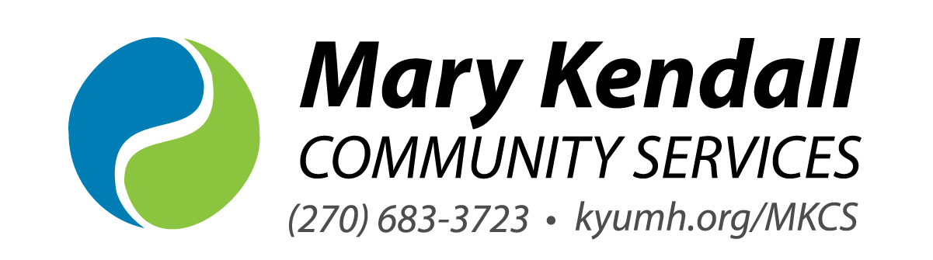

Referral for Services
Referred by:
Name: __________________________________ Affiliation: __________________________________
Phone #: ________________________________ Email: __________________________________
What is the best way for us to follow up on this referral?
☐ Contact referring source directly ☐ Contact person/family being referred directly
Client Information *SSN or Copy of Insurance Card is required*

Name: ____________________________________ Age/DOB: _____________ SSN: ______________

Parent/Guardian’ s Name & Relationship (under age 18): ___________________________________________

Address: ___________________________________________________________________________

County: ________________ Phone: _________________ Alternate Phone#: ____________________

School attending (if applicable): _________________________________________ Grade Level: ____

IEP/504 Plan (if applicable): ☐ Yes ☐ No Primary Language Spoken in the home: ___________________

Reason for referral/presenting problem:

__________________________________________________________________________________________
__________________________________________________________________________________________
__________________________________________________________________________________________
__________________________________________________________________________________________

Is treatment court ordered? ☐ Yes ☐ No
Are there any substances being used or suspected of being used? ☐ Yes ☐ No
Current legal charges (if applicable):

Please indicate source of payment for services: ☐ Anthem (Medicaid) ☐ Aetna (Medicaid)
☐ Humana (Medicaid) ☐ Passport (Medicaid) ☐ WellCare (Medicaid) ☐ Private Insurance
☐ No insurance ☐ Self-pay

Send referrals by email to mkcs@kyumh.org or by fax – (270) 926-0817
For questions about Mary Kendall Community Services call (270) 683-3723

