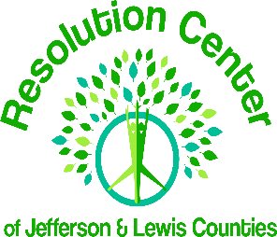
Resolution Center of Jefferson and Lewis Counties, Inc.
Community/Family Court Mediation Program
200 Washington Street, Suite 207
Watertown, NY 13601

Instructions for “Intake and Referral Form”
To get started, choose below from either Electronic Filing or Print and Fill out by hand and follow the instructions. A member of the Resolution Center staff will contact you within 2 business days of receiving your forms to begin the process of scheduling you for a mediation.

For Electronic Filing:

- Click on the following link for custody/visitation: ____________
- Click on the following link for community: _________________
- Follow instructions on the form to complete
- Double check all fields for accuracy
- Click the submit button

To Print and Fill:

- Print the entire form, unless you already have a hard copy
- Follow instructions on the form to complete
- Double check all fields for accuracy
- Submit it one (1) of three (3) ways:
1. Scan or take pictures with your phone and email to: info@resolution-center.net
2. Fax to: 315-785-0332
3. Drop off or mail to: The Resolution Center, 200 Washington Street, Suite 207,
Watertown, NY 13601

Thank you

