20th Annual Metroplex Energy Tennis Tournament
March 26-March 28, 2020
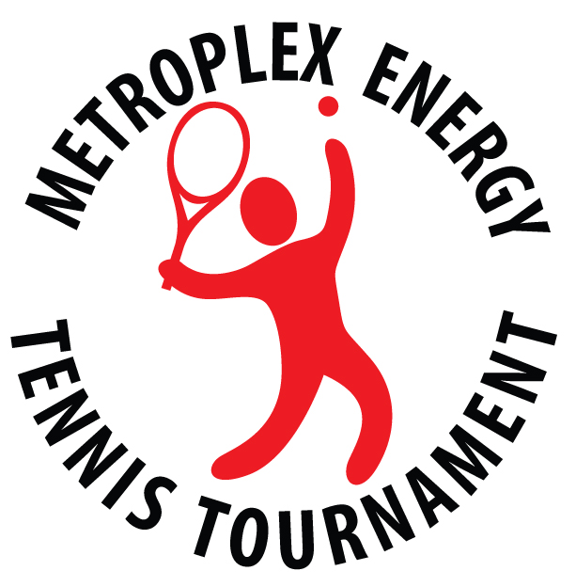
Benefiting

Sponsor company:__________________________________________ name:__________________________________

title: ______________________________________________________ phone: _________________________________

address: ___________________________________________________ email: __________________________________
(Street, suite #, City, State, Zip)
Ultimate Sponsor - $6,000
Major Sponsor of the tournament merchandise or social function
Recognition at all tournament functions and on program cover
Includes 4 player entry fees*
Grand Slam Sponsor - $3,000
Sponsor of the tournament merchandise or social function
Recognition at major tournament functions and in program
Includes 3 player entry fees*
US Open Sponsor - $2,000
Sponsor of social function
Banner recognition and in program
Includes 2 player entry fees*
Wimbledon Sponsor - $1,500
Level-appropriate recognition on compilation banner and in program
Includes 1 player entry fee*
French Open Sponsor - $1,000
Level-appropriate recognition on compilation banner and in program
Australian Open Sponsor - $500
Level-appropriate recognition on compilation banner and in program
Davis Cup Sponsor – Under $500
Level-appropriate recognition on compilation banner and in program
If your company would like to contribute ditty bag items with your company name/logo for purposes of networking opportunities, your contribution would be welcomed and appreciated.

Please display my sponsorship in the following name: ________________________________________________________

* A player entry fee may be exchanged for two (2) social passes
* E-mail your logo (EPS format) to: chill@kandsins.com or cconine@lucasgroup.com
* Provide the names of each complimentary social function attendee so that name tags can be prepared
* Complete a Registration Form for each player prior to February 24, 2020, so that ditty bag items can be ordered
* Make checks payable to METT and return to:
Attn: Ron I. Bliss, TSC Oil & Gas, Inc., 4925 Greenville Ave., Suite 600, Dallas, TX 75206

For information about sponsorship opportunities please contact:
Chris Hill: chill@kandsins.com (972) 467-5223 & Clayton Conine: cconine@lucasgroup.com (972) 201-1248

