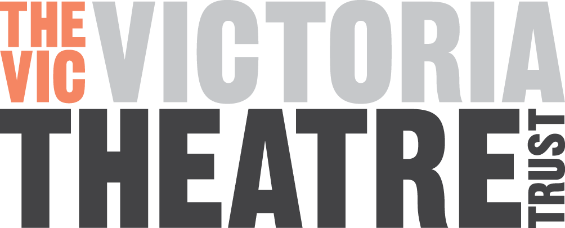

Minutes of the

Annual General Meeting of

THE VICTORIA THEATRE TRUST

Monday 24th September 2018 at 7.30pm

At The Victoria Theatre

Trustees Present: Mark Sigglekow Co Chair
Margot McRae Co Chair
David Downs
Libby Boyd
Mark Pearce
Hamish Grotian
Apologies: Rebecca Nolan; Amanda Mays; Alistair Fletcher and Gail Carran.

In attendance: 12 members of the public, including Cr Chris Darby and Cr Richard Hills and Philipp Jaser

1. Approval of Previous AGM Minutes

That the minutes of the Annual General Meeting of the Victoria Theatre Trust held on 21 September 2017 be adopted.

Moved/Seconded (McRae/Boyd)

2. Co Chair’s Report

Mark Sigglekow and Margot McRae presented the Co Chairs’ Annual Report.

(Attachment 3)

Moved/Seconded (Boyd/Downs) That the Annual Report of the Co-Chairs’ be adopted.

3. Treasurer’s Report

David Downs presented his Treasurer’s report and the Audited Financial Statements for the year ended 31 October 2016 (Attachment 1 & 2)

Moved/Seconded (Sigglekow/Boyd) That the Reports from the Treasurer be accepted.

4. Questions / Discussion

There were questions and discussion around: Building; Earthquake Strengthening; Community use of the theatre

The meeting concluded at 8.15pm.

Confirmed____________________________________________________________

