Be. Institute 10 Year Impact Report

Part A: Introduction
Dear New Zealand,
On 17 January 2011, I found myself alone, in a dark corridor outside an office, in downtown Auckland. I had just locked myself out of the office for the third time because the keypad was teeny, and as a woman who regularly tries to put her cat on over her head because she thinks it is her black jersey, eyesight is not my greatest strength.
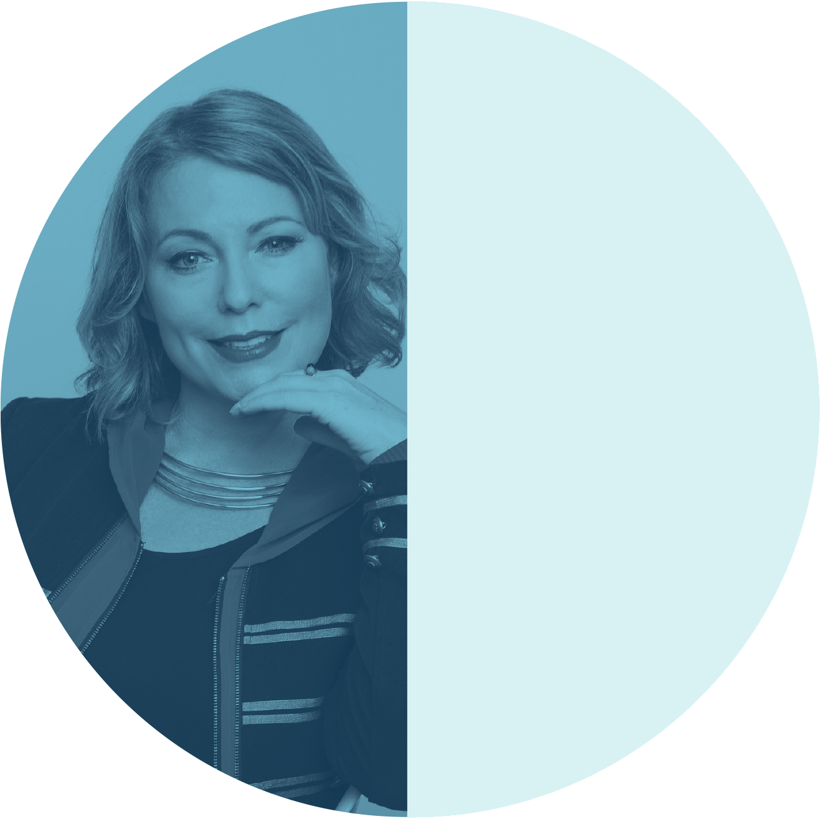
Six weeks earlier I had resigned from my job as the disability advisor to the Auckland City Council and returned from a not-so-relaxing whirlwind tour of Vietnam and Malaysia with a friend who was retracing her traumatic escape as a seven-year-old refugee, crikey…! I had just convinced several large organisations to invest in a pretty ambitious dream I had for New Zealand - and was now locked outside a door facing the reality that I was about to set up my own social change agency (if only I could get in).
It is fair to say that this was quite a significant life moment!
So, what was that dream ten years ago? What did all of us who came on board and invested in Be. believe was possible?
It is extremely simple. We created the Be. Institute in 2011 because we believed we could create an organisation and an approach to social change that would improve the lives of the 25% of New Zealanders with access needs.
We felt the status quo, which seemed to silently accept the costs of an unequal and disabling society, was no longer acceptable, and we realised that we needed to take action if we wanted an inclusive and socially innovative New Zealand we could be proud of in the 21st century. Our vision centred around leadership and possibility.
Our goals were:
- To create a contemporary nationwide leadership programme that invested in the leadership development of people with access needs and to build a strong, supportive community and network of access leadership.
- To engage and inspire businesses to become accessible to the 1 in 4 New Zealanders living with access needs – and not wait to do it as a matter of compliance or law.
- To create a movement and a story that would invite New Zealanders to value the idea of an accessible world and to have a fresh conversation, one that focused on what was possible... not on limits.
- To create a network of powerful leaders across business, government and community that would advocate for and advance a more accessible world.
- To build a contemporary organisation and a sustainable business model, one that embodied the very best aspects of the social and the enterprising.
- To be a good employer, an employer of choice, and to model accessible employment. We wanted to professionalise access expertise by paying people properly.
- To innovate, disrupt, take some risks, shake things up, work with new and interesting people and organisations, and aim as high as we could.
In summary, we wanted to be an accessibility social change agency that catalysed and generated a culture of innovation and social change that would advance a more accessible world here – and around the world!
Ten years on, the million-dollar question is, what impact has been achieved? How well have we honoured our end of the bargain and innovated for a more accessible Aotearoa? Did we get everything right first time? Of course not – it took Edison 1,000 attempts to create the lightbulb after all, but we are heading in the right direction.
New Zealand, with your support, we have:
- Invested in leadership – 150 access leaders
- Enabled meaningful employment – 232 individuals placed into meaningful employment opportunities, and $1.1m of social value created through just one of our employment programmes
- Engaged businesses – 800+ businesses and 4,000+ access improvements to spaces, places and events
- Reframed the conversation – 20 million views of media coverage, moving the conversation from disability to accessibility and possibility
- Mobilised strategic influence – 65 influential New Zealand leaders championing accessibility in their organisations and across their spheres of influence
- Created a new generation of social enterprise – $2m/year revenue with half driven by our own consultancy; 15 team members, half of which have access needs
- Catalysed a future of possibility design and innovation – Created the first Global Centre of Possibility to lead future-focused access innovation and to support emerging access entrepreneurs, established a Possibility Fund and a Possibility Index.
This ten year report looks back on the journey that got us here today and I do hope you enjoy some of the incredible stories that shape the achievements set out above.
New Zealand, ten years ago you took a punt on our vision for Aotearoa to become the most accessible little country in the world. These achievements are your achievements.
We want to let you know that we have deeply honoured and treasured that faith you placed in us, and feel that while there is still so much to do, we have done our very best to deliver on that promise. I believe we have done our very best to reimagine, recreate and start to deliver a more accessible Aotearoa. Have we done it perfectly? Of course not. Have we made mistakes? Yes. Have we made a difference to the fabric of New Zealand and the lives of our citizens with access needs? I deeply believe we have! Can we do more? Absolutely we can.
The Be. Institute is a New Zealand social change story in which each and every one of you plays an important part. As we look towards the next ten years, we hope that you will continue to stand with us as we challenge the status quo and continue to reimagine more innovative and more accessible futures where every individual can thrive.
With much love and deep gratitude,
Minnie Amanda Jane Baragwanath
Chief Possibility Officer for the Global Centre of Possibility
Founder of Be. Lab and Be. Accessible (that girl outside the office door!)
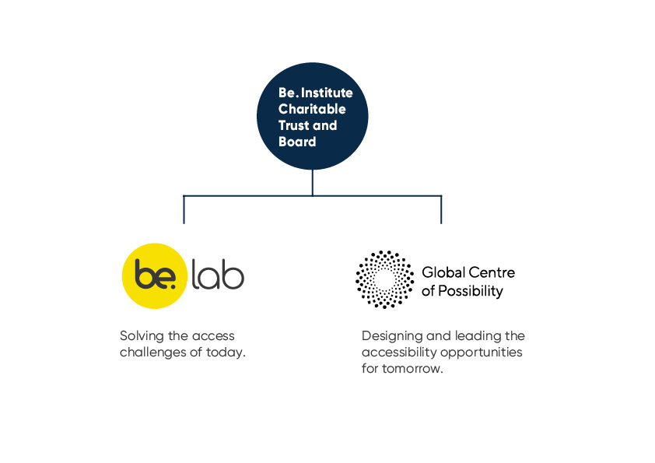
A note from John Allen, Chair of the Be. Institute
Being Chair of Be. is simply the most rewarding job I have ever had.
It is great that Be. has the ambition to change attitudes and lives. It is even better, after ten years of delivery, to be able to demonstrate that we have actually done so – and that we can now scale our programmes and leverage our relationships to have even more impact.
Our Board meetings are unlike anything in the corporate world. It’s all about new ideas and opportunities, passion, laughter (and occasionally tears) and the constant tightrope of wanting to do more than our budget will allow. It is exhilarating but not for the faint-hearted. Then again delivering social change is never easy. It requires resilience, commitment and great teamwork.
Speaking of which, Be. has a great team! Led by Minnie there is such a galaxy of stars that I don’t have room to list them here, but I can thank them. They are simply the best. They believe in the cause, and they turn up each day to make a meaningful difference in the lives of access citizens across New Zealand.
Thanks also to all our funders and partners and to my Board colleagues, past and present. You have all helped shape this remarkable Taonga. Here’s to the next ten years. There is so much still to do.

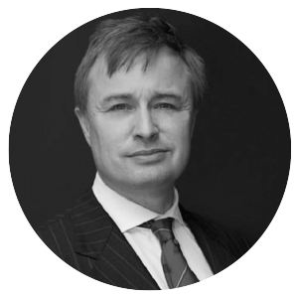
Current board members
John Allen
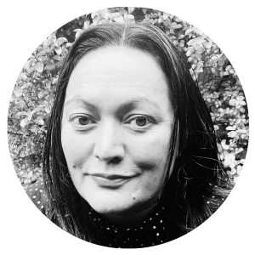
John Allen has been Chair of the Be. Institute since its inception in 2011 and is the current Chief Executive of Wellington NZ, formerly known as the Wellington Regional Economic Development Agency.
Aroha Lowe
Aroha Lowe is a Be. Leadership alumni, social justice activist, community worker, educator and advocate, as well as a fluent speaker of Te Reo Maori. She co-founded NOA Open Art Studio at Te Manawa Museum and Art Gallery in Palmerston North.
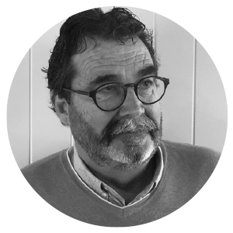
Ant Howard
A former CEO of Wang New Zealand (now known as gen-i), which under Ant’s leadership reinvented itself from a product company to become one of the country’s most innovative and successful systems integration and services companies.
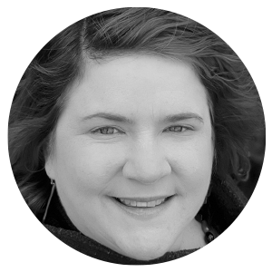
Prudence Walker
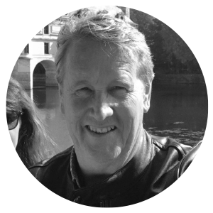
Prudence is the Chief Executive of the Disabled Persons Assembly NZ (DPA), a Be. Leadership alumni, and a proud disabled woman dedicated to designing a more accessible Aotearoa for all.
David Wilson
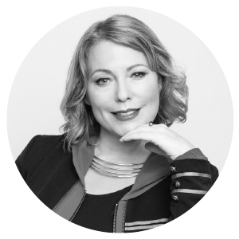
A positive, visionary, optimistic and authentic leader with a blend of public and private sector experience and strong academic qualifications.
Minnie Baragwanath
Minnie Baragwanath is the Founder of the Be. Institute and Chief Possibility Officer of the newly established Global Centre of Possibility @ AUT.

We also acknowledge and thank:
Our past board members: Mark Bagshaw, Ian Scherger, Mary-Jane Rivers, Ross Brereton and Andy Martin; as well as all the incredible individuals who have worked at the Be. Institute over the past decade. Their commitment, passion and enthusiasm to imagine what’s possible has been integral to our achievements as an organisation and a wider access community.

Part B: Ten years of social change, innovation, and possibility

2010 | While working as the Disability Advisor to the Auckland City Council, Be. Lab founder Minnie Baragwanath begins to develop the seeds of an idea for a social change programme that would transform the lives of the 25% of New Zealanders with access needs and make our country the best place in the world for all people to simply Be.  Gathering support through colleagues, mentors and peers, the Be. Accessible (later known as Be. Lab) concept is born.
2011 | The year kicks off with a bang as the first Be. Leadership programme gets underway and the small founding team occupies its own office space in downtown Auckland.  By May, the Be. Institute and its primary nationwide campaign, Be. Accessible, is officially launched at the Auckland Museum with the support of its founding partners – AUT, Auckland Council and Auckland District Health Board and an amazing board of trustees chaired by John Allen.  But it’s not only Auckland that gets to celebrate the launch! Be. goes on the road with a nationwide roadshow and collects ideas and stories from all corners of the country about what a fully accessible New Zealand should look like.  Back to Auckland for the Rugby World Cup – the catalyst for creating Be. Accessible – and working with Auckland Tourism Events and Economic Development (now Auckland Unlimited) to make all attendees and tourists feel truly welcome.  Year 1 wraps up with our first Be. Leadership graduation – an inspiring night of celebration at the Auckland Art Gallery, with guest speaker Len Brown, Mayor of Auckland.
2012 | We start to see Be. Welcome stickers appearing all over the country as businesses embark on an accessibility journey and get accredited. The AUT Excellence in Business Support Awards becomes the very first event to be accredited too!  The vision for a truly accessible New Zealand continues to be explored and celebrated at the Big Event Health & Disability Expo in Auckland and our Be. the Poss-ability event at Te Papa in Wellington.
2013 | In its third year, Be. launches a new programme – Be. Employed – to train and place talented access citizens into meaningful employment and enable them to thrive.
2014 | Be. Welcome ‘Lite’ is introduced to help smaller businesses on their accessibility journey in a quick and easy way.
2015 | Support for Be. gathers momentum with the launch of the Fab 50 – a network of notable leaders across New Zealand committed to championing accessibility in their organisations and communities.  In June a beautiful documentary of Minnie’s, and Be.’s, story is released – To. Be. Me.
2016 | Five years after launching, it’s time for a bit of reflection.  Minnie delivers a powerful speech at TedxAuckland about hers, and Be.’s journey, to a captivated crowd.
2017 | An expanding team with boundless energy sees the launch of a series of monthly events, Be. Curious, designed to challenge and inspire leaders, young and old, to push the boundaries of what’s possible and take this social change movement to the next level.  The team also begin work on a ‘future scenarios’ project – the beginnings of what would become the Possibility lens and the Global Centre of Possibility in a few years’ time…
2018 | Be. embarks on an exciting new partnership with accessibility leaders, Microsoft NZ – aligning on a bold vision for accessibility in the Asia Pacific region.  In the second half of the year, Minnie heads off on a global study tour to further her thinking on Possibility.
2019 | Employment of access citizens comes into focus for the Be. team who pilot a 21st century employment programme to support more access citizens into meaningful careers.  The spirit of innovation at Be. is crystalised as the organisation rebrands to ‘Be. Lab’.
2020 | A year that no one could have imagined brings immense uncertainty and change.  However with determination and optimism, Be. adapts to the world around it.  Be. Lab’s sister organisation, the Global Centre of Possibility, is finally launched with the mission of leading and enabling an ecosystem of access innovation to ensure that accessibility is always at the forefront of design and future communities have it inherently built in.  Be. Lab’s core programmes are repositioned as the One Stop Shop for all New Zealand businesses or organisations – for everything from design planning to customer service, to employment of talented access citizens.  And we fittingly close the year celebrating the graduation of the tenth cohort of Be. Leadership.  As we look to the next decade, the Be. Institute continues to challenge the status quo with possibility and innovation.

Part C: Our Theory of Social Change
The vision – creating and enabling a 100% accessible New Zealand
Since its inception, the Be. Institute’s vision has been for New Zealand to become the best place in the world to ‘be’ for all people – no matter their differences or access needs.
We believe that focusing on the positive potential of access citizens and the opportunity for society to flourish when all people have true access to society enables us to discover and inspire a completely different kind of world – one in which all people are valued.
From disability to accessibility to possibility
The possibility spectrum represents the transition from the deficit-based view of people with access needs, often framed as a burden or a cost to society, to understanding the concept of accessibility which acknowledges that we may all be access citizens at some stage in our lives due to injury or age-related conditions, and finally shifting to understanding the deep inherent value and possibility these members of our community present now and into our future.
We believe that transforming society’s perceptions and ways of thinking along the possibility spectrum will help us to unlock and enable long-lasting change.

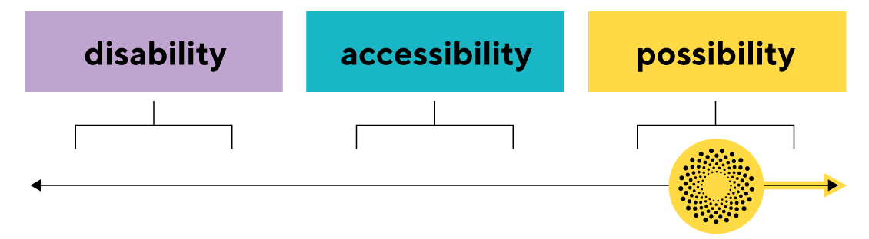

Creating change – our impact goals
In order to deliver our ultimate social change goal of a truly accessible New Zealand, the Be. Institute has operated across four key areas of society. We believe that by striving for change in each of these areas, we will not only improve the lives of access citizens today but we will also be creating a future in which accessibility is inherently built in.
Our approach has always been to place access citizens at the heart of everything we do – focusing on what they need to be able to truly thrive and contribute to the world around them.

  - Personal
    - Leadership: To develop the leadership potential and capacity within the access community in order to catalyse and accelerate progress for accessibility everywhere.
  - Physical
    - Accessible organisations, places, spaces, events: To invite businesses to become 100% accessible to all New Zealanders and not wait to do it as a matter of compliance or law.
    - Employment: To give access citizens the opportunities to thrive and contribute to society in a way that benefits everyone.
  - Social
    - Attitudes: To transform beliefs about access citizens and accessibility, ultimately shifting to a mindset of possibility.
  - Future
    - Possibility Innovation: To push the boundaries of possibility and inspire others to do the same – creating an ecosystem whereby society will continue to innovate and evolve for the benefit of all people.

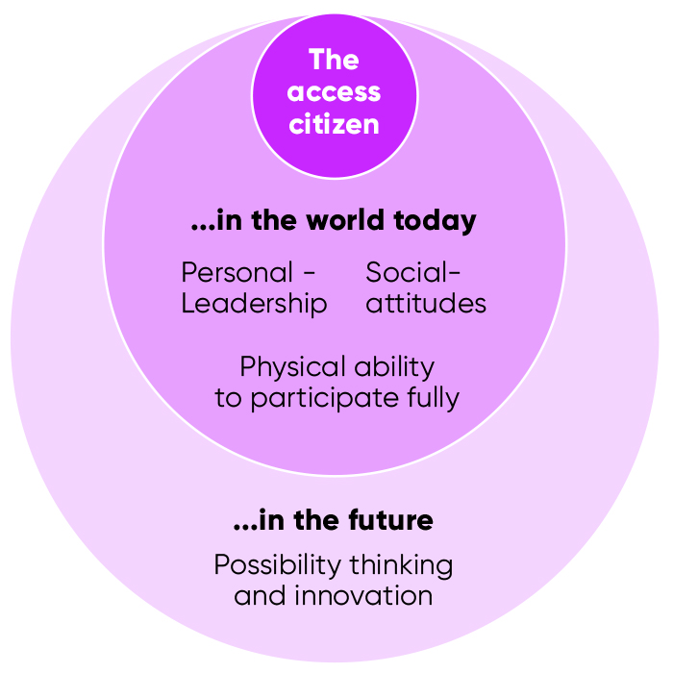

Contributors to the Be. Institute theory of change
This theory and way of thinking certainly wasn’t developed in isolation – we have had the support and input from some incredible leaders in social change over the past ten years.

Some of these notable people include:
- Mark Bagshaw – Be. Institute trustee and a pioneer of the accessibility movement in Australia and New Zealand. Mark introduced the concept that true accessibility is only possible when the physical, the social and the personal aspects of life are addressed simultaneously.
- Margaret Wheatley – American writer, speaker and leadership consultant whose work centres around the fact that leaders must learn how to invoke people’s inherent generosity, creativity and need for community.
- Peter Block – American author and consultant known for his work in community strengthening through possibility and generosity.
- Peter Salmon, Dean Ogilvie and Gavin Healey – Future centred designers and consultants at SO Future Centred Design
- Jeanine Spence – Global design consultant who extended how we think about designing to, for and “with” the access citizen.
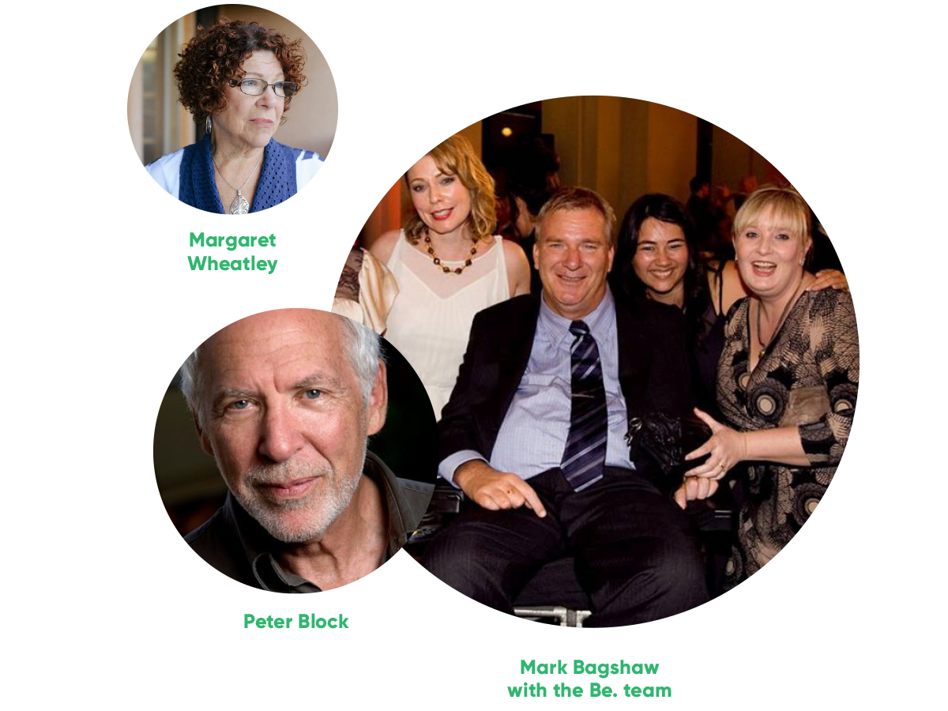

Part C: Our Impact

1. Building an access leadership community
One of the very first programmes to be designed and launched as part of Be.’s social change ecosystem was Be. Leadership. Our vision for this programme was to design a world-class programme that developed the leadership potential amongst the access community in New Zealand. This would in turn help to catalyse and accelerate progress for accessibility everywhere.
By supporting our access citizens to develop the skills and confidence required for bold leadership, we are strengthening the capacity of access citizens to drive change for themselves and their community.
Be. Leadership is about bold thinking, resilience, community, compassion, bravery and innovation.
What we did:
- Innovated a brand new, world-class leadership programme for access citizens.
- Supported 150 access leaders from across New Zealand to develop the confidence and skills to pursue their goals and advance accessibility.
- Established a strong national network of leadership alumni who continue to support each other and thrive in their own communities.

Our impact:
- 500+ applicants
- 150 alumni throughout New Zealand
- 400+ workshops and 200+ incredible speakers
- 89% of participants reported that they were either “much more confident” or “more confident” as a result of their participation in the programme*
- 85% of participants reported that the Be. Leadership programme has made them more intentional about building connections and mutually beneficial relationships with others*

*Cogo Consulting survey, July 2017

How we did it:
A note from Programme Co-Directors Lesley Slade and Philip Patston
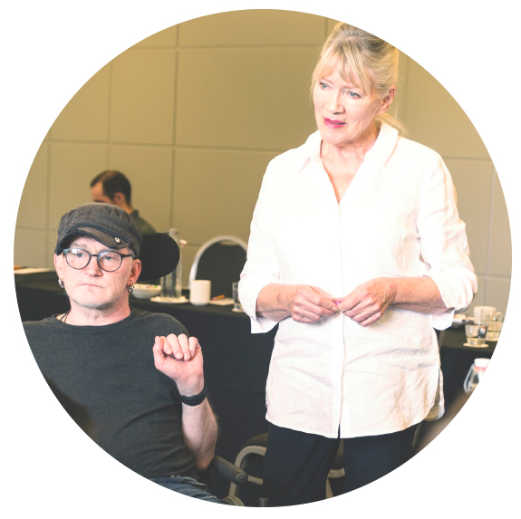
If it takes a community to raise a child, how many people does it take to imagine, design, develop, resource and support a leadership programme that spans a decade?
The answer is hundreds. And we thank each and every one of you for your unlimited imagination and generosity.
In 2010 Minnie invited and gathered together over 100 people from the disability community and asked several questions – one of them being, “What would make a significant difference to your ability to actively participate in all aspects of society?”
Professional and leadership development topped the list. The glass ceiling for people with disabilities was perilously low and the tyranny of low expectations limited talented people to roles in society that were far below their capabilities and talent.
In 2011 the Be. Leadership programme was the first Be. programme to be launched into the world. In true possibility spirit, we acknowledged the uncertainty of the future and ongoing funding and support, and stepped into the unknown. Our goal was to grow individual leadership capacity and a community of access leadership throughout New Zealand. Within months of starting, generous funding and support followed.
The notion and practice of leadership is an evolving space in an increasingly complex global environment – its evolution requires the ability to look at the world with curiosity and keep asking of each other, “What does the world need from leadership at this time and what are the possibilities here?”
Nora Bateson says that “finding a way is about the unique possibilities that occur in relationship between particular people. There is no formula, no method, this realm of possibility is accessed through a sentiment of human care and imagination.”
Throughout the past ten years, 150 programme graduates have experienced a unique leadership development programme that has evolved each year as participants have engaged in new conversations with themselves and each other, challenged and been challenged in an interactional, dynamic and personal way and explored possibilities for the future.
In 2020, throughout New Zealand there is now a community of 150 Be. leaders who are taking their curiosity, care and imagination for what is possible into the world.
Thank you to the many people who have found a way with us. Thanks to our countless wonderful speakers, all of whom have generously given their time, many over multiple years. Thank you to our funders and supporters, who have believed in us, even when the future hasn’t been certain. But, in particular, thank you to the 150 participants who have trusted us to walk with them through a year of self-reflection, critical thinking, changes in values, beliefs and attitudes, and finding their possibility and potential.

Possibility leadership in action: Be. Leader Arash Tayebi
Securing a place on the Be Leadership programme has always been competitive – places have been offered to approximately 25% of all applicants and they have brought to each programme year their diverse, rich and multi-layered aspirations. Often the only thing they have had in common is their desire to participate in a fully accessible world.
For the past decade we have asked Be. Leadership participants to consider the question: “What leadership does the world need right now?”
Arash Tayebi, 2019 Be. Leadership graduate is a beautiful example of the possibility leadership model that we have been evolving for the last ten years – exactly the leadership the world needs right now.
Who knew, way back in 2013 when he arrived in New Zealand from Iran to study, that within seven short years Arash would have a PhD under his belt, be a graduate of the Be. Leadership programme and be recognised as a leading access entrepreneur.
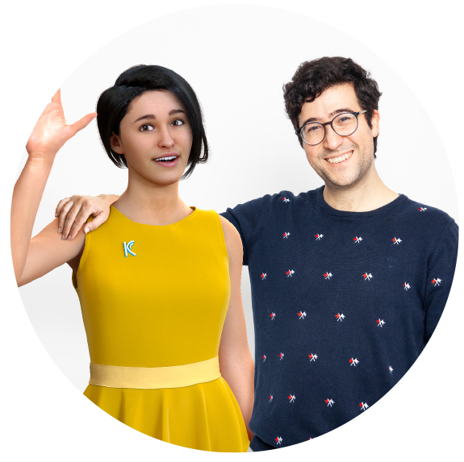
In 2013 Arash might not have had a fully formed vision for what was possible, but he had imagination, courage and the ability to reimagine a truly accessible future for all. He also knew that curiosity and well-formed questions are more transformative than answers. And so when Arash, who is partially deaf, realised that despite technological advances, there had been no meaningful improvement for the deaf community he set out to understand why and do something about it.
The result is what has been described as a game changer and is absolutely transformative. In his quest to make sign language accessible to the 70 million deaf people around the world and to transform education, critical information and services for all deaf people in their native language, Arash and his co-designers have designed an expressive, hyper-realistic avatar called Niki, using AI and animated digital characters to translate content into sign language.
At the end of his Be. Leadership year, Arash wrote: “By participating in the Be. Leadership programme, I have learned how to be a better leader through self-awareness, resilience and inclusion”.
And as Kara chief executive and founder, Arash has truly applied his learning to all that he does and demonstrated amazing results. Arash has embraced critical components of the possibility leadership model as he has engaged with the deaf community and built a team of artists, sign language experts, business experts and very smart engineers, all of whom understand the need to design with diverse others to achieve relevant, accessible and sustainable results.
Arash is the first person to receive a grant from the Possibility Fund, set up by Minnie Baragwanath and Perpetual Guardian to support access innovation and entrepreneurship in New Zealand. He has also ensured that Kara Technologies is a Be. Lab Business and worked with the Be. Lab Talent and Employment team to recruit a sign language expert and communications manager with access needs.
Reflecting on his experiences as part of the Be. Lab community, Arash says “being part of the Be. Lab community is an eye-opening journey for me. Not only am I constantly being inspired by visionary people, but also Be. Lab helped me learn how to work collectively from an accessibility perspective towards realising new possibilities”.

2. Creating accessible organisations, places, spaces and events
Our goal:
To invite businesses to become 100% accessible and not wait to do it as a matter of compliance or law so that every organisation place, space or event is accessible to all New Zealanders.

What we did:
- Developed a world leading accessibility accreditation programme for New Zealand businesses
- Created and trained a network of highly skilled assessors (Be. Coaches) to implement the assessment programme throughout New Zealand
- Created a business model that ensures access experts up and down the country are well paid for their expertise
- Worked with 800+ businesses and brought them on a journey to becoming fully accessible
- Enabled these businesses to make over 4,000 access improvements as a result
- Researched and analysed the most effective access improvements that would make the biggest difference to access citizens – with the top three being: welcoming staff, clear access information, and an accessible physical environment

Our impact:
- Over 4,000+ access improvements
- 800+ organisations
- 90%+ organisations make purposeful change
- 150+ changes on large infrastructure projects
- Top 3 Insights: Welcoming staff, clear access information, physical environment

How we did it:
A note from Programme Director, Neville Pulman
With New Zealand hosting the Rugby World Cup in 2011, Minnie and the Be. team identified an opportunity to create the most accessible World Cup event – working with Auckland Tourism, Events and Economic Development (now known as Auckland Unlimited) to make all attendees and tourists feel truly welcome.
Through this, Be. Lab developed Be. Welcome, an assessment and accreditation programme designed to create and enable more accessible places, spaces and events throughout Aotearoa New Zealand.
The programme was founded on the belief that when all people feel truly “welcomed” and have true access to society, this enables us to discover and inspire a completely different kind of world – one in which all people are included, valued and can participate.
Beginning with the physical environment, Be. Welcome combines a human-centred design approach with expert access knowledge. It is a powerful assessment tool designed around access citizens’ needs and focuses on the full journey an access citizen takes - from gathering information to fully participating in the experience, space or place.
This not only allows the one in four New Zealanders with access needs to access their communities, it also provides an enormous opportunity for businesses to tap into the “yellow dollar” – the $13 trillion access economy (annual disposable income of the 1.85 billion access citizens globally and their friends and family – ROD Group).
Since 2011, hundreds of leading New Zealand businesses – across a wide range of private, public and local body community spaces and places – have demonstrated that great access design and thinking ultimately benefits all visitors and customers.
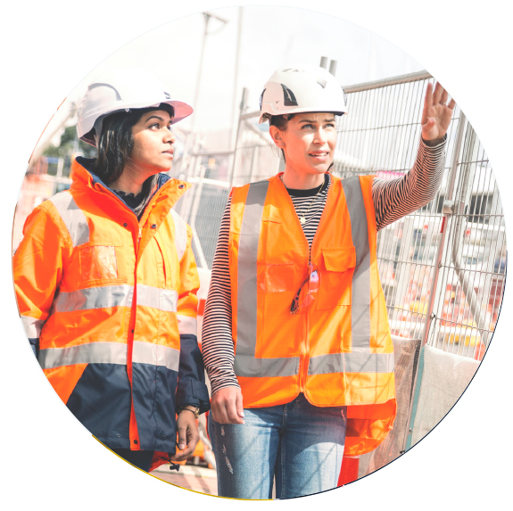
Be. Lab is incredibly passionate and proud of the work achieved by these organisations which together have made over 4,000 accessibility changes across Aotearoa.
Over the years Be. Lab has continued to evolve its offerings including the development of programmes that address not only physical spaces but also organisational culture, customer service, leadership, policies and practices, and more. Our ‘One Stop Shop’ works as a virtual accessibility department to develop and guide New Zealand businesses on their own bespoke accessibility journey.
The learnings from the past ten years have also reinforced that welcoming all customers isn’t necessarily about extra cost and complexity – in fact it is primarily about culture, better design and systems thinking anchored on the primary needs of the access community. Our Access 2020 Survey in collaboration with research agency, Cogo, found that the top two enablers to greater accessibility were welcoming and helpful customer service and accessible information online – neither of which are expensive or complicated changes for a business to make.
We extend a warm thanks to the pioneering organisations that have come on this journey so far – from the small organisations and visitor spaces that have got so personally involved, to the local parks, recreation and community teams, and the large complex infrastructure projects. These innovative thinkers and organisations have taken a lead on true accessibility for all in New Zealand.
We also extend our thanks to the incredibly dedicated, talented and diverse team that have made these assessments possible and for the innovative, human-centred approach they have brought to this area of our work.
Access design and thinking has never been positioned better to benefit all New Zealanders. With so many Kiwi businesses already on the journey and demonstrating the value of accessibility, we invite you all to join us and imaginewhat’s possible in a truly accessible Aotearoa

Be. Lab Business Network

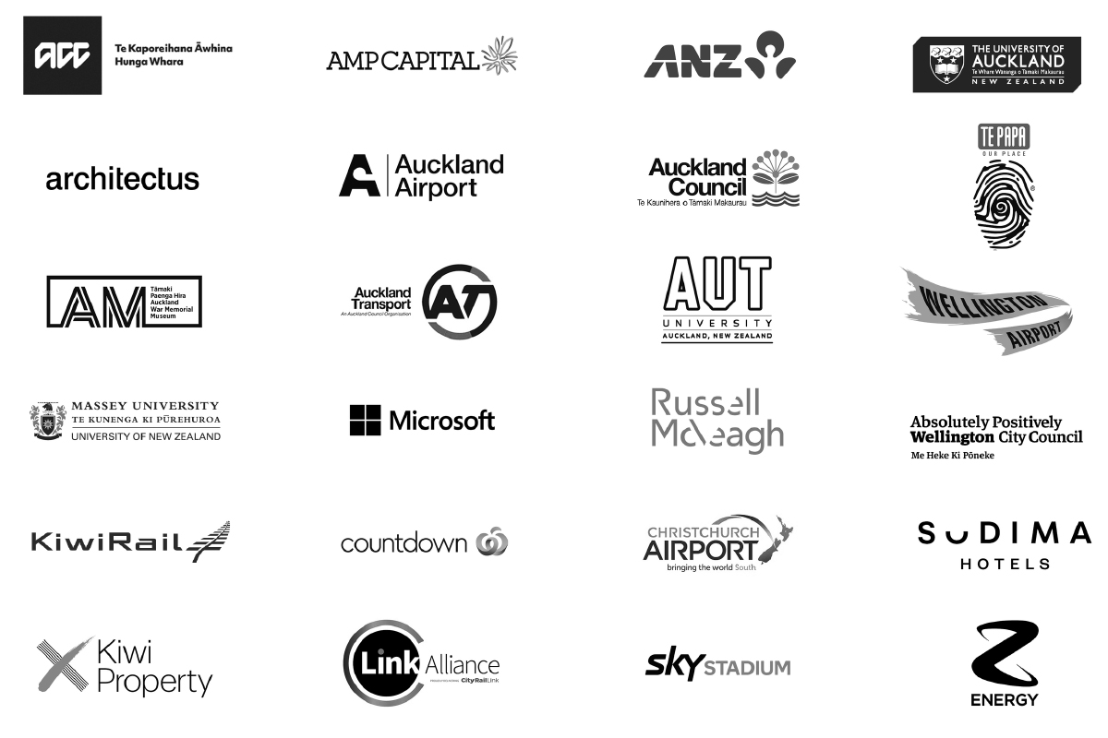

Kiwi Property embraces accessibility across portfolio
Being confident with access customers was central to Kiwi Property’s success in gaining accessibility accreditation for 10 of their retail and commercial properties with Be. Lab.
Kiwi Property, New Zealand’s largest listed diversified property company, prides itself not just on its bricks and mortar investments, but on its investment in people, too. It is this commitment to put the people who engage with their spaces at the heart of their strategy that led them to working with Be. Lab to ensure that their shopping centres and main commercial buildings are on a path to being as accessible as possible to all New Zealanders.
Ten properties went through Be. Lab’s accessibility accreditation programme, with two of these achieving the highest possible rating of Platinum: Northlands shopping centre and The Plaza shopping centre in Palmerston North.
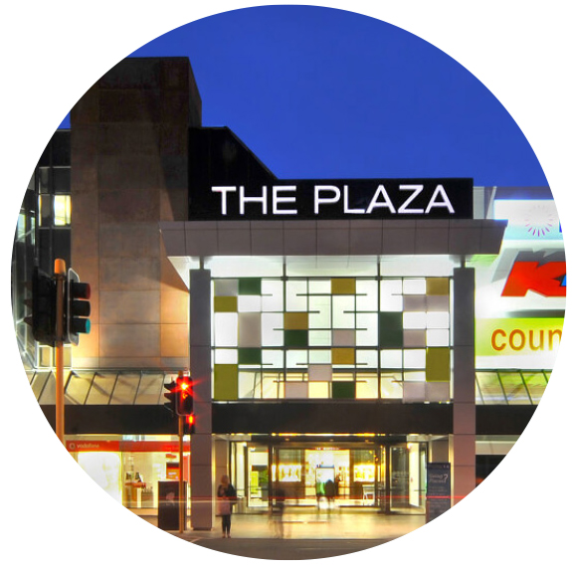
Along the way there were ‘aha!’ moments big and small – the accreditation process at Centre Place in Hamilton, for example, found that an accessible bathroom door opened outwards rather than sliding across. It may seem small, but the recognition of how these factors impacted the experience of access customers enabled the team to shift the way they think about how their buildings work for all people.
As well as implementing a number of accessibility improvements such as this, the team at The Plaza also underwent training with Be. Lab which encouraged them to think differently about how they could be as welcoming as possible to all customers.
Be. Lab coach, Genevieve McLachlan hosted this training and took the team through a number of ‘access citizen scenarios’ such as someone with autism spectrum disorder or a sensory disorder who might find the hyper- stimulating noise, lighting and busyness of the shopping centre overwhelming, or a parent visiting the centre with a pram. This workshop is designed to unlock ‘possibility thinking’ and encourage the team to think outside the box about what they can all do – as management, as customer service, as security, or as cleaning teams – to engage with all visitors and customers.
Genevieve says, “it gives people the confidence to treat everyone with the same degree of respect and courtesy they would want to receive themselves, and teaches people how they can improve the centre in practical ways – from LED lighting to tactile indicators in elevators and at entrance – while helping people in one-on-one scenarios.”
Kiwi Property Communications Lead Campbell Hodges says of their experience working with Be. Lab, “Among senior management and staff at our various retail centre and properties, there is a shared view about the value and importance of accessibility. We are dedicated to becoming highly accessible and see it as a path we are on over time. We are collectively excited by the challenge of finding practical ways to improve the experience for customers.”
In engaging with Be. Lab and doing the work to achieve accreditation, Kiwi Property has raised the bar for New Zealand enterprise. Their work across 10 properties represents a significant commitment to access and possibility thinking that will help them connect and sustain with their local and visitor community, with economic, social and cultural benefits both within their business and outside it.

3. Developing employment opportunities for access citizens
Our goal:
To give access citizens the opportunities to thrive and contribute to society in a way that benefits everyone.

What we did:
- Co-designed, prototyped and delivered two employment programmes for access citizens that place them into permanent employment and internships.
- Over six years, Be. Lab has successfully placed 211 graduates into paid internships.
- Of the 211 interns placed, 69% have gone on to secure permanent employment.
- In addition, Be. Lab has connected 21 access citizens to permanent roles at leading employers through our Accessible Employment programme.
- For every $1 invested in the Accessible Employment Programme, Be. Lab delivered $4.80 of social value, representing a 480% return on investment.*

Our impact:
- 232 access citizens placed into permanent roles or internships
- 69% of interns go on to secure permanent employment
- $1.1m social value created through just one of the Be. Employed programmes*
- 480% return on investment from one of the Be. Employed programmes*
- 80% of organisations surveyed told us Be. Lab has influenced their culture relating to employing access citizens

*Impact Lab. Statistics for the Be. Employed Industry Partnership programme only; doesn’t include additional value created by the internship programme

How we did it:
A note from Programme Director Tonya Baker
By 2012 many of the businesses we were working very closely with through our Be. Welcome program told us they wanted to employ access citizens but did not know where to go for great talent.
So in its third year, Be. Lab launched the third of its foundation programmes – Be. Employed – with the goal of developing and placing talented access citizens into meaningful employment.
Despite the fact that access citizens are incredibly dedicated employees who increase innovation, revenue and profits, and bring critical skills that 21st century employers need, they are still three times more likely to be underemployed than non-disabled people. (Statistics New Zealand, June 2020)
Be. Lab’s work in this space has therefore been focused on shifting perceptions of access citizens as employees and unlocking their potential to thrive in employment.
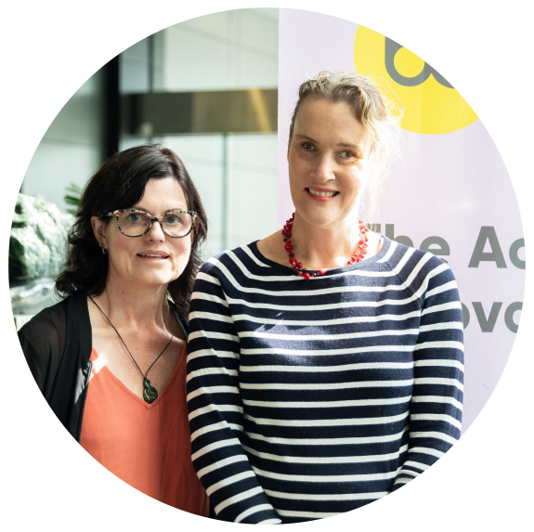
Be. Employed began as a programme targeted at recent graduates with access needs, ensuring that they were workplace ready and confident in their own skills and capabilities. Since launching, we have successfully placed 211 young people into paid internships, with 69% of these going on to secure permanent employment as a result.
In 2019, we expanded this service and partnered with the Ministry of Social Development (MSD) and Microsoft to support up to 30 New Zealanders – living with a long-term health condition, injury or disability and in receipt of a main work and income benefit – back into employment or their own entrepreneurial venture in industries such as Technology, Design, Tourism and Professional Services.
Through this unique programme which includes professional development, strength-based training and connection with an external mentor, Be. Lab placed 21 access citizens into permanent roles during the initial pilot. We are delighted that this programme will be continuing and offering even more New Zealanders the opportunity to find a job they love and thrive.
A study done by Impact Lab has demonstrated that this employment programme has so far delivered nearly $1.1 million in social value to our communities, and that for every dollar invested in access citizens through this programme, $4.80 of social value is delivered in return.
From 2020 onwards, the impact of COVID-19 on unemployment will likely affect access citizens disproportionately and the inequity they face could unfortunately widen. These programmes are therefore more valuable now than ever and we are excited to continue working with all New Zealanders to create employment opportunities that benefit us all.
We are very grateful to our talented, passionate and committed team, who have worked with some extraordinary candidates and organisations over the years ensuring mutually rewarding employment experiences.

Testimonials
“Be. Lab gave me direction and the tools I needed to get to where I wanted to go. With their support, I was able to rediscover my self-confidence and land a job that I love.”
- Duncan Sharples
“As we notice the ever-changing landscape of recruiting in New Zealand, we’ve been pleased to deal with an organisation which meets our commitment to diversity and equal opportunities within our firm.”
- Kelly Larsen, Meredith Connell

“It has been a wonderful collaborative opportunity for Vaka Tautua, a Pacific provider, to work with another specialised disability service and provide pathways to employment.”
- Kristina Sofele, Vaka Tautua

Case Study: Reimagining and rebuilding a career in tech
Many of us are likely to develop access needs due to unforeseen health setbacks at some point in our lives, and while this can cause a knock to our self-confidence in the short term, with the right support and opportunity, we can reimagine what we are capable of and rebuild new and wonderful professional career pathways.
Read Duncan’s story to learn more about how he worked with Be. Lab’s Talent Shop to rediscover his strengths and pursue a career that is more fulfilling than ever.
Duncan Sharples is a creative and dedicated tech analyst with notable experience at leading organisations such as Vodafone, TelstraClear and Infosys. He is also a passionate writer, working on a novel in his spare time. Writing is Duncan’s creative outlet, with a particular passion for science fiction, fantasy and satire genres (which when combined, “makes for some entertaining reading!”, he laughs).
Unexpected events
At the beginning of 2018 however, Duncan was faced with a couple of curve balls, both professionally and personally, that impacted his relatively smooth-sailing career to date.
It started with a redundancy from his job of four years in mid-2018. Then a few months later, triggered by the stress of this experience, Duncan also suffered a major stroke.
The combination of the physical and mental toll following this series of events unsurprisingly had an impact on Duncan’s self-confidence. And he was faced with the challenge of balancing rest and recovery with a desire
to get back out there to a career he loved.
Upskilling and pivoting
Knowing that exercising the brain is vital to stroke recovery, Duncan saw an opportunity to delve into his passion for writing while he took some time out from his more demanding technical services career. After completing
a technical writing course and two copy writing courses, Duncan secured some freelance writing gigs, offering flexibility during his recovery whilst also keeping his mind active.
When he felt ready, Duncan also upskilled in his core area of expertise by completing two Microsoft data analysis courses. It was through one of the Microsoft courses that Duncan learned about Be. Lab’s employment programme which matches talented New Zealanders with health conditions or access needs with meaningful employment in the career of their choice. As someone intentional about growth and development, it was the professional development and mentoring aspect that really stood out to him as an invaluable part of the service.
Rebuilding a meaningful career
After connecting with the Talent team at Be. Lab and going through the recruitment assessment process, Duncan was offered a place on the programme.
The first stage of the programme involved a full day professional development workshop with other talented candidates across the country, facilitated by Be. Lab, Capability Group and Microsoft. “It was a great experience,” says Duncan. “the multi-pronged approach of the Talent Shop went far beyond just a basic recruitment service. Developing my skills and having access to a personal mentor was invaluable.”
The Be. Lab team then worked with Duncan to fine tune his CV and provided special coaching for job interviews. More importantly, they encouraged him to be open and confident about his situation and to focus on his strengths. Duncan’s resilience and flexibility which enabled him to pivot in difficult circumstances are some of the top qualities forward-thinking employers are looking for in today’s world.
After a few months Duncan was offered not one, but two technical services roles at different organisations, so he was able to choose the one that was more suited to his expertise, experience and values – as Technical Officer in the housing division at the Ministry of Social Development (MSD). Not only does he find this position deeply rewarding, Duncan is also working towards a career path in Report Writing at MSD, a job that would combine his technical ability and love of writing.
Duncan says he is happier today than he has ever been. While he has faced challenges over the past couple of years, the journey has brought out his innate strengths, and a renewed self-confidence highlights the enormous value he brings to his work and wider community.
Reflecting on his experience with the Talent Shop Duncan says, “Be. Lab gave me direction and the tools I needed to get to where I wanted to go. With their support, I was able to rediscover my self-confidence and land a job that I love”.

4. Changing the conversation and shifting attitudes and behaviours
Our goal:
To reframe how we think about access citizens and accessibility in Aotearoa in the 21st century, moving from disability to accessibility and on to possibility.

What we did:
- Reached millions of New Zealanders with new language and storytelling – shifting the conversation from disability to accessibility and possibility
- Established the Fab 50 network – made up of 65 influential leaders across New Zealand advocating for change
- Developed proprietary research to begin measuring how accessible New Zealand’s physical spaces and social attitudes are towards people with access needs

Our impact:
- 2,000+ articles in national media across newspapers, television, radio and digital media
- 4x the population of New Zealand reached with accessibility and possibility messaging
- 65 influential New Zealanders advocating for change in their communities

How we did it:
When we set out to create the Be. brand ten years ago, we had a very clear goal in mind. For too long, disability was seen through a deficit lens – a hinderance on society, or a challenge to be overcome. With the Be. brand we wanted to bring a bright, positive, opportunity-focused lens to the “disability” conversation – to shift the language to accessibility, and now through the Global Centre of Possibility, ultimately possibility.
In doing this, the Be. Institute aims to transform perceptions of the 1 in 4 Kiwis living with access needs and the value that this significant portion of the population brings to our society.
Just as ‘sustainability’ was once a foreign concept but is now embraced by businesses and individuals alike as an essential part of the climate solution, ‘accessibility’ was poorly understood as a platform for meaningful change.
For several years, conversations with media, journalists and businesspeople would continue to default to ‘disability’ challenges and reporters would often stick to the topics of wheelchair ramps and user-friendly bathrooms.
However, through thousands of articles across newspapers, the radio, TV and digital media, we have steadily pushed for a positive framing of accessibility and invited everyone to the table for future-forward conversations. We estimate that we’ve reached the New Zealand population four times over through more than 2,000 pieces of media coverage over the last ten years.
In addition to this, the hundreds of businesses, local councils, universities and businesses leaders who have worked with Be. Lab are now advocates for accessibility and the value it brings to their communities.
We have been incredibly lucky to work with a team of brand, design and communication specialists that truly ‘get it’ and each bring their own bit of magic to Be. Lab’s storytelling. We would not have achieved a fraction of this impact without them.

With huge thanks to:

Media highlights
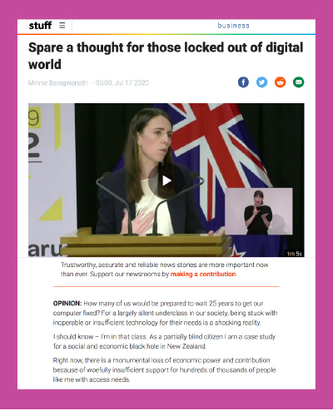
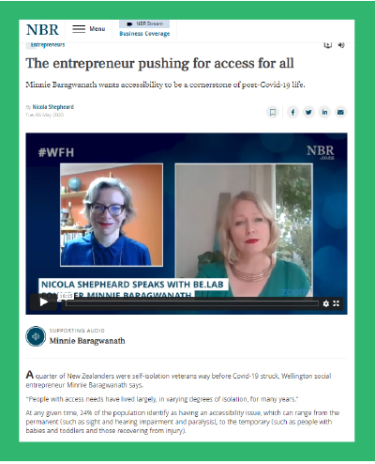

It is feedback in response to these articles, like the below from 2015, which shows just how much impact we can have if we keep having these open, progressive conversations:
“Hey there, my name is Lorna Coker and I have just read the article about you in the Waikato Times Your Weekend Supplement. I am a year 12 student at Matamata College and I too have Stargardts Disease. After reading your article I felt inspired. I have a passion to work with animals, although I have never had the confidence to go out there and approach an employer to say “hey, I love animals and I want to work for you, oh and by the way I have
a vision impairment”. Reading your article has quite possibly given me the excitement and drive I needed. I have successfully completed NCEA Level 1 and are well on my way to passing Level 2.”
The first ten years of our journey have given a marvellous indication of what is possible, and yet to come.

5. Driving innovation
Our goal:
To push the boundaries of possibility and invite others to do the same so that we create a future where accessibility is always at the forefront of leadership, design and innovation.

What we did:
- Developed the Possibility lens and created the Global Centre of Possibility @ AUT to pioneer Possibility leadership, design and innovation for Aotearoa and the world
- Catalysed the Possibility Fund to accelerate access innovation and awarded an initial grant of $30,000
- Partnered with Microsoft New Zealand to deliver two IT hacks with a goal of improving digital access for blind people in the 21st Century
- Partnered with AUT to develop the Possibility Index which aims to measure individuals’ experiences of accessibility in 2021 and beyond
- Designed and delivered a truly unique Possibility Philanthropy workshop for Philanthropy NZ to encourage and enable funding into a fully accessible future

How we did it:
Innovation and creativity have been at the heart of the Be. Institute from its very inception. From the Be. brand itself, through to the suite of social change programmes and even the day to day running of the organisation, we are driven by what is possible in the world, refusing to accept limiting beliefs and attitudes.
When Be. Accessible began in 2011, we were committed to inviting New Zealand to embrace the concept of “accessibility”, and our desire to create a more equitable society. Even that simple shift from disability to accessibility was seen by many as very disruptive and it has taken most of the last ten years for the language of access to become embraced by the mainstream.
However, four years ago, we realised that moving to accessibility was not the final destination in the Be. story. With the reality of our modern globalised world full of uncertainty, ambiguity and complexity, we realised that the accessibility innovation frame also needed to be updated. We needed a new way of looking at and talking about a contemporary accessible future.
And that is when the Possibility lens was created. Possibility invites us to be deeply curious about our future and how we want it to be, letting go of the past limiting beliefs and attitudes. It is firmly focused on what can be, on emergent ideas and concepts fit for a rapidly changing modern world, one where technology, globalisation and climate change are impacting all our lives in unprecedented ways.
We spent three years developing this concept and framework, working with a small team of designers, futurists and social change agents to create this model and new way of seeing and being in the world. We worked with local and international thinkers, leaders and creators to give birth to this framework for innovation we call Possibility and we invite today’s forward-thinking leaders to embrace this lens along with us.
In 2020, we established the Global Centre of Possibility @ AUT in order to house and incubate possibility design, leadership and innovation to ensure an accessible future. And now as we celebrate ten years since the inception of the Be. Institute, we are preparing to pilot the first ever programme in Aotearoa to hothouse and support access entrepreneurs, innovators and designers for a more accessible future.

Possibility Lens

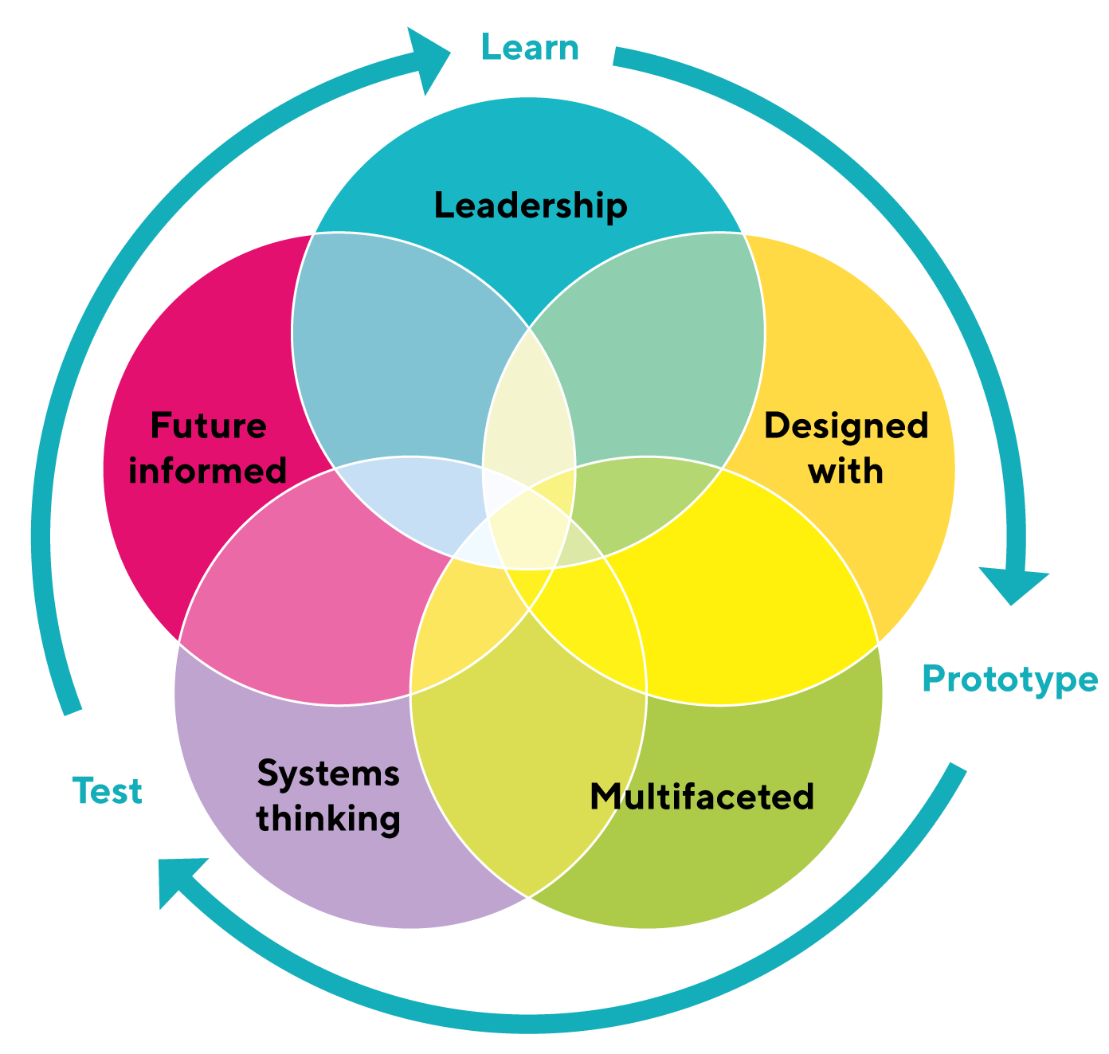

Part E: Our Future – The Next 10 Years

A future of Possibility
The year is 2030 – and Aotearoa is the global centre of access leadership, innovation and design.
Access citizens are creating a range of goods and services that meet the needs of a global market of more than 2 billion people with the most beautifully designed products and services that are fully accessible.
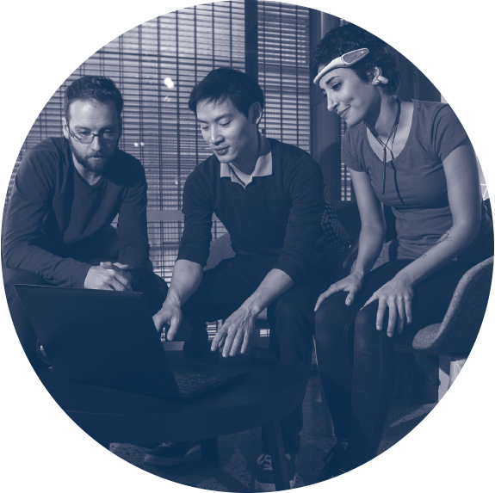
Aotearoa has a truly equitable society, a thriving economy and access innovation industry built on the skills and the entrepreneurship of people who are deaf, blind, have dyslexia, or physical impairments. They are our leading designers, thought leaders and shapers of a more equitable future Aotearoa and world.
Our access entrepreneurs and designers are not only at the table, they have completely redesigned the table and how we use it.
While none of us can know exactly what the future holds, what we do know is that we are now living in a world of unprecedented volatility and uncertainty – a world where global trends such as climate change, new technology such as AI and blockchain, and global pandemics are not only occurring at an extraordinary rate, but are also colliding together to cause disruption to our lives in ways never before experienced by humankind.
We only need to look at COVID-19 to fully appreciate the extent to which our world can be turned upside down by just one massive global trend. But imagine what happens when multiple trends all collide simultaneously?
As the founder of the Be. Lab, the newly formed Global Centre of Possibility, and the Possibility Fund – and as an access entrepreneur and agent of social change – I am deeply aware that this emergent world can and will have an unequal impact on the lives of the more than 1 million access citizens in Aotearoa and the more than 1 billion access citizens globally.
It is certain, that if left to chance, not only will access citizens possibly lose many of the hard fought for wins of the last few decades in terms of human rights and equity, but worse still, may be completely designed out of this future world.
Why is that? Because our current dominant societal approach to design, to leadership, and to how we imagine our world, is deeply flawed and outdated, the status quo is deeply inaccessible, and it is simply NOT able to create an accessible future world. If we truly want to create an accessible future, we must now embrace an approach to being in our world that truly works for all.
Welcome to the world of Possibility! An approach to leadership, design and innovation, an approach to reimagining our world that is truly future focused, that is led by a contemporary 21st century accessibility world view. A way of being that was imagined, created and born here in extraordinary Aotearoa!
In the world of Possibility, we understand there is no “average” human we can design for. Our world is all about facets, and we have an approach to designing that ensures all people can contribute.
Aotearoa, we are at a critical juncture in our human story – will you be part of reinforcing an old and outdated inaccessible world? Or will you bravely embrace and invest in a new way of being that is entirely future-focused with Possibility and the well-being of all people at its heart?
Aotearoa, over the last ten years we have shown you the power of “Accessibility”, now work with us to unleash the power of Possibility for all!

In memory of:
The Be. whanau is made up of so many incredible individuals, some of whom are sadly no longer with us today. This ten year report and celebration of what’s possible is dedicated to these people. We will continue working towards our vision of a 100% accessible New Zealand in their memory.

Mark Bagshaw
Peter Taylor
Rena Savage
Shaun McKinney
Alex Smith
Josh Anderson
Joyce Scott

