Appendix 1
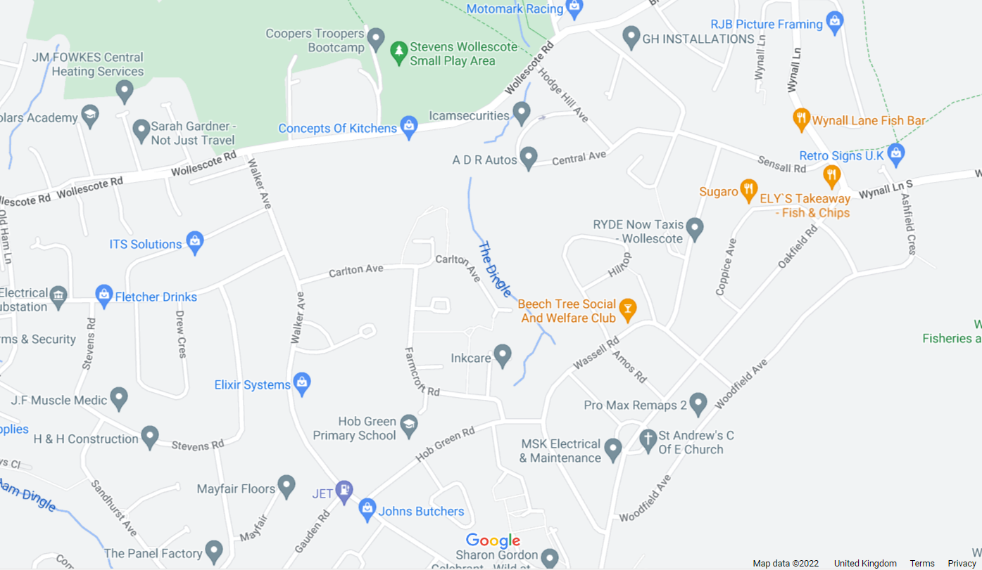
Map showing location of ‘The Dingle’ - SO 92316 83333

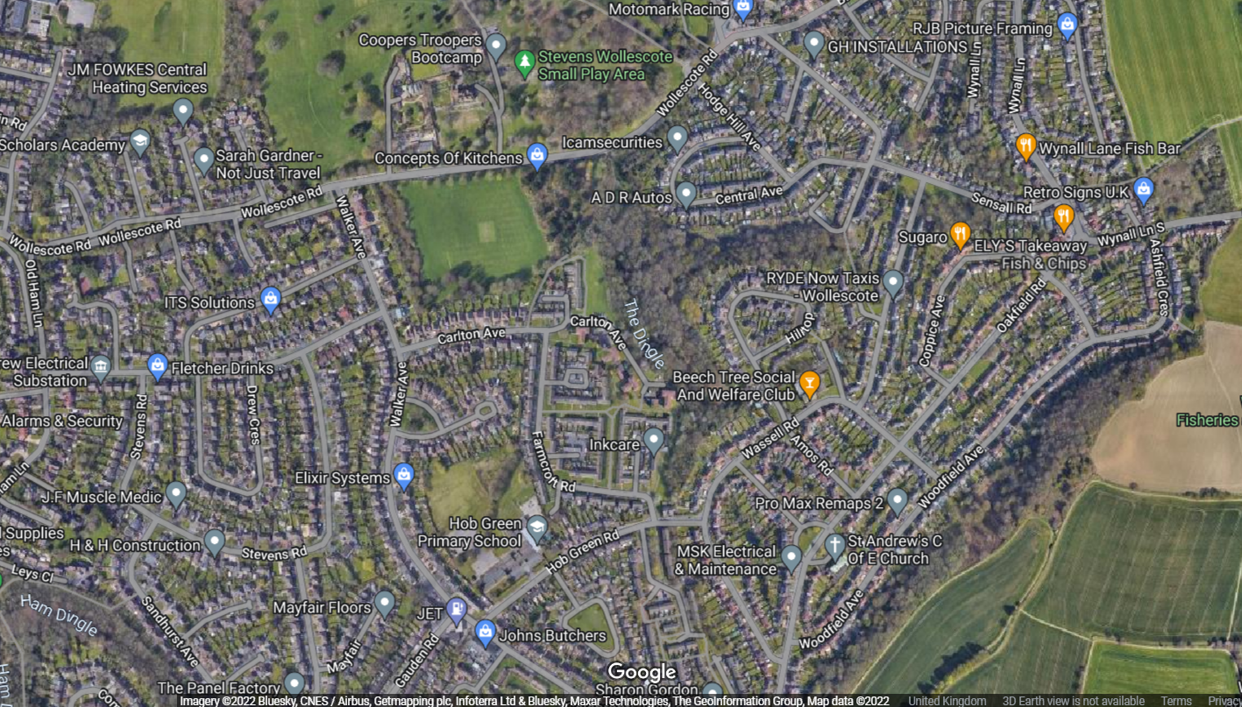

LiDAR map of The Dingle
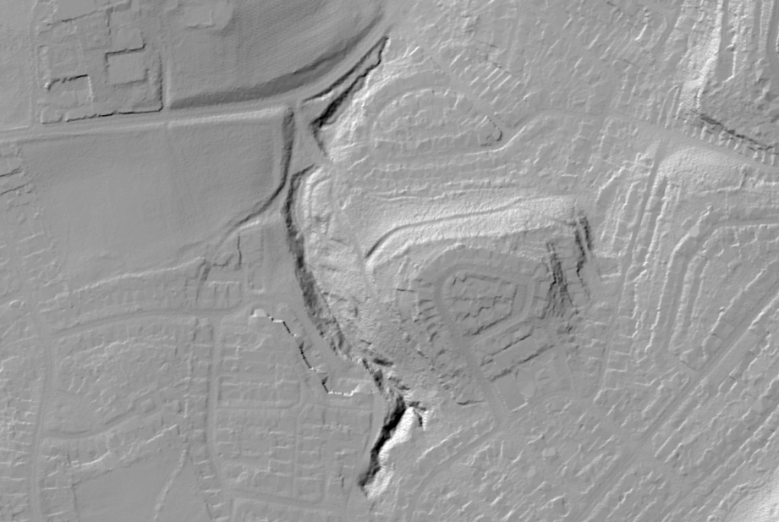

Environment Agency Flood Zone maps showing the site does not fall within Flood Zones 2 or 3.
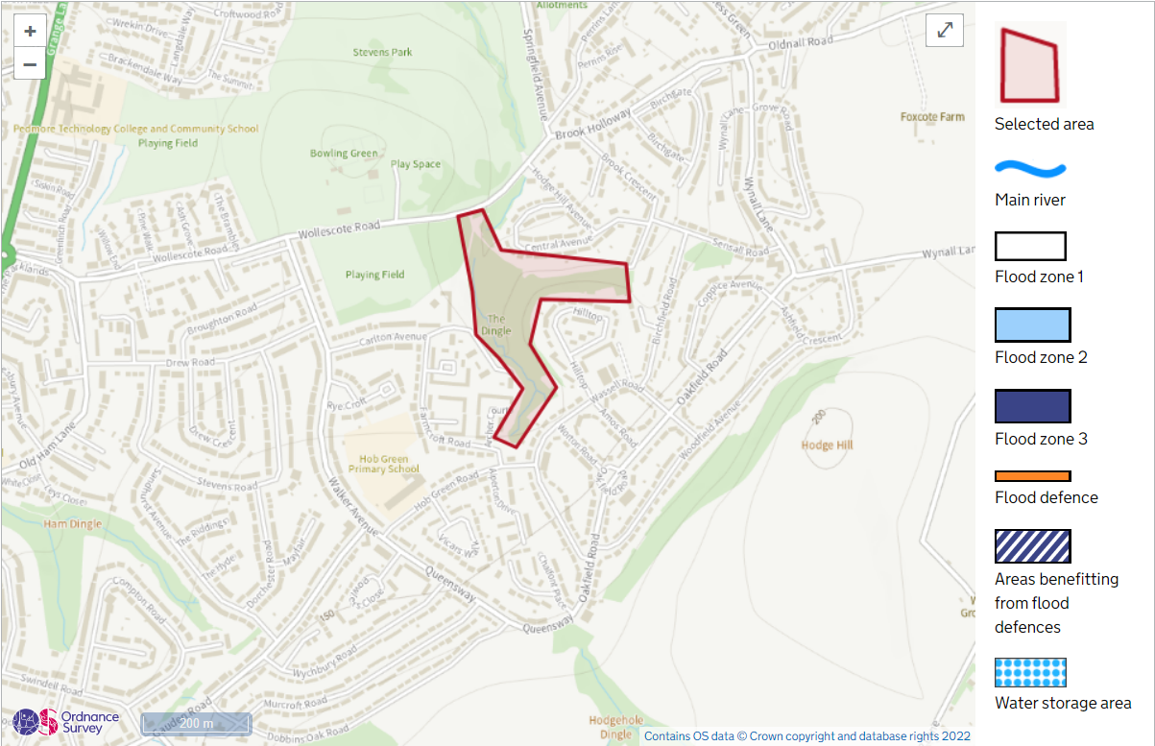
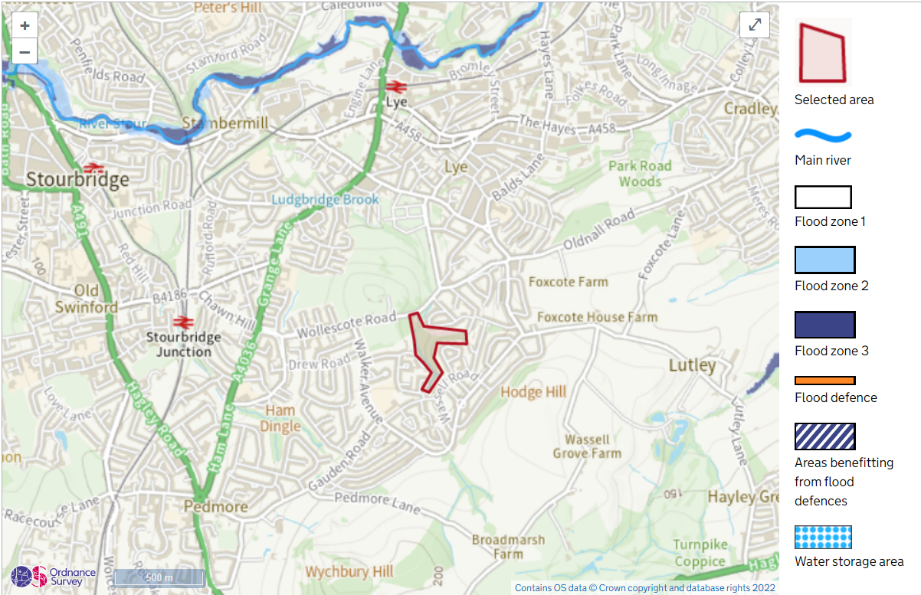

Proposed in-channel works
The Dingle is a mixed remnant woodland that can be accessed off Wollescote Road, Stourbridge. The Northern area is relatively flat and open but quickly becomes steep sided as you move upstream.
The Northern part of the dingle is where the brook enters a culvert which becomes blocked with wooded debris and litter. The area around the culvert is low lying which the brook floods into during high flows. There are some existing large logs which would be used to create varying flow regimes in the lower part of this flat area by scraping back the bank, dropping the logs in place and covering them back over, so that they cannot be moved by high flows. Just above these, an overhanging ash tree will be removed and placed in channel to slow the flow and hold back debris from blocking the culvert (SO 92309 83232)
Moving up the channel, there is an area which appears to be a natural backwater pool that may have been created in high flows. This would be increased in size by roughly 1.5 metres towards the brook and 0.5 metres away from it, whilst scraped out to clear. This would be planted with plugs and cuttings from the Dingle. The excess soil from the excavation would be placed against the bank behind the ‘pool’, thus not affecting the flow. (SO 92333 83200)
Above this area, there are three existing NFM features. The first of which will be replaced with another in channel log which would be tethered. These would be from an Ash tree which looks to have already been marked. (SO 92326 83184)
Moving past the other existing features, the channel straightens and widens, leading to an outfall pipe. This section would have 3 large boulders installed to again create channel roughening and flow diversification. (Outfall pipe 92333 83200)
Above this section toward the end of Carlton Avenue, a large Ash tree will be felled directly into the channel for the final ‘chop & drop’ feature. (Roughly SO 92400 83066)
The timber will be transported off site or chipped and all of the woody debris will be tethered to stumps or stakes to ensure they do not move in high flow.
No further management of the installations would be required.

Below:
Yellow = Wood debris/ chop & drop locations
Blue = Backwater pool
Red = Large boulders
White = Outfall pipe
Green = Culvert

Example of large woodie debris at a separate site. The main brash will be removed from the truncated stems to reduce wash down. The log can be pinned or back tethered to felled tree stumps such as the example below.
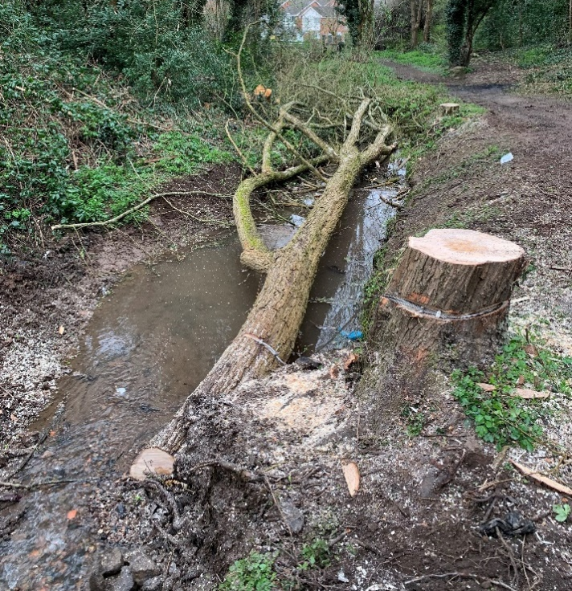

Further works
In addition to the above, invasive tree species such as Laurel would be removed from the site which would allow native species present to thrive (Throughout the Dingle but denser around SO 92408 93073). We would also look to install Owl nesting boxes to encourage Tawny owls to use the Dingle, as well as standard bird boxes.

