Saltwells NNR wet woodland and zero stage channel creation

Appendix 1
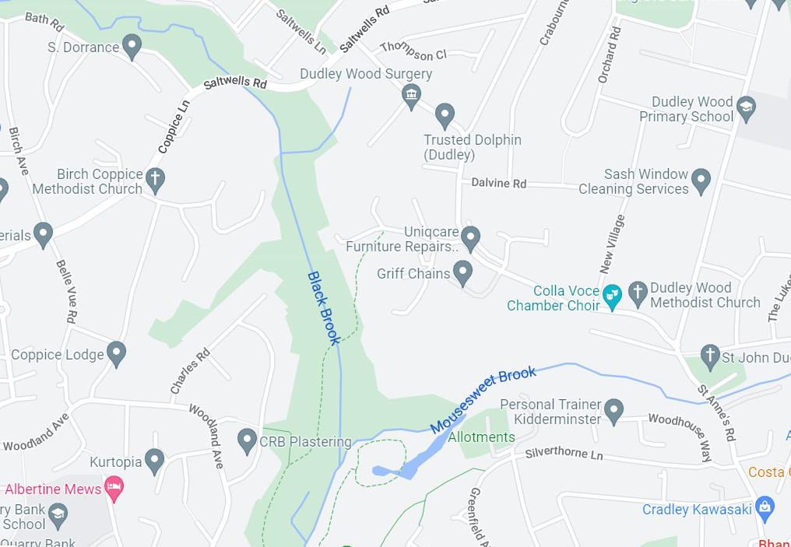
Google map showing the location of the site with the Black Crook running through the centre in a North South Direction.
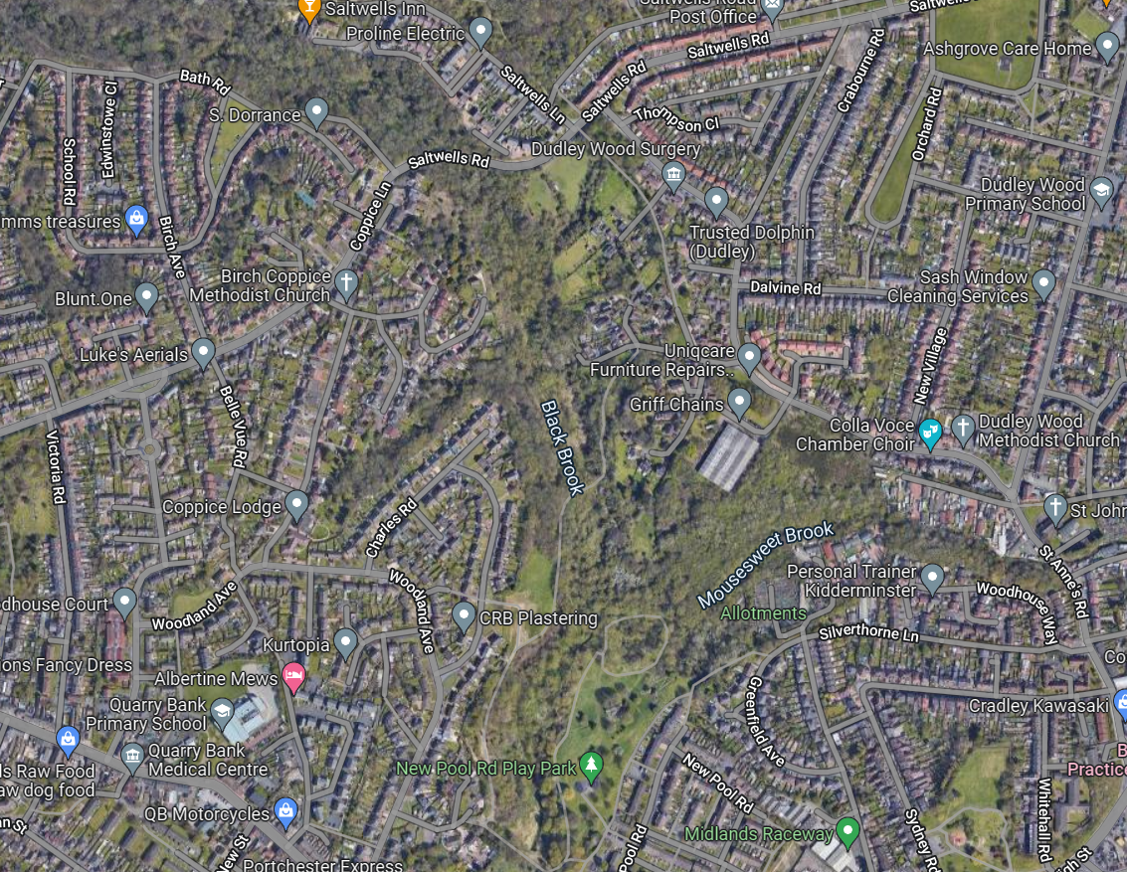
Arial map from google showing the location of the site with the Black Brook running North to South
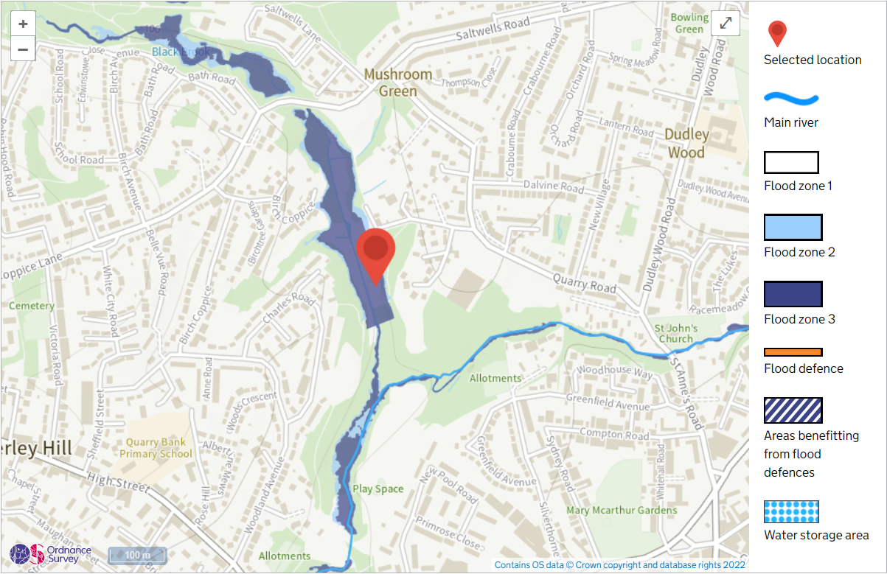
Flood map from the EA flood mapping webpage
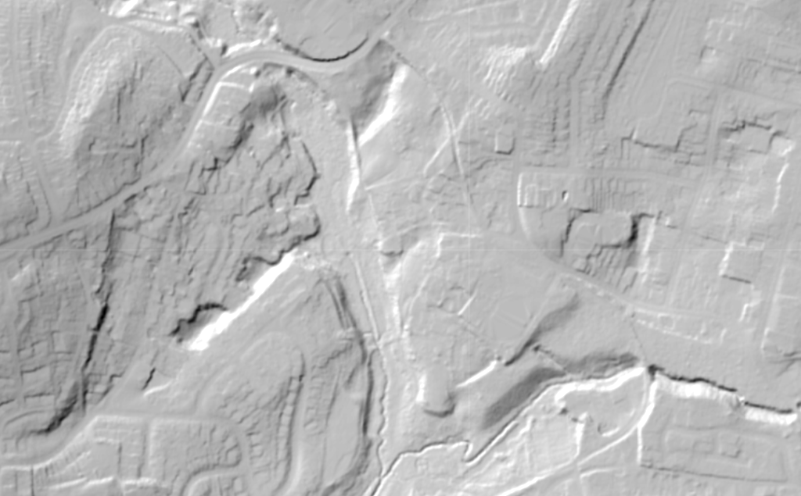
Lidar image of the proposed area of works
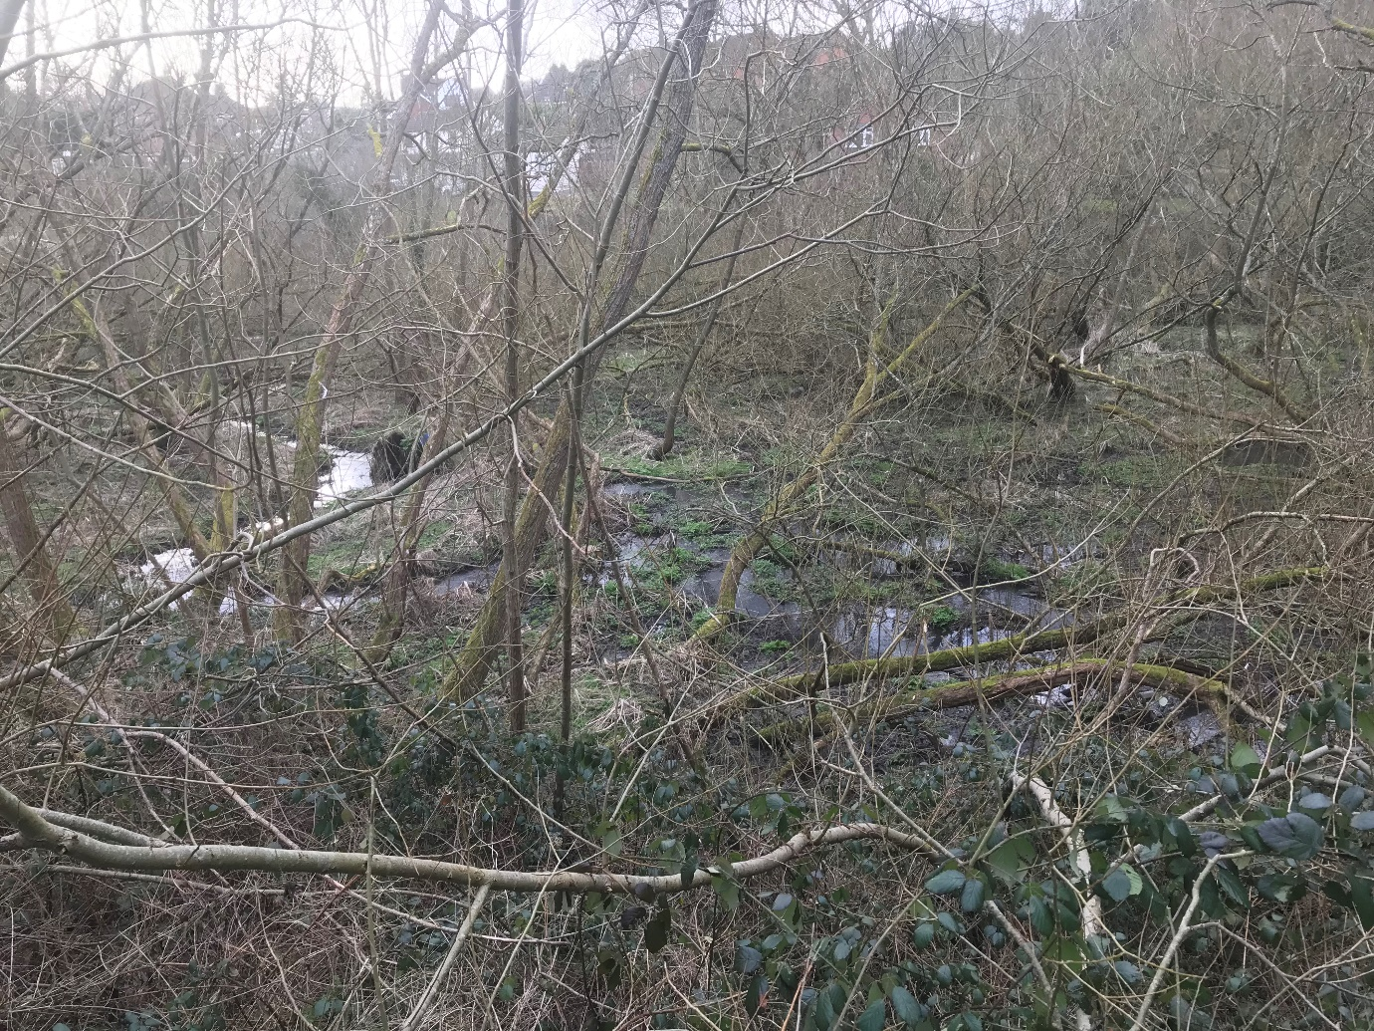
Image 1: Anastomosing wet woodland above newly discovered high weir.
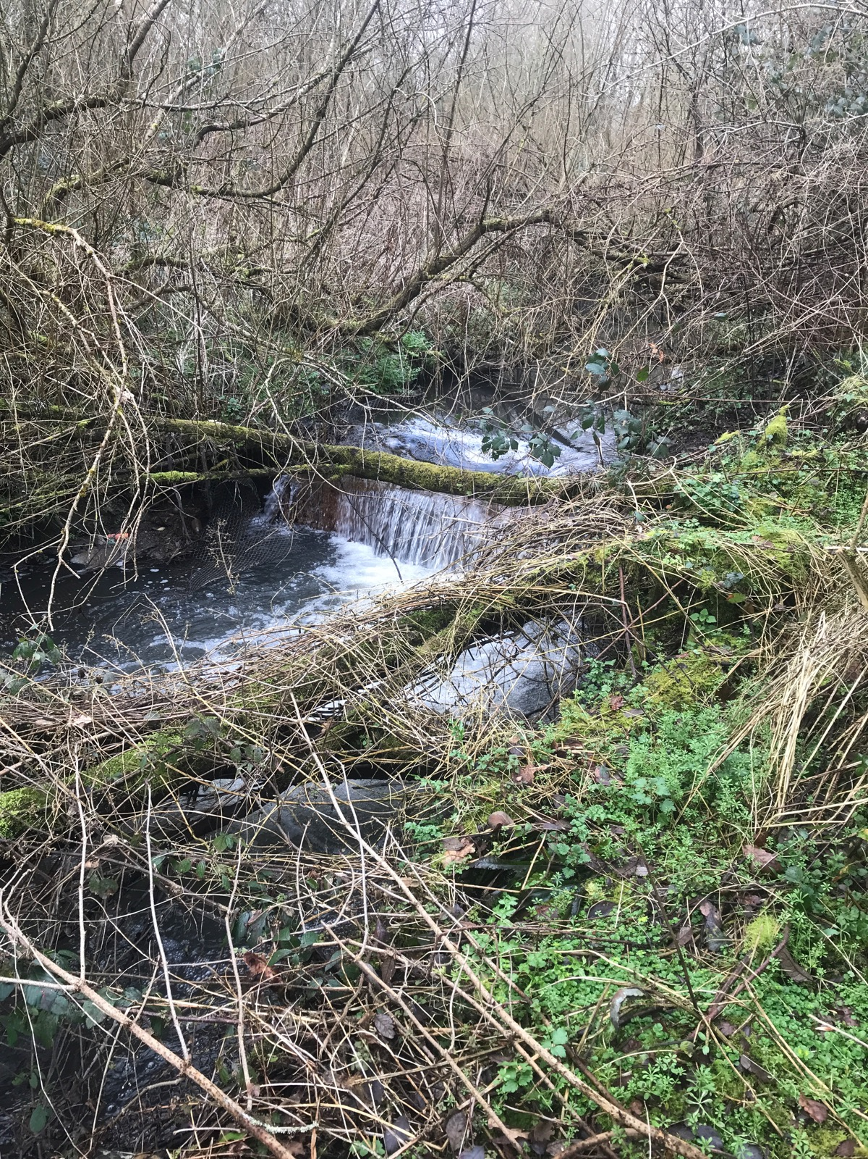
Image 2: South weir SO933873 which was discovered in the original scope of works.
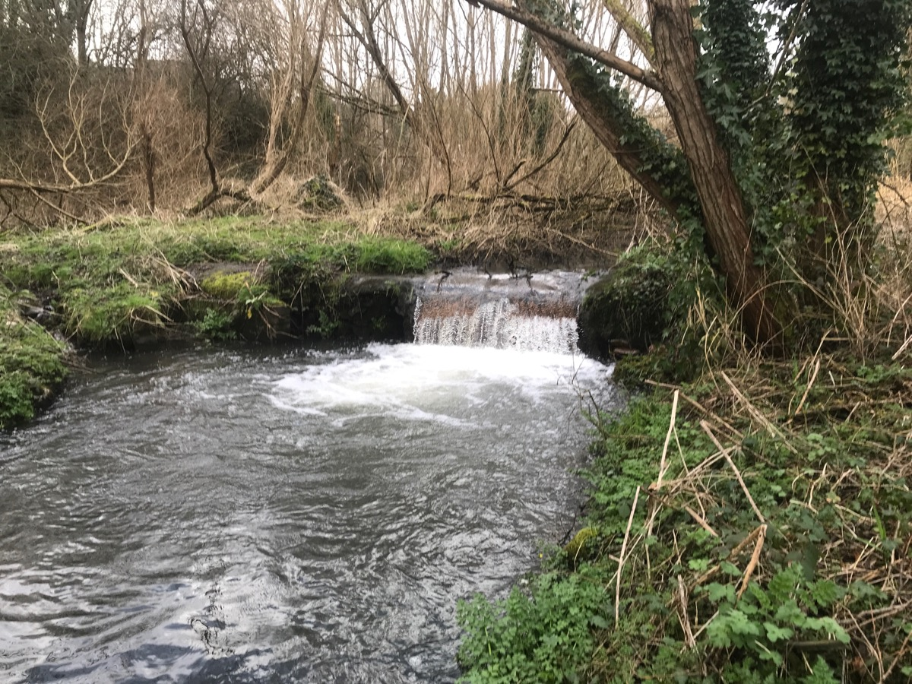
Image 3: North weir SO933873 located further up channel from yesterdays walk over.
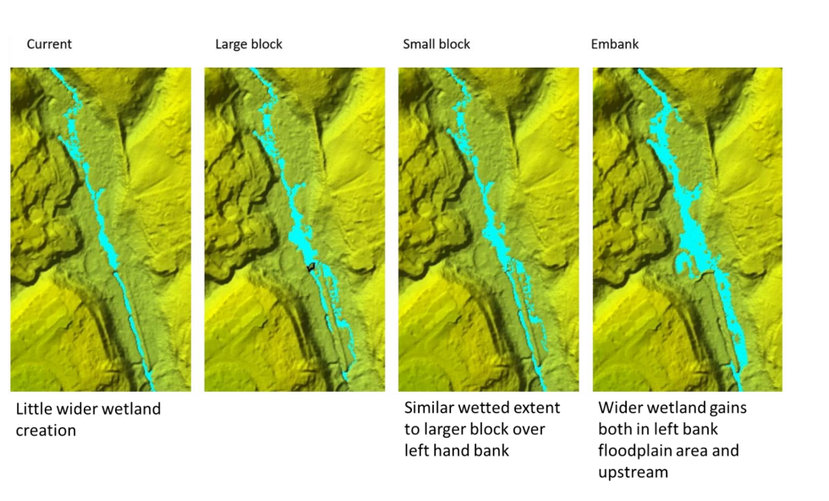
Image 4: map showing collection of options for embankment or small/ large scale bloc of river to cause increased wetting up channel, and creation of zero stage channel to the south of intervention.
Scope of Works
Small Block:
Following the flood modelling report from Dynamic Rivers, we have decided that the most cost effective approach would be the creation of a small block shown in image four above. This will push some or all the flow of water over onto the true lefthand bank/ floodplain, this will increase the diversity of the site and increase the presence of wet woodland and increase the amount of flood storage under heightened flow conditions.
The block will be formed from material within the existing floodplain location. Once constructed, if needed the block will be protected with soft engineering in the form of felled trees pegged into place to slow the flow of water pre block.

Large Woodie Debris :
Across the upper part wet woodland area we are proposing the chop and drop approach to enrich the in channel habitat and help with the retention of flood waters under higher flow conditions.
Within the Zero Stage channel (created when the water is pushed out onto the left bank) area we are proposing to also undertake some chop and drop to help cause the river to deviate and braid further.
At the lower extent of the project site we are intending to include some bankside soft engineering to provide stability under increased flow and direct new channel flow back into the existing river channel. This will be done through installing felled trees onto the bankside and pegging with stakes, behind the installed trees Willow/ Alder saplings will be planted to further strengthen the bankside.
