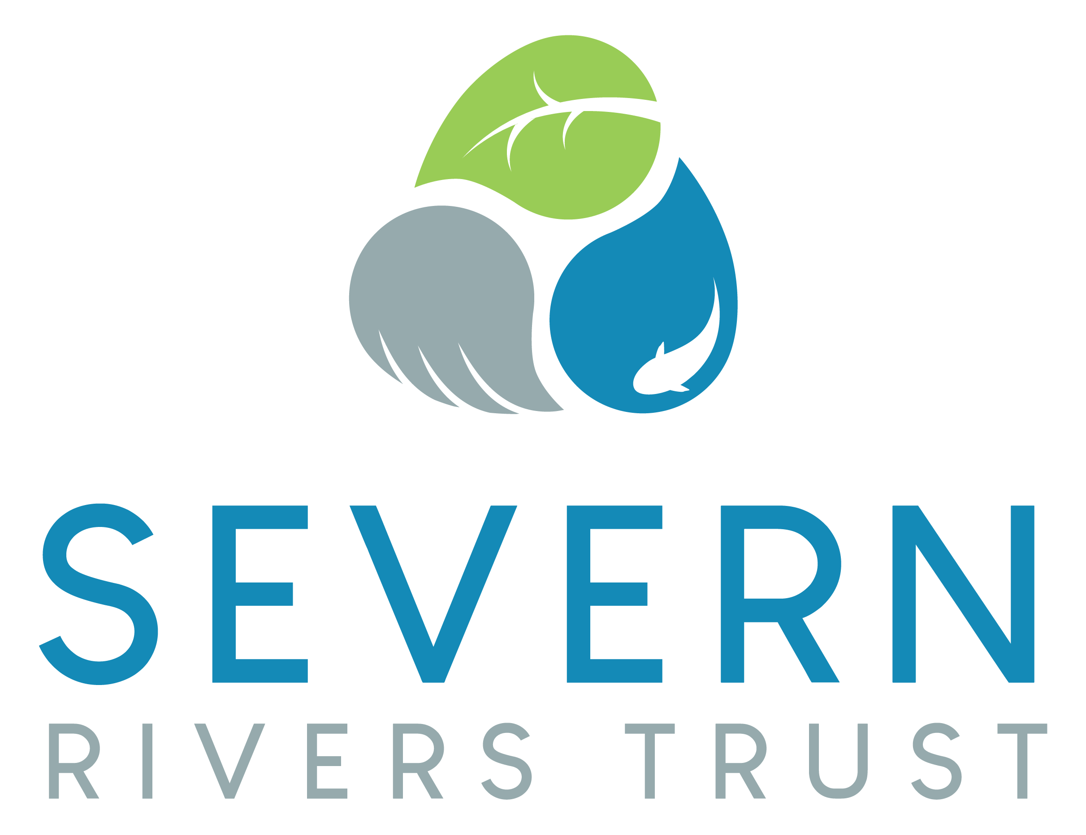

INVITATION TO TENDER FOR:
Undertaking all required Consents & Permissions
for x2 Fish Passage Projects

WEG Waterscapes (Frome) Project

Location:

Fromebridge & Stroud, Gloucestershire

Defra Water Environment Grant Funded

Contents

1. Overview & Background 3
2. Definitions 4
3. Objectives 5
4. Specification of Required Works 5
4.1. Health and Safety 5
4.2. Specification 5
5. Environmental Considerations 6
Section 2: Information and Instructions for Tendering 7
Section 3. Form of Tender 11
Time Schedule: 12
Proposed Start Date 12
Proposed Completion Date 12
SUB CONTRACTORS 13

Overview & Background

  - Overview
Severn Rivers Trust is a registered environmental charity whose objectives are to improve the River Severn, its tributaries, and the Severn Catchment across both England and Wales. Severn Rivers Trust delivers its work through grant funded projects to make physical improvements to the river catchments (such as installing fish passage solutions and initiating tree planting schemes) as well as providing education and advice to local communities and businesses.

  - Project Background
  - The grid reference for:
Delivery Site 1 (Stroud) is SO 85540 04526 and address is Arundel Mill Weir, Arundel Mill Lane, Stroud GL5 2AE (approximately)
Delivery Site 2 (Fromebridge) is SO 76933 07220 and address is Fromebridge Mill Wier, Fromebridge Lane, Whitminster GL2 7PB

  - Severn Rivers Trust, funded through the Water Environment Grant and in partnership with the Environment Agency, Wetlands and Wildfowl Trust & Stroud Valley Partnership secured funds to undertake x3 fish passage projects on the River Frome catchment in Gloucestershire.
The construction works are due to take place in 2021 following a delay caused by the COVID 19 lockdown and associated restrictions.
Two of the fish passages require a range of consents and permissions to be identified, applied for, secured and reported as necessary in order for the construction works to successfully take place by September 2021.

Definitions

In this document the following terms shall have the meanings prescribed unless otherwise stated or otherwise required by the context:

‘the Trust’ shall mean the Severn Rivers Trust.

‘Client’ shall mean the Severn Rivers Trust, for whom the project is carried out.

‘Nominated Officer’ shall mean Head of River Restoration for the Severn Rivers Trust or such other officer as the Trust may nominate.

‘CDM’ shall mean the Construction (Design and Management) Regulations 2015

‘Delivery Site’ shall mean Arundel Mill Weir, Stroud & Fromebridge Mill Weir, Gloucestershire

‘Tenderer’ shall mean the person/company submitting a Tender to the Client and where a Tenderer consists of more than one person obligations and submissions shall be deemed to have been made jointly and severally and the masculine gender shall include all other genders. Tenderer shall refer to all possible applicants including Principal Designer, Designer, Principal Contractor or Contractor.

‘Contractor’ shall mean those who are selected from the Tender process to deliver the actual work

‘Method Statement’ shall mean the method statement forming part of the tender specific to the Works.

‘Risk Assessment’ shall mean the risk assessments forming part of the tender specific to the Works.

‘Works’ shall mean the work to be performed and the services to be provided as described in the Tender Documentation, together with any alterations and amendments that are made in accordance with these conditions.

‘Landowner’ shall mean the Stroud Valley Partnership in the case of Arundel Mill Weir in Stroud and Greenekings Breweries Ltd. at Fromebridge Mill Weir.

Objectives

To have identified, made application for, secured, sought & successfully gained approval / authorisation and reported against the required range of consents and permissions necessary to install fish passage solutions at Arundel Mill Weir in Stroud and at Fromebridge Mill Weir in Fromebridge, Gloucestershire

Specification of Required Works

- To identify any and all required permissions and consents relating to the installations of a proposed Bypass Channel at Fromebridge Mill on the main River Frome and a proposed Rock Ramp installation at Arundel Mill Weir on the River Frome

- To produce any required reports or assessments relating to the successful approval and authorisations to proceed with the works at both Fromebridge Mill Weir and Arundel Mill Weir. This includes but is not limited to Environmental Impact Assessment, for example.

- To prepare and make application as required to the local planning authority and Fish Pass Panel and provide ongoing liaison and information input throughout the process to ensure permissions are granted.

- To provide such checks, applications, reports, etc. that secure the necessary permissions and consents to enable the planned works at Fromebridge Mill Weir and Arundel Mill Weir to be successfully carried out from May 2021.

Health and Safety

The Trust’s Health and Safety Policy and procedures shall always be adhered to by the Tenderer whilst undertaking the Works. Copies of the Policy and Handbook of any Tenderer are available to the Client on request. The Tenderer shall exceed or at least adhere to the Trust’s requirements, duties and responsibilities.

The Tenderer shall be responsible for the health and safety implications of all operations to complete the required Works.

The Tenderer must be aware that there is always potential public access and as such the Tenderer may be approached by the public at any time during any site visits.

The Tenderer must prepare a site risk assessment to cover site visits, engagement with the public and safeguards against spreading of any potential COVID 19 infection.

Specification

The Nominated Officer will identify the Delivery Site so that the Tenderer can visit the site and satisfy himself on the location and requirements before a Tender is submitted.

Neither this invitation to Tender nor an acceptance constitutes a permission or consent to undertake the Works. The Tenderer will be responsible (and liable) to ensure that all required consents and permissions are identified and obtained and all conditions of such consents or permissions are complied with and supply evidence of such.

In particular, (but not limited to) work on a Site of Special Scientific Interest (SSSI) the consent of the Natural England is obtained if required. Also, consent and permission must be obtained by the Tenderer from the Environment Agency including flood defense, temporary impoundments, possibly abstraction or discharge consents, planning and an archeological assessment and statement.

The Tenderer agrees to comply with and abide by any conditions or instructions that may be imposed or required as a condition of obtaining such consent.

The Tenderer will provide a complete and inclusive breakdown against a forecast schedule of works of all costs quoted. It is acceptable that certain assumptions be costed when responding to the Tender invitation with the expectation by the Client that any works ultimately not required will be subtracted from the original quotation and reflected as such in the final invoice.

A separate breakdown of costs inclusive of VAT is required for each site.

Whilst the works are expected to be complete by the 30 April 2021, the Tenderer agrees to continue any outstanding work required outside of this period and at no additional costs to ensure that complete and full approvals and permissions are acquired.

Any costs quoted by the Tenderer must include VAT.

The Tenderer will be required to attend an initial works meeting with the Nominated Officer to agree a schedule of works and will be expected to provide regular updates of progress.

All required permissions and consents for each site works must be obtained by 30 April 2021.

Environmental Considerations

  - Plants and animals protected under the Schedules of the Wildlife and Countryside Act 1981 and other Acts are not to be harmed or their habitat damaged. Nesting birds are not to be disturbed and are to be reported immediately to the Nominated Officer. It is a criminal offence to recklessly destroy a bird’s nest.

  - Any public complaints must be immediately reported to the Nominated Officer.

  - The Delivery Site must be left clean and tidy at all times.

  - All gates to be closed regarding access and egress to/on the Delivery Site where necessary to ensure security.

Section 2: Information and Instructions for Tendering
N

Tenders must be submitted in accordance with the following instructions. Tenders not complying with these instructions, in any particular way, may be rejected by the Trust, whose decision on the matter is final.

- Invitation to Tender
  - The Trust is seeking tenders from suitably experienced and equipped consultants and/or contractors and those who can demonstrate an ability to undertake the works in a professional manner to undertake the Works required, pursuant to the particulars described in Section 1.

- Basis of Tenders
  - Tenders are being invited from a selected list and from the wider community.

- Scope of Tender
  - Tenders are being invited on the basis of undertaking and completing the whole of the Works.

- Contract Period
  - Tenders are invited for a period of a single task. All works must be completed before 30 April 2021. All invoices must be delivered to the Nominated Officer at Severn Rivers Trust, Unit 3, Hope House Farm Barns, Hope House Lane, Martley, Worcestershire, WR6 6QF no later than 30 May 2021 and must include the reference code ‘WEG Frome’.

- Tenderers to visit
  - Tenderers are invited to visit the Delivery Sites to ascertain all relevant conditions and means of access and to thoroughly acquaint themselves with the extent and nature of the proposed Works and will be deemed to have done so before submitting a Tender.
  - Arrangements for any such visit can be made with the Nominated Officer by email – mike.winstanley@severnriverstrust.com.

- Presentation to the Trust
  - All selected Tenderers may be asked to make a presentation to the Trust on methods proposed for the performance of the Works.

- Tender queries
  - Tenderers are advised to study the Conditions of Contract, Specification and all other documentation provided by the Trust. The whole of these documents should be read and their true intent and meaning ascertained before submitting a Tender. Tenderers should seek to clarify any points of doubt or difficulty (including any apparent ambiguities, errors and omissions in the tender documents) with the Trust through its Nominated Officer prior to submitting a tender. For this purpose please contact the Nominated Officer at mike.winstanley@severnriverstrust.com
  - Deadline for Queries – 5pm Friday 20th November 2020

- Errors in completed tenders
  - Where examination of a tender reveals arithmetical errors these will be corrected on the basis that the rates entered into the Schedule of Rates are correct and the Tenderer will be afforded the opportunity of confirming the revised totals (in writing) or withdrawing its tender within 7 days.

- Period of Validity
  - Tenderers are required to keep Tenders valid for acceptance for a period of 30 working days from the closing date for receipt of tenders.
- Tendering procedure
  - The Tender shall be made on the Form of Tender enclosed. It must be completed and signed by the Tenderer in ink and accompanied by the following information:

    - Experience and knowledge of the Works described in Sections 3 and 4, including suitable references.
    - Experience of the role required by the Client i.e. Principal Designer, Designer, Principal Contractor or Contractor.
    - Organisation and Method of Working (including Method Statements, risks assessments and CDM information)
    - Analysis of Resources
    - Schedule of Rates
    - Details of any part of the Works to be sub-contracted
    - Copies of all Insurance Certificates, for the supplier and any sub-contractors in accordance with this Tender as applicable.
    - Case studies/examples of similar Works

  - The Form of Tender must be signed, where the Tenderer is an individual, by that individual; where the Tenderer is a partnership, by two duly authorised partners; where the Tenderer is a company, by two directors or by a director and company secretary, such persons to be duly authorised for the purpose. To nominate another individual please confirm with the Nominated Officer.

  - No tender will be deemed to be received unless:

    - The envelope bears no name or mark indicating the sender. If delivered by hand a receipt will be issued.
    - Tenders must be delivered to the following address on between the hours of 9.00 am and 4.30 pm or sent by post bearing the correct postage and addressed in either case to:

Severn Rivers Trust
Unit 3, Hope House Farm Barns
Hope House Lane
Martley
Worcestershire
WR6 6QF

  - THE DEADLINE FOR RECEIPT OF TENDERS IS 4.30PM ON 27th NOVEMBER 2020

  - Proof of posting will not be accepted as proof of delivery if the tender fails to arrive at the stipulated address before the specified time.

  - No tender received after the specified time shall be considered. Any such tender shall be returned promptly to the Tenderer by the Nominated Officer who may open the tender only to ascertain the name and address of the Tenderer.

- Tender evaluation
  - The Trust will be conducting a full financial and technical evaluation of all tenders. Due to the time constraints of the grant body, the Trust will also be evaluating based on an ability to commence and complete in sufficient time.

  - Tenders will be evaluated in accordance with the following:

    - Products and services shall be competitively priced, readily available and fit for their intended purposes, bearing in mind health and safety or other legislative requirements.

  - In the evaluation of Tenders the following will apply:
- Experience of similar Works
- Suitable knowledge and working experience of identifying, applying for and obtaining consents and permissions for river restoration project works
- Method Statement and Resources
- Other Items
- Written technical and financial references may be requested and considered as part of the evaluation procedure.

  - The Trust may also seek clarification in respect of the Method Statement and Resources Analysis in various ways including but not limited to:
- Site visits
- Interviews with key personnel who would be assigned to the Contract and appropriate Senior Managers of the Company.

- Basis of Tender
The Tenderer shall show the Tender sum for the actual Works inclusive of VAT.

The Tender must include value of all of the Works and must cover all costs and expenses which may be incurred in order to complete the Works in accordance with the Conditions and to assume all express and implied risks, liabilities and obligations imposed by the Conditions, the Specification and all other documents forming part of the Tender documentation.

The Tenderer shall be deemed to have satisfied itself before submitting its Tender as to the correctness and sufficiency of its rates and prices.

- Sub-contracting
  - When submitting its Tender, the Tenderer must notify the Trust of any parts of the Works that it proposes to sub-contract. Failure to do so will invalidate any such tender.

  - The Trust’s prior written approval must be obtained before any part of the Works is sub-contracted. The Trust reserves the right to refuse such approval as its absolute discretion.

  - An approved sub-contractor must give a direct warranty and undertaking to the Trust but the Tenderer will nonetheless remain primarily liable for carrying out and completing the Works.

  - Should any sub-contracting be required, the Tenderer shall assume the role of Principal Designer or Principal Contractor as appropriate.

- Award of Contract
  - The Trust expects to award the Contract within 10 working days of accepting a tender but reserves the right to delay awarding the Contract to a later date for any reason.

  - The successful Tenderer will be required to execute a formal contract incorporating the Conditions and until such execution, the successful Tender together with the Trust’s written acceptance shall constitute the contract.

- Health and Safety
Tenderers will be required to comply with the Health and Safety at Work Act 1974, Construction (Design and Management) Regulations 2015 and all other regulations made under and after the Act and all other legislation and regulations relevant to the performance of the contract.

- Obligations
Tenderers proposing to submit a Tender are advised to ensure that they are familiar with the nature and extent of their obligations if their Tender is accepted.

- Accuracy
Information supplied to Tenderers by the Trust (whether in these tender documents or otherwise) is supplied for general guidance in the preparation of the tenders. Tenderers must satisfy themselves by their own investigations with regard to accuracy of any such information and no responsibility is accepted by the Trust for any inaccurate information obtained by Tenderers.

- Confidentiality
All information supplied by the Trust in connection with this invitation to tender shall be regarded as confidential by the Tenderer except that such information may be disclosed for the purpose of obtaining sureties and quotations necessary for the preparation of the Tender.

- Canvassing
Tenderers face automatic disqualification if they canvass for the Contract by approaching the Trust or Officer of the Trust with a view to gaining more favourable consideration of their Tender. Tenderers should state whether Board Members or Officers of the Trust have any direct or indirect interests in their company.

- Late Tenders
Tenders received after the closing time and date stated above will not be considered unless by prior arrangement with the Nominated Officer via email - mike.winstanley@severnriverstrust.com

- Definitions
The words defined in the Conditions and Specification shall have the same meaning in these instructions.

Section 3. Form of Tender
(To be completed by the Tenderer and returned to the Nominated Officer relating to the supply of the Works).

We offer to execute the whole of the works described in your Invitation to Tender Specification (dated 31st October 2020) for WEG Waterscapes Consents & Permissions

Total all-inclusive tender for each of the works inclusive of VAT:

Works: Consents & Permissions for Arundel Mill Weir fish passage works

£ ……........………………………pounds and ................. pence

Consents & Permissions for Fromebridge Mill Weir fish passage works

£ ……........………………………pounds and ................. pence
We confirm
(i) That we have not communicated and will not communicate to any person under any agreement or arrangement, the amount of this Tender. (ii) That the amount of this Tender has not been adjusted under any agreement or arrangement with any person. (iii) Having examined the Conditions of Contract and Specification for the above mentioned works we offer to complete the whole of the Specification for the Delivery Site for such as may be ascertained in accordance with the said Conditions of Contract. (iv) We undertake to complete and deliver the whole of the Works comprised in the Contract within the time stated in this Tender. (v) Unless and until a formal Agreement is prepared and executed this Tender, together with your written acceptance thereof, shall constitute a binding contract between us. (vi) We understand that you are not bound to accept the lowest or any tender you may receive. (vii) We understand that Work on this Delivery Sites may not take place even after the Contract has been awarded depending upon Consent.

Name of Firm: .

Address:

Post Code Tel No

VAT No
If a Limited Company, please state address of Registered Office;

Signature

The Tender to be enclosed and sealed in an official addressed envelope and delivered by not later than 5pm on the 27th November 2020

Note: Any Tender received after this date will not be considered**
Itemised:
General Items and Preliminaries:-
Works Required |  | No. | Rates £'s | Cost  (ex VAT) | VAT | Total Cost £'s
Items | Contractual Requirements

Note: Please photocopy and use additional sheets as necessary.

Time Schedule:

Proposed Start Date | 1st December 2020
Proposed Completion Date | 30th April 2021

SUB CONTRACTORS
(To be completed by the Principal Designer and/or Contractor)
The Principal Designer or Principal Contractor shall indicate the names and addresses of those firms to whom he proposes to sub-let any portion of the work included in this tender.

- The Principal Designer or Principal Contractor is to include copies of all relevant insurance certificates for those Designers or Contractors listed below.
- No sub-contractors may be used without the written consent of the Trust, or without the insurance documents having been vetted and approved by the Trust.
(iii) Any other sub-contractor must not be utilized without the prior consent of the Nominated Officer.
- Only sub-contractors with substantial experience of remote and sensitive working and with prior experience in this particular type of work may be considered.
- The Trust requires that the Contractor submit a full resume of the sub-contractors experience.

The Trust reserves the right to reject any proposed Sub-Contractor.

If no subcontracting is to be undertaken simply state none below.

Sub-Contractor

Section or nature of the work to be Sub-let

Names and Address

Signature ....................................................................................................
Address ....................................................................................................
Date ....................................................................................................

