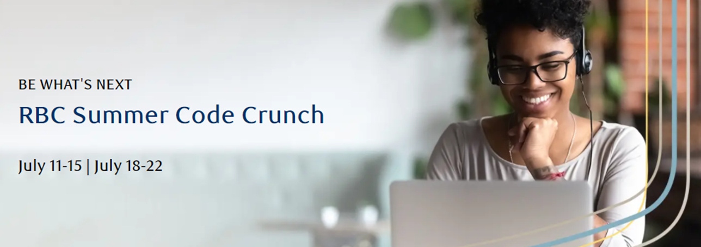

Registration for RBC’s Summer Code Crunch program is now open!

The RBC Early Talent team is excited to announce that Summer Code Crunch will be returning for 2022 with expanded program offerings for diverse students.

As a top tech employer in Canada, RBC is committed to ensuring students from diverse backgrounds have the opportunity to learn, grow and work with purpose. We’re focused on helping motivate and encourage the next generation of brilliant minds to grow their skills, make an impact and Be What’s Next. We appreciate your support, as our trusted academic and community partners, to promote this opportunity with eligible students.

What is Summer Code Crunch?
Summer Code Crunch (SCC) is a 1-week virtual ‘bootcamp’ where students learn the basics of coding, such as Python, CSS, HTML, and Java. Students will get the opportunity to build their very own game (think Heads Up) and a website, which they can show off to family and friends! Aside from coding, students will also gain experience through professional development and speaking with RBC mentors.

Who can register for SCC?
• All applicants should identify as Womxn* for the week of July 11-15 and BIPOC** for the week of July 18-22.
• All applicants should be Canadian and have just completed grades 8, 9 or 10.
• We are looking for students with little or no coding experience who are able to join for the full duration of the 1-week program.

When is SCC being held?
• July 11-15, 1-4:30PM EST for Womxn* students
• July 18-22, 1-4:30PM EST for BIPOC** students.

*RBC recognize that the word “Woman” may be used as an identifier for some but not all. We understand the imperfection of language, and we use Womxn to welcome cis and transgender Women, non-binary, agender, and intersex persons.
**BIPOC includes Black, Indigenous, and People(s) of Colour

How can students register?
Included below is a link to our registration page. No resume or cover letter is needed, but we do ask students to provide a few sentences on why they are interested in the program! We will send out acceptances on a rolling basis, until we have reached program capacity or our deadline of May 15, 2022.

Click here to register!

Want to learn more? Visit our website https://jobs.rbc.com/ca/en/code-crunch for more information.

