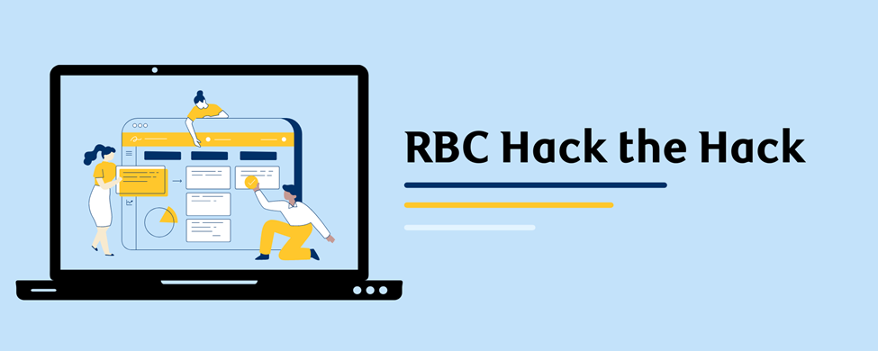

RBC Hack the Hack Frequently Asked Questions
Q: How long is the program?
A: The program runs Wednesday from 4:00-5:30PM Eastern time from October 20-November 24, 2021. The sessions are about 45 minutes of learning and then about 45 minutes of time to work on what you’ve learned.

Q: Who is eligible for the program?
A: The program is by application based on the below criteria and open until we have reached program capacity or our deadline of October 12, 2021.

All applicants should identify as womxn, transgender, non-binary, or agender Canadian students who are currently in grades 8, 9 or 10. (A few exceptions may be made for students in grade 7 or 11.). We are looking for applicants with little to no coding experience and who are able to join for the full program.

Q: How can I apply for the program?
A: Apply here: https://vote.pollstream.com/l/kby8aIi
It is a quick application process and no resume is required!

Q: Where does the program take place?
A: It is completely virtual! You will need a computer/laptop/tablet and a WiFi connection. If you don’t have these that is OK. Please let us know and we can help make arrangements.

Q: What will I learn in the program?
A: This program is designed to help students start to feel comfortable with hackathons and build introductory coding skills. The lessons include topics like introduction to HTML, java, and WordPress. Students will feel ready to attend their first hackathon at the end of this program.

Q: Will I be doing other activities, or just coding?
A: Yes! We have a full range of engagement activities planned! These include: meeting RBC mentors, fun contests, and professional development.

Q: Who is teaching the classes?
A: RBC has partnered with Canada Learning Code to teach the classes. They are an amazing organization with tons of teaching experience. You can learn more about them [here].

Q: How much does the program cost?
A: It is totally free!

Q: Do I need to attend every day?
A: We do ask that you plan to attend every day. We understand though that things happen and you might miss a lesson.

Q. What personal information, if any, will RBC collect about me?
A: As part of the application RBC will ask for your name, email address and home address. We need your name and email so that, if you are accepted into the program, we can communicate with you, and your home address, so that we can mail you cool stuff (think ‘swag’)! We also ask questions about demographics (how you identify), these are totally optional. We collect this type of information to make sure that we are fairly representing all Canadians (we take inclusive approach to reach out to different diverse communities). We will not sell or share your personal information. We store the information in aggregate and do not use it to determine who is accepted into the program. If you have any questions or concerns about this, please ask us.
Q. I can’t attend this time around, but am interested in future opportunities for students. How can I learn more?
A: No problem at all! We have a mailing list! Click here to sign up

Q: When will I find out if I am accepted?
A: We are accepting people into the program until October 12 or we reach program capacity. We will let you know quickly after you apply.

Q. I have more questions, is there someone I can talk to?
Yes! Please email freetechprograms@rbc.com

