Interlacing an Elementary Longitude Reading Intervention Program: Internal Assessment and Cost Benefit Analysis

Derrick R. Fries, Ph.D.
Tom Harwood, Ed.D.
Greg Johnson, M.A.
Grosse Pointe Public School System
(In collaboration with Eastern Michigan University)
Administration Building
389 St. Clair Ave.
Grosse Pointe, MI 48230
http://gpschools.schoolwires.net

Corresponding Author: dfries@emich.edu 248-941-1365 (cell)

Abstract
This article chronicles the development of a systematic reading intervention program and a large based suburban school district. The search for a systematic reading intervention is always a topical curriculum intervention for school systems. Many different reading intervention strategies and program s have been introduced in the past for decades. School systems have spent precious resources adopting these various reading strategies without complete and adequate data analysis and review. This article reviews a thorough data assimilation of a reading intervention program from a longitudinal study over multiple years and grade levels. This long term approach has assisted the school district in determining performance standards and cost benefit analysis.

Key Words:
Multisensory approach, systems phonics, low ability reading, reading specialist.

Overview
School personnel have a myriad of responsibilities for educating our nation’s young elementary students on a limited curriculum budget. Public school administrators have a large amount of choice when identifying a particular reading intervention program to assist in elevating reading test accountability scores. Each of these programs has impressive claims to help elevate reading comprehensive skills that generate itself across all subject matter to help the challenged readers. With the reduction school and administrative staff including data assessment personal within the public school systems, it is becoming increasing difficult for school districts to know which programs are most effective. One large suburbia school district with approximately 8000 students asked a fundamental question, of how we could measure, evaluated and determine a cost benefit analysis of a reading program that will generate itself over all elementary schools over a period of five years. Prior to the school year of 2007-2008 the language arts program at this comprehensive school district used an eclectic approach to instruction. This de-centralized approach included aspects of numerous intervention program including Orton Gillingham, Discover and Intense Phonics, Lindamood Bell, Guiding Reading, Project Reading, Whole Language, Sore to Success, and Early Success to name few. The school district did have resources to provide reading specialist throughout the school district. The district was the recipient of a large grant over the five year period from the school districts internal school district foundation . The school district was fortunate to have generally one reading specialist per elementary school with intervention strategies and in service training. The reading specialist would select their choice of appropriate programs and text that they thought worked for their designated student population. At the end of the 2007 school year the curriculum director at the time asked a fundamental question which included what would happen if we could consolidated a reading intervention strategy into one approach and examined it over a longitude study of five years? The school district set out on a comprehensive single reading intervention technique for all of it’s over 5,000 elementary students. That reading program the school district chooses was The F.A.S.T Reading Program Intervention Strategy.
Purpose of the Article
The purpose of this article is to review findings of a longitudinal reading intervention program over a five year time period, 2007-2012. It is seldom that school districts take time to evaluate whether reading intervention program actually work and provide feedback to its educational staff and its clientele. A complete and thorough data analysis was conducted on the efficacy of the F.A.S.T. Reading Program utilized by approximately 1,300 elementary students and over a five year period. Reading Specialists for the school district were trained in this F.A.S.T. Reading Program and a consolidated effort was directed to assist its low preforming readers through a singular delivery model to help evaluate standardized test scores and overall school performance. This school district was a recipient of an internal foundation for public education established by active parent groups within the school district that funded this intervention program. One of the original foundation members has a student that benefited from this reading intervention techniques. This school district is asking a fundamental question on the long term effects of this F.A.S.T. Reading Program and has it effective cost benefit analysis. These are important and unique questions that school districts often fail to ask in review of important intervention strategies.

Target Population
Throughout this longitudinal five year study the school district asked a fundamental question, is this F.A.S.T. Reading Program really helping students read and learn better? Since all 10 elementary schools were K-5 buildings the district used recognized assessment tools to help identify all students who presented weak performances in reading skills. Emphasis was placed on the 2nd grade as the most likely grade to be assessed in reading performance. Beginning in the 2007-2008 school year the district undertook the assessment of all students in grades 1-3 and how they performed using NWEA reading assessment test. A cut score of approximately 40% level targeted students that were in both regular education and special education classrooms. This assessment tool was used throughout the 1st , 2nd and 3rd grade, in the upper grades, 4th – 5th the NWEA at the 40% level was used along with appropriate MEAP cut scores that varied per year in grades 4th-5th ( see Figure 1). The 10 elementary schools ranged in student population size from 280 students to 504 students. All students were administered (including special education students) the NWEA test at each grade level and year. The NWEA would then determine which students would receive the designated intervention of the F.A.S.T. Reading Program which was administrated by the reading specialist after their prior training and comprehensive understanding of the F.A.S.T. Reading Program. Approximately 12% of the total elementary school population received the F.A.S.T. intervention treatment each year.
Participants
Over the five year study regular education students and special education students were treated identically in this longitudinal study. Student demographics included approximately 80% Caucasian, 15% African American, and 5 % other. All of the reading specialists had been classroom teachers and had the minimum of a Master’s Degree in reading related curriculum. Each of the reading specialists’ caseloads was determined by the students’ NWEA scores and the MEAP cut scores. Generally one reading specialist was assigned to one elementary building in the mentioned school district.
Targeted F.A.S.T. Reading Intervention Strategies
The comprehensive school district wanted to provide a uniform reading delivery intervention model. The F.A.S.T. Reading Program was chosen due its comprehensive and integrated reading analysis system. The Curriculum Director and various Administrators within the school district believed that this program provided a reading intervention program for weak performing reading students; and supported five critical aspects identified by the United States Department of Education National Reading Panel (September, 2001). These five initiatives included phonemic awareness, phonics, fluency, vocabulary, and text comprehension. The F.A.S.T. lessons contained sound syllable word drills using a particular phonetic concept. These drills were rehearsed prior to practicing those concepts within the F.A.S.T. student publications. In addition, F.A.S.T includes writing and response to a text in every unit, as well as learning a critical skill for competency in literacy development. Magnetic board delivery systems are utilized along with teaching comprehensive phonetics systems using a multimodality delivery technique.

School Delivery Systems
The reading specialist would work coordination with regular education teaching into a pull-out program that occurred at the same time as the language arts instruction. During this time the Reading Specialist would pull out approximately five to ten students to a designated small group setting. School administration and the Reading Specialists believed that using a comprehensive, highly focused reading intervention program that students would elevate their reading comprehensive fluency and test scores. The ultimate goal would be to work themselves out of the F.A.S.T. Reading Program and reintegrate themselves into regular education setting. Additionally, each F.A.S.T. student’s parents were contacted and provided with a contract to assist in reading performance at home. This was a vital part of the intervention technique that parents were required to sign this contract and support the Reading Specialist through supplemental reading at home. The school district also provided an internal reading club that would happen during language arts instructions for students both in the F.A.S.T program and regular education students. This comprehensive integration also included training of the regular education teachers in the F.A.S.T delivery model, and special education teachers, which was done at a staggered yearly rate.
F.A.S.T. Reading Intervention and Extraneous Factors
Assisting in the intervention of the F.A.S.T Reading Program are other important factors that increase its success rate for family and students. Although these individual factors are difficult to measure, they provided rich qualitative measures to the intervention as a whole. Sometimes these pull-out programs cause stigmas or embarrassing situations for students. In this particular district the extraneous factors actually act in reverse and often seemed as something extremely positive for students and families. Students and parents would often request to be in the F.A.S.T Reading Program. This was the large paradigm shift for the district that turned a lot of special effort and sensitivity to bring this cultural change. Additional extraneous factors include the following:
• Reading specialist in all buildings were kid friendly and kid orientated.
• Reading clubs were established in each of the ten elementary schools.
• Regular Education and Special Education Teachers received F.A.S.T. Training and greatly embraced it.
• Through its accreditation process in North Central’s one of the Professional Learning Communities (PLC) was a reading specialist as integrated with regular education communities.
• Comprehensive administered support and encouragement.
• High number of student involvement in the district wide approach and parental support and encouragement.
All those factors added to widely accepted program that seem to have the confidence of the administrative, regular education staff, the reading specialist, its students and its parents.
Results
By the year 2012 the School District through descriptive statistics had results of students’ growth periods over the beginning of the F.A.S.T. Intervention Program in 2007. The data assessment is inclusive of both special education and regular education students. From the onset of the F.A.S.T. Reading Program the students were evaluated on the MEAP. In the reading portion of the MEAP students were divided into 4 State designated categories. These categories included: Not Proficient, Partially Proficient, Proficient and Advanced. For students to get an acceptable MEAP Reading test score that would indicate a successful pass on the state designated test students needed to score in the Proficient or Advanced categories. The most common comparison the district used was students’ performance on the MEAP F.A.S.T. vs. Non-F.A.S.T. students. In Figure 2, students were measured on the Overall MEAP Performance in the Proficient and/or Advanced categories.
The students who were placed in the F.A.S.T. program were students who were performing at substandard reading levels. Therefore, these targeted students placed in the F.A.S.T. Program should have slower targeted reading performance rates than the non-F.A.S.T. students. Since the districts goal was the reintegration of these students back to regular education after their F.A.S.T. Reading Intervention (intervention times range from 1-3 years) the comparison group between F.A.S.T. students was the remaining student body or the non F.A.S.T. reading group. This baseline comparison for data analysis was very high for the F.A.S.T. reading intervention students (see Figure 2).
Additionally, students were examined on the performance between 3rd and 5th grade on the NWEA annual test (see Figure 3). The growth rate for the F.A.S.T. students on the NWEA matched the Non-F.A.S.T. group for the vast majority of F.A.S.T. students. The Figure 3 results indicate students in the F.A.S.T. program made significant reading gains upon conclusion of the F.A.S.T. Intervention Program.
In Figure 4 the comprehensive data analysis showed that the F.A.S.T. students’ performance on the NWEA by increasing one reading level actually increased greater for the F.A.S.T. students then the non F.A.S.T. comparison group. Of the 512 non F.A.S.T. students who took the NWEA test grades 3rd-5th, 32% students increased one or more NWEA levels. The F.A.S.T. group of students who took the same test increased their NWEA level by one or more by 38% during the same testing window. The F.A.S.T. students increased their NWEA performance rate at 18% greater than the non F.A.S.T. students. The F.A.S.T. students (see Figure 4) had 57 students who actually increased one or more NWEA levels out pacing the non F.A.S.T. counterparts. Additional descriptive statistics were conducted using a matched T-Test (see Table 1) using a comparison between the 512 Non-FAST students who took NWEA test grades 3rd-5th and 144 FAST students who took the NWEA during the same test time. Table 1 showed an average percent change of 9.3% larger increase when compared to the 512 Non-FAST students. These results exceeded the School Administrators and the Reading Specialists long term expected performance rates. Additionally, the district was interested in the cost benefit analysis that the grantors supplied. On a per student basis this intervention cost the grantor approximately $186 per student that receive the F.A.S.T. Reading Program intervention. Therefore, this relatively small cost per student has resulted in significant educational gains at an efficient and effective cost benefit analysis. The average length of the F.A.S.T. Intervention Program was approximately 14 school months long and in Table 5 the displays the grow difference over two years (3rd grade vs 5th grade)for non F.A.S.T. students was 29% increase and F.A.S.T. Students a 38% increase. The cost benefit analysis and efficacy of the F.A.S.T. Intervention Program showed efficient educational results.

Limitations
A major limitation of this study was the lack of a pre and post score for F.A.S.T. students. Students who participated in F.A.S.T. were compared against their non F.A.S.T. peers resulting in a non-equivalency benchmark standard. Additionally, other factors such as additional district interventions listed as extraneous factors were not isolated and/or measured. Individual F.A.S.T. students were able to meet standards and once their reading scores were elevated they would be reintegrated back into the regular education setting and not participate in the pull-out program. This was done on an individualized basis and composite student data sets were not reviewed.
Implications and Future Directions
One of the refreshing directions that this suburbia school district enacted was to ask fundamental questions of educational and cost benefit examination. Often time’s school districts embark on these intervention programs that can be seen as waves of reform and fail to provide a longitudinal examination of their results and costs. This district focused its concentration on a single intervention technique and consolidated this program in all ten buildings with great uniformity and parity. Additionally, approximately the same percentage of students in all 10 elementary buildings received equal access and interventions of the F.A.S.T. reading techniques. This provided a comprehensive and uniform delivery model that was embraced by regular education staff, special education parents, teachers and students. The district also developed intrinsic change by getting reading assistance that was beneficial and in vogue for all types of students. The district also showed insight in asking a fundamental question that is often overlook in public school systems regarding cost benefit analysis for educational reform on a per student basis. The district additionally commissioned one of its own math teachers to assist in its data analysis and review of the end educational performance product.
Administrators who work with limited resources and tight financial budgets often do not have the time to review efficacy questions for educational intervention strategies. Working contrary to this notion the school district help set a standard by doing its own internal audit of educational gains. Most school districts would not have the good fortune of received $250,000 of outside funds to use for an intervention of educational reform. Any school district who uses its own internal funds for reading intervention techniques or other educational intervention techniques needs to be able to conduct a detailed internal audit of performance gains and cost benefit analysis.
Further research would be helpful in looking at pre and post-performance scores for students who receive the F.A.S.T. Reading Program. By examining the onset of this intervention technique greater educational significance can be articulated.

References
Lewis, D. M., Mitzel, H.C., & Green, D. R. (June, 1996). Standard setting: A Bookmark approach. In D. R. Green (Chair), IRT-based standard-setting procedures utilizing behavioral anchoring. Symposium conducted at the Coucil of Chief State School Officers National Conference on Large-Scale Assessment, Phoenix, AZ.
Lyon, R. & Chhabra, V. (2004). Educational Leadership. The Science of Reading Research, 61, number 6, 12-17.
Mead, Sara. (2010). The American Prospect. Reading for Life, Washington, D.C., Volume 12, No. 2.
Moran, Lisa. (2009). The Early Literacy Crisis: A Mom’s Congress Special Report. Parenting Magazine, Orlando, Florida. Volume 6, 128-129.
Reyna, V. (2004). Why Scientific Research? The Importance of Evidence in Changing Educational Practice, Volume 4, 79-80.
Senn, Nicole. (2012). The Reading Teacher. Effective Approaches to Motivate and Engage Reluctant Boys in Literacy, 66, issue 3, 178-180.
Woodcock, R. W., McGrew, K.S., & Mather, N. (2001). Woodcock-Johnson III Tests of Achievement. Itasca, IL: Riverside.

Figure 1
K-5 F.A.S.T. Reading Systems Flowchart for the GPS

Fountas & Pinnell (F & P) Benchmark Assessment System Pre and Post
F.A.S.T. Reading Contract with Parents
F.A.S.T Program Support from the Grosse Pointe School System Foundation
Supplemental Training Support Given to Elementary Regular Education Teachers (in progress)
Reading Clubs at Each of the Ten Elementary Schools in GPPSS
F.A.S.T. Reading Intervention by GPPSS Reading Specialist (Based on: Repeated Readings, Swinging Underneath, Pressure Release Technique)
Allocation of Reading Specialist Assigned by Formula and Elementary Building Type and Needs
F.A.S.T Reading Intervention Program by Stephan Tattum
(Hands on systematic, multi-sensory approach)
Examination of Scores on MEAP & NWEA 40% MEAP Cut Scores Grades 4-5 (see appendix A)
Examination of Scores on NWEA at 40% Level Grades 1-3 (see appendix A)
Regular Education Identification of Reading Weakness Grades 1-5
(note: highest priority in 2nd grade)

Continue Evaluation of F.A.S.T. Reading Intervention and Continuation of Regular Education Elementary Teacher Training
Special Education Student Reintegration in Regular Education Reading Classes and Reading Competency for All Subjects
Regular Education Student Reintegration in Regular Education Reading Classes and Reading Competency for All Subjects
Post Data Analysis on Each F.A.S.T. Student via MEAP/NWEA/F&P

Figure 2

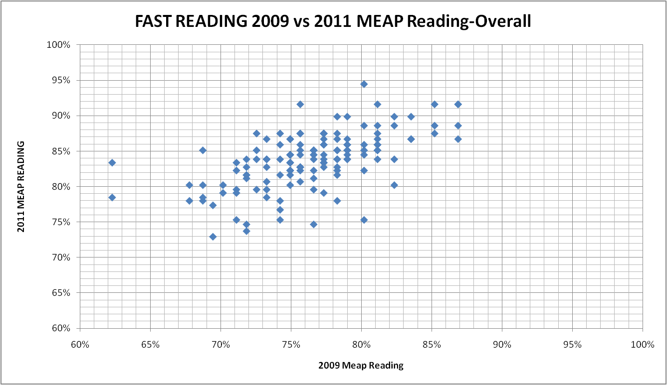

Figure 3
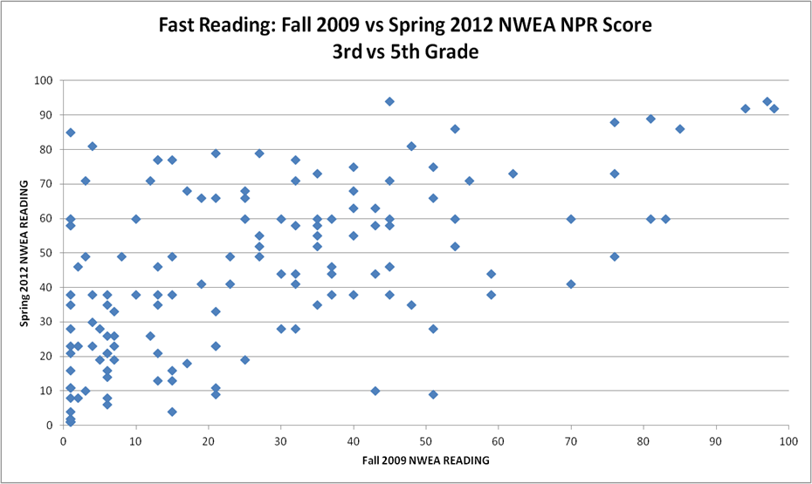
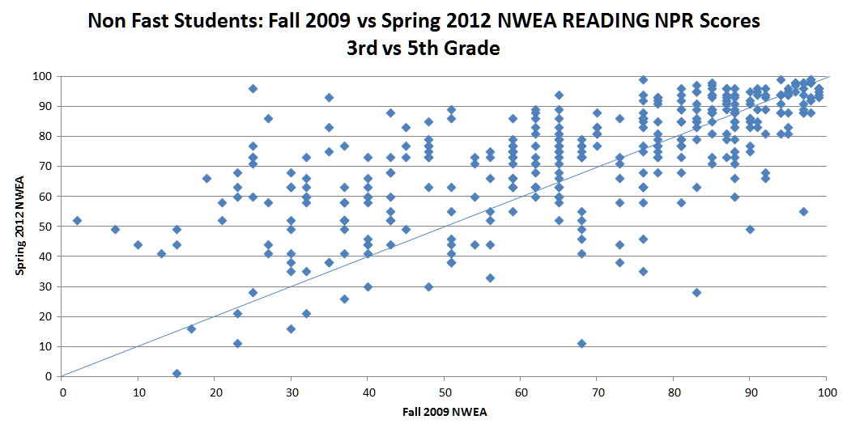

Figure 4
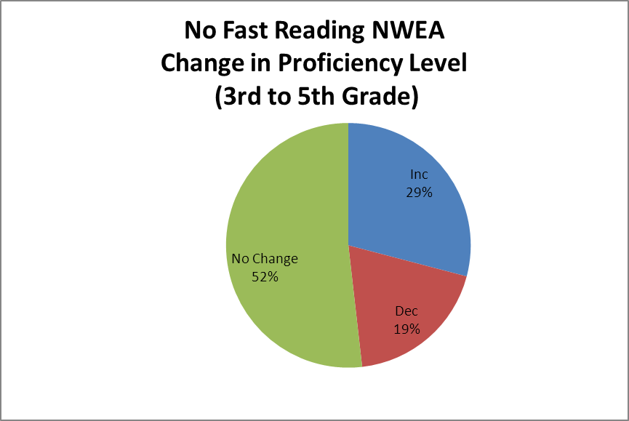
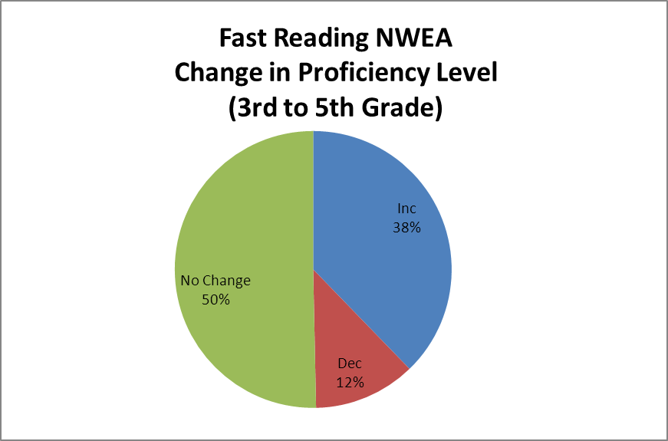

Table 1
Final TTest of 20 Random FAST Students vs ALL Other Non-FAST Students
 |  | Student ID | 2009  Reading MEAP | 2009  Reading  MEAP | 2011  Reading MEAP | 2011  Reading  MEAP | Change in %
1 | 94 | 94 | 317 | 76% | 552 | 87% | 12%
2 | 87 | 87 | 331 | 79% | 537 | 85% | 6%
3 | 129 | 129 | 298 | 71% | 519 | 82% | 11%
4 | 15 | 15 | 420 | 100% | 596 | 94% | -6%
5 | 45 | 45 | 324 | 77% | 552 | 87% | 10%
6 | 94 | 94 | 317 | 76% | 552 | 87% | 12%
7 | 61 | 61 | 294 | 70% | 506 | 80% | 10%
8 | 33 | 33 | 304 | 73% | 552 | 87% | 15%
9 | 133 | 133 | 314 | 75% | 533 | 84% | 10%
10 | 106 | 106 | 331 | 79% | 547 | 87% | 8%
11 | 94 | 94 | 317 | 76% | 552 | 87% | 12%
12 | 9 | 9 | 324 | 77% | 552 | 87% | 10%
13 | 68 | 68 | 301 | 72% | 465 | 74% | 2%
14 | 132 | 132 | 298 | 71% | 475 | 75% | 4%
15 | 102 | 102 | 298 | 71% | 499 | 79% | 8%
16 | 3 | 3 | 311 | 74% | 529 | 84% | 10%
17 | 24 | 24 | 261 | 62% | 526 | 83% | 21%
18 | 141 | 141 | 307 | 73% | 522 | 83% | 9%
19 | 107 | 107 | 314 | 75% | 519 | 82% | 7%
20 | 30 | 30 | 336 | 80% | 596 | 94% | 14%
 | T TEST Matched |  | 1.49555E-19
 | avg change |  | 9.254%
 | stdev |  | 0.053673671
 | count |  | 20
 | T Test Two Sample / Variance |  | 0.001348451

Grosse Pointe Public School System (GPPSS) is a comprehensive public school system (K-12) located in XXXX.
Grosse Pointe Foundation for Public Education (GPFPE) is a non-profit organization. Approximately $250,000 was given to GPPSS over five years for F.A.S.T. training and implementation.
Fundamental Applications for Successful Teaching, Founded by Steve Tattum and Incorporated by the Denver Academy in Denver, Colorado
Northwest Evaluation Association (Reading Assessment)
Michigan Educational Assessment Program
The Grosse Pointe Foundation for Public Education

