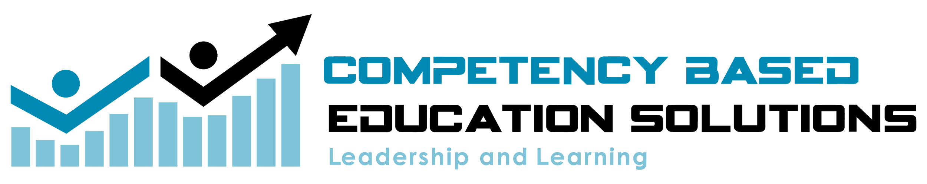

Student Agency:

Building a Culture of Ownership and Leadership

Building a shared vision, code of cooperation and a system to monitor student academic behaviors.

Supporting learning communities with student centered design and practices to foster leadership, engagement, and achievement.

Student Voice and Agency
There are certain steps and components needed to create a learner-centered culture. All of the steps below should be developed collaboratively with the input of the students to promote ownership.
- Building a shared vision as a class.
- Develop a code of cooperation, these are the behaviors/attributes we desire to help us reach our shared vision.
- Develop a scale (way to measure) the unpacked behaviors in the code to provide feedback to the student.
- Develop strategies students can employ to make adjustments and progress in their behaviors. (SOP’s, Goal Sheets, etc.)
- Goal-setting (classroom or individual) to deepen ownership of behavioral choices when appropriate.
Step 1:  Develop Shared Vision (Plan) | Shared Vision  Our long term, overarching goal. Where we want to be as a class.  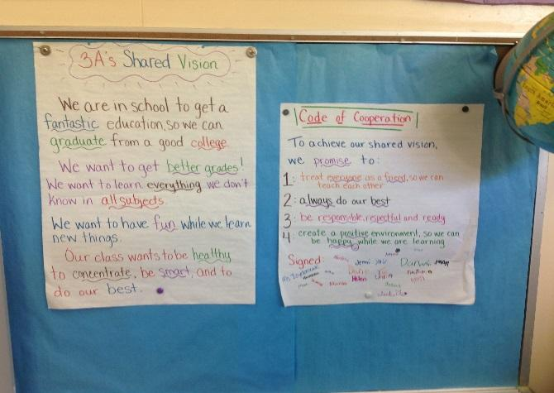  Components:  - Starts with essential questions  - What makes a great student?  - What makes a great teacher?  - Aligned to key performance indicators  - Respectful, Responsible, Safe etc….  - Can be built with Affinity Process!  - Voice of the shareholder is heard and captured- Engaging process!
Step 2:  Code of Cooperation  (Do) | Code of Cooperation  The day to day actions that help us achieve our Shared Vision  Components:  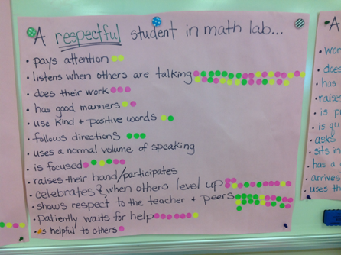  - Identified behaviors and norms we must hold each other accountable to:  - Behaviors are unpacked and operationalized  - Apply these expectations to a particular situation  - i.e. What does an independent worker look, sound and feel like when the teacher is teaching,
Step 3:  Scale  (Check) | Scale  Feedback tool for students to monitor behavior as compared to expectations.  Components:  - Develop learning expectations for behavior:  - I can statements….  - I can keep my hands to myself.  - Place expectations on a scale for students to track and monitor their behaviors.  For Example:  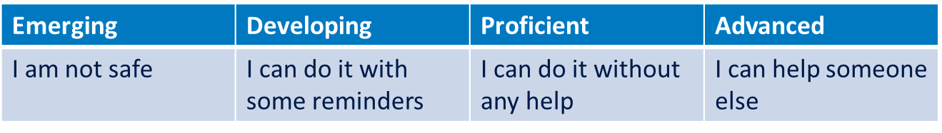
Step 4:  Strategy- SOPs  (Adjust) | SOPs  Standard operating procedures (SOP) create leadership, ownership and problem solving for students.  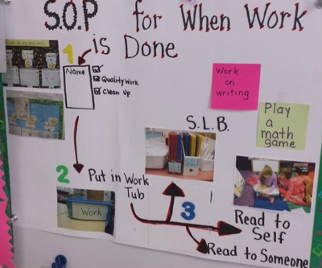  Components:  - Determine situations where students can “own” the process or problem solve.  - Procedural SOPs for processesFlow Chart SOPs for Problem Solving
Step 5:  Goal Setting and Celebrations. | Goal Setting  A way to deepen ownership of behavioral choices,  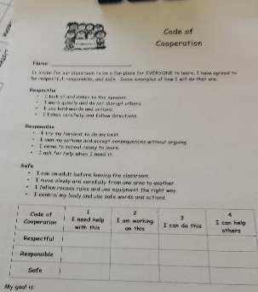  Components:  - Develop goals at the individual and/or classroom levels.  - Develop a recording and reporting tool for goal monitoring and reflection  - Goal Board (public)  - Data Binder (personal)  - Determine celebration choices for reaching the goal

Steps:
Developing the scale
- Develop a shared vision with your students.
- Identify key performance indicators (Respect, responsible, ready to learn, safe etc.)
- Select one of the key performance indicators and unpack it with the students. Thinking of a situation. What does responsible look, sound and feel like when you are working independently?
- Have student develop I can statements for “Independent Responsible Learner”
- Place those I can statements in a scale at the level 3 proficient box. This is saying they can be an independent Responsible learner without any reminders.
- Now, fill out the remaining boxes levels 1,2, and 4. Using I can statements.

Using the scale
- For the first few weeks, tell the students that you are expecting them to follow the scale for the identified trait. Example: Responsible Independent learner.
- Have students read the level 3 indicators.
- Tell students that the must be using those statement to make the right choices.
- Periodically, as the student to check and adjust.
  - Look at the scale
  - What level are you at?
  - How do you know?
  - Show me on your hands what level you are 1-4
  - Select a level 2 and ask them what they need to do to get a level 3?
  - Student should identify an “I can statement..”
  - Ask them if they have a strategy to get to the next level.
  - Can someone else give a strategy? The student that shares the strategy is now a level 4!!
Monitoring
- At the end of the designated time period for using the scale. Have the students record their level or share their level with another person. You can choose to have a class goal or an individual goal.

