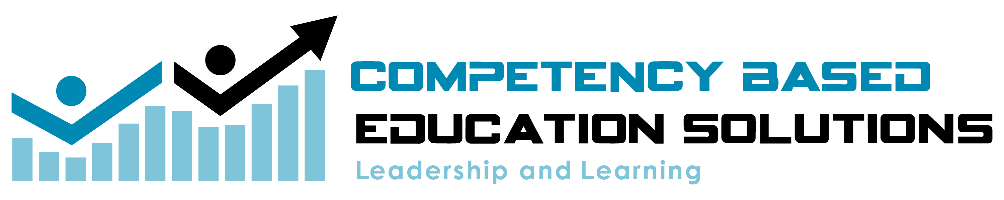

Building a Transparent Learning Progression

Template for guiding teachers from standards to develop leveled rigorous learning pathways. These pathways will be transparent for students as well as offer timely feedback to foster learner engagement, targeted instruction and flexible grouping.

Supporting learning communities with student centered design and practices to foster leadership, engagement, and achievement.

Standards Unpacking

Grade Level:_________________ Content/Topic:______________________

Scope and Sequence of Standards
Take the standards you have identified and do the following;
  - Circle all of the verbs (the dos of the learning). Each verb will represent a learning segment. (see example)
  - Underline the content (the knows of the learning).
  - Identify the number of segments you have identified in your unpacked standards.
Use the chart below to organize your segments and your vocabulary for this learning progression.
Essential and Supporting Standards | Learning Segments  Determined by Verbs in Standard
Essential Standard | -  -  -
Supporting Standard | -  -  -
Supporting Standard | -  -  -

II. Determine Rigor and III. Learner Evidences
Learning Segments  Essential and Supporting Standards | II.  What the student must do  (Rigor) | III.  Key Vocab and Concepts | Learning Goals or Evidence  “I can….”
1.

2.
3.
4.
5.
6.
7.
8.
9.
You can begin to construct the pre-assessment and the formative assessments.

IV. Levels of Learning
Now that you have your learning pathway and associated rigor levels we need to create a process for helping students prove their proficiency at each level. Also, we need to be transparent in order to target the learning opportunities for each student.

Learning Levels | Rigor | Learning Evidences  I can statements from above
1.

2.

3.

4.

V. Assessments
  - Identify assessment items that you currently use in the instruction and assessment of the identified learning level?
  - Ensure these assessment items are aligned to the appropriate task level and rigor
  - As you find these items make a plan to organize these assessments in one or more of the following categories;
      - Pre-assessment
      - Formative Assessments

Learning Levels | Rigor | Leveled Assessments  (Pre, Formative, Common Formative)
1.

2.

3.

4.

Building a Proficiency Scale for Scoring

This is the Summative scoring scale, measuring tool for learner demonstration of proficiency at the end of the learning pathway.
Build your scale based on the learning progression, with score three being the proficient target.
Place your, "I can" statements into the chart below at the Foundational Level 2.
It is very import to keep the vocabulary of the standard.
Align the column scores to the rigor progression.
Use the taxonomy chart and verbs to help.
Develop a summative learning demonstration that aligns the rigor and the task.

Level 4  Advanced | Level 3  Proficient | Level 2  Foundational | Level 1  Emerging

Creating a System for Monitoring, Leveling and Targeted Instruction

Go back into each learning target and develop checklists, goal sheets or capacity matrices for the targets. You can group targets together into one list or matrices.
This is for transparency.

