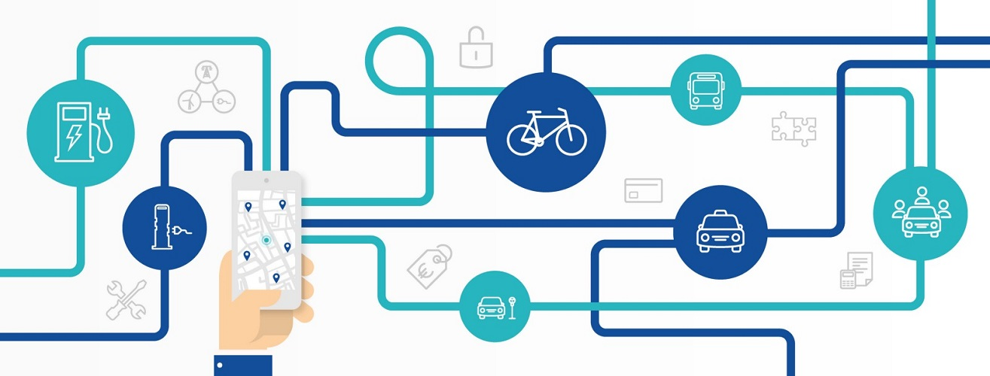

As cities work to reduce congestion and improve safety, can a multimodal transportation ecosystem in which users buy shared, mass, on-demand, and/or first- and last-mile transportation services, serve as an effective a solution? And if it can – how can Texas achieve it?

Mobility as a Service (MaaS) offers Texas the opportunity to be a leader in 21st century transportation, giving its residents the flexibility to choose transport options that best suit their needs. It also has the potential to reduce personal vehicle use, which would lower congestion, death and injury, and ease financial burdens on Texas families. Despite the promulgation of public-private partnerships in the transport sphere, many endemic conditions to Texas cities make MaaS difficult to realize, including urban sprawl, unsafe pedestrian conditions, and disinvested public transit. Texas has the potential to increase wellbeing for its residents/economic investment through targeted infrastructure investments and deregulation in the housing sector.

KEY STRATEGIES

Provide Resources to Support Multimodal transportation. For MaaS to reduce congestion and improve safety, some travelers will need replace commutes with MaaS offering such as shared rides, transit, or other non-automobile travel. Bus service is a cheaper, flexible alternative to rail, and can be changed to fit consumer demand. New mobility options such as carpooling and dockless bikes and scooters can be a tactical alternative to drive-alone automobile trips. Resources should be allocated to build out dedicated bus lanes, park-and-ride facilities, rail, amenities at stops, and frequent service.
Explore Alternative Finance Mechanisms to Mitigate Congestion and Fund Multimodal Projects. In addition to adding capacity, states and cities can explore pricing strategies and provide awareness to drivers about the full cost of their trip. These tools can help discourage unnecessary travel alone and fund multimodal alternatives. Texas can explore a number of pricing mechanisms including cordon or corridor pricing, surge pricing, and managed lanes.
Invest in Supportive Infrastructure for Alternative Modes. To make streets safer for bicycles and scooters – and to keep scooters off the sidewalk – new bike lanes should be physically separated from cars. This gives residents more options, reduces congestion, offers easier access to businesses along their route, and improves public health. Protected bike, scooter, and pedestrian facilities can be developed in priority corridors.
Support MaaS Programs in Activity Center and Highway Commutes. States, regions, and cities, should focus on offering transit services in communities that are higher density and offer mixed land uses. Opportunities to integrate services into highway commute trips or encourage shared rides should be identified.
Create Data Standards for Privacy. Collaboration between public agencies and private mobility agencies will stall without a data sharing standards that protects user privacy while allowing public agencies to examine the effects of new mobility options. Texas can support and lead in collaborating with other public agencies and industry partners to craft data privacy protocols that, among other things, may exempt individual geolocated trip records data from Freedom of Information Law requests.

WHY IS DISRUPTION HAPPENING IN THE TRANSPORTATION SPACE?
Public transit ridership has been falling in most U.S. cities since 2007. There are several explanations, each dependent to a degree on place. Some experts believe that the majority of transit users who have significantly reduced their transit use did so because of new access to a private car. Private car access began increasing in the early 2000s; this may be due to demographic change within a metropolitan area, as transit-dependent residents away. An increase in the availability of no-interest car loans for those with good credit (and subprime car loans for those without) are also driving up ownership, which rose 140% between 2010 and 2015. [1] Falling gas prices further enable car ownership, following the maxim that when driving is cheaper, more people drive. [2]
Other subject matter experts argue that this alone does not account for the sharp dive in transit ridership that began in 2015, the time that TNCs began proliferating in U.S. cities. Indeed, in New York City, in which car ownership relatively uncommon, the increase in monthly Uber and Lyft rides corresponds to a nearly identical drop in public transit boardings between 2015 and 2018. Studies of other large cities return similar results, in aggregate showing a slight decrease in bus and heavy rail rides (1-2%) once TNCs are introduced, increasing each year. [3]

Surveys have attempted to determine if the riders who have left transit did so because of TNCs, and if so, why they are doing it. Results from seven major U.S. cities reveal that TNC use lowers bus and light rail use among respondents, while increasing heavy rail use. [5] A comprehensive survey of Boston TNC riders investigated the reasons that people changed. 61% of respondents said that they chose ride-hailing because it is faster than transit. Other important reasons included lack of access to a car, difficult or expensive parking, inability to drive, and desire for usable work time during trips. Hearteningly, these are all benefits offered by transit, suggesting that improvements to transit service speed could capture ridership. Surveys show that TNC riders are college-educated, moderately high-earning young adults. [6]

Shared scooters and bicycles that recently entered the market further impact transit. The implementation of docked bikeshare in dense urban environments is found to accompany a slight drop in bus ridership, on the order of 1% – 3%, and a slight increase in heavy and light rail ridership. This suggests that bikeshare trips replace some bus rides, but help users connect to typically longer light and heavy rail rides. [3] [4]

It is probable that auto ownership and service cuts lead to decline among transit’s core ridership of elderly, low-earning, and transit-dependent residents, while TNCs draw away more affluent users. It is also possible for cities to counteract the effects of all three by improving transit service systemwide. This takes the form of more frequent service, covered bus stops, on-bus WiFi, and dedicated bus lanes [7].

MOBILITY AS A SERVICE: DEFINED
There is no one definition of Mobility as a Service (MaaS), though most definitions include emphasis on multimodal transportation that can be purchased on a single platform. Per Dr. Maria Kamargianni’s succinct assessment, “The term Mobility as a Service stands for buying mobility services based on consumer needs instead of buying the means of mobility” [8]. Why would Texas consumers want this?
80 to 90% of commuters in Dallas, San Antonio, Austin, and Houston commute by car, and 70 to 80% of commuters drive alone. [9] The negative impacts of so many cars on the road are being acutely felt in traffic congestion, smog, and roadway deaths. MaaS envisions a system in which residents do not need to own a car to meet their travel needs; instead, they can use a variety of modes to complete trips. A healthy multimodal transportation system has benefits beyond reducing traffic and injury. High-quality multimodal transportation options facilitate elderly exercise and mobility. [10] When fewer people drive personal cars, less parking is needed, freeing up urban space for profitable use. Multimodal mobility also provides opportunities to area businesses: Imagine a couple that wants to travel from their home north of downtown to the downtown public library, after which they will get lunch at a new restaurant one mile away. Wanting to avoid paying for four hours of parking, the couple opens up their transportation marketplace on their phone; using the multimodal trip planner, they decide to take a bus downtown, walk to the library, and use dockless scooters to cover the one-mile distance that they do not want to walk, as it is a hot day. Not only can they plan a trip, but they can purchase both services in one app, and reserve two scooters. They now saved money on parking and gas, avoided the hassle of parking, did not add any smog emissions, did not expose themselves or others to risk of car accidents, and spent one mile traveling past businesses that they could easily stop their scooters to patronize.

Mobility Marketplace Options
New and old technologies make up the current suite of transportation options. They are organized below.
Car-Based Modes
Technology | Definition | Example(s)
Ridesourcing  Or  Transportation Network Companies (TNCs) | TNCs connect private vehicle owners with passengers via smartphone applications. Users can purchase service and communicate with the driver through the application. Drivers that use TNCs to connect with customers are treated as independent contractors instead of employees. [11] | Uber, Lyft
Carsharing | Services wherein customers can access a personal vehicle for short period of time. Different business models require the vehicle to be returned to its origin, to park at a designated location, or have a free-floating model that allows the driver to end the trip at any location. [11] | Car2go, ZipCar
Peer-to-peer (p2p) car sharing | p2p models enable car owners rent out their vehicles while they are not being used, similar to AirBnB [12] | Turo, Getaround
Taxis | Traditional for-hire taxi drivers are required to follow taxi cab commission rules related to insurance, hours, and often where and when to provide service. | Yellow Cab, eCab

Mass Transit
Technology | Definition | Example(s)
Bus Rapid Transit (BRT) | Bus system providing features that facilitate speed, efficiency, and accessibility. Features generally include dedicated bus lanes, multiple-door boarding, WiFi at stations and on buses, signal priority, and digital signage indicating the ETA of incoming lines. [11] | HealthLine (Cleveland, OH), Martin Luther King, Jr. East Busway (Pittsburgh, PA)
Commuter Rail | Connects center city to urban fringe. Characterized by long distance between stops, few stations in central business district [13] | Austin MetroRail
Heavy Rail | Electric railway transport mode with high passenger capacity. Characterized by exclusive right-of-way and high platform loading [13] | Washington Metro, Bay Area Rapid Transit (BART)
Light Rail | Typically electric transport mode with lower passenger capacity than heavy rail. Characterized by exclusive right of way, low platform loading, connection to an overhead electric line for power. [13] | Dallas Area Rapid Transit (Red, Blue, Green, Orange Lines)
Streetcar | Low-volume mode operating in same right-of-way as cars, usually connected overhead electric lines for power. [13] [14] | Sun Link (Tucson, AZ), Dallas Streetcar, El Paso Streetcar

Micromobility
Technology | Definition | Example(s)
Dockless scooters | A system in which users can locate free-standing scooters using an app, activate it using their phone for a small fee, then pay a fee per minute of use. When the user arrives at their destination, they park the scooter in the pedestrian right of way and re-lock the it through their phone app. [15] | Lime, Bird, Lyft, JUMP
Dockless bikeshare | Bicycles owned by a private entity are distributed throughout an area, standing free (no station). Bicycles are locked, and can be located and unlocked using a smartphone app. The user pays an activation fee, then a fee per minute of use. When the user arrives at their destination, they park the bicycle in the pedestrian right of way and re-lock the it through their phone app. [16] | JUMP, VeoRide
Docked bikeshare | Bicycles are rented from and returned to fixed stations distributed throughout an urbanized area. Stations are typically unmanned. [16] [17] | San Antonio BCycle1, Austin B-Cycle

TRIP & PAYMENT INTEGRATION: A SINGLE PAYMENT PLATFORM
The MaaS concept’s final form would allow users to, in one website or cell phone application, plan a trip that includes a variety of transportation modes from a variety of providers, and then pay for it with one account. In this paper we refer to such a unified application as a Single Trip Platform (STP). A STP would merge two functionalities: multimodal trip planning, and payment integration (the ability to pay for all trip modes in one transaction, be they from public or private providers). Multimodal trip planning does not simply mean that the user can select one of many different modes to reach a destination; rather, that they could a variety of modes to take within the same trip. Both public agencies and TNCs are pursuing some of these functions in their platform. This creates an inherent tension, as all transportation providers want theirs to be the platform with which users engage. Being the organization users go to for their transportation needs – even if they use the organization’s app to buy an outside service – is still desirable for relationship building and brand loyalty. Uber and Lyft each want to run a STP of their own (excluding other TNCs); public agencies are just starting to consider it. Since an STP requires many actors to participate (unless cities begin providing their own on-demand service, such as Dallas with its GoLink pilot), different participants will need to reach consensus on a single provider to interface with users. The big question is: who will own the final platform?

Say public transportation agencies own the STP user interface. This raises issues with TNCs, as they do not want their fare prices listed side-by-side in a single platform, for fear of unflattering comparisons. In addition, public transit ticketing software is sometimes flat fee or zone based, while TNCs and micromobility companies used origin/destination based software: integrating flat payment software into O/D software is easier than the reverse, making it more difficult for public transit providers to display private partners’ on-demand fares on their platforms. Final responsibility for service provision is also undecided. Say that a commuter plans to take a TNC ride to the train station. The TNC driver is late, and the commuter misses their train. If the user is dissatisfied with their service, and purchased as a bundle, who is responsible? This is already noticeable in current integration pilots, where, for example, Uber has begun showing Lime scooter locations and prices within the Uber app. Now, Uber is receiving complaints about Lime scooters from those customers who use the Uber app to locate nearby Limes, which must then be forwarded to Lime.

While the tension between public and private actors remains, some integration between the two has taken place. The following are case studies chosen for their geographic diversity, varying levels of integration, and their illustration of particular barriers or opportunities.

Case Study: Denver, CO
Participating Organizations: Denver Regional Transportation District (RTD), Uber, Masabi
Launched: January 2019
Summary: Public transit tickets for RTD services can be purchased in the Uber app. Masabi, a ticketing software provider contracted with RTD, saw the potential for collaboration, and reached out to Uber. The three companies met and agreed on common goals of raising transit ridership and reducing SOV travel; then, RTD and Uber contracted with Masabi, rather than directly with each other. RTD plans to evaluate success by monitoring total transit ridership moving forward. RTD has no data sharing agreement with Uber, and Uber is thus not obligated to share.

12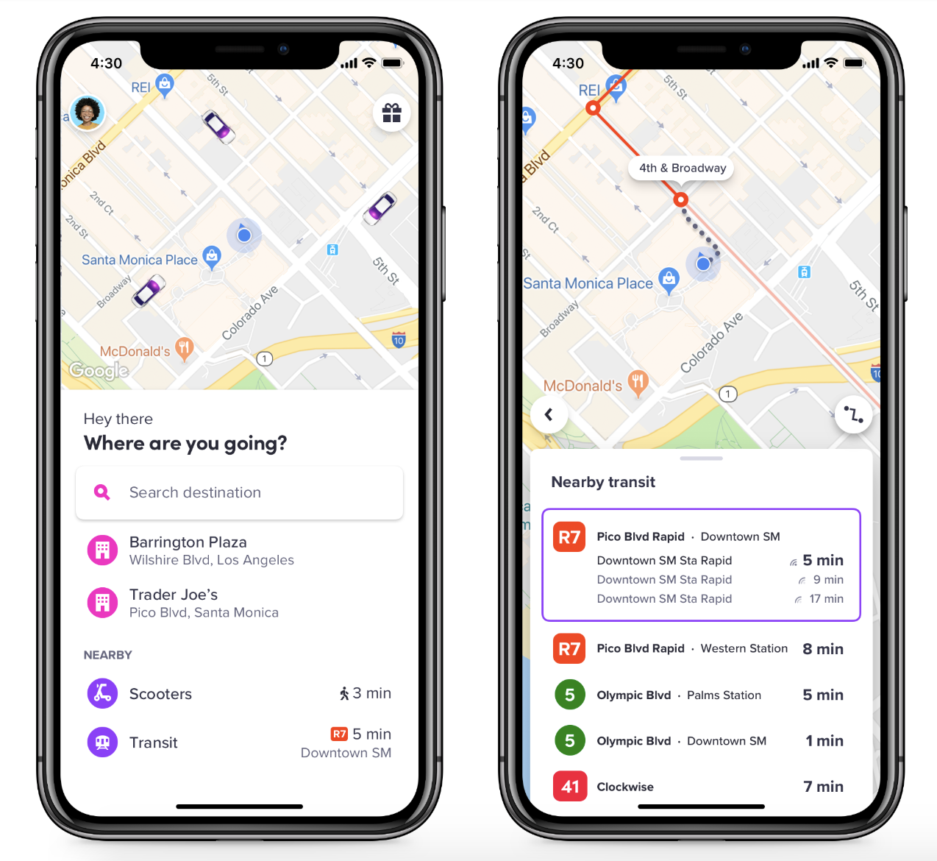

[22]

HOW LOCAL, REGIONAL, & STATE AGENCIES ARE IMPLEMENTING MAAS TO MEET CONSUMER NEEDS
It remains unclear whether MaaS can currently be implemented to meet consumer needs and public goals both, sustainably. Most public agencies that are trying are in the pilot phase of certain projects. The following were chosen to showcase the range of forms that MaaS-related projects have taken across the geographic & political diversity within the U.S. They have been selected from a review of academic literature, government reports, and conversations with subject matter experts in shared mobility. Since the technology for a MaaS concept has existed for a short time, not all have thorough, publicly available evaluations. The level of detail available on the projects below is thus case dependent.

Pinellas Suncoast Transit Authority (PSTA) – Pinellas County, FL
Partnership: Direct Connect
A 2015 defeat for a transit funding bond led PSTA to explore cheaper substitutes for two low-performing bus routes. PSTA partnered with Uber, United Taxi, and Care Ride (a paratransit provider) for Direct Connect, a program in which PSTA would subsidize a flat amount of market-rate fares ($3 initially) if the ride connected to a designated transit stop within a service area. (cite: Bonnie) Funds for marketing and ride subsidy were allocated from the money saved by cutting one of the low-performing bus routes. To allay concerns that PSTA would be exposed to financial risk, the agency was added as “second insured” on Uber’s insurance policy. Uber was responsible for up to $2 million of general commercial liability.

Drug and Alcohol testing presented a barrier; Uber’s testing policy is not compliant with the FTA’s, which requires that agencies receiving federal funds (as well as contractors who provide equivalent service) must test drivers. However, the FTA also stated that contractors could be exempted from this if consumers are offered the option to receive the same service from providers that do meet testing requirements. United Taxi and Care Ride’s partnership satisfied the equivalent service requirement, allowing PSTA to move forward despite Uber’s noncompliance. PSTA further did not require background checks of Uber’s contractors.

The program may have violated the Americans with Disabilites Act (ADA) with its initial pay structure. If Care Ride received the same flat fare as Uber and United Taxi, disabled users would have to pay significantly more for the more expensive paratransit service than abled persons. The Care Ride subsidy was changed from $5 to $25.

The program evolved per consumer response, ultimately having three distinct phases. In Phase 1, PSTA subsidies $3 of rides beginning and ending in two service areas around the two low-performing routes. Users booked Uber rides through the Uber app, and United Taxi/Care Ride by contacting the city to receive a code, then contacting the company directly. No app for taxi

Low usage inspired Phase 2, wherein PSTA increased the per-ride subsidy to $5. Further, service areas expanded from 2 to 8. Increased funding (used money from canceled routes). The Uber app interface was changed to be more easily navigable.

Many users found the 8-zone system confusing. As a result, in Phase 3 PSTA merged all zones into one county-wide zone, allowing rides to begin or end at any of 24 designated bus stations within the county. The paratransit subsidy was increased to $25 in response to low usage.

Partnership: Transportation Disadvantaged Late Shift
PSTA’s Transportation Disadvantaged program offers reduced transport costs to residents who meet certain criteria of income and low mobility. The Late Shift program was offered to those residents, providing them Late Shift offers 25 on-demand rides that connect to work during hours when bus service is unavailable, for $9 per month. To be eligible, the resident must have a job that begins or ends between 10 p.m. and 6 a.m. Monday – Friday, have an income at or below 150% of the poverty level, and have purchased a monthly bus pass for $11.

Evaluation: Direct Connect:
While a replacement relationship is inconclusive without TNC rider surveys, data showed that Direct Connect ridership grew as the Pinellas Park Circulator ridership shrank, resulting in the route’s cancellation. This suggests that Direct Connect took rides from fixed-route transit instead of riding them. Bus sensor data is inconclusive on this point.

Most riders came from census block groups with lower income, lower population density, and slightly higher transit commuters than the areal average, potentially indicating that high-need populations are being served. Concerningly, though, a small group of users took most trips. The top 10% of frequent users took 40% of the provided Uber trips, and 30% of United Taxis. This suggests that most users are not using Direct Connect to complement regular transit trips.

Further, Uber had several technical issues that inflated reported ridership totals between 60 and 300 percent. The geofenced area within which users were eligible to take subsidized trips encompassed a larger area than stipulated in the partnership. Thus, trips which would not normally be eligible were given at the subsidized rate. Uber did not charge the city for these accidentally subsidies, but the error had further implications: the apparent strong growth in Direct Connect usage likely influenced the PSTA board’s decision to extend the program to 2021. The error was only discovered after the extension was made.

Evaluation: Transportation Disadvantaged Late Shift
The program delivered 2724 trips in April 2019. 160 individual users in February, estimated 200 now. Late Shift was widely used by members of the Transportation Disadvantaged program, largely because it engaged a ridership base through a program in which they were already members. Communicating Late Shift’s existence was easy, and could be done while current Transportation Disadvantaged members were renewing their monthly subscription. [23]

Lessons Learned from Pinellas:
- Public agencies must have a way to evaluate a pilot’s success or failure before it starts
- First mile/last mile programs like Direct Connect can take riders from the fixed-route bus lines they are intended to help
- Building relationships with TNCs leads to more in-depth data sharing
- Simplicity is of the essence: multiple-zone geofences for service provision proved prohibitively confusing for users

City of Arlington, TX
Location: Arlington, TX (Bordering Ft. Worth to the West)
Duration: December 2017 – present [24]
Program: Via Rideshare replaces fixed-route transit
Traveling without a personal vehicle is particularly challenging in Arlington, TX, a 99-square-mile city. Residents have largely rejected traditional solutions. Citywide fixed-route transit bonds have consistently lost on the ballot since 1985. [24] Arlington had a single downtown bus route, carrying fewer than 100 riders per day when it was cut. To replace the service, the city of Arlington launched a pilot program with the ridesourcing company Via. Via’s fleet provides on-demand microtransit service – that is, 13 6-passenger Mercedes Metris vans accessible by Via’s smartphone app. [25 [27]
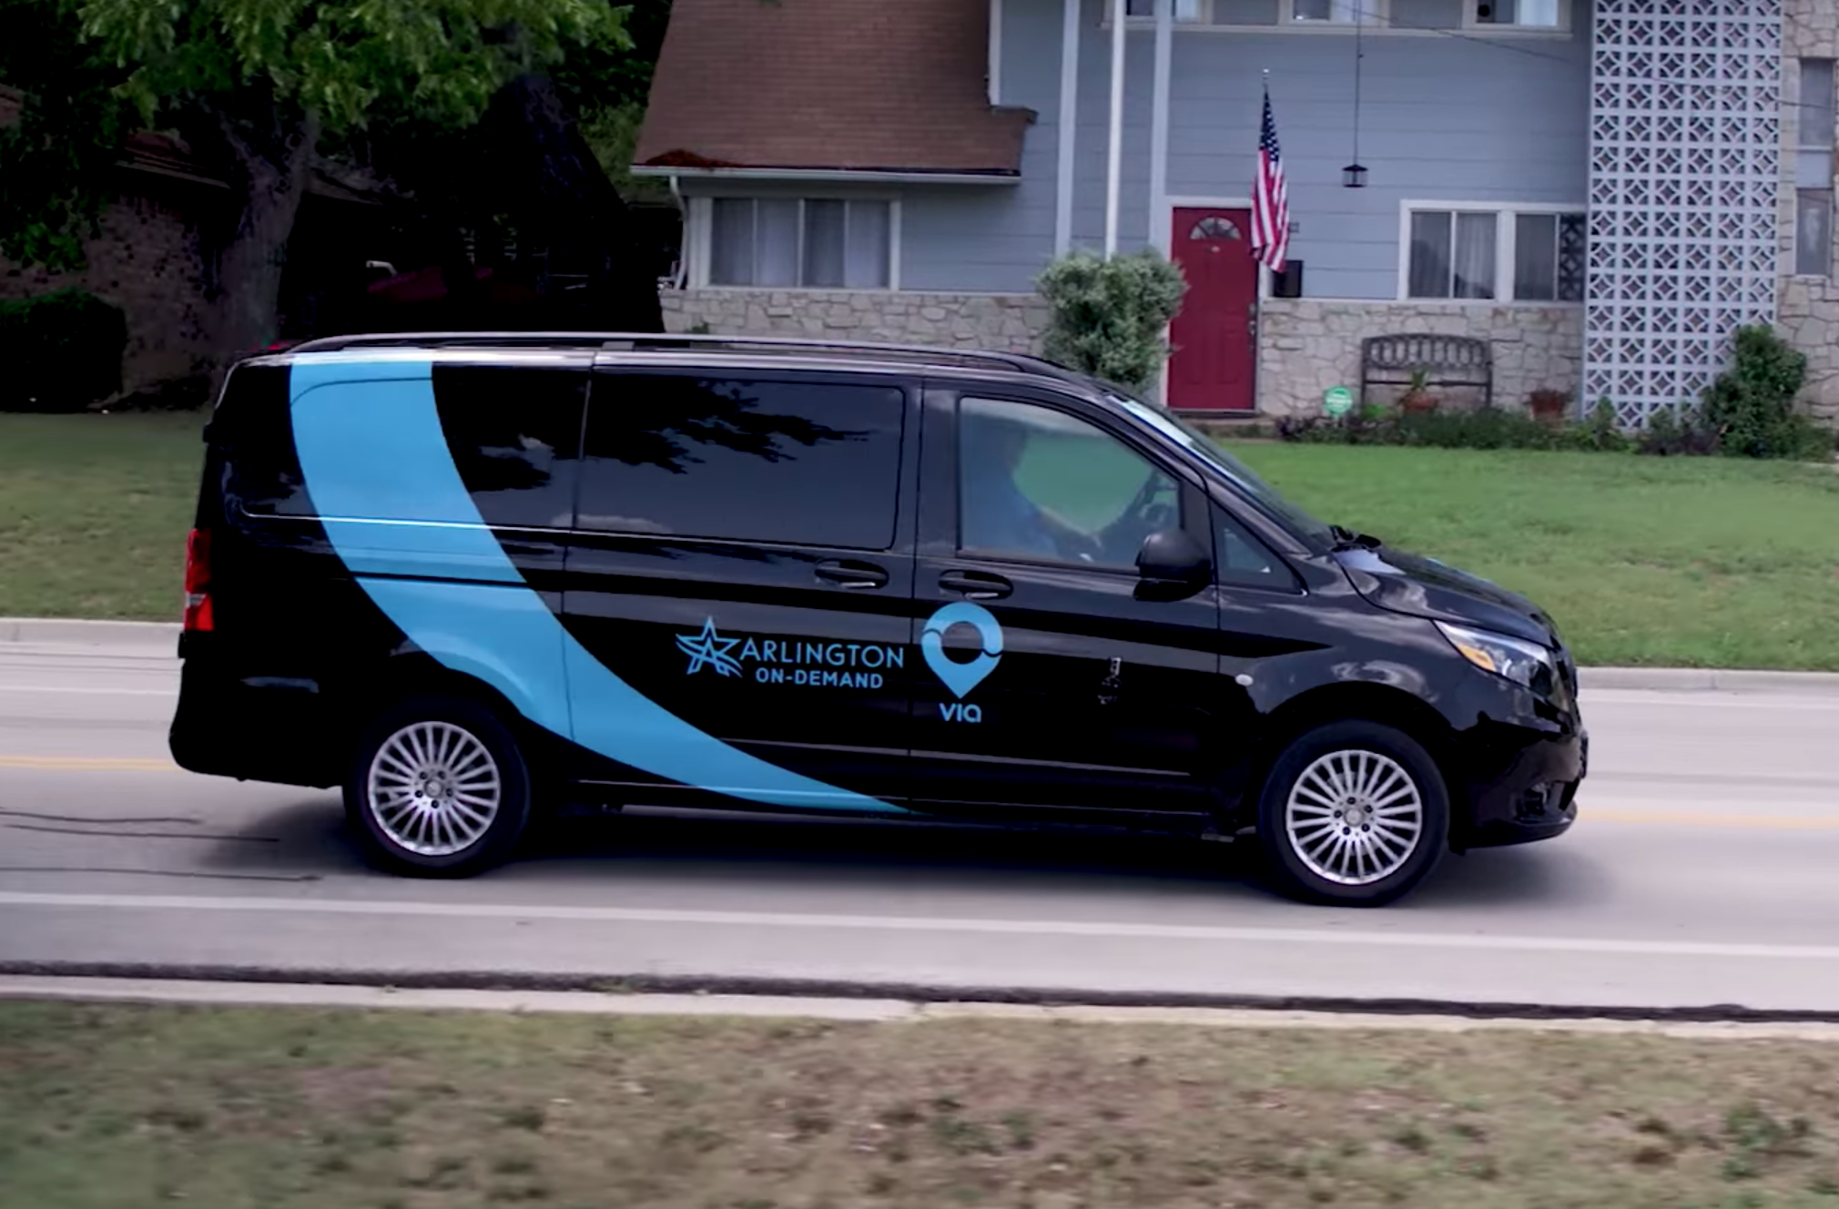
[26] Via microtransit vehicle

Users can take curb-to-curb rides within a service area for a $3 flat fare. The service area encompasses a variety of high-use destinations including downtown, the University of Texas at Arlington, Parks mall, and certain medical services. The vehicle carries multiple riders at a time. Program funding is evenly split between local dollars and the FTA. All revenue is reinvested into system [24] [26].
The shuttle operates from 6am-9pm on weekdays, and 9am-9pm on weekends. With an average wait time of 12 minutes. Users book rides through the Via app or by calling a designated Via number (users who book through the number will need to book in advance, about 30 minutes in most cases). Users need a credit or debit card to purchase service. Unbanked users must buy a prepaid debit card.
Via shares data with the city through an online interface (called a ‘dashboard’) that gives access to: total number of rides given since the program began, percent of rides that were shared, number of daily/weekly rides given, number of rides by time of day number of user accounts, number of active drivers, average trip distance and duration, average wait time once van is requested, and origin/destination heat maps.

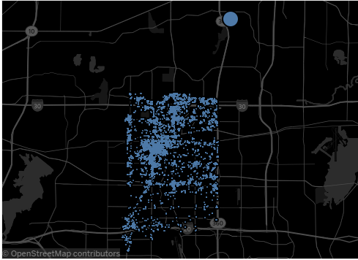
[27] Pick up locations within service area
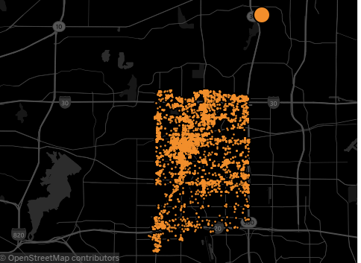
[27] Drop off locations within service area

Evaluation
Via’s rider survey indicates that users have positive experiences. Over 70% of respondents were repeat users, and 97% of respondents were satisfied with the service. The city council decided to extend the pilot (for another year?). It is unclear what metrics they used to make this decision. This makes it difficult to evaluate the pilot. Suffice it to say, the pilot provided quite a few rides, almost 200,000 as of July 2019, had a growing ridership through October, 2018, at which point it provided about 3000 rides per week. To evaluate the partnership’s impact on total VMT, detailed travel behavior data is needed.

It is unclear if Via service is accessible to low-income, unbanked populations, who commonly depend on public transit. Existing survey data show that 39% of respondents have an annual income less than $20,000. It is important to note that 31% of respondents are students, who typically have little income but may have other financial support. 5% of respondents were unemployed and seeking work, and 2% were unemployed and unable to work. (compare area age to user age demographics) Roughly 80% of respondents were less than 44 years of age.
Information on the new service can be found online, which may be a problem for persons experience homelessness. Purchasing a prepaid card creates an additional step beyond the cash transaction that a user can make while boarding a traditional bus. Additionally, senior citizens use the service at low rates. Smartphone-based business models often discourage seniors who are unfamiliar with the technology. [24] [27]

Lessons learned
- Public agencies must have a way to evaluate a pilot’s success or failure before it starts
- Survey data describing rider travel behavior helps assess and modify transportation programs
- Those who used Via’s on-demand microtransit reported overwhelmingly positive experiences.
- Smartphone-based services may be inaccessible to seniors
- On-demand microtransit may be a cheaper solution that increases mobility for residents in areas that are poorly-suited to high-capacity fixed-route transit (depending on the agency’s particular goals, and the VMT analysis)

City of Centennial, CO
Location: Centennial, CO
Program: Go Centennial
Centennial is a suburb of Denver, located 15 miles to the southeast. Despite having Regional Transportation District (RTD) light rail lines crossing through the community, 88% of respondents in a 2015 commuter survey reported driving alone to work. 23% of all respondents reported choosing to drive because getting from their home to the light rail station was prohibitively difficult.
RTD has tried to address this first mile last mile issue with its Call-n-Ride bus service that operates in the Centennial area. Residents of the Dry Creek Call-n-Ride service area can schedule trips in advance that will provide curb-to-curb trips within the area. The service has a flat fare of $2.60 payable upon pickup, but is free for trips connecting to Dry Creek station, as well as for monthly and annual light rail pass holders. [33]
Call-n-Ride trips are heavily subsidized. The service totaled 2% of RTD subsidies while providing 0.5% of its total trips. The City of Centennial launched the Go Centennial partnership to explore cheaper options that responded immediately to consumer needs. The program partnered the city of Centennial with TNCs Lyft and Via, which were to provide on-demand carpool-type service to riders traveling to Dry Creek Station. Via was contracted to provide paratransit service so that the service would be accessible. Lyft and Via invoiced the city for trips provided each month at market rate. Funding was provided by the Southeast Public Improvement Metropolitan District, the City of Centennial, and a Bloomberg Philanthropies grant. Lyft created the geofence and created marketing material for its users.
Service goals were clear: it should be on-demand, accessible, provide riders with information about transit schedules, and be accessible to those without smartphones or credit cards. The pilot ran from 5:30 am to 7:00 pm, August 17, 2016 to February 17, 2017, with this particular time period chosen to assess Go Centennial’s performance during different seasons. [28]

Evaluation
Go Centennial had clear evaluation criteria established before the pilot, allowing for deep analysis upon its conclusion. All results are informed by low public awareness of the pilot; In the third month of operation, 97% of respondents surveyed at Dry Creek Station had not heard of Go Centennial. To market the program, Lyft sent push notifications to drivers and riders in the service area, flyers were distributed at the station, local businesses and homeowner’s associations were contacted, and was featured in local news stories. City staff proposed recruiting ‘neighborhood champions’ – enthusiastic residents who can communicate effectively with neighbors – as a possible solution. They further noted that advertising at Dry Creek Station was kept to a minimum to avoid direct conflict with Call-n-Ride, which was running concurrently with the pilot.
Go Centennial did not conclusively meet its goal of increasing light rail ridership at the Dry Creek station. Ridership increased 11.6% over the pilot’s duration; however, ridership increased 10% at the adjacent Arapahoe at Village Center station, which was not served by the pilot, making it difficult to attribute all of Dry Creek’s ridership to Go Centennial. The city also reported a decrease in VMT, accepting some assumptions in the absence of data indicating the average trip distance of Go Centennial users. The analysis does not, however, include VMT added by the Go Centennial trips themselves, nor by the distance on-demand vehicles travel to reach pick-up spots themselves. It is clear, however, that the pilot enabled most users to replace driving trips. Data showed that 98% of Go Centennial trips were longer than ½ mile. The standard assumed distance that people are expected to walk to transit stops is ¼ mile; it is thus safe to assume that Go Centennial replaced vastly more driving trips than walking trips.
Go Centennial had a far lower subsidy than Call-n-Ride: $4.70 per boarding and $18.54 per boarding respectively. Go Centennial’s accessible service (Go Centennial Access) similarly had a lower subsidy than RTD’s accessible Call-n-Ride service (Access-a-Ride): $20.07 and $42.96 respectively. In addition, Go Centennial Access provided free trips, compared with Access-a-Ride’s $4.70 fare for local trips and $8.50 fare for regional trips, increasing mobility for disabled riders. However, the Via paratransit service took up about 75% of the $61,000 budget for trip delivery, despite providing only 20 rides over the entire 6-month deployment. [28] Go Centennial service was cheaper for customers than RTD’s Call-n-Ride. That is likely due to driver pay. RTD’s full-time bus operators made, at minimum, $18.36 per hour in 2015. [34] TNC hourly earnings vary by location, but Lyft reports a national average of $18.83 per hour in 2019. This number, however, does not include Lyft’s variable fee that it takes from each fare. It also excludes maintenance costs, including gas and vehicle wear. [35] These will significantly lower hourly earnings. Cities considering large-scale deployment of a program similar to Go Centennial must explore these costs for their own region to determine if cheaper service comes by replacing full-time public driving jobs that offer benefits with lower-paying private driving jobs; essentially, subsidizing trips from drivers’ paychecks instead of city funds.

Lessons Learned
- Paratransit service needs large service areas to minimize costs, and can expand from many projections with minimal risk to service provision depending on demand
- Informing the public of new transportation projects is a major barrier with no easy solution
- TNC partnerships can offer cheaper alternatives to city-provided microtransit, likely due to lower driver pay

SunMetro – El Paso, TX
Program: Brio Rapid Transit System
While SunMetro, El Paso’s public transit provider, has not implemented widespread on-demand service, it has focused on creating a transit system that could meet accessibility needs at all corners of the city – something other public agencies are missing in their MaaS implementations. SunMetro is improving bus service across the entire city. There are four main rapid transit routes: the Mesa, Dyer, Montana, and Alameda. The first three are funded by an FTA Capital Investment Grant, while the fourth is funded by the City of El Paso.

Bus Rapid Transit is defined by an array of features which SunMetro provided: on-bus WiFi, three-door buses with articulated units for greater capacity and boarding speed, honor system ticketing, and peak period frequency of 10 minutes – down from 20 before the RTS. Notably, the RTS does not have dedicated bus lanes, but SunMetro anticipates that these will be necessary to deal with the traffic effects of increasing sprawl.

Not only buses were improved, but also the pedestrian environment by which riders connect to them. Bus stations provided free WiFi, which was added value for adjacent businesses – signage displayed real-time information on arrivals, art pieces, ticketing machines to facilitate faster boarding, and public employees who would educate riders on bus features at the major terminals.
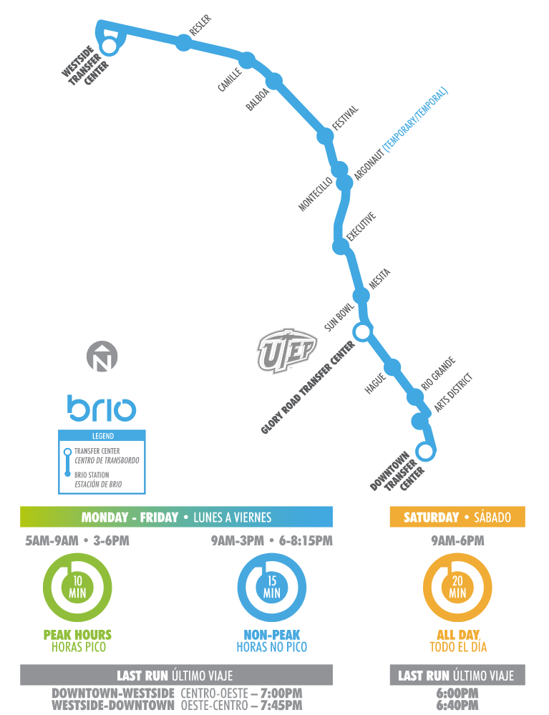
SunMetroBrio.net [32]

In addition, the city revived the streetcar, which had been extinct since the 1970s. SunMetro decided to write a specification for a streetcar revival project once it started hearing whispers that state money may be available for transit projects; when the whispers became reality, El Paso submitted its specification, and was awarded $97 for its streetcar project in 2014.

El Paso is unique in having a citywide rapid transit system; many have corridors, but not coverage that makes bus transit viable beyond the center city. In contrast to the other cases, SunMetro has foregone TNC partnerships for service provision, focusing entirely on transit. A big reason for this is TNCs’ incompatibility with FTA drug and alcohol testing requirements. Public agencies and their contractors must comply with this regulation and test drivers (even if not accepting FTA$?); TNCs do not do this. The ‘taxicab exception’ allows public agencies to contract with an entity that is noncompliant so long as it provides other options to provide the same service, one of which meets FTA standards. If SunMetro wanted to provide on-demand service as, for example, a first mile last mile solution, they would have to partner with at least one compliant organization such as a taxi group. With limited resources to go around, the time and money this would take disincentivized SunMetro from pursuing this type of accessibility solution.

Evaluation

The RTS expansion is not without problems. Recruiting drivers remains problematic: lucrative oil jobs near the city, the customer service skills required, and a complex application have resulted in fewer drivers than necessary who are working more and more overtime.

Since opening in November 2018, streetcar ridership has been dropping steadily. Hitting a peak of 37,000 riders in November, when weekend rides were free, ridership has since dropped to 14,000 in January with the resumption of weekend fares, and 9,000 in February. These fall far short of the 42,000 monthly riders needed to meet initial projections. SunMetro is implementing changes to boost ridership, such as a real-time streetcar app and bus shelters at all stops.

The Bus improvements are relatively new, making evaluation unlikely to provide meaningful insight. The Mesa line, however, opened in 2014. It opened strong but experienced a dip in ridership, which was corrected by consolidating parallel bus routes into Mesa. [29] [30] [31]

Lessons Learned
- Having preliminary plans for desired transit development positions public agencies well to respond when funding becomes available
- Bus drivers can be a limiting factor on service expansion
- Fixed-route service such as streetcars are harder to modify when attempting to combat low ridership

Dallas Area Rapid Transit (DART) – Dallas, TX
Program: Mobility on Demand Sandbox
In DART’s service area, 28% of residents live over ¼ mile from a transit stop. ¼ mile is the general standard for transit walkability. That is, ¼ mile is the distance that the average person will walk to reach a transit station. DART aimed to rectify this first mile last mile problem by exposing its users to an incredibly thorough array of transportation options. The agency did this by partnering with transportation providers, mapping companies, and ticketing companies display private transportation options in its GoPass mobile ticketing and trip planning app. GoPass will display first mile last mile options for transit trips, including micromobility and TNCs; users who want to purchase one of these services – say, Lime – would be transferred from GoPass to the Lime app, where the trip would be purchased. DART’s own on-demand microtransit service – GoLink – is also available.
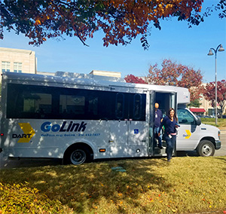
[36] www.dart.org

Evaluation

DART had measurable performance metrics based on the program goals. For example, goal (1) is to “Increase transit ridership on DART within the pilot region of implementation.” The performance metric corresponding to goal (1) is then, “Ridership change as a result of the app on selected routes that are affected by the app.” In addition, DART had user surveys to be used before and after the pilot. The evaluation was submitted in May 2019, and is yet to be made available (call 2 confirm). [18]

Lessons Learned
- Establish clear project goals
- Establish evaluation metrics before project deployment
- Tie evaluation metrics to project goals

CONSIDERING MAAS FEASIBILITY
Large-scale MaaS adoption is not a foregone conclusion; the concept is new, and plagued with unknowns. First, the size of the potential U.S. market is unclear, as demand for MaaS is unproven. Participants in U.S. pilots have largely responded positively, but fully scaled programs will likely differ from pilots in ways which are not clear. Further, most people presently complete their daily trips without MaaS, so if it is implemented, it will need both significant added value and aggressive marketing. Added value, in this case, could be a desire for more exercise, aversion to finding or paying for parking, desire to avoid waiting in traffic, or a desire to reduce environmental impact.

Literature tells us that driving being expensive (gas) and difficult (parking) takes cars off the road. If a sustainable U.S. model exists, we do not know the critical mass of users that entails. The time to reach this critical mass - or, the time to Return on Investment (ROI) - is also unknown.

MBTA study, national study -- big US city people use TNCs to -avoid bad parking, -travel faster than alts, -get morning work time on commute. Speed and parking availability seem to impact most. Shoup says parking ability does. Lit to scrape for inclusion: Parking subsidies and travel choices: Assessing the evidence (1990). PA skepticism that this is solving a problem.

Since the canonical MaaS concept requires multiple transport modes, rural areas with extremely low building density are excluded. Thus, if MaaS is pursued by an MPO containing rural areas, (or with regional responsibilities) it should be understood that other measures will need to be improve rural mobility.

HOUSING AND MAAS FEASIBILITY
The preconditions to sustainable MaaS require infrastructural changes to enable walking, bicycling, and bus travel. While MaaS has the potential to meet TxDOT goals of reducing congestion, facilitating connectivity, and increasing Texas’s economic competitiveness, current conditions make that unlikely. One reason that other modes do not compete with cars is housing policy in Texas cities. The following are some examples of changes in housing policy that could help Texas meet its transportation goals.

Relax Zoning Restrictions on Development
In Texas cities, single-family zoning commonly establishes a minimum lot size on which a unit may be constructed. This curtails developers’ ability to maximize return on their land investment, as they are not allowed to subdivide a large lot into two lots if such development suits local demand. Forcing them to only build on large lots results in lower population density for a neighborhood, which means that more people will be forced to live farther and farther from central business districts. This generates more traffic, increases commute times, and spaces residential areas far from jobs and entertainment, thus making walking and biking difficult. Further, large-lot single-family layouts do not provide buses with population hubs with which large numbers of riders can be accessed.

Increased residential density is a necessity for transportation solutions that reduce traffic and roadway injury. Thus, when planning transportation projects, transportation agencies should collaborate with local zoning authorities to achieve housing outcomes that complement transportation goals. Lowering minimum lot sizes for single-family housing, enabling dingbats, duplexes, triplexes, and fourplexes can increase density without fundamentally altering the character of residential areas.

Remove Burdensome Parking Minimum Regulations
Any increase in residential density raises questions of parking; where will additional cars go? Currently, local parking minimums require developers to build parking that their residents may not need. Parking minimums are requirements [cities] [place]d on developers to provide a particular amount of parking spaces per unit, or per square foot for commercial development. Allowing developers to build only the parking that is needed lowers the cost of development and allows density increases without curbside congestion. Allowing Texas residents to choose to pay less to live in an area with less parking incentivizes multimodal transportation, the backbone of MaaS.

QUESTIONS FOR TEXAS PUBLIC AGENCIES WHEN CONSIDERING MAAS
While fully-scaled MaaS adoption is distant, public agencies may look to MaaS solutions to serve high-need populations, increase mobility in the urban fringe, or attract tourists with easy-to-use transport options. MaaS needs specific infrastructural and cooperational milestones to be met for it to be realistic. A review of MaaS projects provides questions for public agencies to ask before beginning strategic planning.

Is Public Transit “Adequate”?
To meet goals of reducing personal car use MaaS requires a healthy transit environment. Users cannot simply replace a personal car trip with a TNC trip; this would actually increase the total trip VMT due to “deadhead,” or the time a TNC driver spends circulating between rides. Instead, the majority of a user’s replaced trips must use public transit (li & Voege p99-100). Transit must then be viable options for most users’ needs.
In the U.S., most public transit suffers from long wait times and inconsistency [cite, meets TNC user needs of no parking, wanting to use morning commute time, etc. will elaborate from MBTA study] However, current funding and infrastructure does not provide results that have enticed large amounts of Texans away from single car use. One or both of these will need to change: money to increase frequency, or dedicated lanes to decrease trip time.
Further, certain modes of public transit are directly in conflict with TNC growth. A growing body of research has found that the introduction of TNCs to a city corresponds to a dip in light rail and bus ridership and an increase in commuter rail ridership. Survey data of TNC and bus users indicates that core demographics of bus ridership are not being poached by TNCs, but rather wealthy, educated folks. It seems unlikely that TNCs are, alone, responsible for dramatic revenue loss in public transit, but they do appear to be responsible for replacing transit rides for segments of the population who will need to use PT for MaaS/TxDOT goals. [TNCs as trip generators] Further, Uber’s plans for growth involve replacing public transit with Uber transit rides. Uber’s 2019 IPO listed under its growth strategy an intent to “[Increase] Ridesharing penetration in existing markets” and that “We believe we can continue to grow the number of trips taken with our Ridesharing products and replace personal vehicle ownership and usage and public transportation one use case at a time” (link p168).

How Can Ticket Purchases Be Made to Be More Convenient.
More and more public transit agencies provide online ticketing options for purchase vis app, but not all. Concerns have been raised about how purely digital purchase platforms may exclude unbanked populations.

Are Privately-Owned Transportation Providers Willing to Share Data at the Required Level?
Private transportation providers tend to view data as an asset. Sharing data with public agencies opens it to Freedom of Information requests, thus making it publicly available. This raises privacy concerns. TNCs collect geolocated routing data, or exact latitude and longitude of where its users are picked up, dropped off, and the route between the points. Using this data, it is relatively easy to determine a traveler’s identity, even when personal information has been removed. To avoid this, routing data can be aggregated; that is, ten trips taken from one area to another would be represented with one line. Public and private entities have yet to agree on a level of aggregation that meets both parties’ needs. Private entities also chafe at public agencies asking for all of their data without a specific purpose. Public agencies should then be able to articulate what specific data will be used for when deciding on the required level of data sharing.

Do the Privately-Owned Transportation Providers Accept Online Payment?
For TNCs, whose business model involves on-demand service payable through an online app, the answer is overwhelmingly yes. Other collaborators, such as paratransit providers and traditional taxi service, may not.

Other Considerations
Active Mode Infrastructure. Micromobility suffers from a lack of appropriate place: drivers are a threat to scooters and bikes using the road, and scooters and bikes are a threat to pedestrians if they use the sidewalk. Without infrastructure that is visibly safe to users: i.e., while Texas roads are designed for car use above all else: these modes are unlikely to a) be safe, b) meet any needs on a scale that would significantly reduce VMT.
TNCs and the Future. The future pricing and service model of TNCs is undetermined as the this sector is still evolving [17]. Uber’s growth has slowed in recent years, and cautioned in its IPO that it “may not achieve profitability”[18] While TNCs may prove to be a valuable partner to transit agencies, these partners should strive to minimize competition with transit agencies and work together to develop an optimized and sustainable MaaS ecosystem that serve the public interest.

OPPORTUNITIES FOR TEXAS
MaaS has the potential to reduce personal car use, but weaknesses in Texas’ local transit systems and pedestrian infrastructure suggest that implementing MaaS at present would likely entail a drop in personal car use but an increase in car trips, increasing VMT and exacerbating current issues. Investment in these infrastructural deficits can position Texas as a leader in the transportation space, reduce death/congestion, and increase Texas’ attractiveness to investors. Before these structural issues are addressed, large-scale MaaS is unlikely to meet goals in most Texas cities.
- Reallocate some roadway expansion funds to car-alternative modes. Reducing the amount of trips that the average Texan takes by car will reduce the occurrence of roadway injury and death, consistent with TxDOT’s #EndTheStreakTX campaign. Improved car alternatives will reduce deaths directly by removing drivers from the road, and indirectly by adding more pedestrians to the environment. Pedestrian presence has been shown to increase driver awareness and will increase foot traffic to local business. Alternate modes; bicycling, scootering, walking, busses; will become more attractive when pedestrians feel safe.
- Collaborate with lawmakers to enable transportation-friendly housing construction. Texas can position itself as a leader in the transportation and housing spaces, innovating a new planning process that does not separate the two related fields. Without this, the fundamental layout will continue making public transit expensive, walking unviable, and driving the easiest way to get around.
- Collaborate with metropolitan planning organizations to reduce parking minimums and replacement parking requirements. This will allow market forces to dictate parking amounts, reduce housing costs, and more accurately price driving. In turn, this will incentivize multimodal transport options that do not require parking, meeting traffic and injury goals while opening the door to future MaaS implementation.
- Emergent transportation technologies have adversely affected both taxi drivers and the seniors who depend on them. As TNCs and micro mobility reshape the transportation space, Texas agencies should project future job loss in older industries, and collaborate with those workforces to ensure job retention or smooth transition to new industries.
- Explore the potential for MaaS to serve populations whose needs are not met by current public transit, such as night shift workers and residents of areas with poor transit connectivity.

BIBLIOGRAPHY
- Manville, M., Taylor, B. D., & Blumenberg, E. (2018). Falling Transit Ridership: California and Southern California.
http://www.scag.ca.gov/Documents/ITS_SCAG_Transit_Ridership.pdf
- Boisjoly, G., Grisé, E., Maguire, M., Veillette, M. P., Deboosere, R., Berrebi, E., & El-Geneidy, A. (2018). Invest in the ride: A 14 year longitudinal analysis of the determinants of public transport ridership in 25 North American cities. Transportation Research Part A: Policy and Practice, 116, 434-445. https://www.sciencedirect.com/science/article/pii/S0965856418300296
- Graehler Jr, M., Mucci, R. A., & Erhardt, G. D. (2019). Understanding the Recent Transit Ridership Decline in Major US Cities: Service Cuts or 1 Emerging Modes? 2 (No. 19-04931).
http://usa.streetsblog.org/wp-content/uploads/sites/5/2019/01/19-04931-Transit-Trends.pdf
- Campbell, K. B., & Brakewood, C. (2017). Sharing riders: How bikesharing impacts bus ridership in New York City. Transportation Research Part A: Policy and Practice, 100, 264-282.
https://www.sciencedirect.com/science/article/pii/S0965856416304967
- Clewlow, R. R., & Mishra, G. S. (2017). Disruptive transportation: The adoption, utilization, and impacts of ride-hailing in the United States. Institute of Transportation Studies, University of California, Davis.
http://usa.streetsblog.org/wp-content/uploads/sites/5/2017/10/2017_UCD-ITS-RR-17-07.pdf
- Gehrke, S., Felix, A., & Reardon, T. (2018). Fare choices: A survey of ride-hailing passengers in metro Boston. Metropolitan Area Planning Council.
https://www.mapc.org/farechoices/
- There’s a Reason Transit Ridership is Rising in These 7 Cities. (2019, Feb 10).
http://transitcenter.org/2019/02/27/theres-a-reason-transit-ridership-is-rising-in-these-7-cities/
- Kamargianni, M., Li, W., Matyas, M., & Schäfer, A. (2016). A critical review of new mobility services for urban transport. Transportation Research Procedia, 14, 3294-3303.
https://www.sciencedirect.com/science/article/pii/S2352146516302836
- Dimmick, Iris. (2017, December 11). Census Data: Almost 80% of San Antonians Drive to Work Alone. https://therivardreport.com/census-data-almost-80-of-san-antonians-drive-to-work-alone/
- Heikkilä, S. (2014). Mobility as a service-a proposal for action for the public administration, case helsinki.
https://aaltodoc.aalto.fi/handle/123456789/13133
- Shared Mobility Definitions. (2017, January 13). https://www.transit.dot.gov/regulations-and-guidance/shared-mobility-definitions
- Megna, Michelle. (2018, September 6). Peer-to-peer car rental (Turo, Getaround): A guide to insurance coverage.
https://www.carinsurance.com/Articles/peer-to-peer-car-rental-insurance-coverage
- National Transit Database (NTD) Glossary. (2019, April 29).
https://www.transit.dot.gov/ntd/national-transit-database-ntd-glossary
- Category: Streetcars in Texas. (2016, October 10). https://en.wikipedia.org/wiki/Category:Streetcars_in_Texas
- Garber, Casey. (2019). Electric Dockless Scooters Whitepaper. American Association of Motor Vehicle Administrators.
https://www.aamva.org/ElectricDocklessScootersWhitepaper/
- Transport Matters. (2018). Optimizing Dockless Bikeshare for Cities. [Blog post].
https://www.itdp.org/2018/05/11/dockless-bikeshare/
- THE BEST WAY TO GET AROUND SAN ANTONIO. (2017). Retrieved from: https://sanantonio.bcycle.com/
- MOD Sandbox Demonstrations Independent Evaluation (IE) Dallas Area Rapid Transit (DART) – First and Last Mile Solution Evaluation Plan. (2018, June 1).
https://rosap.ntl.bts.gov/view/dot/36657
- Wiener Linien. WienMobil – the app for all your travels in Vienna. Retrieved from: https://www.wien.info/en/travel-info/transport/wienmobil
- Wiener Linien. (2019). WienMobil: the city under control with an app. Retrieved from:
https://www.wienerlinien.at/eportal3/ep/channelView.do/pageTypeId/66526/channelId/-3600060
- Leidos, Shared Use Mobility Center. (2018). Shared Use Mobility: European Experience and Lessons Learned. (Report No. FHWA-PL-18-026). Washington, DC: Federal Highway Administration.
https://sharedusemobilitycenter.org/wp-content/uploads/2019/01/fhwapl18026_sum_european_experience.pdf
- Dickey, Megan Rose. (2018). Lyft now integrates public transit info in app. Retrieved from: https://techcrunch.com/2018/09/19/lyft-now-integrates-public-transit-info-in-app/
- Murphy, Colin, & Karner, Kevin. (2019). When Uber Replaces the Bus: Learning from the Pinellas Suncoast Transit Authority's "Direct Connect" Pilot. Chicago, IL: Shared-Use Mobility Center.
https://learn.sharedusemobilitycenter.org/wp-content/uploads/SUMC_CaseStudy_Final3_06.21.19-1.pdf
- Schrock, S. (2017, December 11). VIA, CITY OF ARLINGTON LAUNCH INNOVATIVE, ON-DEMAND RIDESHARE PILOT PROGRAM. Retrieved from: https://www.arlingtontx.gov/cms/One.aspx?portalId=14481146&pageId=15127256
- (2018, March 5). Texas city ditches buses for Via ride-hailing service. Retrieved from: https://www.cbsnews.com/news/arlington-texas-experiment-replaces-buses-with-via-partnership/
- (2019). Via Rideshare. Retrieved from: https://www.arlingtontx.gov/city_hall/departments/office_of_strategic_initiatives/transportation_planning/via_rideshare
- Powering On-Demand Shared Rides in Arlington, Texas [Slideshow].
- (2017). Go Centennial Final Report. Denver, CO. Fehr & Peers Transportation Consultants.
- Wanek-Libman, M. (2019, February 7). Sun Metro brings the heat to El Paso. Retrieved from: https://www.masstransitmag.com/management/article/21044369/sun-metro-brings-the-heat-to-el-paso
- Curtis, G. (2019, March 20). KFOX14Investigates: Amid slumping ridership, Sun Metro looking to get passengers on street. Retrieved from: https://kfoxtv.com/news/kfox14-investigates/kfox14investigates-amid-slumping-ridership-sun-metro-looking-to-get-passengers-on-street
- Binkovitz, L. (2016, June 20). El Paso, Texas, Drives Into the 21st Century of Transportation. Retrieved from:
https://www.govtech.com/fs/El-Paso-Texas-Drives-Into-the-21st-Century-of-Transportation.html
- [Image]. Retrieved from: http://www.sunmetrobrio.net/images/mesacorridor.svg
- (2019). Call-n-Ride. Retrieved from:
http://www-test.rtd-denver.com/callNRide.shtml
- Regional Transportation District Salaries. Retrieved from:
https://www.nataliementen.com/index.php/search/rtd-salaries/rtdsalaries (searching for better one)
- Martin, E. (2019, January 21). How Much Do Lyft Drivers Make, Really? Factors That Eat Into Lyft Driver Salary. Retrieved from:
https://www.ridester.com/how-much-do-lyft-drivers-make/
- (2017). Moving North Texas Forward. Retrieved from:
https://www.dart.org/about/inmotion/february18/4.asp

