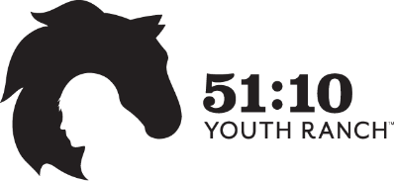

Participant Application

Today’s Date:
Name of Child:
Child’s gender:
Child’s Date of Birth:
What grade is your child in?
Please identify all allergies your child has:
Parent/Guardian Name(s):
Contact Information - Phone#:
E-Mail Address:
Mailing Address:
What is your preferred method of contact?
- Email
- Text message
- Phone Call
- Any of the above

Please answer the following questions as it relates to your child:
Where does your child live?

Where does your child attend school?

What is the main reason for your interest in 51:10?
- Mentoring
- Tutoring
- Horse Experience
- Christian Influence

If Tutoring is their choice:
What subject(s) does your child need tutoring in?

What does your child enjoy?

Can you tell us about any struggles your child may have at home, school or with friends that may help us better pair them with a mentor?

Can you give us a brief description of your child’s home life?

Please complete and mail to: 51:10 Youth Ranch, P.O. Box 433, Buena Vista, CO 81211 or scan and e-mail to MaryKate@5110youthranch.org. Once received, someone from 51:10 Youth Ranch’s staff will be in contact with you. Thank you for your interest.

