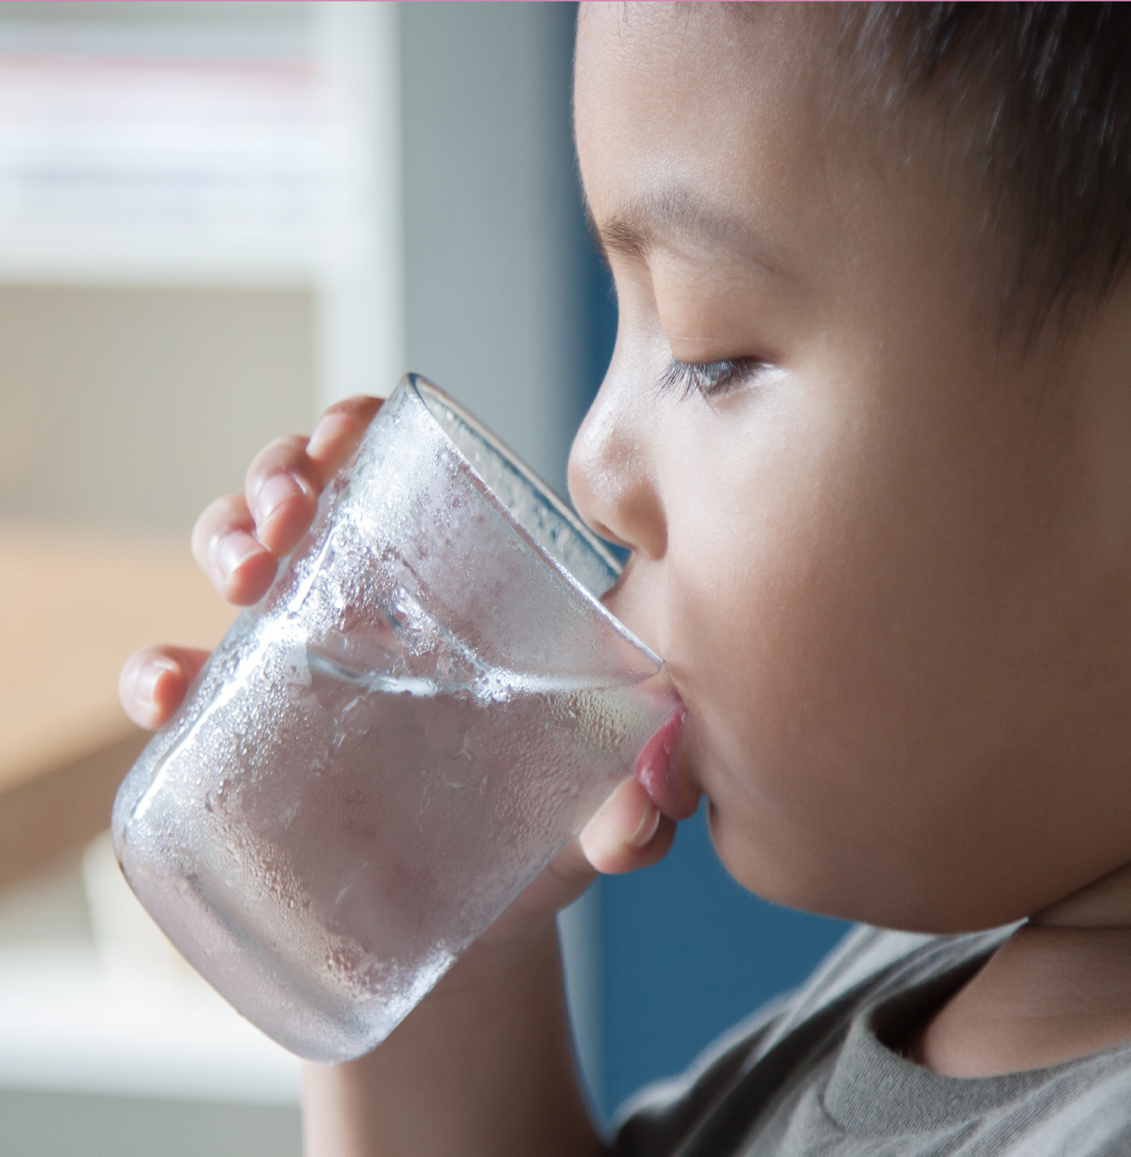
2022 Consumer Confidence Report

Reporting Year 2021

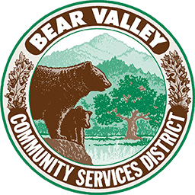
This report is intended to provide you with important information about your drinking water quality.

Este informe contiene informaci n muy importante sobre su agua beber.
Trad zcalo o hable con alguien que lo entienda bien. www.bvcsd.com

Contents

- The Bear Valley CSD Water Department 3
- Terms, Definitions, and Acronyms Used in This Report 4
  - Sources of Drinking Water and Contaminants that May Be Present in Source Water 5
  - Additional General Information on Drinking Water 5
- About Your Drinking Water Quality 6
Table 1 - Microbiological 6
Table 2 - Lead and Copper 6
Table 3 - Sodium and Hardness 6
Table 4 - Primary Drinking Water Standards 7
Table 5 - Detection of Contaminants with a Secondary Drinking Water Standard 7

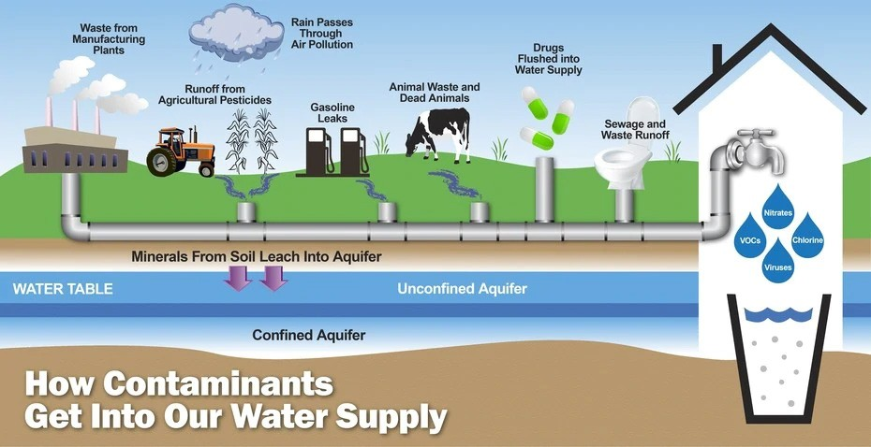

- The BVCSD Water Department

Our mission is to effectively manage the water resources in our care for the benefit of Bear Valley Springs residents and the environment.

The Bear Valley Community Services District is charged with provid- ing quality drinking water to Bear Valley Springs residents in an en- vironmentally responsible manner. Our focus is on finding solutions to the water management challenges we face, both in day-to-day operations and in the development of long-term programs that will meet future needs.

About this report
We test the drinking water quality for many constituents as required by State and Federal regulations. This report shows the results of our monitoring for the period of January 1 to December 31, 2021 and may include earlier monitoring data.
During the past year, your water was tested for chemical, physical, radiological, and bacteriological parameters. We also test for additional organic and inorganic chemicals that are not regulated. Unless otherwise noted, the data presented are from testing performed in 2021.
The State allows us to monitor less often for certain substances where concentrations do not change frequently. In these cases, the most recent sample data are included, along with the year in which the sample was taken.
The tables in this report include all substances detected. The presence of these substances does not necessarily indicate that the water poses a health risk.
Your water is safe to drink straight from the tap.
For more information: Call (661) 821-4428 Monday through Friday, 8 am to 4:30 pm.
Over the past 50 years we have dedicated ourselves to providing drinking water that meets all State and Federal standards. As new challenges in drinking water regulations emerge, we remain vigilant.
We believe that our District’s most valuable asset is our people. We support and retain a highly trained staff that are knowledgable, en- gaged, team oriented, and responsive to our community. Drawing upon the experience of our staff and the needs of our community, we strive to make decisions in a sound and reasonable manner.
We partner with the Tehachapi Cummings County Water District, the City of Tehachapi, Golden Hills Community Services District, and Stallion Springs Community Services District to participate in the Greater Tehachapi Area Regional Urban Water Management
Plan. This plan is required to be submitted to the California Depart- ment of Water Resources every five years.
The Urban Water Management Plan describes and evaluates our water deliveries and uses, water supply sources, efficient water use, demand management measures, and water shortage contingency planning. The most recent plan can be found on our website at www.bvcsd.com in the Documents Library.
These partnerships also help us to provide conservation programs that save water through encouraging more effective and efficient use.

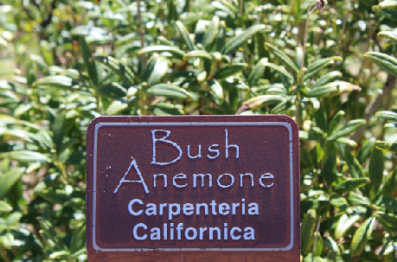
Visit our water-wise gardens!
If you’re considering making a landscaping change, visit our water-wise garden to discover native and adapted plants that thrive in our particular area. The water-wise showcases can be seen in front of the Bear Valley Market and in front of the Bear Valley CSD Administrative office at 28999 S. Lower Valley Rd, across from Cub Lake.

You are invited to attend!
Our Board of Directors meet on the second Thursday of each month at 6:00 pm. Meetings are held at the District office
located at 28999 S. Lower Valley Rd, Tehachapi CA, 93561. For questions please call (661) 831-4428

Terms, definitions, and acronyms used in this report

Term | Definition
Level 1 Assessment | A Level 1 assessment is a study of the water system to identify potential problems and determine (if possible) why total coliform bacteria have been found in our water system.
Level 2 Assessment | A Level 2 assessment is a very detailed study of the water system to identify potential prob- lems and determine (if possible) why an E. coli MCL violation has occurred and/or why total coliform bacteria have been found in our water system on multiple occasions.
Maximum Contaminant Level (MCL) | The highest level of a contaminant that is allowed in drinking water. Primary MCLs are set as close to the PHGs (or MCLGs) as is economically and technologically feasible. Secondary MCLs are set to protect the odor, taste, and appearance of drinking water.
Maximum Contaminant Level Goal (MCLG) | The level of a contaminant in drinking water below which there is no known or expected risk to health. MCLGs are set by the U.S. Environmental Protection Agency (U.S. EPA).
Maximum Residual Disinfectant Level (MRDL) | The highest level of a disinfectant allowed in drinking water. There is convinc- ing evidence that addition of a disinfectant is necessary for control of microbial contaminants
Maximum Residual Disinfectant Level Goal (MRDLG) | The level of a drinking water disinfectant below which there is no known or expect- ed risk to health. MRDLGs do not reflect the benefits of the use of disinfectants to control microbial contaminants.
Primary Drinking Water Standards (PDWS) | MCLs and MRDLs for contaminants that affect health along with their monitoring and reporting requirements, and water treatment requirements.
Public Health Goal (PHG) | The level of a contaminant in drinking water below which there is no known or expected risk to health. PHGs are set by the California Environmental Protection Agency.
Regulatory Action Level (AL) | The concentration of a contaminant which, if exceeded, triggers treatment or other requirements that a water system must follow.
Secondary Drinking Water Standards (SDWS) | MCLs for contaminants that affect taste, odor, or appearance of the drinking water. Contaminants with SDWSs do not affect the health at the MCL levels.
Treatment Technique (TT) | A required process intended to reduce the level of a contaminant in drinking water.
Variances & Exemptions | Permissions from the State Water Resources Control Board (State Board) to ex- ceed an MCL or not comply with a treatment technique under certain conditions.
ND | Not detectable at testing limit.
ppm | parts per million or milligrams per liter (mg/L)
ppb | parts per billion or micrograms per liter (µg/L)
ppt | parts per trillion or nanograms per liter (ng/L)
ppq | parts per quadrillion or picogram per liter (pg/L)
pCi/L | picocuries per liter (a measure of radiation)

Sources of Drinking Water and Contaminants that May Be Present in Source Water
The sources of drinking water (both tap water and bottled water) include rivers, lakes, streams, ponds, reservoirs, springs, and wells. As water travels over the surface of the land or through the ground, it dissolves naturally-occurring minerals and, in some cases, radioactive material, and can pick up substances resulting from the presence of animals or from human activity.
Contaminants that may be present in source water include:
- Microbial contaminants such as viruses and bacteria that may come from sewage treatment plants, septic systems, agricultural livestock operations, and wildlife.
- Inorganic contaminants such as salts and metals that can be naturally occuring or result from urban stormwater runoff, industrial or domestic wastewater discharges, oil and gas production, mining, or farming.
- Pesticides and herbicides that may come from a variety of sources such as agriculture, urban stormwater runoff, and residential uses.
- Organic chemical contaminants, including synthetic and volatile organic chemicals, that are byproducts of industrial processes and petroleum production. These can also come from gas stations, urban stormwater runoff, agricultural application, and septic systems.
- Radioactive contaminants that can be naturally occuring or be the result of oil and gas production or mining activities.

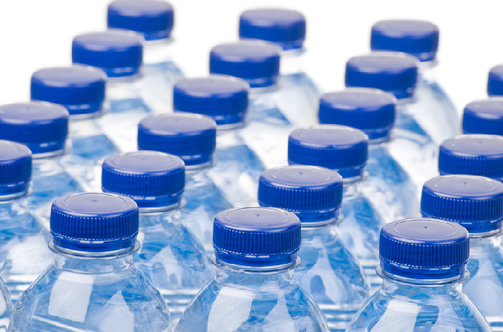
In order to ensure that tap water is safe to drink, the U.S. EPA and the State Board prescribe regulations taht limit the amount of certain con- taminants in water provided by public water systems. The U.S. Food and Drug Administration regulations and California law also establish limits for contaminants in bottled water that provide the same protection for public health.

  - General Information on Drinking Water
Drinking water, including bottled water, may reasonably be expected to contain at least small amounts of some contaminants.
The presence of contaminants does not necessarily indicate that the water poses a health risk. More information about contaminants and potential health effects can be obtained by
calling the U.S. EPA’s Safe Drinking Water Hotline (1-800-426-4791).
Some people may be more vulnerable to contaminants in drinking water than the general population. Immuno-compromised persons such as persons with cancer undergoing chemotherapy, persons who have undergone organ transplants, people with HIV/AIDS or other immune system disorders, some elderly, and infants can be particularly at risk from infections. These people should seek advice about drinking water from their health
care providers. U.S. EPA/Centers for Disease Control (CDC) guidelines on appropriate means to lessen the risk of infection by Cryptosporidium and other microbial contaminants are available from the Safe Drinking Water Hotline (1-800-426-4791).
Lead: If present, elevated levels of lead can cause serious health problems, especially for pregnant women and young children.
Lead in drinking water is primarily from materials and components associated with service lines and home plumbing. The Bear Valley Community Services District is responsible for providing high quality drinking water, but cannot control the variety of materials used in plumbing components. When your water has been sitting for several hours, you can minimize the potential for lead exposure by flushing your tap for 30 seconds to 2 minutes before using water for drinking or cooking. If you are concerned about lead in your water, you may wish to have your water tested. Information on lead in drinking water, testing methods, and steps you can take to minimize exposure is available from the Safe Drinking Water Hotline (1-800-426-4791) or at http://www.epa.gov/lead.
Nitrate: Nitrate in drinking water at levels above 45 mg/L is a health risk for infants of less than six months of age. High nitrate levels in drinking water can interfere with the capacity
of the infant’s blood to carry oxygen, resulting in serious illness; symptoms include shortness of breath and blueness of the skin. High nitrate levels above 45 mg/L may also affect the ability of the blood to carry oxygen in other individuals, such as pregnant women and those with certain specific enzyme deficiencies.
Nitrate levels may rise quickly for short periods of time because of rainfall or agricultural activity. If you are caring for an infant or are pregnant, you should ask advice from your health provider.
Coliform Bacteria: Coliforms are bacteria that are naturally present in the environment and are used as an indicator that other, potentially harmful bacteria may be present.
Radionuyclide: Certain minerals are radioactive and may emit a form of radiation known as alpha radiation. Some people who drink water containing alpha emitters in excess of the MCL over
many years may have an icreased risk for cancer. Naturally occuring uranium has been detected in groundwater throughout many areas of California, particularly in areas that have deep bedrock wells where uranium leaches into groundwater from natural mineral deposits within the bedrock. Areas with an abundance of uranium mineralization, and where uranium concentrations have been detected in water supply wells above the MCL include Kern, San Bernadino, and Riverside Counties.

Public Safety Power Shut-off (PSPS)
During 2021, there was one Public Safety Power Shut-off (PSPS) which was implemented by Southern California Edison. Due to the extended length of the outage, we experienced low to no water in several areas in the system served by pneumatic tanks. Boil Notices were hand delivered to affected residents.

About Your Drinking Water Quality
During the past year, your water was tested for chemical, physical, radiological, and bacteriological parameters. We also test for additional organic and inorganic chemicals that are not regulated. The tables included in this report list all the substances detected. The presence of these substances in the water does not necessarily indicate that the water poses a health risk. Unless otherwise noted, the data presented in this table are from the testing performed last year. The State allows us to monitor less often for certain substances where concentrations do not change frequently. In these cases, the most recent sample data are included, along with the the year in which the sample was taken.

Table 1 - Microbiological
Microbiological Contaminants | MCL | PHG (MCLG) | Highest # of detection | Number of months in violation | Typical source of bacteria
Total Coliform Bacteria | No more than one positive monthly sample | 0 | In a month: 0 | 0 | Naturally present in the environment
Fecal Coliform or  E. Coli | A routine sample and a repeat sample are total Coliform positive and one of these is also fecal Coliform or E. Coli positive | 0 | In the year: 0 | 0 | Human and animal fecal waste

Table 2 - Lead & Copper The Lead and Copper results are from the 2020 sampling and are scheduled to be
taken in 2023.

Lead & Cop- per | Action Level (AL) | PHG (MCLG) | 90th Percentile Detected | Number of Sites Sampled | Number of Samples Ex- ceeding (AL) | Typical Source of Contaminant
Lead (ppb) | 0.015 | 2 | .0052 | 20 | 0 | Internal corrosion of household water plumbing systems; discharges from in- dustrial manufactures; erosion of natural deposits
Copper (ppm) | 1.3 | 0.17 | 0.46 | 20 | 0 | Internal corrosion of household water plumbing systems; discharges from in- dustrial manufactures; erosion of natural deposits

Table 3 - Sodium & Hardness
Chemical or constituent (and reporting units) | MCL | PHG (MCLG) | Level Detected (Average) | Range of Detection | Typical Source of Contaminant
Sodium (ppm) | None | None | 28.6 | 17 - 32 | Generally found in ground and surface water.
Hardness (ppm) | None | None | 263.3 | 220-330 | Generally found in ground and surface water.

Table 4 - Primary Drinking Water Standards

Radioactive Contaminants | Units | MCL | PHG (MCLG) | Level Detected (Average) | Range of Detections | Violation (Yes/No) | Typical Source of Contaminant
Gross Alpha Activity | pCi/L | 15 | 0 | 14.6 | ND - 14.6 | No | Erosion of natural deposits
Uranium | pCi/L | 20 | 0.5 | 13 | ND - 13 | No | Erosion of natural deposits
Combined ra- dium 226 & 228 (total) | pCi/L | 5 | (0)(b) | ND | ND - ND | No | Erosion of natural deposits
Inorganic Contaminants | Units | MCL | PHG (MCLG) | Level Detected (Average) | Range of Detections | Violation (Yes/No) | Typical Source of Contaminant
Arsenic | ppb | 10 | NA | 1.2 | ND - 1.4 | No | Erosion of natural deposits; runoff from orchards; glass & electronics production wastes
Nitrate as N | mg/L | 10 | 10 | 4.75 | ND - 9 | No | Runoff from leaching from fertil- izer use; leaching from septic tanks; sewage; erosion of natural deposits
Disinfection Byproducts | Units | MCL | PHG (MCLG) | Level Detected (Average) | Range of Detections | Violation (Yes/No) | Typical Source of Contaminant
TTHM’s (Total Trihalometh- anes) | ppb | 80 | NA | 19.35 | 1.7 - 37 | No | Byproduct of drinking water disin- fection
HAA5’s (Halo- acetic Acids) | ppb | 60 | NA | 5.85 | 1.7 - 10 | No | Byproduct of drinking water disin- fection

Table 5 - Detection of contaminants with a secondary drinking water standard

Constituent | Units | MCL | PHG (MCLG) | Level Detected (Average) | Range of Detections | Violation (Yes/No) | Typical Source of Contaminant
Iron | ppb | 300 | NA | 9.4 | ND - 9.4 | No | Leaching from natural deposits; industrial waste
Total Disolved Solids (TDS) | mg/L | 1000 | NA | 491.67 | 350 - 600 | No | Runoff/Leaching from natural deposits
Sulfate | mg/L | 500 | NA | 74 | 20 - 110 | No | Runoff/Leaching from natural deposits
pH (1) | pH Units |  | NA | 7.73 | 7.05 - 8.08 | No
Note: There are no PHGs or MCLGs for constituents with secondary drinking water standards because these are not health- based levels. Secondary MCLs are established by the DHS and address taste, odor, or appearance of drinking water.

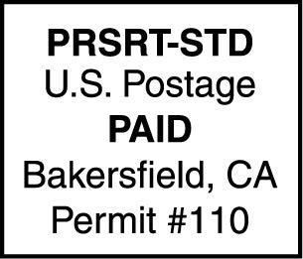
Bear Valley CSD
28999 S. Lower Valley Rd. Tehachapi CA 93561
Phone: (661) 821-4428
www.bvcsd.com

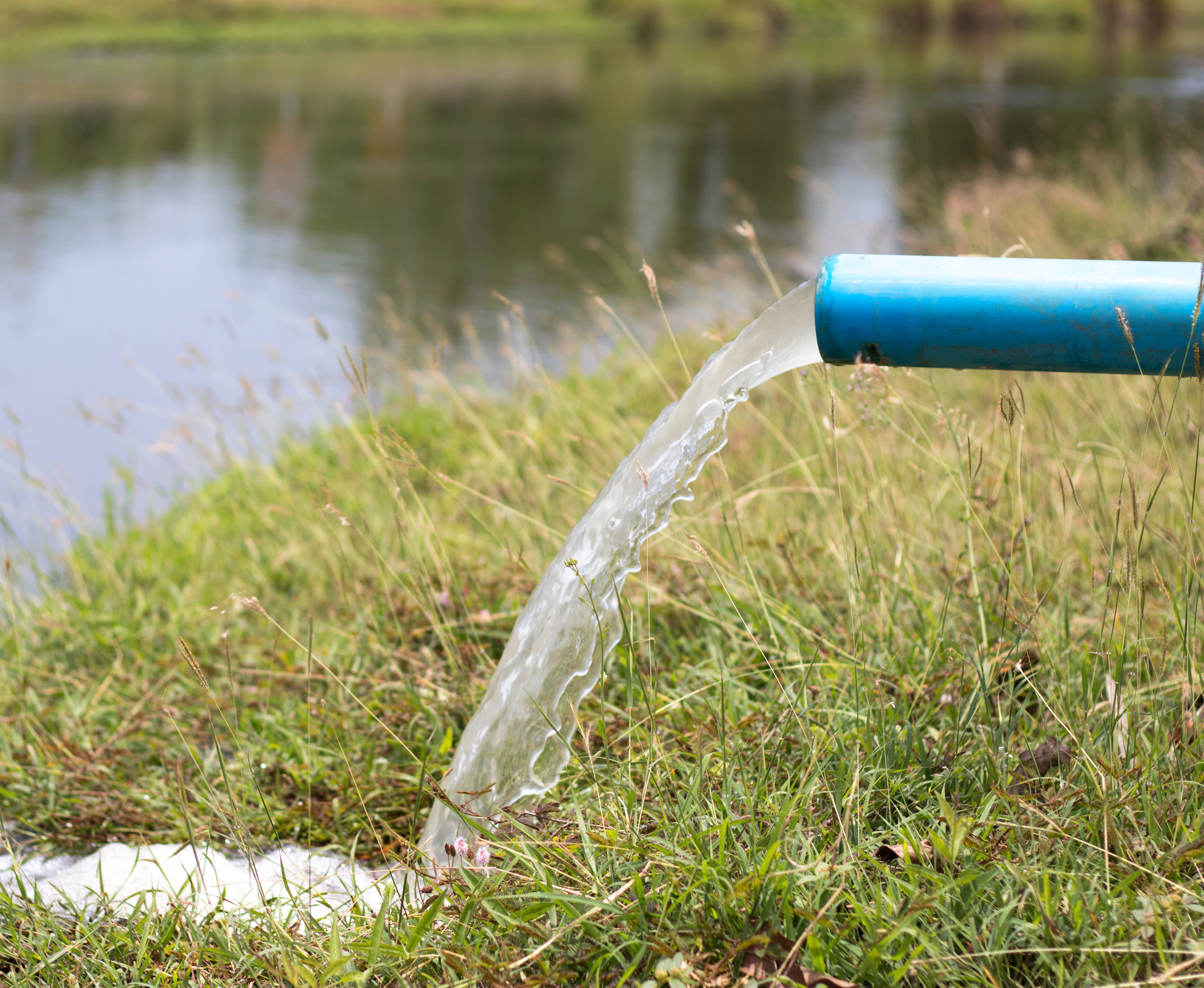You can help us protect your water supply by following labels when using lawn and garden chemicals. Please do not pour hazardous materials down drains or on the ground, and be conscious of fragile watershed areas when hiking, fishing, or enjoying other outdoor activities. When disposing of household chemicals, used oil, paint, and other hazardous waste, please make use of the Kern County Sanitary Landfill’s free Household Hazardous Waste events. For more information on Household Hazardous Waste (HHW) and county collection events visit
Protect the Water we drink.
https://kernpublicworks.com/hazardous-waste/

