**Quarterly**

Activities Report

# **Highlights**

* **Commencement of +4,000 metre diamond drilling programme at Bekisopa designed to extend and confirm iron mineralized zones along strike and depth**
  + **Initial drill results show iron mineralisation continues in both North and South zones**
  + **Significant intercepts containing massive and coarse disseminated iron mineralisation**
* **Premium iron grade product from crushing trials at Bekisopa with benchmark 62% iron at 3mm crush and 64% iron at 2mm crush**
* **Final 2020 drill hole assay results continue to highlight potential to deliver high-grade 64.5% iron ore product grades at a 2mm coarse crush size**
* **62.8% iron product grades from composites with massive and coarse disseminated iron mineralisation with low silica, alumina and phosphorus**
* **65.5% iron product grades achieved from massive iron mineralisation**
* **Bekisopa product grades appear excellent when compared to globally traded iron ore products in regard to high iron content and low impurity levels**
* **No environment, social or governance issues in the quarter**
  + **Supportive contacts made with local officials in the lead up to drilling activities at Bekisopa**
* **Quarter expenditure**

**Quarterly expenditure was A$836,000 including A$511,000 expended on exploration activities**

* **Cash balances**

**Cash balances as at 30 June 2021 were A$3,705,000 (including the Australian dollar equivalent of US$1,564,000) with no debt**

Pursuant to the requirements of Listing Rules, this announcement on the Quarterly Activities Report and Quarterly Cashflow has been authorized by the AKORA Resources Limted board of directors.

# For more information:

|  |  |
| --- | --- |
| **Paul Bibby**  *Managing Director*  Akora Resources  + 61 (0) 419 449 833  [**paul.bibby@akoravy.com**](mailto:paul.bibby@akoravy.com) | **Peter Taylor**  *Media & Investor Relations*  NWR Communications  + 61 (0) 412 036 231  [**peter@nwrcommunications.com.au**](mailto:peter@nwrcommunications.com.au) |

AKORA Resources Limited (ASX: AKO, AKORA or the Company) is pleased to report its activities during the June 2021 quarter.

AKORA Managing Director Paul Bibby commented, *“****The past quarter has seen continued evaluation of the 2020 exploratory drilling programme with excellent iron intercepts in the southern zone, with very encouraging product grade trial results averaging 62.8% iron at a 2mm crush. Then further crushing trials showed that a 3mm crush delivers benchmark 62% iron ore product grades. These results have informed our plan for the recently commenced 4,000 plus metre drilling campaign at Bekisopa, which we are aiming to complete in the last quarter of 2021.”***

**Operating activities**

**Commencement of 4,000-metre diamond drilling campaign**

In June, the Company commenced its 4,000-metre drilling campaign at its flagship Bekisopa iron ore project after mobilizing drilling equipment and support in late May. The campaign aims to deliver a JORC compliant initial resource by year-end (*see* ASX announcement 31 May 2021). The Company will undertake this drilling programme at Bekisopa tenements 3757 and 10430. During camp construction a contractor received lacerations, first aid managed the injury, and the contractor will return to his employment when recovered. Completion of the establishment of the camp and commencement of drilling has proceeded well despite restrictions imposed due to Covid-19.

The campaign’s timeframe assumes the Company can complete all necessary work activities (drilling, assaying, metallurgical test work and resource estimation) without being impacted by operation issues, Covid-19 in Madagascar or limited international transport options to get samples for analysis to accredited ALS laboratories. The various operational and logistical lessons learnt from the successful 2020 Bekisopa drilling programme will assist in managing the necessary steps to complete this drilling programme in as timely a manner as practical.

The 2021 drill plan expands on results previously reported for the Bekisopa iron ore project (*see* ASX Announcements dated 13 April 2021, 27 April 2021 and 25 June 2021). The plan is to complete 4,000 metres of diamond drill holes focusing on areas at the northern and southern limits of the main 6-kilometre strike. The proposed drilling programme is set out in Figure 1.

In the north, across tenements 3757 and 10430, drilling is targeting a zone of high magnetic intensity and the encouraging drill intercept in 2020 drill hole BEKD01, at 200m line spacing to a depth of around 250m below surface.

In the south (tenement 10430), where continuous iron mineralization appears to be dipping much more shallowly, 200m line spaced drilling will target shallower mineralization such as that intersected in 2020 drill holes BEKD09, 10 and 11, to a depth of about 150m below surface.

AKORA selected these drill grids to confirm the continuity of the known iron mineralization in these two zones, within the selected grid areas, and predominately to confirm the known mineralization to the west and at depth. These two drilling grids will only confirm the extent of the iron mineralization along some 30% of the 6 km strike. Therefore, depending on these drill results, the potential for a larger iron resource after further drilling is considerable.

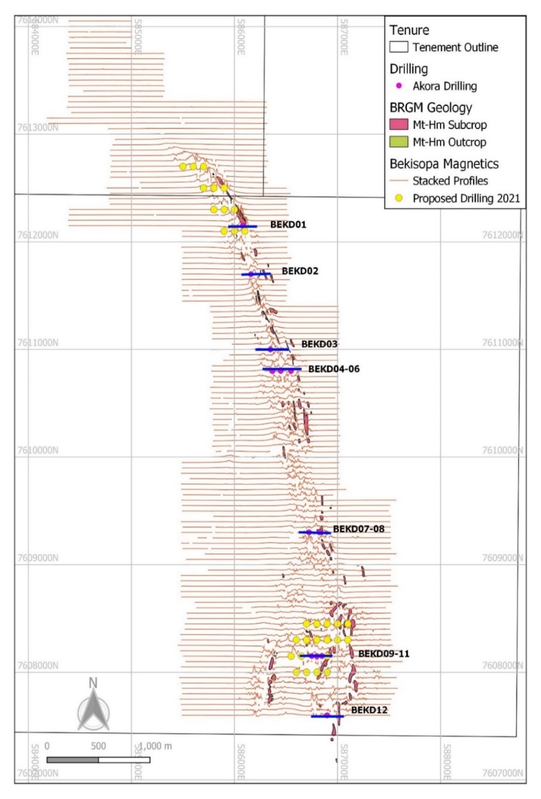

**Tenement 10430**

**Tenement**

**3757**

2021 Northern

Drill Grid

2021 Southern

Drill Grid

**Figure 1**

Bekisopa Proposed 2021 Drilling Plan

**COVID-19 Precautions**

AKORA has been proactively managing the potential impact of COVID-19. With all employees and contractors requiring a negative COVID test to be allowed to travel to site and limiting risk to its operations and community. All operations, activities and movements have been minimised to what is deemed essential. Bekisopa site has first aid, increased hygiene practices and nonessential travel banned for the foreseeable future.

**Crushing trials results**

The Company continued to receive pleasing results from its crushing trials on 2020 drill cores taken from the Bekisopa project (*see* ASX announcement 15 July 2021).

These processing trials continue to show excellent iron ore product grades of 62% iron at a crush size of 3mm and 64% iron at a crush size of 2 mm from massive and coarse disseminated iron mineralization types. As expected, the iron grade increases proportionally with finer crush sizes while the silica, alumina, phosphorus and sulphur levels decrease substantially.

Analysis of the product grades achieved from all processing trials to date (*see* ASX Announcements on 13 April 2021, 27 April 2021 and 25 June 2021) shows the iron mineralization along the Bekisopa strike length can deliver high-grade iron products. The excellent product grades achieved in processing trial from the northern and southern zones, where the 2021 drill grids are planned, ranged from 60.7% to 68.3% Fe, averaging 65.2% Fe.

These trials confirm that a 2mm crush delivers quality high-grade iron ore fines products, resulting in the Company to undertake for the JORC resource estimation product trials on drill core samples from the 2021 drilling campaign at 2mm and wLIMS (wet low intensity magnetic separation). This series of crushing trials confirms the favorable upgrading characteristics of the iron mineralization at Bekisopa in achieving high-grade clean iron ore fines products.

**Final assay results from 2020 12-hole drilling programme**

During the quarter, AKORA also received assays for the final four drill holes from its 2020 12-hole drilling programme at Bekisopa (*see* ASX announcement 27 April 2021). The Company reported results from the first eight drill holes in April (*see* ASX announcement dated 13 April 2021).

The results confirm the previous interpretation of a broad, shallow (15°) westerly dipping iron mineralized zone with a true thickness of at least 45 metres, increasing to the west. The mineralized zone outcrops and is continuous from surface. Simple coarse crushing and wet LIMS test work generated outstanding recoveries of up to 90.6%Fe and delivered product grades of up to 66.9%Fe. These final laboratory results confirmed the excellent qualities of the Bekisopa mineralization and highlighted the potential for low capital and operating costs and high-grade iron ore product.

The drilling has confirmed the previous interpretation of an outcropping zone of massive and coarse disseminated magnetite +/- hematite in the southern area of the project area, starting at surface and continuous to the limit of drilling to date. The new results show very high-grade massive mineralization is present in each of the weathered surficial, totally oxidized weathered, transitional and fresh rock zones. This outcome suggests the potential for large scale mineralization at depth and to the west.

**Corporate activities**

During the June 2021 quarter, the Company issued 329,000 fully paid ordinary shares at 30 cents per ordinary share on the exercise by shareholders of options over ordinary shares issued pursuant to the listing of the Company on the Australian Securities Exchange.

The Company received $98,000 in new funds from the exercise of options during the June quarter.

The Company expended $836,000 on exploration and corporate activities during the second quarter of 2021 with $511,000 expended on exploration and the balance on corporate activities.

As at 30 June 2021, the Company had $3,705,000 in cash balances (including the Australian dollar equivalent of US$1,565,000 in US deposits) and nil debt.

Capital structure as at the date of this Quarterly Activities Report is as follows:

Fully paid ordinary shares (tradeable) 51,225,600

Restricted securities

- Ordinary shares (escrowed 5/8/21) 981,492

- Ordinary shares (escrowed 30/9/21) 136,364

- Ordinary shares (escrowed 7/12/22) 8,693,266

---------------

61,036,722

---------------

Unlisted options

- Exercisable up to 7/12/22 @ 30 cents 8,592,266

- Escrowed until 7/12/22 @ 30 cents 2,244,750

**Related parties**

During the quarter Messrs PG Bibby and JM Madden acquired 14,000 and 57,000 ordinary shares, respectively, on the market. Disclosure of these purchases was detailed in Appendices 3Y submitted to the ASX on 29 April 2021.

**ASX Listing Rule 4.10.19**

In accordance with Listing Rule 4.10.19, the board of directors wish to confirm that the Group has been utilising the cash and assets in a form readily convertible to cash that it held at the time of its admission to the Official List of ASX on 15 December 2020 and since its admission to the end of the reporting period (being 30 June 2021) in a way that is consistent with its business objectives.

**Board of directors**

MH Stirzaker Non-executive Chairman

PG Bibby Managing Director and Chief Executive Officer

SL Fabian Non-executive Director

JM Madden Executive Director and Company Secretary

**Website** [www.akoravy.com](http://www.akoravy.com)

***End Notes***

*The information contained in this announcement related to the Company’s past exploration results is extracted from, or was set out in, the following ASX announcements which are referred to in this Quarterly Activities Report:*

* *(ASX: AKO), ‘2021 Drilling Campaign continues to enhance the potential of Bekisopa as a significant iron project’ 20 July 2021*
* *(ASX: AKO), ‘AKORA Achieves Premium Iron Product Grades From Further Crushing Trials At Bekisopa’ 12 July 2021*
* *(ASX: AKO), ‘Bekisopa Iron Ore Product Grade’, 25 June 2021*
* *(ASX: AKO), Mobilisation of 2021 Drilling Programme at Bekisopa Iron Ore Project Commences’ 31 May 2021*
* *(ASX: AKO), ‘AKORA Delivers Further Outstanding Drill Results With Iron Ore Product Grades Up To 66.9% Fe’ 27 April 2021.*



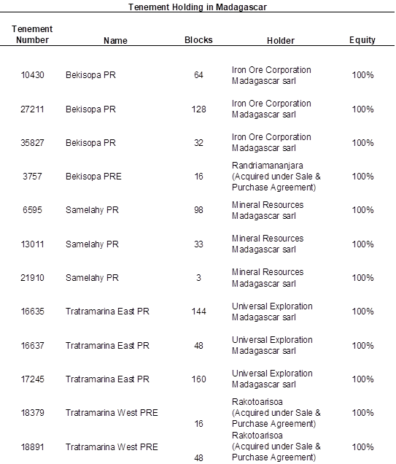

# Appendix 5B

## Mining exploration entity or oil and gas exploration entity quarterly cash flow report

|  |  |  |
| --- | --- | --- |
| Name of entity | | |
| AKORA Resources Limited | | |
| ABN |  | Quarter ended (“current quarter”) |
| 90 139 847 555 |  | 30 June 2021 |

| Consolidated statement of cash flows | | Current quarter $A’000 | Year to date (six months) $A’000 |
| --- | --- | --- | --- |
| 1. | Cash flows from operating activities | - | - |
| 1.1 | Receipts from customers |
| 1.2 | Payments for | (511) | (700) |
|  | 1. exploration & evaluation |
|  | 1. development |  |  |
|  | 1. production |  |  |
|  | 1. staff costs | (217) | (427) |
|  | 1. administration and corporate costs | (107) | (273) |
| 1.3 | Dividends received (see note 3) |  |  |
| 1.4 | Interest received |  |  |
| 1.5 | Interest and other costs of finance paid |  |  |
| 1.6 | Income taxes paid |  |  |
| 1.7 | Government grants and tax incentives |  |  |
| 1.8 | Other  (Cash Boost from Commonwealth Government) |  |  |
| **1.9** | **Net cash from / (used in) operating activities** | **(835)** | **(1,400)** |
|  | | | |
| **2.** | **Cash flows from investing activities** |  |  |
| 2.1 | Payments to acquire or for: |
|  | 1. entities |
|  | 1. tenements |  |  |
|  | 1. property, plant and equipment |  |  |
|  | 1. exploration & evaluation |  |  |
|  | 1. investments |  |  |
|  | 1. other non-current assets |  |  |
| 2.2 | Proceeds from the disposal of: |  |  |
|  | 1. entities |
|  | 1. tenements |  |  |
|  | 1. property, plant and equipment |  |  |
|  | 1. investments |  |  |
|  | 1. other non-current assets |  |  |
| 2.3 | Cash flows from loans to other entities |  |  |
| 2.4 | Dividends received (see note 3) |  |  |
| 2.5 | Other |  |  |
| **2.6** | **Net cash from / (used in) investing activities** | **-** | **-** |
|  | | | |
| **3.** | **Cash flows from financing activities** |  |  |
| 3.1 | Proceeds from issues of equity securities (excluding convertible debt securities) |
| 3.2 | Proceeds from issue of convertible debt securities |  |  |
| 3.3 | Proceeds from exercise of options | 98 | 290 |
| 3.4 | Transaction costs related to issues of equity securities or convertible debt securities |  |  |
| 3.5 | Proceeds from borrowings | - |  |
| 3.6 | Repayment of borrowings |  |  |
| 3.7 | Transaction costs related to loans and borrowings |  |  |
| 3.8 | Dividends paid |  |  |
| 3.9 | Other (provide details if material) |  |  |
| **3.10** | **Net cash from / (used in) financing activities** | **98** | **290** |
|  | | | |
| **4.** | **Net increase / (decrease) in cash and cash equivalents for the period** | (737) | (1,110) |
| 4.1 | Cash and cash equivalents at beginning of period | 4,428 | 4,770 |
| 4.2 | Net cash from / (used in) operating activities (item 1.9 above) | (835) | (1,400) |
| 4.3 | Net cash from / (used in) investing activities (item 2.6 above) | - | - |
| 4.4 | Net cash from / (used in) financing activities (item 3.10 above) | 98 | 290 |
| 4.5 | Effect of movement in exchange rates on cash held | 14 | 45 |
| **4.6** | **Cash and cash equivalents at end of period** | **3,705** | **3,705** |

|  |  |  |  |
| --- | --- | --- | --- |
| 5. | Reconciliation of cash and cash equivalents at the end of the quarter (as shown in the consolidated statement of cash flows) to the related items in the accounts | Current quarter $A’000 | Previous quarter $A’000 |
| 5.1 | Bank balances | 284 | 340 |
| 5.2 | Call deposits | 1,340 | 1,600 |
| 5.3 | Bank overdrafts |  |  |
| 5.4 | Other US dollar accounts | 2,081 | 2,488 |
| **5.5** | **Cash and cash equivalents at end of quarter (should equal item 4.6 above)** | **3,705** | **4,428** |

|  |  |  |
| --- | --- | --- |
| 6. | Payments to related parties of the entity and their associates | Current quarter $A'000 |
| 6.1 | Aggregate amount of payments to related parties and their associates included in item 1 | 140 |
| 6.2 | Aggregate amount of payments to related parties and their associates included in item 2 | - |
| *Note: Salaries for executive directors are allocated to both corporate and exploration activities*  *Note: if any amounts are shown in items 6.1 or 6.2, your quarterly activity report must include a description of, and an explanation for, such payments.* | | |

|  |  |  |  |
| --- | --- | --- | --- |
| 7. | Financing facilities *Note: the term “facility’ includes all forms of financing arrangements available to the entity.**Add notes as necessary for an understanding of the sources of finance available to the entity.* | Total facility amount at quarter end $A’000 | Amount drawn at quarter end $A’000 |
| 7.1 | Loan facilities |  |  |
| 7.2 | Credit standby arrangements |  |  |
| 7.3 | Other (Convertible Notes) |  |  |
| 7.4 | **Total financing facilities** |  |  |
|  |  | |  |
| 7.5 | **Unused financing facilities available at quarter end** | |  |
| 7.6 | Include in the box below a description of each facility above, including the lender, interest rate, maturity date and whether it is secured or unsecured. If any additional financing facilities have been entered into or are proposed to be entered into after quarter end, include a note providing details of those facilities as well. | | |
|  | | |

|  |  |  |
| --- | --- | --- |
| 8. | Estimated cash available for future operating activities | $A’000 |
| 8.1 | Net cash from / (used in) operating activities (item 1.9) | (835) |
| 8.2 | (Payments for exploration & evaluation classified as investing activities) (item 2.1(d)) | - |
| 8.3 | Total relevant outgoings (item 8.1 + item 8.2) | (835) |
| 8.4 | Cash and cash equivalents at quarter end (item 4.6) | 3,705 |
| 8.5 | Unused finance facilities available at quarter end (item 7.5) | - |
| 8.6 | Total available funding (item 8.4 + item 8.5) | 3,705 |
|  |  |  |
| 8.7 | **Estimated quarters of funding available (item 8.6 divided by item 8.3)** | 4.44 quarters |
| *Note: if the entity has reported positive relevant outgoings (ie a net cash inflow) in item 8.3, answer item 8.7 as “N/A”. Otherwise, a figure for the estimated quarters of funding available must be included in item 8.7.* | |
| 8.8 | If item 8.7 is less than 2 quarters, please provide answers to the following questions: | |
|  | 8.8.1 Does the entity expect that it will continue to have the current level of net operating cash flows for the time being and, if not, why not? | |
|  | Answer: N/A | |
|  | 8.8.2 Has the entity taken any steps, or does it propose to take any steps, to raise further cash to fund its operations and, if so, what are those steps and how likely does it believe that they will be successful? | |
|  | Answer: N/A | |
|  | 8.8.3 Does the entity expect to be able to continue its operations and to meet its business objectives and, if so, on what basis? | |
|  | Answer: N/A | |
|  | *Note: where item 8.7 is less than 2 quarters, all of questions 8.8.1, 8.8.2 and 8.8.3 above must be answered.* | |

## Compliance statement

1 This statement has been prepared in accordance with accounting standards and policies which comply with Listing Rule 19.11A.

2 This statement gives a true and fair view of the matters disclosed.

Date: 26 July 2021

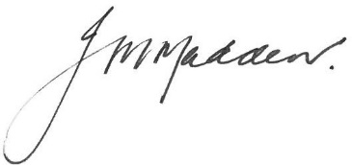

Authorised by: JM Madden (Company Secretary)

(Name of body or officer authorising release – see note 4)

## *Notes*

*1. This quarterly cash flow report and the accompanying activity report provide a basis for informing the market about the entity’s activities for the past quarter, how they have been financed and the effect this has had on its cash position. An entity that wishes to disclose additional information over and above the minimum required under the Listing Rules is encouraged to do so.*

*2. If this quarterly cash flow report has been prepared in accordance with Australian Accounting Standards, the definitions in, and provisions of, AASB 6: Exploration for and Evaluation of Mineral Resources and AASB 107: Statement of Cash Flows apply to this report. If this quarterly cash flow report has been prepared in accordance with other accounting standards agreed by ASX pursuant to Listing Rule 19.11A, the corresponding equivalent standards apply to this report.*

*3. Dividends received may be classified either as cash flows from operating activities or cash flows from investing activities, depending on the accounting policy of the entity.*

*4. If this report has been authorised for release to the market by your board of directors, you can insert here: “By the board”. If it has been authorised for release to the market by a committee of your board of directors, you can insert here: “By the [name of board committee – eg Audit and Risk Committee]”. If it has been authorised for release to the market by a disclosure committee, you can insert here: “By the Disclosure Committee”.*

*5. If this report has been authorised for release to the market by your board of directors and you wish to hold yourself out as complying with recommendation 4.2 of the ASX Corporate Governance Council’s Corporate Governance Principles and Recommendations, the board should have received a declaration from its CEO and CFO that, in their opinion, the financial records of the entity have been properly maintained, that this report complies with the appropriate accounting standards and gives a true and fair view of the cash flows of the entity, and that their opinion has been formed on the basis of a sound system of risk management and internal control which is operating effectively.*