Spain & the Camino
11 – 27 May 2020
The Way of St. James, often known by its Spanish name, El Camino de Santiago, is the pilgrimage to the Cathedral of Santiago de Compostela (north-western Spain), where legend has it that the remains of the apostle, Saint James the Great, are buried.
In the 9th-century, according to legend, a shower of falling stars led the Spanish hermit Pelayo to Santiago, where he discovered the long forgotten tomb of the apostle St. James. Since then, pilgrims from all over the world have travelled the Camino de Santiago. Walk through eleven centuries of history, legends and traditions, and along the way learn of the many miracles that have occurred on the trail. As you add your footprints to the millions who have travelled before you – including such legendary pilgrims as St. Francis of Assisi, Charlemagne, and Pope John Paul II – you become part of the Camino’s ongoing history.
Follow the yellow arrows and scallop shell signposts that point the way through forests, farmland, medieval villages and hamlets, where cows meander down country lanes and locals wish you a “Buen Camino!” You are not a tourist any more, but a pilgrim on a spiritual journey. Enjoy the camaraderie on the Camino and meet fellow "peregrinos" from around the world, all wearing the scallop shell symbolic of St. James.
On this Camino de Santiago trip you will walk the beautiful and historic sections of the Camino from O Cebreiro to Santiago de Compostela. Like thousands of pilgrims before you, celebrate your safe arrival by embracing the statue of St. James behind the altar of the spectacular Cathedral in Santiago. Join us, and discover for yourself why the Camino de Santiago is a once-in-a-lifetime adventure!
Your Itinerary:
Day 1 – Monday May 11th
Upon arrival we’ll be met by our bilingual Camino guide to transfer to our first lodgings.
Welcome to Galicia! This lovely region in north-west Spain is a dreamy, spiritual land featuring rolling emerald green hills covered in mist, medieval castles, "pazos" (beautiful, historic manor houses, many converted into small, charming hotels), stunning coastline with romantic coves and sandy white beaches spotted with quaint fishing villages and the belief in meigas (witches). The Galicians have their own language distinct from Spanish, called "Gallego" which resembles a mix of Portuguese and Spanish.
En route enjoy a lunch made up of local specialities. Over lunch, your guide will give a Briefing, and also hand out your pilgrim guidebooks and passports (credentials).
After lunch continue to the Hotel Ambasmestas in the small village of the same name, in the province of León.
Dinner in the hotel tonight.
⌂ Your hotel tonight:
Hotel C.T.R. Ambasmestas

Day 2 – Tuesday May 12th O Cebreiro – Triacastela (20,7 km)

Meet your guide in the lobby to load your luggage into the van and go over the details of the day’s walk. You’ll drive up to O Cebreiro, from where you’ll commence your first day on the Camino.
O Cebreiro is a beautiful village located on the top of a mountain and on the Galician side of the León-Galicia border. Surrounded by heather and forests of oak and boasting wonderful views, the village is famous for its primitive, circular thatched-roofed huts called pallozas (pre-Celtic in origin) and a tiny chapel where one of the famous legends on the Camino is said to have taken place.
The history of O’Cebreiro has always been closely tied to the Way of St. James. O’Cebreiro was the birthplace of Don Elias Valina San Pedro, a dedicated priest and scholar who devoted his life to the Camino de Santiago, in both academic and practical ways (he was responsible for painting many of the ubiquitous yellow arrows on rocks and trees that mark the Camino de Santiago for pilgrims).
Depart O Cebreiro and enjoy wonderful views of the valleys and mountains around you as you follow the trail. Your day starts with a steady climb up to the Alto do Poio, the highest point of the Camino de Santiago in Galicia. Your destination is Triacastela (a village meaning “three castles”). Although there are no castles remaining, there is an 18th century church still standing.
After arriving in Triacastela, meet your guide and transfer back to the village of O Cebreiro.
Dinner in the hotel.
⌂ Overnight: Casa Valina (Hotel O Cebreiro)

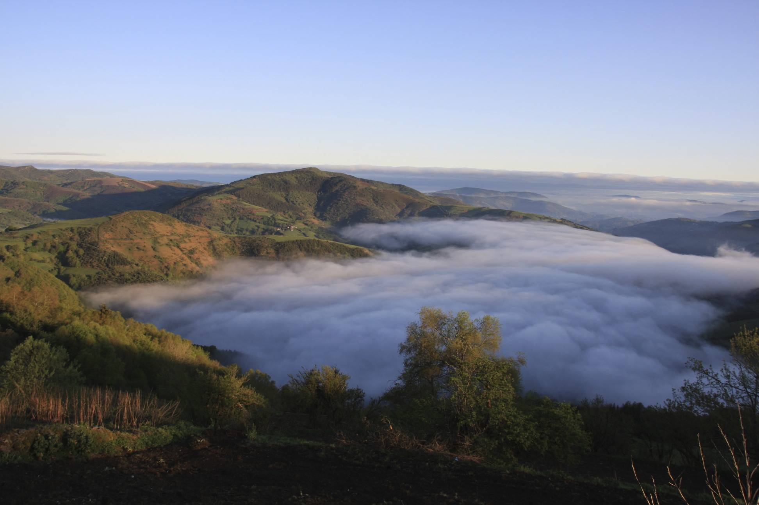
Day 3 – Wednesday May 13th Triacastela – Sarria (18.7 km)

After breakfast, meet your guide to transfer back to Triacatela. From here, there are two options to walk to Sarria; on paved roads via the monastery of Samos, or the more picturesque trail via the hamlets of San Xil and Furela. We recommend you walk the latter. In Furela a lovely carved capital can still be seen, dedicated to San Roque, one of the patron saints of the pilgrimage).
You’ll meet your guide in Sarria (the antiques capital of Galicia) to transfer to the wonderful Rectoral de Goian, your tranquil rural inn and home for the next two nights.
Dinner at the hotel
⌂ Overnight: : Rectoral de Goian, Goian (Sarria), Rural Guest House - This unique 18th century country inn has been beautifully restored. Formerly the rectory of the Goian parish church, the house is situated 8 km from the Camino de Santiago. Your dinners and breakfasts are created by the owner / chef Javier – truly delicious!

Day 4 – Thursday May 14th Sarria to Portomarin (22.7 Km)
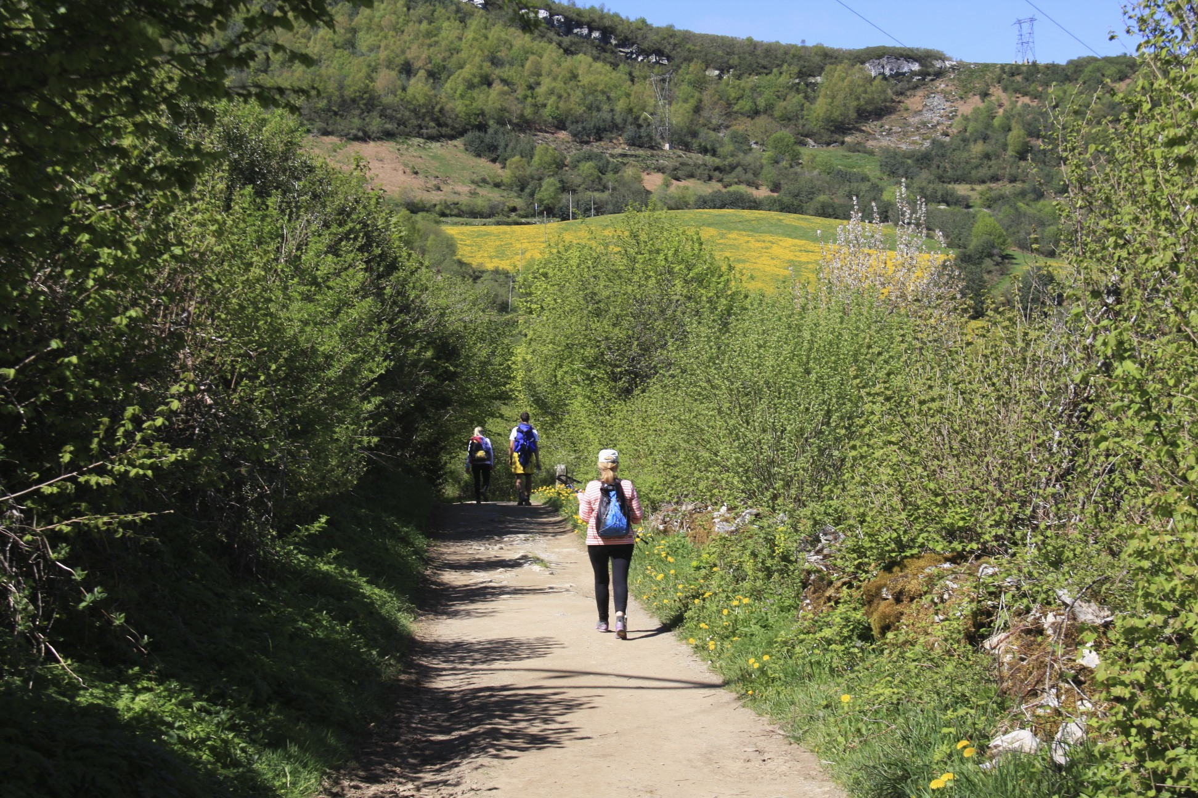
After breakfast your guide will drive you the short distance from the Rectoral de Goian back to Sarria (where you will commence your walk). Today’s section of the Camino is one of the most picturesque. Walk through bucolic countryside, traversing enchanted forests and small patches of farmland to the banks of the Miño River. En route to Portomarín you’ll pass the 100 km marker (only 100 km until Santiago de Compostela!) - a milestone for pilgrims who travel the Camino.
Portomarin is a picturesque village with an interesting history. Most of the old buildings of the town (including the Romanesque Church of San Juan) were moved stone by stone to higher ground in the 1960´s when the Miño river was damned to create the Belesar reservoir.
Upon arrival in Portomarin meet your guide in the main plaza by the Church of San Juan. After exploring the village, transfer to the Rectoral de Goian.
Dinner in the hotel
⌂ Your hotel tonight:
Rectoral de Goian
Day 5 – Friday May 15th Portomarin to Lestedo (19,8 km)

Meet your guide in the lobby with bags packed and ready to farewell our lovely inn and hospitable hosts, Javier and Raquel. You’ll be dropped off in Portomarin (where you finished walking yesterday).
Passing through small villages decorated with cruceiros (carved stone crosses that mark the way to Santiago) and containing only three or four houses, you’ll meet other peregrinos on the trail. But although you share your quest and a sense of camaraderie with fellow pilgrims from around the world, there are always moments of solitude to contemplate this special journey.
After walking through Portos, the next hamlet will be Lestedo, where you’ll spot your inn, the Rectoral de Lestedo, right on the Camino.
Dinner in the hotel.

⌂ Your hotel tonight:
Rectoral de Lestedo

Day 6 – Saturday May 16th Lestedo to Melide (20 Km)
Walk straight out the door this morning to pick up Camino markers once more. Walk through Palas de Rei, where we recommend you visit the 12th century Iglesia de San Tirso – especially welcoming of pilgrims and where we are offered a message/prayer for the day. After Palas de Rei, look for the statue of a female and male pilgrim dancing. Also – note the “Wolf House” (on the right side) which has unique stones and other handcrafted gifts for sale.
The undulating countryside is studded with meadows and forests of eucalyptus and pine as you approach Melide. On the final approach to Melide notice the remains of a series of standing stones. In Melide various pilgrim trails merge with the Camino Frances. From here to Santiago, we are likely to walk with more and more peregrinos.
In Melide you’ll be met by your guide to be driven back to the Rectoral de Lestedo.
Dinner in the hotel.
⌂ Your hotel tonight:
Rectoral de Lestedo

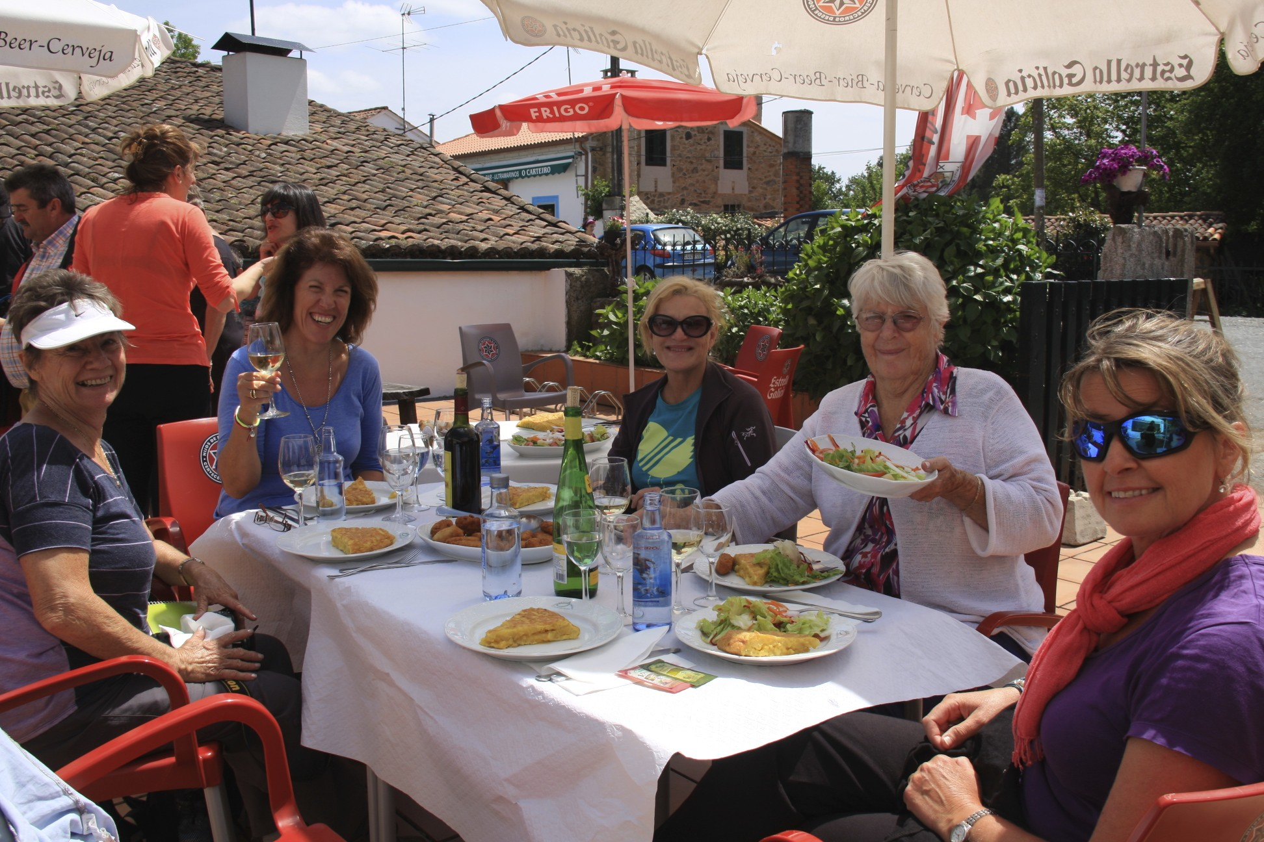
Day 7 – Sunday May Melide to Salceda (25,3 km)

After breakfast rendezvous in the lobby, with bags packed, ready to continue your journey. Your guide will transfer you back to Melide. On the Camino, see the Iglesia Santa Maria de Melide, on a slight rise to your right. This Romanesque church contains Celtic imagery and an ancient baptistery.
Trace the Camino as it weaves along country lanes and ancient stone pathways called corredoiras. Farmers tend their fields and the chimes of cowbells accompany the sounds of your footsteps. In this area of rural Galicia, it is not uncommon to see villagers still using scythes to work the land. At lunch, be sure to try the creamy cows’ cheese from Arzúa and empanada, a light crusty pastry-pie filled with beef or tuna.
Continue walking past the busy town of Arzua. Our pick-up spot this afternoon is in the small village of Salceda, and here your guide will drive you onwards to the lovely Pazo Xan Xordo, where your innkeeper Alfonso will be waiting to greet you.
Dinner in the hotel.
⌂ Your hotel tonight:
Pazo Xan Xordo

Day 8 – Monday May 18th Salceda to Lavacolla (19,1 Km)

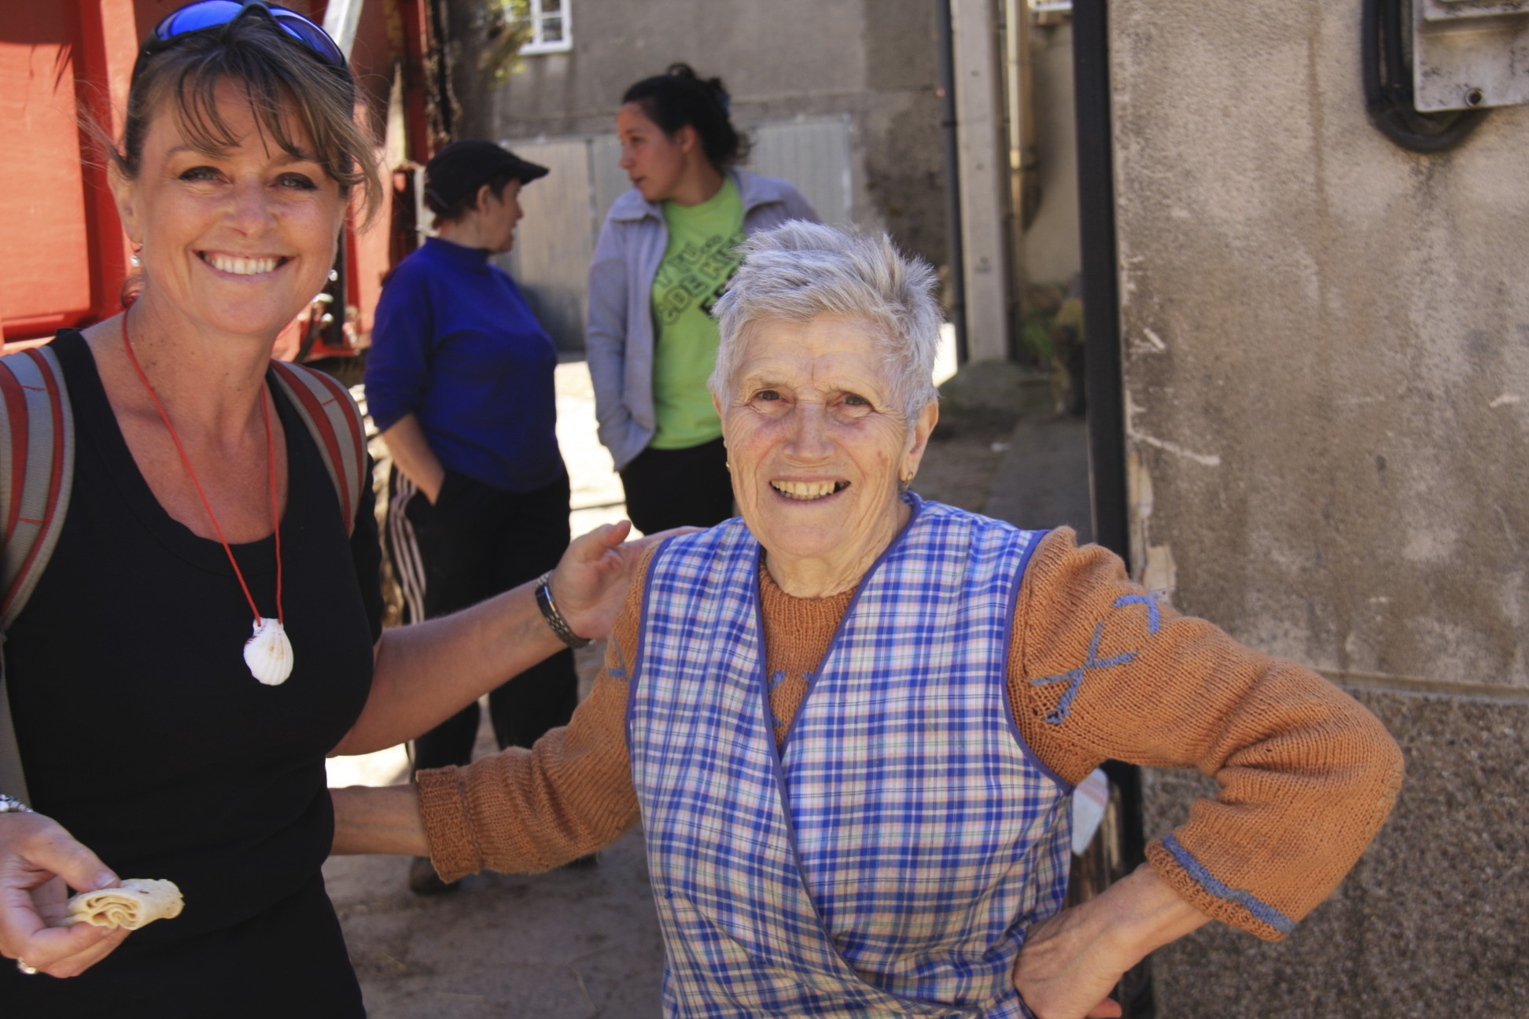
Your guide will drive you back to Salceda to continue the walk. Today’s section of the Camino will take you past vegetable patches, meadows, forests and tranquil villages with curious names such as Xen, Ras and Brea. In the village of Santa Irene, you can stop to visit the small Romanesque chapel dedicated to the saint of the same name, St. Irene. The trail now rises and falls through river valleys crossing gentle streams. Stroll under fragrant eucalyptus to reach Lavacolla, where some 2.0 km beyond the village is our destination, the peaceful Pazo Xan Xordo.
Lavacolla is where medieval pilgrims traditionally bathed in the river to purify themselves before arriving the next day in the holy city of Santiago.
Dinner in the hotel.
⌂ Your hotel tonight:
Pazo Xan Xordo

Day 9 – Tuesday May 19th Lavacolla to Santiago de Compostela (10,6 Km)

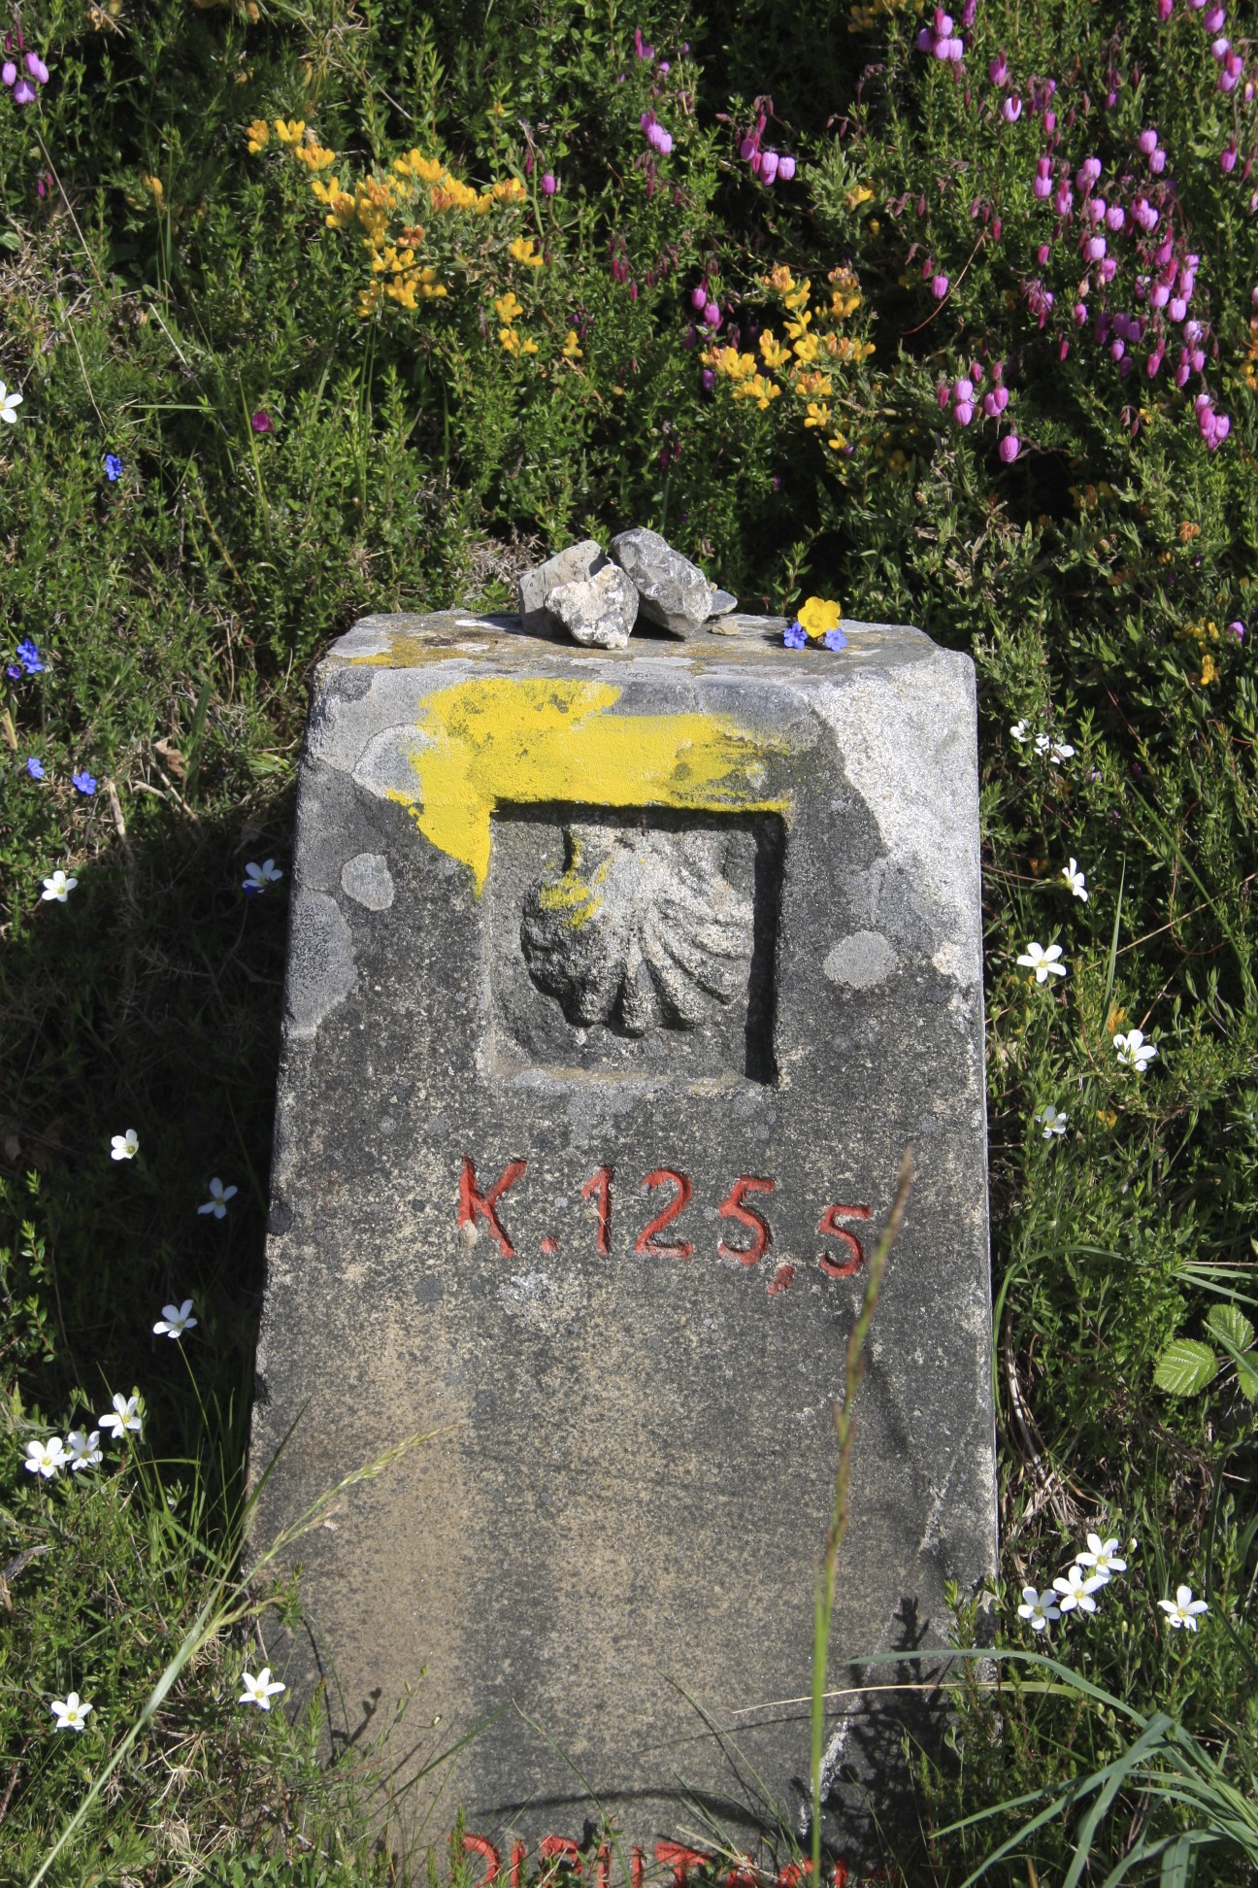
Excitement mounts as the trail brings you closer to Santiago de Compostela. From here you’ll begin to ascend the Monte del Gozo (Mount of Joy), the point where pilgrims first catch sight of the spires of the Cathedral of Santiago, these days surrounded by the bustling city of Santiago de Compostela.
Arriving in the Obradoiro Square, in front of the immense Cathedral, is an exciting moment, and after performing the traditional pilgrim rituals inside the Cathedral, check in to the beautiful Hotel Altair for a well-earned rest!
Tonight we celebrate our arrival in Santiago with a wonderful dinner in Santiago at Restaurante O Curro da Parra. This small but cozy bistro is located in a typical house in the historic heart of Santiago, close to the Mercado de Abastos – Santiago’s fresh produce market - where the Chef shops daily.
⌂ Overnight: Hotel Altair, Santiago de Compostela
Perfectly located in the old quarter of Santiago de Compostela (a brief stroll from the Cathedral), this small hotel combines the structure and wonderful granite stone of the original building, with a minimalistic, avant-garde interior.
Day 10 – Wednesday May 20th Discover the Spiritual Heart of Santiago de Compostela
Meet your guide in the lobby of the Hotel Altair. Enjoy a private tour of the magnificent Cathedral, in addition to exploring the narrow streets or rúas of the Old Quarter, where the vibrancy, history and magic of Santiago de Compostela come alive. Your historical visit will end in time for pilgrims' mass at noon in the Cathedral (where you might be lucky enough to see the Botafumeiro, the giant incensory swung by the priests high above the nave during Mass).
The rest of the day is free (lunch on your own) to explore this wonderful UNESCO designated city. Later in the evening, enjoy a free evening to sample Galician cuisine on your own. This vibrant university town has a plethora of bars and restaurants serving fresh seafood. If you are lucky, you might also catch a boisterous and spontaneous performance of traditional Galician minstrels called the Tuna; university students who dress in medieval garb including doublets, puffy shirts and tights and play the guitar, bandurrias and lutes in the plazas of the old quarter.
Dinner on your own tonight.
⌂ Overnight: Hotel Altair, Santiago de Compostela

Day 11 – Thursday May 21st Santiago to Finisterre, the “End of the Earth”
After breakfast, meet your guide in the lobby of the Hotel Altair. Farewell Santiago de Compostela and travel to Cape Finisterre (or Fisterra as it is known in the local language gallego). Finisterre is the final destination for many pilgrims on the Way of St. James (a further 90 km walk from Santiago). In the times of the Romans and Celts, Finisterre was considered to be the farthest edge of the northwesterly land mass and was described as “the end of the earth” (in Latin “finis terrae” means “end of the world”).
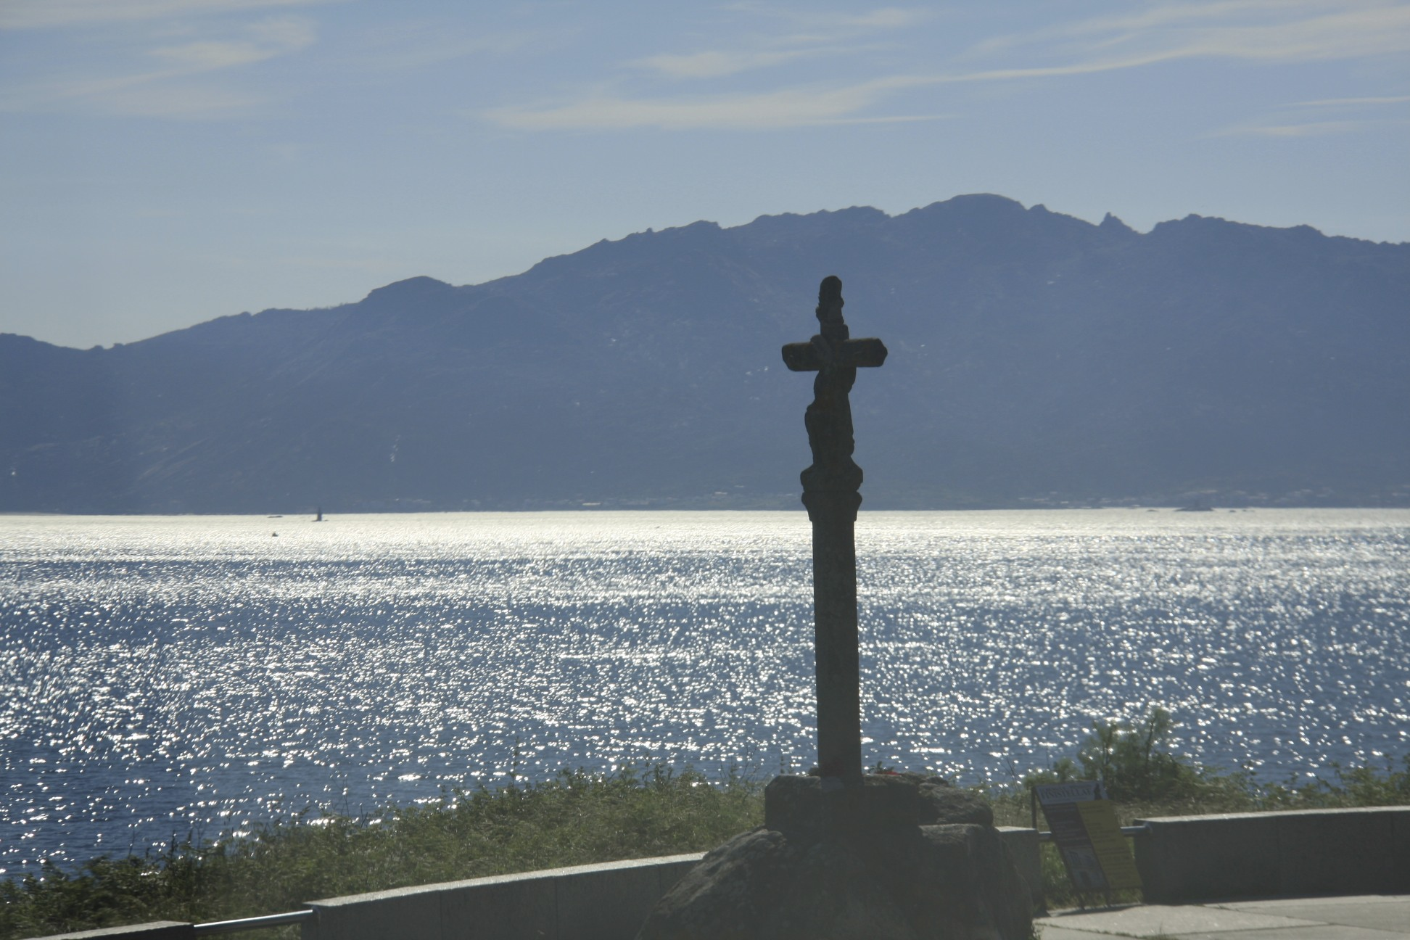
After visiting the lighthouse and cape, and performing a ritual to close our journey, your guide will take you to your lovely accommodations.
(NOTE: for those who are interested, there is the possibility of walking into Fisterra today).
Dinner tonight in the village includes wonderful fish dishes and seafood.
⌂ Your hotel tonight:
Hotel Alén do Mar
Calle Calcoba, s/n, Fisterra (A Coruña)

Day 12 – Friday May 22nd Fisterra – Castro Baroña – Quinta San Amaro
After a leisurely breakfast, we farewell Fisterra and continue toward the province of Pontevedra. Your guide will take you to visit several of the small coastal villages along this spectacular coastline. Here, the imprint of different cultures from the era of the Celts right down to the Modern Ages have all left their mark on the Galician culture. From Celtic Castros (Hill-forts) to the Dolmens left here by the region’s first inhabitants, the ability to work stone with the enviable expertise and craft of the master mason never seems to have been a secret in these parts.
Continue to the spectacularly located Castro de Baroña, an excavated site of an ancient Celtic fortress settlement. Situated on a highly exposed and rugged outcrop of land, the remains of the settlement are connected to the mainland by a narrow sandy stretch of beach on the wild Galician coastline. After pausing for lunch continue with your driver/guide to Quinta de San Amaro, your lodgings for the following four nights.
Dinner in the hotel tonight.
⌂ Your hotel for the next four nights:
Quinta de San Amaro
Calle San Amaro, 6. 36968 Meaño (Pontevedra)

Surrounded by lush vineyards, this lovely family-run hotel is located in the heart of the Rias Baixas wine region. Combing both avant-garde and rustic décor, this ancestral home features a cosy living room with fire-place, several cosy reading corners and a wonderful restaurant serving traditional Galician cuisine with a modern twist.
Day 13 – Saturday May 23rd Galician Cooking Class
This morning you’ll participate in an exclusive Galician cooking class at the Quinta de San Amaro. Your cooking class will commence with a trip on a fishing boat to the Ría de Arousa estuary and the nearby Atlantic Islands of Galicia National Park, where the best Spanish seafood comes from. Your hands-on class will then take place at the Quinta de San Amaro and after your cooking lesson you’ll enjoy your creations in the hotel restaurant, accompanied of course, by the best local albariño wine. Note: a bilingual guide accompanies your cooking workshop to translate for the Chef.
After lunch, the rest of the day at leisure, with free time perhaps for a relaxing massage in the hotel’s treatment room (we’ll inform you of prices the week before) or a stroll through the lovely grounds.
Dinner this evening in our hotel consists of delicious Galician tapas!
⌂ Your hotel tonight:
Quinta de San Amaro

Day 14 – Sunday May 24th Route of the Mills
Meet your host Nacho in the lobby to drive the short distance to the Monastery of Santa Maria in Armenteira. Built in the mid-twelfth century, this medieval Cistercian monastery has been fully restored in recent years. After a visit of the Monastery, commence a lovely walk which runs alongside the Armenteira riverside. Known locally as the “Water and Stone Route” or the “Route of the Watermills”, this leisurely trail traces the riverbank and passes a plethora of historic water mills along its seven kilometre length. Stroll through picturesque rolling countryside in a landscape dominated by lush green pastures and ancient forests.
Enjoy a wonderful picnic lunch in a idyllic spot towards the end of the walk. You’ll then be transferred back to the Quinta de San Amaro by taxi.
Dinner in the hotel
⌂ Overnight: Quinta San Amaro, (Meano)
Day 15 – Monday May 25th Shopping in Valença and lunch in Pontevedra
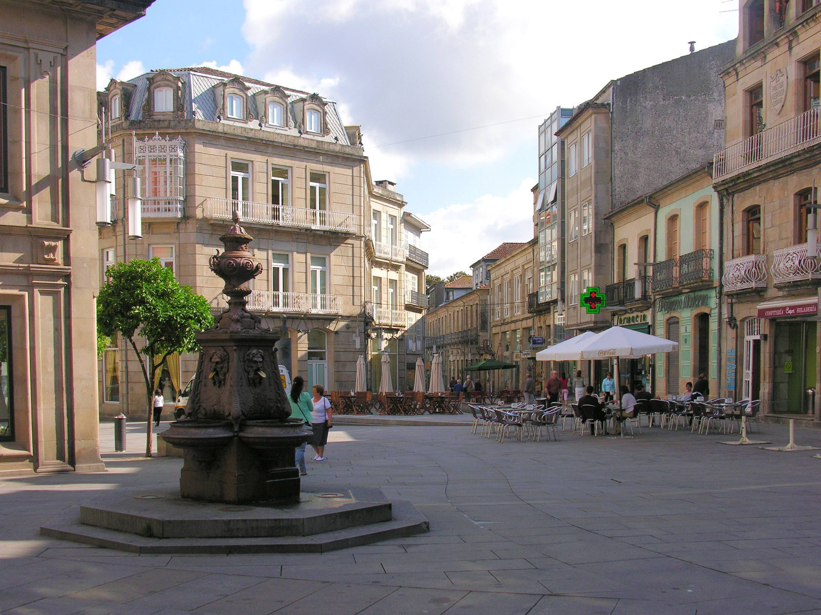
This morning you’ll visit Valença, a charming Portuguese market town located on the Spanish/Portuguese border and overlooking the Minô River. Stroll the narrow streets and shop for typical textiles such as embroidered tablecloths, the most exquisite bed linen, clothes – all uniquely located within the old fortress walls.
Continue to Pontevedra and perhaps pause for an aperitif in the lively main square (a great place to people-watch) before enjoying a light lunch of local seafood. Pontevedra is located on the Portuguese Camino and you will no doubt see several of the beloved yellow arrows that most recently guided you to Santiago !
Return to Quinta de San Amaro for dinner.

⌂ Overnight: Quinta San Amaro, (Meano)
Day 16 – Tuesday May 26th Return to Santiago
A private transfer will take you to Santiago for your last evening in this fascinating city.
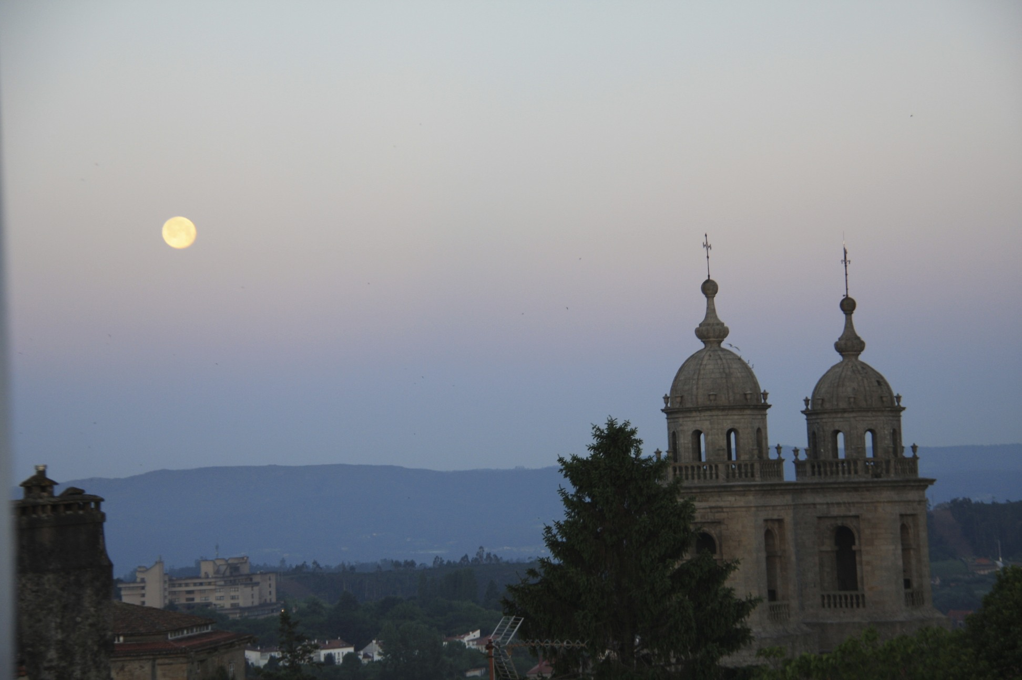
Enjoy lunch today in a unique “gastronomic space” located within Santiago’s Abastos fresh produce market. Here, the talented young Chefs prepare delicious dishes utilizing ingredients found only in the adjacent market stalls.
The afternoon is free and dinner is on your own tonight.
⌂ Your hotel tonight:
Hotel Altair

Day 17 – Wednesday May 27th Transfer to Santiago airport
Private transfers will take us from the hotel to meet our onward flights or train journeys.
It’s time to farewell the mystical land of Galicia. Buen Viaje!
Important Note:

Whilst every effort is made to adhere to this itinerary, please keep in mind that this is adventure travel in remote parts of Spain. There may be changes to this itinerary - from the hotels we use, to the places we visit & due to circumstances outside our control like weather, road conditions and last minute changes to government policy.

Journeys of the Spirit will do everything possible to ensure a memorable and exciting trip for you whatever situation presents itself, however it is highly recommended to take your lead from the locals, let go and let the magic of the Camino take over...

We thank you in advance for your flexibility and your open mind. Buen camino!

