Investment Appraisal for
Manufacturing Customer

Basis of Preparation
This appraisal has been prepared in order to provide Manufacturing Customer with the potential financial implications and investment returns arising from the proposed solution.

It is based upon a number of stages that together provide an assessment of the investment returns likely to be delivered as a result of project acceptance.

This assessment is based upon information and explanation from Manufacturing Customer and is indicative only. It is therefore not a part of the contractual offer from Software Supplier.

Background to Investment Appraisal
All the benefits identified in this project have been assumed to start after the installation and training have taken place in month 7 unless otherwise stated.

The sales proposal for this solution is submitted separately - and should be cross-referred to this appraisal.

In order to complete the investment appraisal Manufacturing Customer has requested the use of the following appraisal methods:

Net Present Value
A financial measure of whether a proposal delivers a "profit" or a "loss" using an annual cost of money applied to the timing of spend and savings. It includes the initial cost of the equipment / services, the monthly cost of maintenance, compared to the financial benefits accruing. The result is the change in shareholder value to be anticipated from project acceptance.

Internal Rate of Return
The return rate per year to Manufacturing Customer taking into account: initial cost of the equipment / services, monthly cost of maintenance, and comparing these to the timing of benefits identified as a result of implementing the project. The "percentage" answer is compared to the minimum requirement specified by Manufacturing Customer for approval.

Payback
This is a comparison of the initial outlay of monies, to buy equipment or services, against the time taken for the net benefits to cover the initial outlay. This derives an answer which is a time measure, and is usually quoted in months / years.

Discounted Cash Flow - to NPV and IRR
A detailed statement of all the cash flows and timings that underpin the results provided for Internal Rate Of Return and Net Present Value analysis.

Investment Summary

Non-Recurring Costs
 | Value | Month
Licenses | 150,000 | 0
Professional services | 75,000 | 0
Training | 20,000 | 5
Hardware | 10,000 | 0
Total non-recurring costs (€) | 255,000

Figure 1: Non-recurring costs |  | total €255,000

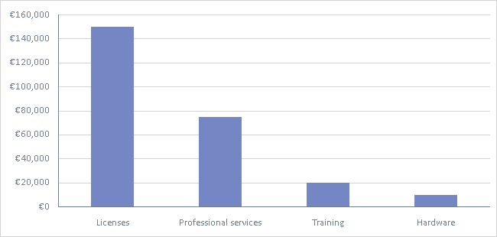

Recurring Costs
 | Value | Month | Growth (per yr %)
Maintenance licenses | 45,000 | Yearly  1 - 36 | 2
Maintenance hardware | 10,000 | Yearly  1 - 36 | 0
Support | 40,000 | Yearly  1 - 36 | 0
Average monthly costs (€) | 7,992

Figure 2: Average monthly costs |  | €7,992

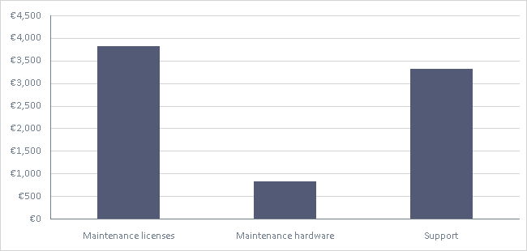

Benefits Evaluation
The following benefits have been identified that support this appraisal:

Manufacturing Benefits

Increased Plant Utilization
Annual unavoidable fixed costs in process (€) | 10,000,000
Current plant utilization level (%) | 85
Improved utilization (plant cost recovery) (%) | 86.5
Utilization improvement (linear %) | 1.8
Recovery of unutilized cost (%) | 1.5
Impact Life (months) | 7 - 36
Average monthly increased asset recovery (€) | 10,417

Reporting Savings - Document / Content Management
Time spent reporting (total FTE hours per month) | 400
Annual loaded cost per person (€) | 86,000
Reporting efficiency improvement with solution (%) | 50
Annual value of time saving (€) | 122,311
Annual non-labor cost saving (€) | 0
Impact Life (months) | 4 - 36
Average monthly savings (€) | 9,344

Activity Time Savings - Searching and managing info
Time spent on activity (total FTE hours per month) | 300
Annual loaded cost per person (€) | 86,000
Efficiency improvement post-solution (%) | 25
Annual value of time saving (€) | 45,867
Annual non-labor cost saving (€) | 0
Impact Life (months) | 3 - 36
Average monthly savings (€) | 3,610

There are 25 people in the design department and they currently spend a 25% of time looking for and handling information which will be kept centrally with the proposed system. An estimated 25% saving will be made in this area, freeing up the staff to do more useful activity.

Reduce Downtime Costs
Current downtime per month (hours) | 1.5
Downtime cost per hour (€) | 115,000
Reduction in downtime post-solution (%) | 2
Growth (per yr %) | 25
Impact Life (months) | 7 - 36
Average monthly savings (€) | 3,885

Bill of Materials Management Savings
Number of people managing BOMs | 25
% of time managing BOMs | 4
Annual loaded cost per person (€) | 86,000
Time saving post-solution (%) | 25
Annual savings (€) | 21,500
Impact Life (months) | 7 - 36
Average monthly savings (€) | 1,493

Reduce Warranty Provisions
Annual cost of warranty provision (€) | 400,000
Reduction in provision post-solution (%) | 5
Revised annual warranty cost (€) | 380,000
Impact Life (months) | 13 - 36
Average monthly saving (€) | 1,111

Improved production quality will lead to reduced need for warranty set-aside. Counted from the start of year 2.

Better Forecasting - Control Inventory
Current value of inventory (€) | 15,000,000
Percentage reduction with improved forecasting (%) | 2.5
New level of inventory post-solution (€) | 14,625,000
Annual interest cost (%) | 3
Impact Life (months) | 13 - 36
Average monthly savings (€) | 625

This benefit will be realised after the start of the second year.

Benefits Summary
 | Monthly Saving
Manufacturing Benefits
Increased Plant Utilization | 10,417
Reporting Savings - Document / Content Management | 9,344
Activity Time Savings - Searching and managing info | 3,610
Reduce Downtime Costs | 3,885
Bill of Materials Management Savings | 1,493
Reduce Warranty Provisions | 1,111
Better Forecasting - Control Inventory | 625
Total average monthly benefits (€) | 30,485

Figure 3: Average monthly benefits |  | €30,485

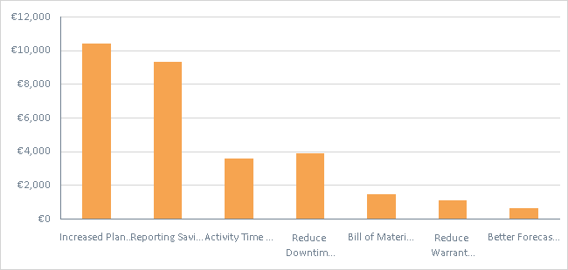

Cash Only Summary
The cash only impact of this appraisal, which specifically excludes any revaluation for time value of money is summarized in the table below. This table should be reviewed in isolation from the rest of the appraisal which may include revaluations for delays, growths, timings, interest costs etc.

 | Value
Benefits
Increased Plant Utilization | 375,000
Reporting Savings - Document / Content Management | 336,369
Activity Time Savings - Searching and managing info | 129,948
Reduce Downtime Costs | 139,860
Bill of Materials Management Savings | 53,760
Reduce Warranty Provisions | 40,008
Better Forecasting - Control Inventory | 22,512
Total benefits (€) | 1,097,457
Costs
Licenses | 150,000
Professional services | 75,000
Training | 20,000
Hardware | 10,000
Maintenance licenses | 137,700
Maintenance hardware | 30,000
Support | 120,000
Total costs (€) | 542,700
Net benefits (€) | 554,757
Simple ROI (%) | 102

Return On Investment Appraisal Elements

Net Present Value (NPV)

Calculation
Review period (months) | 36
Non-recurring costs (€) | 255,000
One-Time Benefits (€) | 0
Peak monthly benefits (€) | 36,938
Average monthly costs (€) | 7,992
Minimum return (per yr %) | 10
NPV (€) | 415,844

Discounted Cashflow Analysis - NPV
Month | Year 1 | Year 2 | Year 3 | Year 4 | Year 5
0 | -235,000
1 | -94,248 | -55,068 | -49,995 | 0 | 0
2 | 0 | 31,241 | 29,215 | 0 | 0
3 | 3,732 | 31,061 | 29,060 | 0 | 0
4 | 13,577 | 30,882 | 28,906 | 0 | 0
5 | -5,752 | 30,706 | 28,755 | 0 | 0
6 | 13,363 | 30,532 | 28,606 | 0 | 0
7 | 30,101 | 30,360 | 28,459 | 0 | 0
8 | 29,925 | 30,190 | 28,314 | 0 | 0
9 | 29,750 | 30,023 | 28,170 | 0 | 0
10 | 29,578 | 29,857 | 28,029 | 0 | 0
11 | 29,408 | 29,693 | 27,890 | 0 | 0
12 | 29,240 | 29,532 | 27,753 | 0 | 0
Total |  |  |  | 415,844

Figure 4: NPV Cumulative Discounted Cashflow |  | €415,844

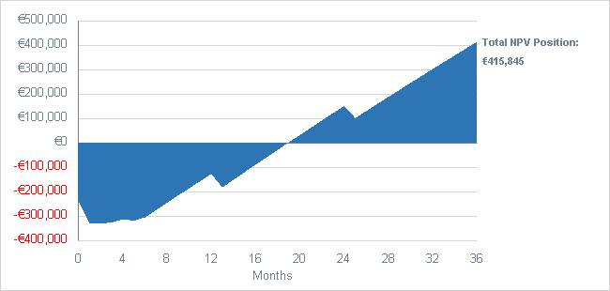

Internal Rate of Return (IRR)

Calculation
Review period (months) | 36
Non-recurring costs (€) | 255,000
One-Time Benefits (€) | 0
Peak monthly benefits (€) | 36,938
Average monthly costs (€) | 7,992
IRR (%) | 83.5

Discounted Cashflow Analysis - IRR
Month | Year 1 | Year 2 | Year 3 | Year 4 | Year 5
0 | -235,000
1 | -90,312 | -31,625 | -17,207 | 0 | 0
2 | 0 | 17,192 | 9,635 | 0 | 0
3 | 3,284 | 16,379 | 9,184 | 0 | 0
4 | 11,447 | 15,605 | 8,754 | 0 | 0
5 | -4,647 | 14,868 | 8,344 | 0 | 0
6 | 10,345 | 14,166 | 7,954 | 0 | 0
7 | 22,329 | 13,498 | 7,583 | 0 | 0
8 | 21,272 | 12,862 | 7,229 | 0 | 0
9 | 20,265 | 12,256 | 6,892 | 0 | 0
10 | 19,306 | 11,679 | 6,571 | 0 | 0
11 | 18,393 | 11,130 | 6,265 | 0 | 0
12 | 17,524 | 10,607 | 5,974 | 0 | 0
Total |  |  |  | 0

Payback

Calculation
Non-recurring costs (€) | 255,000
One-Time Benefits (€) | 0
Peak monthly benefits (€) | 36,938
Average monthly costs (€) | 7,992
Payback (months) | 18

Figure 5: Payback Cumulative Cashflow |  | 18 months

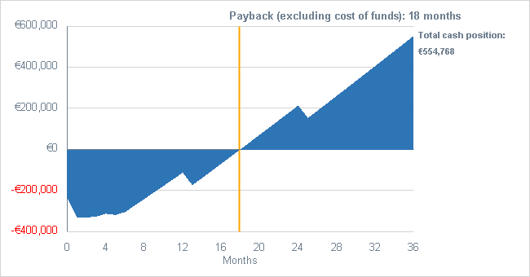

Cost of Delay
Every month that the decision is delayed is worth €22,493. If Manufacturing Customer chooses to delay the decision by 4 months net benefits of €89,972 would be lost.

Summary
€255,000 | €7,992 | 36 months
Non-recurring costs | Average monthly costs | Review period
€30,485 | €415,844 | 83.5%
Average monthly benefits | Net Present Value | Internal Rate of Return %
18 months | Based upon an assumed cost of capital of
Payback | 10% per yr

The Investment Appraisal outlined above is based upon identified benefits that would accrue to Manufacturing Customer as a result of project acceptance.

The investment evaluation of these costs and savings has been completed using the Shark appraisal tool. The output from this tool is fully visible and can be audited by Manufacturing Customer if so required

This indicative analysis stands separately from the contractual elements of the Software Supplier solution and is necessarily dependent upon the benefits identified jointly with Manufacturing Customer.

