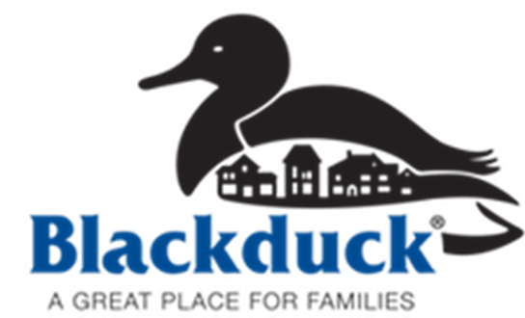

City of Blackduck: Small Business Recovery Fund Guidelines

A small business recovery fund to support and assist

local businesses adversely impacted by the COVID-19 pandemic.

September 10, 2020

Purpose:
To provide emergency recovery support to small local businesses in the City of Blackduck adversely impacted by the COVID-19 pandemic, the City of Blackduck Small Business Recovery Fund will aid of up to $5,000 to small businesses most in need of support. Funds will help businesses pay for critical expenses such as current payroll obligations, rent payments, mortgage payments, utilities, and payments to suppliers. Providing this support will increase the capacity of small businesses with a physical location in the City of Blackduck to rebound from the current crisis and will help prevent potential future blight scenarios. The Small Business Recovery fund was made possible by CARES ACT funds with the authorization of the City of Blackduck. The Headwaters Regional Development Commission (HRDC) will administer the fund on behalf of the City.

Funding Availability:
  - Applications will be available at the announcement of funding (expected about September 19th, 2020).
  - Applications will be due to HRDC or City of Blackduck by expected October 3, 2020.
  - All applications will be reviewed by the funding committee within two weeks of the closing of the application period.
  - Awards will be made within one week of the committee meeting (expected by October 9th, 2020).
  - If funds are still available after the first round of funding, the City may solicit additional applications.

PROJECT & APPLICANT ELIGIBILITY:
- Be able to demonstrate that they were directly and adversely affected by COVID – 19 (The recipient must be able to demonstrate a significant reduction in revenues as calculated by monthly sales from the period March 1, 2020 through June 30, 2020 compared to the prior year sales for the same time period).
- Have a physical location in Blackduck.
- Priority will be placed on businesses who’ve experienced a significant decline in revenue, faced closure due to Executive orders, not received additional state or federal disaster assistance, or experienced other extraordinary hardships due to the pandemic.
- Must be current on all financial obligations as of March 1, 2020.
- Eligible Activities Included but not limited to:
    - Working Capital
    - Inventory and Equipment to resume operations
    - Business investments that will make the business more resilient to future disruptions.
    - Other operational expenditures necessary to keep the business from closing.
- Ineligible Activities include:
    - Direct selling, multi-level marketing businesses, etc.
    - Home-based businesses without a physical establishment
    - Businesses in default conditions prior to February 29, 2020
    - Businesses that primarily derive income from gambling
- Approval Authority
  - The City of Blackduck will have the ultimate authority to approve or deny applications on a case-by-case basis and may impose certain conditions on approved projects.
TERMS:
All funds granted under this program shall be subject to the following terms and conditions:
- Project participation is limited based on the availability of program funds.
- The City will provide the business financial assistance in the form of a grant.
- The minimum assistance granted under this program shall be $1,000 and the maximum shall be $5,000 per business.
- Funding level is based on the total impact resulting from the pandemic during the period March 1, 2020 through June 30, 2020, number of applicants and the total funds that are available.
- Businesses are eligible to receive the amount of the reduction due to the pandemic for the time period less any other funding received, up to the maximum assistance available.
- Subsequent funding round applicants may receive additional resources up to the total amount of loss, based on availability of funding.
PROGRAM PROCEDURES:
- Applicant submits application to the HRDC or City of Blackduck. Including the following materials
- Either prepared financial statements for a 2 – year period, or historical cash flow, or income statement, OR 2 years tax returns
- Documentation of other assistance received.
- The City and their staff reviews application and approves or deny request. If approved, the City may place conditions on the proposed project.
  - If denied, applicant may submit a revised application and repeat process.
  - “Assistance Agreement” is drafted by that identifies the terms of the agreement. All parties execute said letter.

