Amazon Web Services (AWS) Database Migration & Conversion

Abstract
Adopting AWS as a new environment for your database workload offers many benefits, including increased flexibility, reduced costs, and general business value, however, moving your database workloads to the cloud also can present some challenges.
These challenges can be predicted and avoided to a large extent with thorough preparation and planning, as well as engaging an experienced partner, such as Aritex IT, to assist.
This paper describes the methods that allow you to migrate your schema and data from your source database to your new AWS target database, while minimizing downtime and mitigating risk.

Why move your database to AWS?
Whether you are a startup or an established enterprise, the AWS public cloud offers a wide range of database management systems and database services that offer many advantages to traditional on-premise architecture.
Business Value
One of the major reasons to migrate to the cloud is a fact that most companies do not want to be in the data center business. They want to focus on what they do the best, which is their business.
By moving your databases to AWS, you will relieve yourself of many of the database related administration tasks. As an example, in the case of moving to AWS Relation Database Services (RDS), almost all the database responsibilities are shifted to AWS as can be seen in the chart below.

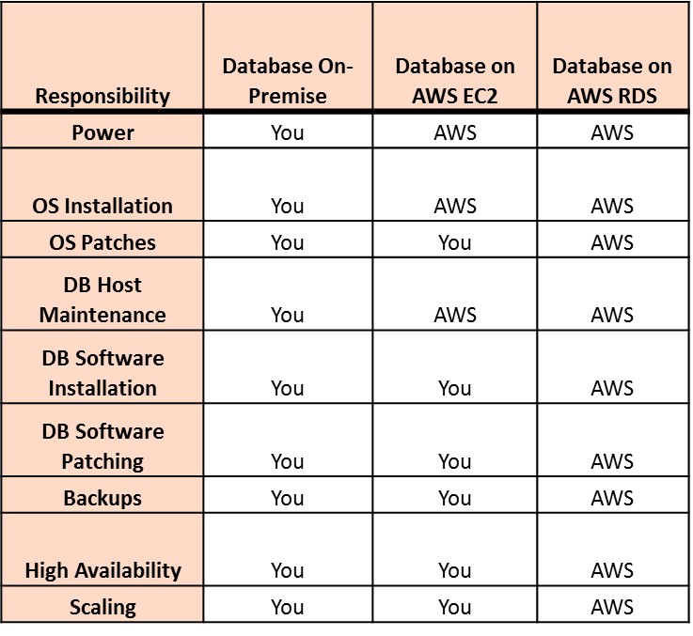
Security & Compliance
Security and compliance are another area where the cloud has a clear advantage over on-premise solutions. AWS employs and enforces industry best security and compliance meeting virtually every compliance standard required to do business on the world stage. This is further proven by not only the millions of customers that trust AWS everyday but also those that require extremely high levels of security including government agencies and global financial institutions.
Growing Data Requirements
Data is the driving force behind any business. The ever-increasing amount of data is driving businesses to look for larger, more scalable, and less costly solutions. AWS is a great solution for this problem.
As an example, Amazon Elastic Block Store (EBS) provides persistent block storage volumes for use with Amazon databases in the AWS Cloud. Each Amazon EBS volume is automatically replicated within AWS data centers, offering high availability and durability. Amazon EBS volumes offer the low-latency performance needed to run database workloads.
Scaling
AWS cloud services were and continue to be built from the ground up to scale. Organizations running on AWS do not need to purchase additional hardware or set up additional infrastructure to meet a sudden, temporary increase in demand. The infrastructure is available and ready to be used when it is needed and can be scaled back just as easily to avoid overspending.
You can easily move your AWS database to more, or less powerful database instance types, paying for only what and when you provision. With Amazon EBS, you can also scale your usage up or down very quickly, again paying for only what you are using.
Reliability
AWS has redundant services scattered throughout the world. AWS currently spans 19 regions and 61 data centers (Availability Zones) within 20 geographic regions around the world. The large number of regions and availability zones allow for redundant, low-latency connections to your network and your databases from anywhere in the world.
Technology
Amazon Web Services has invested heavily in the latest technologies. According to Bloomberg, Amazon's spending in technology and content has doubled since mid-2015, quintupled since 2012 and is up tenfold since 2011. Amazon leads the global list of corporate R&D spenders by a very large margin: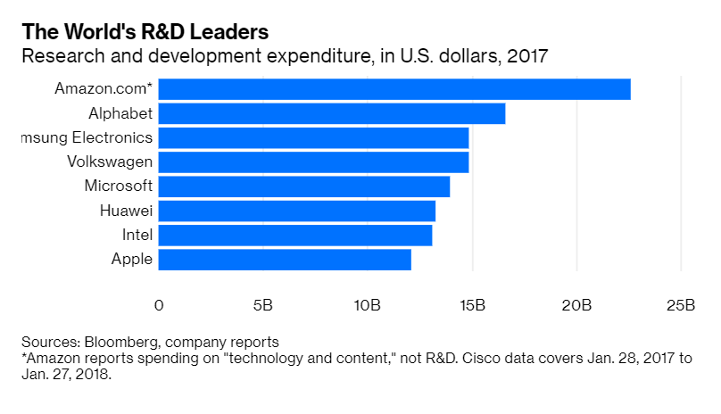
Whether deploying databases under AWS RDS, or Amazon Elastic Compute cloud - EC2, you can take advantage of Amazon’s global advanced computing scalability and reliable infrastructure.
Cost
Predictable accounting is another common reason for cloud adoption. Traditional on-premise server infrastructure falls under capital expenditures (CapEx). Cloud-based solutions fall under operational expenditures (OpEx). Your organization is charged for what it actually uses, rather than investing in hardware that it may or may not be utilized to its full potential before it becomes obsolete.
The benefits of cloud and database migration, both in initial investment and ongoing costs are obvious, however, a database migration is a big undertaking. Having a sound plan in place before starting is very important. It is also crucial to work with a migration & conversion provider that is committed to your success.
Aritex IT can help you with all the migration and conversion steps, from developing a concrete plan, ensuring a successful migration and/or conversion as well as assisting with performance optimization and monitoring of the target database.

AWS Database Migration Options
Infrastructure-as-a-Service (IaaS) Deployments
One way to use the AWS platform is to deploy your database on the AWS IaaS platform similarly to how you would deploy them on on-premises infrastructure. This means allocating AWS Database Server (EC2 instance) for the database software and provisioning an EBS storage for the data.
AWS IaaS offers simple provisioning and management of hardware (servers, storage, network) with interchangeable resources that are easy to replace in case of need. Capacity (CPU, memory, storage) is also very easy to allocate.
Platform-as-a-Service (PaaS) or Database-as-a-Service (DBaaS) Deployments
AWS also offers a PaaS platform - Amazon Relational Database Services (RDS). All major database engines are offered as DBaaS. This is a managed service where Amazon handles all the major DBA and system administrator efforts via complete automation that includes provisioning, upgrades, backups, and high availability (HA) through multi-availability zone replication.
For most workloads RDS is the preferred method. Amazon RDS is a managed service that makes it easy to set up, operate, and scale a relational database in Amazon public cloud. It provides cost-efficient and resizable capacity while automating time-consuming administration tasks such as hardware provisioning, database setup, patching and backups. It frees you to focus on your applications, to provide needed performance, security and support.
Amazon RDS is available on many database instance types, optimized for memory, performance, or I/O. In addition, as mentioned before, Amazon RDS allows you to choose from all the major database engines (Amazon Aurora, PostgreSQL, MySQL, MariaDB, Oracle, and Microsoft SQL Server). Amazon Aurora is a MySQL and PostgreSQL-compatible database engine built for the cloud. It provides a high performance, availability, security, and reliability of commercial databases at very low cost.
To migrate or replicate existing databases to Amazon RDS, the AWS Database Migration Service (AWS DMS) can be used. An AWS DMS consists of Source and Target Endpoints, as well as a Replication Instance. The Replication Instance is a managed Amazon Elastic Compute Cloud (Amazon EC2) instance that hosts one or more replication tasks.

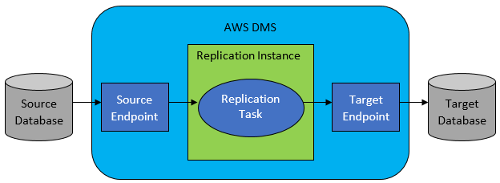
In the event of converting the source database schema to different database engine, AWS offers Schema Conversion Tool (SCT), which helps to automate this process and further mitigate risk.

Database Migration Types
The source database can be migrated to the AWS cloud using the same database engine, however, the source and target databases do not have to be of the same engine type. In the latter scenario, we are talking about database migration and conversion. For example, to avoid licensing costs, you may decide to migrate your commercial on-prem source database to AWS, and move to one of the open-source database engines.
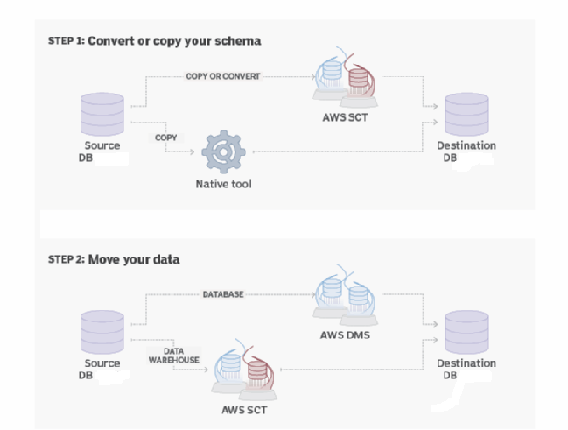
There are two possible types of database migrations:
Homogenous migrations: migrations between the same engine types
Heterogeneous migrations: migrations between different engine types
Aritex IT has vast experience and can help you with both types of migrations.
Also, if your application code is partially, or mostly, on the back end (in the database as functions, procedures or packages), Aritex will help you with the conversion assessment and the automatic conversion process.
One of the most important questions to consider while planning a migration to AWS, is the size of the database. The amount of data to migrate, and the acceptable downtime determine the data migration method.
There are the following 3 options to move the data to AWS:
- Migrate existing data
  - This option can be used if you can afford an outage that’s long enough to copy all the existing data.
- Migrate existing data and replicate ongoing changes
  - Using AWS DMS, the data is fully loaded while capturing changes on the source. After the full load is complete, captured changes are applied to the target.
- Replicate data changes only
  - In this approach, the data is migrated first using some other tool then DMS. You can then use AWS DMS to replicate changes as of the point in time at which you started your bulk load, to bring your source and target systems in sync.
*Options 2 and 3 enable database migration with zero downtime.

Conclusion
Your requirements such as PaaS or IaaS (RDS or EC2), acceptable downtime, migration or migration with conversion, will determine the duration of a migration project and its complexity. Knowing your source database in terms of size and code complexity, is also very important for the duration and the success of the migration project. How busy the source database is, might determine the migration method. Migration tools put additional load on source database. If your traffic is very high, it might be unrealistic to plan a live migration and you should consider alternatives.
In order to better control risk, consider a phased approach to migrating your databases to AWS. For example, if you are planning migration with conversion, the best migration approach may be to migrate first to AWS, and then convert. Converting to a different database engine is an iterative process, potentially a complex one, depending on the amount and the complexity of the code that needs to be converted.
As we can see, there are challenges to completing a successful database cloud migration. Aritex IT will provide all the necessary assistance throughout the entire process, from requirements gathering, writing & executing a playbook, monitoring, on through performance tuning of the target database so please don’t hesitate to reach out for an evaluation discussion.
Resources:

Migrating to Amazon Web Service
https://aws.amazon.com/cloud-migration/

AWS Whitepapers
https://aws.amazon.com/whitepapers/

AWS Services in Scope by Compliance Program
https://aws.amazon.com/compliance/services-in-scope/
AWS Migration Hub
https://aws.amazon.com/migration-hub/
AWS Database Migration Service - User Guide
https://docs.aws.amazon.com/dms/latest/userguide/Welcome.html

