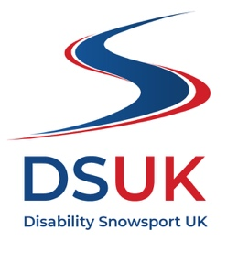

Trustee Recruitment pack

April 2022

Contents

Foreword from our Chair Page 2

About DSUK Page 3

Our Impact Page 3

Our Goals Page 3

Our Values Page 4

Time commitment Page 5

Role and Personal specification Page 5

Remuneration, and how to apply for the role Page 7

Foreword from our Chair

Thank you for showing interest in becoming a Trustee of Disability Snowsport UK (DSUK). Building on our proud history that spans over forty-years, DSUK has recently entered an exciting new phase of growth and recovery from the pandemic.

Currently an active board of 11, we are seeking to appoint an additional Trustee who has a passion for our work and have the capacity and motivation to help us deliver our mission and vision.

To complement our existing board and support our strategic direction, at present we are looking for a committed individual to bring knowledge, skills and experience in Finance – including planning, accountancy and audit.

Having our members’ voice represented at the board is important to us, so we would encourage people who have skied or snowboarded with us, or other adaptive skiers, to apply. Additionally, in the interests of board diversity we would welcome applications from young people and those from ethnic minority backgrounds.

Disability Snowsport UK is an equal opportunities employer and welcome applications from all suitably qualified persons regardless of their race, sex/gender, disability, religion/belief, sexual orientation, gender reassignment, marital status or age.

Previous board experience is not a pre-requisite. Training will be given to new Trustees where appropriate. Our priority is to recruit people who share our passion to make the unique benefits of snowsport accessible to all disabled people, particularly at a time when they may feel their opportunities are limited.

Shona Tate, Chair of the Board of Trustees

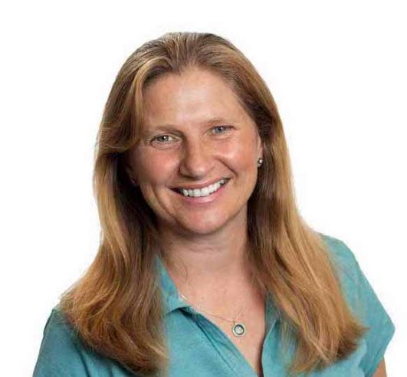

About DSUK
DSUK has for over forty years’ provided the opportunity for so many living with a disability, to experience the thrill and independence that taking part in snowsports can provide. Be it gentle assistance or using the quality specialist equipment we provide, our adaptive instructor team and volunteers can help make life changing moments for individuals and their families.

We’re experts in adaptive snowsports. We run adaptive snowsport schools and support local groups at snow centres and dry slopes in the UK, as well as organising trips to the mountains. Working with a team of qualified instructors and incredible volunteers, we help to build a community, forge new friendships and ensure everyone can access snowsports.

It is our dream that mountains and slopes are free from barriers, where disabled people can learn and take part alongside family and friends.

The company (the Uphill Ski Club of Great Britain t/a Disability Snowsport UK), is a limited company and also a charity registered with The Charity Commission and the Office of the Scottish Charity Regulator (OSCR).

Our Impact
Mastering the slopes can be a life changing experience - particularly for disabled people.

We want to challenge the view that snowsports are only for the able-bodied and wealthy. Everyone has the right to enjoy the physical, mental and social benefits of snowsport.

For our customers, it’s about enjoying achievement and independence. From picking their line to controlling their speed, they can experience something that’s often missing from their everyday lives – freedom.

Our Goals
The organisation usually works to a three year strategy but the ongoing pandemic means that we are currently implementing a one year strategy and will develop a further three year plan during 2021/22. We are currently working towards a series of short-term goals:

GOAL 1: Develop the Skier Journey with expert knowledge and support, ensuring progression in a meaningful way for every skier.
GOAL 2: Build and support the DSUK and adaptive community in the UK.
GOAL 3: Ensure our people have the tools they need to thrive.
GOAL 4: Build sustainability and an organisation fit for the future.

Our Values
At the heart of DSUK are our values which are the cornerstone of our daily work. Staff are invited regularly to demonstrate that they uphold the values, which are front and centre here at DSUK:
We might not always achieve what we intend to but we believe that failure demonstrates effort. We celebrate our effort and courage because we were brave and we gave it our all.
We offer a warm and friendly welcome to everybody - whether you are living with a disability, injury or limb loss, or want to help those who are.
We believe that everyone deserves the power of snowsport in their lives and we’re committed to creating an inclusive and supportive space for all.
We believe in your full potential and are excited to work with you towards achieving your goals.
We will share our honest opinions on what will or will not be possible within any given constraints. We will provide honest feedback on your performance. and progression.
We recognise that you are the expert in your own life. We will listen to you and strive to meet your individual needs.
WELCOMING

CELEBRATING DIFFERENCE

CHALLENGING & SUPPORTING

BEING HONEST
LEARNING
STAYING POSTIVE
LISTENING

We all have tough days but we will try to maintain a positive attitude, because what we achieve together is awesome!

In terms of our social conscience we are a Living Wage Employer, and we are also mindful of our responsibility to protect the environment that we rely on so heavily.
We are building on our existing partnerships with private and public organisations, and always look to work in partnership and support other charities.
We intend to work towards a formal recognition of our organisational practice, for example (Disability Friendly Employer, Investors in Volunteers etc.).

Time commitment
The Board meets formally at least 4 times per year with less formal updates in between times. Formal meetings are generally held in the evenings and last about 2.5 hours. For the foreseeable future meetings will take place by video conference, and this will remain an option in future. Board papers are usually issued one week in advance of the meeting. Trustees are asked to have read all papers ahead of the meetings.

Trustees are also asked to serve on at least one Board sub-committee. The Board sub-committees are Audit & Risk, Nominations, Remuneration & Governance; and Fundraising & PR. The successful candidate will be asked to join the Audit and Risk Committee. These committees meet at different frequency throughout the year. These meetings are generally shorter (approx. 1 ½ hrs). In response to the pandemic the Audit and Risk Committee currently meets monthly however this will be reviewed over the course of the year.

Outside of this, Trustees are sometimes called upon to advise or support the senior management team on specific issues or projects. Trustees are also expected to participate in, or represent the organisation at, external events on occasion. For example, to help raise awareness of DSUK, build partnerships, or at fundraising events. The total time commitment is anticipated to be approximately 6-8 days per year.

Role and Person specification

Board Member Role and Responsibilities
A Trustee/Director may also be known as a Board Member. This is a non-executive role within DSUK. The main responsibilities are as follows:
- To actively serve on the governing body of DSUK to ensure it is well run and meets its charitable objectives as set out in our Articles of Association. Ultimately Trustees/Directors have accountability for ensuring the success and compliance of the organisation.
- To provide strategic direction, agreeing policy, outcomes and outputs.
- To act as a critical friend of the organisation – challenging and supporting your fellow Trustees and the CEO, where appropriate.
- To ensure adherence to the specific statutory duties of a Trustee/Director as set out in the Companies Act, the Charities Act 2011, and the Charites (Protection and Social Investment) Act 2016, and Charities and Trustee Investment (Scotland) Act 2005.
- To use skills, knowledge, expertise, experience, and networks to assist in supporting the development of DSUK.
- To attend Board meetings, scrutinising any papers in advance, being prepared to contribute new perspectives to discussions and help the team focus on key issues.
- To participate in sub‐Committees as required and work with staff accordingly.
- To monitor the performance of the Chief Executive, and the Senior Management Team, as appropriate.
- To uphold the values of the organisation and act as an Ambassador for DSUK to promote the charity and its impact.

Person specification
Personal qualities
Successful candidates will:
- Have a belief in the work of DSUK and an empathy with, and commitment to our vision, mission, and values
- Have an understanding of, and commitment to, the charitable/third sector
- Have an ability to see the big picture and provide strategic vision and leadership
- Be willing to have a viewpoint, to speak up and provide constructive challenge
- Bring imaginative and unique perspectives to bear on issues under discussion
- Be able to assess risks and demonstrate good independent judgment in decision making
- Demonstrate integrity and be a suitable role model for the organisation
Specific skills and experience
To complement our existing board and support our strategic direction, at present we are seeking Trustees who will bring knowledge, skills or experience in Financial Management. This may include experience of managing finance within an organisation, working in an audit function or a regulated environment, and /or experience on an audit and risk committee. Ideally you will be a Chartered Accountant with experience of management reporting (including cashflow) and financial planning. In addition it would be helpful to have an understanding of statutory accounting and reporting requirements for charitable organisations.

Having our members’ voice represented at the board is important to us, so we would encourage people who have skied or snowboarded with us, or other adaptive skiers, to apply. Additionally, in the interests of board diversity we would welcome applications from those from ethnic minority backgrounds.

Disability Snowsport UK is an equal opportunities employer and welcome applications from all suitably qualified persons regardless of their race, sex/gender, disability, religion/belief, sexual orientation, gender reassignment, marital status or age.

Remuneration, and how to apply for the role
This is a voluntary position and therefore unremunerated, however reasonable expenses for travel and subsistence will be reimbursed.
The appointment will be for a fixed term of 3 years initially. Trustees can then stand for re-election and would generally serve for two terms, or a maximum of eight years in total.
If you are interested in this exciting opportunity, please write to Carmel Teusner, Vice Chair, DSUK. We ask that you provide a personal statement as to why you wish to be considered for the position. This should set out and how your knowledge, skills or experience match the role requirements set out above. We do not expect you to be able to cover everything in this list. Please focus on the specific and unique attributes that you bring. This statement should be no more than 2 sides of A4. If you have CV, please attach this as well. Applications should be emailed to - carmelteusner@disabilitysnowsport.org.uk and labelled Private and Confidential – Trustee application.
For an informal discussion outside of this, please contact Virginia Anderson, Chief Executive on virginia.anderson@disabilitysnowsport.org.uk
Applications are open until 29th April
Shortlisted candidates will be contacted and be offered an interview with three current Trustees. These interviews will take place in the week commencing 9th May 2022.

