F R O M T H E D E S K O F

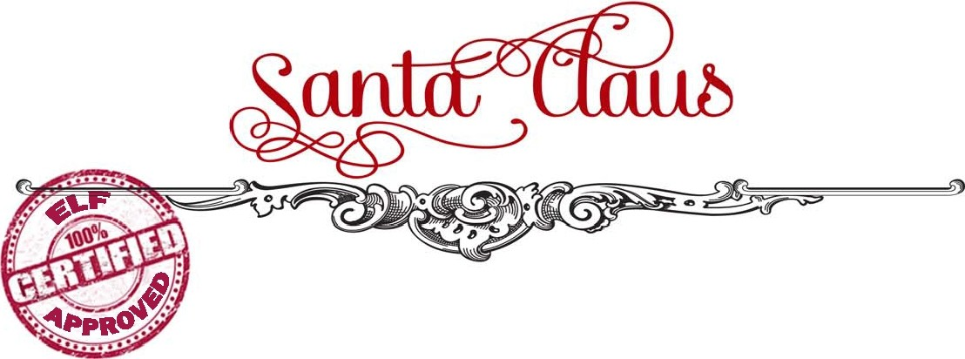

My Dear First name,

Rudolph just whispered in my ear that the sleigh is getting packed soon! Are you getting excited?

It is that time of year and all of the reindeer have been practicing their flying and the elves are putting the finishing touches on all of the toys! And me? Well, Mama (that’s what I call Mrs. Claus) has been feeding me cookies day and night… I need to be nice and plump so my red suit fits perfectly on Christmas Eve!

I am writing to remind you to continue being good! Help your parents as often as you can and be kind to others. Even though some days it can be difficult to be good, I see that you have tried very, very hard. That makes me so proud. You are AGE years old now? That is so hard to believe! I guess time flies when you live in the North Pole! Ho, ho, ho!

My elves have been busy in the workshop all year. They have been making all kinds of toys for good boys and girls. Last week we had a chat and we have all agreed that you deserve something extra-special this year. I have been told that you are hoping to find a special present when you wake up Christmas morning. Please know that we’ll do our very best!

The reindeer and I will be on our way to visit your home in town before too long. I am very excited about my long journey to the homes of all of the good little boys and girls all around the world!

Merry Christmas and Best Wishes for a Happy 2016!

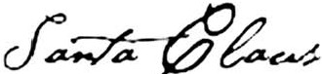
CHECKED TWICE & SIGNED BY

T H E N O R T H P O L E, A R C T I C C I R C L E

