TCBC Worship Guide
Sunday, August 7, 2022

Welcome and Opening Prayer – Pastor Barr

Call to Worship – Psalm 50:1-3, 23 – The Mighty One, God the Lord,
Has spoken and called the earth from the rising of the sun to its going
down. Out of Zion, the perfection of beauty, God will shine forth. Our
God shall come, and shall not keep silent; A fire shall devour before
Him, and it shall be very tempestuous all around Him. Whoever offers
praise glorifies Me; And to him who orders his conduct aright I will show
the salvation of God.

We call on all creation to praise our God and King:
# 58– “All Creatures of Our God and King”

Choir – “When Morning Gilds the Skies”

“Holy, Mighty, Worthy”

Scripture Reading – Philippians 2:1-11 – Daniel Pittman

We humbly confess our need for Christ’s sacrifice:
Psalm 51– “I Plead for Grace”

We find assurance in the work of Christ for us:
# 230 – “Glory to His Name”

Pastoral Prayer – Pastor Parkin

Message – Pastor Barr

We respond with a prayer for the Lord to lead us and strengthen
our faith:
# 91 – “The Steps of a Good Man”

Dismissal
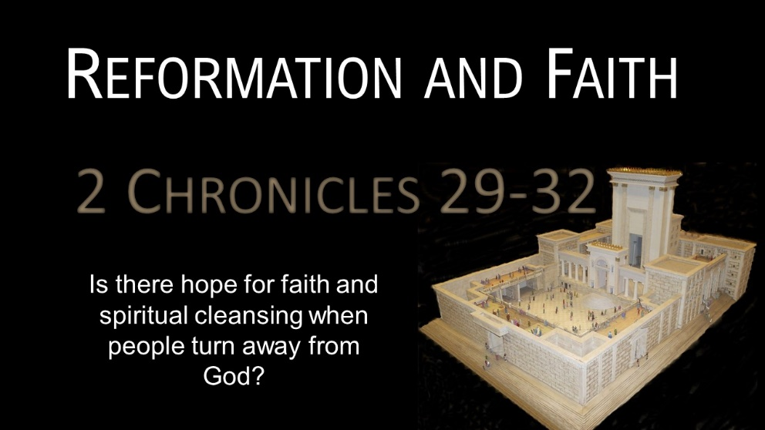

Finishing Well
2 Kings 20:12-21

- After great spiritual victories, temptation can come from unexpected places. 12-13
- After spiritual failure, temptation can lead us to forget our spiritual commitments. 14-19

We need to finish life well by finishing with a tested faith.

