TCBC Worship Guide
Sunday, May 22, 2022

Welcome and Opening Prayer — Pastor Parkin

Call to Worship – Psalm 67:1-4 – God be merciful to us and bless us, And cause His face to shine upon us, Selah. That Your way may be known on earth, Your salvation among all nations. Let the peoples praise You, O God; Let all the peoples praise You. Oh, let the nations be glad and sing for joy! For You shall judge the people righteously, And govern the nations on earth.

We joyfully praise our blessed Redeemer:
# 20 (106) – “Praise Him! Praise Him!” (3 vs.)

Scripture Reading – Ephesians 2:1-10 – Alex Boyles

We humbly acknowledge our sin and hope in God’s mercy:
Psalm 130 (419) – “Out of the Depths” (3 vs.)

Choir – “O Love Divine”

We find assurance in the work of Christ on the cross for us:
“The Power of the Cross” (4 vs.)
Dismiss for children’s church on the 2nd verse

Pastoral Prayer – Pastor Williams
Musicians down
Message – Pastor Barr

We remember Christ’s sacrifice for us:
“Amidst Us Our Beloved Stands” (4 vs.)

Lord’s Supper
Bread – Pastor Parkin
Cup – Pastor Probus

Scripture Reading
I Thessalonians 4:13-18 – Pastor Barr

We respond by meditating on the results of Christ as our Substitute:
Luke Probus – “It Is Well” (piano)
Dismissal

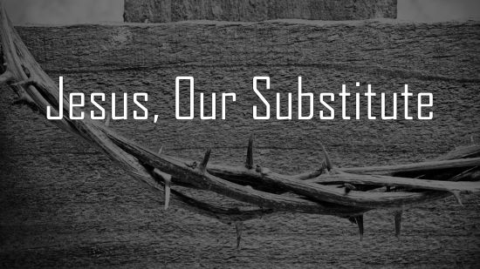

Jesus, Our Substitute
Deut. 21:22-23; Gal. 3:13

- Respect for the Condemned: The Mosaic Law regulated how the death penalty was to be enforced. Deut. 21:22-23
- Reverence for Christ: Jesus endured the curse of the death penalty. Deut. 21:23b, Gal. 3:13

As we partake in communion, we declare our belief in our Savior who willingly became accursed for us.

