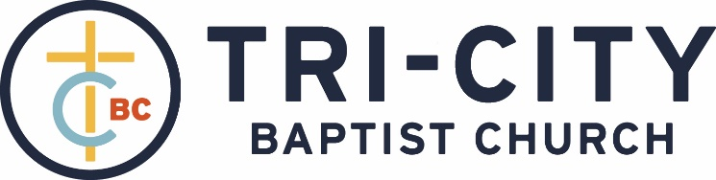

September 12, 2021

Welcome and Opening Prayer – Pastor Probus

Call to Worship – Psalm 116:1-2 – I love the Lord, because He has heard My voice and my supplications. Because He has inclined His ear to me, therefore I will call upon Him as long as I live.

We joyful proclaim our love for the Lord because He loved us:
# 313 – “We’re Marching to Zion”

Psalm 63 – “O God, You Are My God Alone”

Scripture Reading – Psalm 34 – David Leeper

We humbly acknowledge our deep need for the Lord:
“Quicken Me, O Lord”

We find assurance in the redeeming love of Christ:
# 299 – “Arise, My Soul, Arise”

Pastoral Prayer – Pastor Parkin
Message – Pastor Barr

We respond by worshipping the precious, worthy Lamb:
“Every Knee Shall Bow”

Closing Prayer and Dismissal

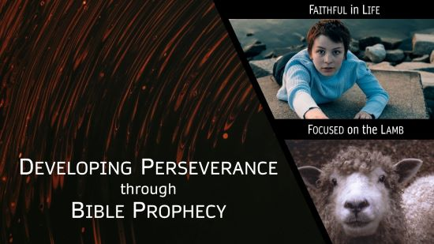
The Lamb: Worthy and Worshipped
Revelation 5:1-14

- Reason to Fear: No one was worthy to open the scroll. 1-3
- Call to not Fear: The Lion will loosen up the seven seals. 4-7
- Fearless Worship: Worthy is the Lamb. 8-14

In a broken and hostile world, we can overcome our fears by worshipping Jesus.

