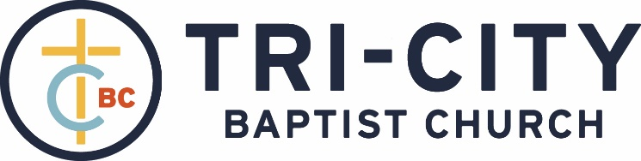

July 25, 2021
Welcome and Opening Song
# 89 (460) – “All the Way My Savior Leads Me”
Stewardship Meeting
Opening Prayer – Pastor Parkin

Call to Worship – Psalm 145:10-13 – All Your works shall praise You, O LORD, and Your saints shall bless You. They shall speak of the glory of Your kingdom, and talk of Your power, to make known to the sons of men His mighty acts, and the glorious majesty of His kingdom. Your kingdom is an everlasting kingdom, and Your dominion endures throughout all generations.

We joyfully praise our glorious King Who reigns forever:
Psalm 99 (59) – “The Lord Is King, Enthroned in Might”

Choir – “Joyful, Joyful, We Adore Thee”

# 50 – “Be Thou Exalted”

Scripture Reading – II John

We humbly express our need for cleansing and guidance:
# 85 (462) – “Savior, Like a Shepherd Lead Us”

We find assurance in God’s love shown through the cross:
“The Power of the Cross”
Dismiss for children’s church on the 2nd verse

Pastoral Prayer
Message – Pastor Barr

We respond by committing to Christlikeness:
# 375 – “O To Be Like Thee”
Vote Announcement, Closing Prayer, and Dismissal – Pastor Barr

- Head scratcher: Paul’s teaching on the baptism for the dead is exceedingly difficult to interpret and apply. 29
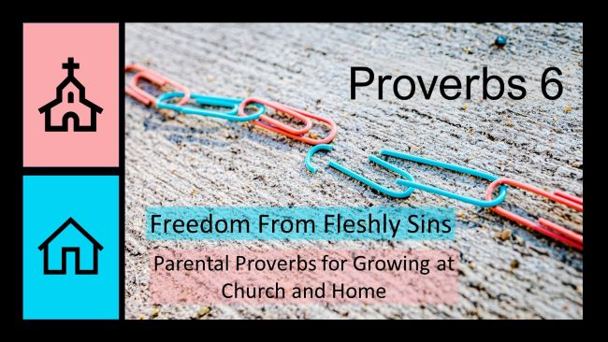
Emancipation from Dishonesty
Proverbs 6:12-15

- Who should we never become? A worthless man or woman. 12, 14b
- How can we identify a worthless man or woman? Their thoughts result in visible behaviors. 13-14a
- What happens to a worthless man or woman? They Will experience Irreversible, sudden destruction. 15
- Issue of Application: There is a continuum of worthlessness which ends in varying levels of disaster.

We must avoid worthless people and not allow them to
influence our lives.

