TCBC Worship Guide
Sunday, November 22, 2020

Prelude – Charity Shambaugh
Welcome – Pastor Probus
Opening Prayer – Pastor Probus
Call to Worship – Psalm 100 – A Psalm of Thanksgiving. ¹Make a joyful shout to the Lord, all you lands! ²Serve the Lord with gladness; come before His presence with singing. ³Know that the Lord, He is God; it is He who has made us, and not we ourselves; we are His people and the sheep of His pasture. ⁴Enter into His gates with thanksgiving, and into His courts with praise. Be thankful to Him, and bless His name. ⁵For the Lord is good; His mercy is everlasting, and His truth endures to all generations.

Handbells – “How Firm a Foundation” (3 vs.)

We praise the Lord for His loving care for us His people:
# 26 – “Praise to the Lord, the Almighty” (vs. 1,3,4)
Piano only on vs. 3

Scripture Reading – I Thessalonians 5:1-11 – Allan Brace

We humbly confess that our satisfaction is found only in Christ:
“My Worth Is Not in What I Own” (vs. 1,2,ch,3,4,ch,5)
Piano only on vs. 2 and 4

We thank the Lord for His gracious gifts, most of all for Christ:
# 492 – “For the Beauty of the Earth” (vs. 1,3,4)
Piano only on vs. 3

Pastoral Prayer – Pastor Williams
Message – Pastor Barr

We respond by resting in our Savior’s care for us:
# 101 – “All the Way” (vs. 1,2,3)
Piano only on vs. 2

Closing Prayer – Pastor Parkin
Financial Update – Mike Lee
Dismissal – Pastor Barr
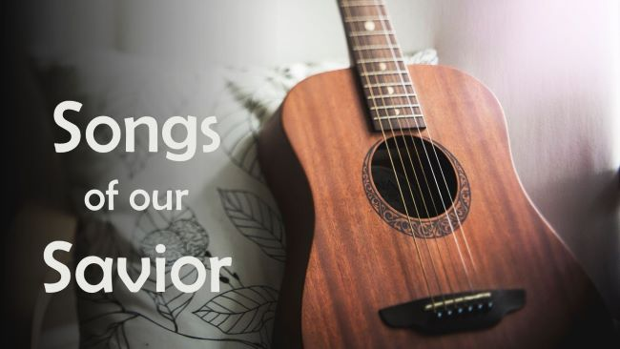

Hopeful Remembrances of Our Messiah
Psalm 52:1-9

- David spoke to his enemy about his destruction. 1-7
- David spoke of his deliverance. 8-9
- We can speak like David if we trust in David’s God.

When relationships become challenging, we can find security in our God.

