TCBC Worship Guide
Sunday, September 27, 2020

Prelude – Charity Shambaugh
Welcome – Pastor Parkin
Call to Worship – Psalm 78:1–4 – Give ear, O my people, to my law; incline your ears to the words of my mouth. I will open my mouth in a parable; I will utter dark sayings of old, which we have heard and known, and our fathers have told us. We will not hide them from their children, telling to the generation to come the praises of the Lord, and His strength and His wonderful works that He has done.
Opening Prayer – Pastor Parkin

We give glory to God Who alone is worthy of praise:
“Holy, Mighty, Worthy” (vs. 1-3)
Piano only on vs. 2

Scripture Reading – Exodus 14:19-31 – David Shambaugh

We humbly acknowledge our sin and wonder at God’s grace:
# 156 – “How Can It Be” (3 vs.)
Piano only on vs. 2

Barbara Crook – “In Your Footsteps”

We rejoice in the saving power of our merciful God:
Psalm 136 – “Give to Our God Immortal Praise” (4 vs.)
Piano only on vs. 3

Pastoral Prayer – Pastor Probus
Message – Pastor Barr

We respond by committing to live for our Savior:
# 387 – “I Will Follow” (3 vs.)
Piano only on vs. 2

Closing Prayer and Dismissal – Pastor Williams

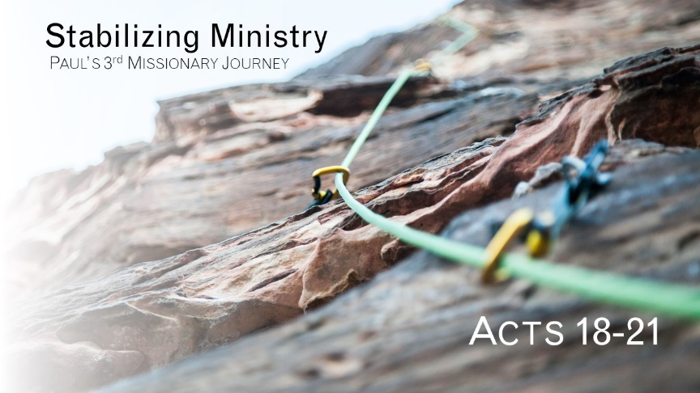

The Faithful Preacher
Acts 20:17-24

- Paul’s example calls pastor/elders to a life of humble service through the midst of regular trials. 18-19
- Paul’s example calls pastor/elders to consistently proclaim the gospel message. 20-21
- Paul’s example calls pastor/elders to lifelong faithfulness. 22-23
- Conclusion: We dare not live for our lives in this life. 24

