TCBC Worship Guide
Sunday, June 28, 2020, 8:00 am

Welcome – Pastor Barr

Call to Worship – Psalm 89:1 – I will sing of the mercies of the LORD forever; with my mouth will I make known Your faithfulness to all generations.

We give glory to God for His faithful love to us:
# 44 – “To God Be the Glory” (3 vs.)

Scripture Reading – Romans 6:12–23
Prayer – Pastor Parkin

Sara Treffer – “God Sees the Heart”

We humbly submit ourselves to the Word of God:
Psalm 19 – “Heaven’s Shout God’s Matchless Glory”
(tune: # 481, vs. 3-5)

We rejoice in the assurance found in our refuge, Jesus Christ:
“I Run to Christ” (3 vs.)

Message – Pastor Barr

We respond by committing to a life of worship:
# 390 – “I Surrender All” (4 vs.)

Prayer – Allan Brace

# 180 – “I Will Sing of the Mercies of the Lord”

SS lesson: Pastor Parkin – Sin has terrible results

Dismissal – Pastor Parkin

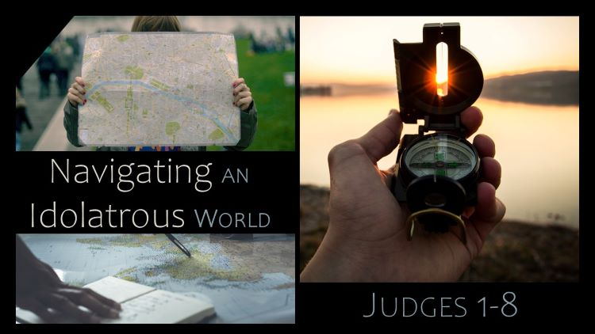

The Idol Trap
Judges 2:6-23

- The Cycles of Sin: When people choose to sin, they will not be able to control the consequences for that sin. 6, 11-23
- The Motivations for Worship: One generation worshipped because they knew God, the next did not. 7-10

Every person, from every generation, must choose to worship God.

