TCBC Worship Guide
June 7, 2020

Welcome – Pastor Barr

Call to Worship – Psalm 116:1-2 – I love the LORD, because He has heard my voice and my supplications. Because He has inclined His ear to me, therefore I will call upon Him as long as I live.

We proclaim the greatness of our Redeemer:
# 5 – “O for a Thousand Tongues to Sing” (5 vs.)

Message – Pastor Barr

We come humbly to remember Christ’s sacrifice for us:
“According to Thy Gracious Word” (5 vs.)

Lord’s Supper
Bread
Cup

Scripture Reading
I Thessalonians 4:13-18 – Pastor Barr

We rejoice that we stand forgiven at the cross:
“The Power of the Cross” (4 vs.)

We respond with thanksgiving and love in our hearts:
# 612 – “God Is So Good” (4 vs.)

Financial Update – Mike Lee

Prayer – Pastor Barr

We sing of the glory of God in creation:
# 60 – “How Majestic Is Thy Name” (Psalm 8; 3 vs.)

SS lesson: Daniel Pittman – God created all things good
Dismissal – Pastor Barr
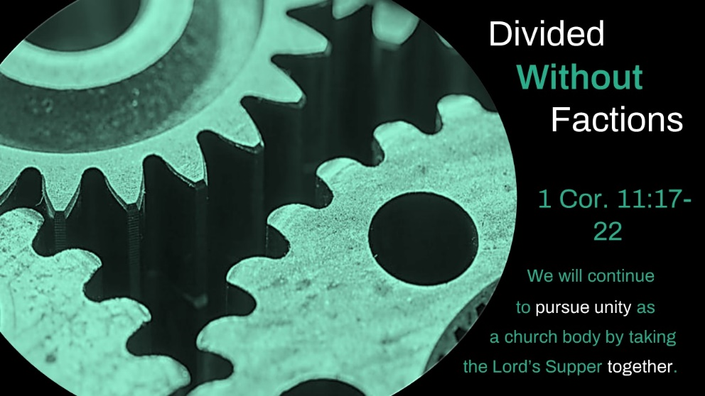

- We are divided, but not in the way that the Corinthian church was divided. 17-19
- We are divided, but we are committed to serving each other in purity. 20-22

We will continue to pursue unity as a church body by taking the Lord’s Supper together.

