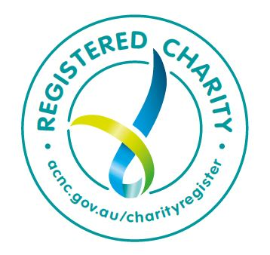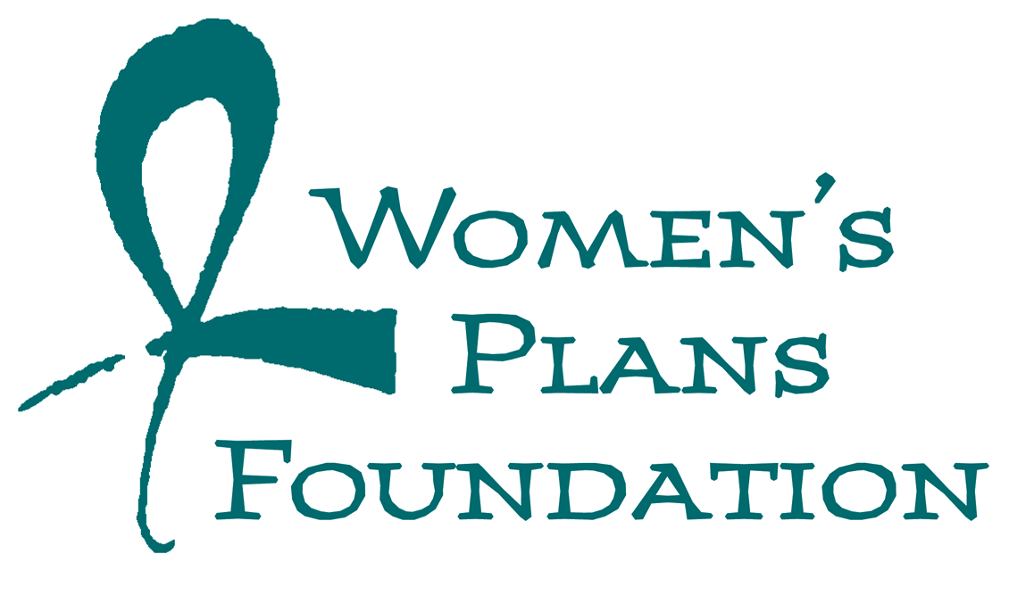

Funding guidelines for proposals for 2020-21 WPF Grants

Introduction
Today around 214 million women in developing countries want to avoid pregnancy but lack access to family planning and contraceptives. All women and girls have the right and must have the means to plan their own lives including when and whether to have children.
By enabling individuals to choose the number and spacing of their children, family planning dramatically improves the health prospects of women and their children, improves the opportunities of women and girls to seek and continue education, fosters empowerment and economic activity, reduces poverty and, by reducing population, improves the sustainability of life on Earth.

WPF objectives
Women’s Plans Foundation (WPF) is a charitable trust raising funds for family planning as an integral part of overseas aid programs. These funds are primarily used for grants to organisations that deliver high quality family planning services and facilitate take-up of modern contraceptive methods. The overriding purpose of WPF’s grants is to make contraceptives available to people who have limited or no access to family planning services and to provide education about and advocacy for family planning.

Types of organisation that can apply
Non-Government organisations that can apply must be AusAID accredited. It is an Australian Government requirement that WPF donate only to Deductible Gift Recipients registered in Australia. We have a preference for organisations that have provision of family planning and contraceptive services as a clear and important part of their mandate and with family planning outcomes reflected in their key performance indicators. The position of your organisation in the Sexual and Reproductive Health Sector and with respect to overseas aid is also important to WPF when establishing partnerships.

Priorities

Geographical
Projects in the Asia Pacific area are our priority because:
- More than 50% of 10 year olds on Earth, the source of the next generation, live there. Countries with larger cohorts of 10 year olds tend to be poorer.
- We have commitments to our immediate neighbours.
- We do not want to spread our resources too thinly.
- As the most disaster prone area in the world, Asia Pacific presents particular risks. Amongst the humanitarian impacts of disasters and conflict are those relating to reduced access to contraceptives. Sexual assault is common in disaster-struck areas, and the victims may end up dealing with unwanted pregnancies as a result of rape.
We prefer to fund projects in countries that are already committed to expanding access to and take-up of high-quality, voluntary family planning and where there is a reasonable chance that the projects will be effective. Support for in-country government policies that favour family planning and take-up of modern contraceptive methods is a key factor that can affect whether projects are effective and sustainable.

Target groups
These include but are not limited to:
- People who want to plan their pregnancies or discontinue expansion of their families but have limited or no access to contraceptives (e.g. rural communities; language and cultural barriers).
- Those most at risk of unwanted pregnancies and for whom unwanted pregnancies can cause the most problems (e.g. young girls, those in disaster prone areas).
- Women and girls who are not using any form of contraception because of perceived barriers (e.g. side-effects experienced with a particular type of contraception that deter them from using any type; myths and misunderstandings about contraceptives, cultural factors that may in some cases constitute an abuse of human rights).
We would like to know about and will consider funding proposals for other marginalised and needy groups.

Types of activities
Choice of activities will be made in the light of local needs, circumstances and likely effectiveness. Our preference is for projects that include or link into some direct provision of contraceptive services. We also value partnerships with other organisations to jointly improve prospects of take up.
We will also consider projects that have the potential to lead to increased knowledge of and demand for modern contraceptives and more effective delivery and take-up of contraceptive services (e.g. research into reasons that women in a particular community do not use particular types of contraceptive; education of young people about contraception; training for insertion of long-acting reversible contraceptives) provided that a convincing case can be made for how those projects and their outcomes will contribute to improved demand for, access to, and take-up of contraceptives.
While we believe that every woman should choose the type of contraceptive that she considers appropriate to her circumstances we have a preference for projects that are endeavouring to expand access to and take-up of long-acting reversible contraceptives (LARCs) that are more effective with respect to reducing unwanted pregnancies.
Advocacy is vital, and we are ourselves actively engaged in advocacy with government, political and community leaders and the broader community. We value the evidence and case examples that organisations can provide to us to strengthen our advocacy. However as a relatively small organisation we are generally not in a position to fund large scale longterm advocacy projects of the type that might be required to change legislation or government policy in a developing country. Hence our desire to fund projects in countries where a considerable degree of support for modern family planning is evident.

Sustainability
WPF wishes to fund projects that are themselves sustainable or lay the foundation for further advances. When preparing proposals we ask that the rationale and some evidence be given concerning the sustainability prospects of the project and its outcomes. For example, projects that lead to enhanced awareness and understanding of types of contraceptives are important as long as there is potential for awareness and understanding to convert to action. So in this case it is important to be able to demonstrate that supply of contraceptives will be able address increased demand. Similarly, capacity building of health care providers on the ground is a means of improving sustainability. When capacity has been developed there should be opportunity to apply, maintain and refresh capacity.

Budget, timeline and funding issues
Typically our grants range between $10,000 and $40,000 over a one year period. However we will consider proposals that are for a continuation of funding in the light of results achieved in the previous year(s), and opportunities to scale up or consolidate. Please advise if you have any critical dates for project implementation and funding.
When preparing a proposal, we would appreciate learning how WPF funding will make a difference and add value to what is already being done or would in any case be done without WPF funding. You might consider how WPF funding would make a difference to what is done, how it is done, when, where and/or with whom it is done and so on.
We would also like to know how WPF funding would integrate with other sources of funding. We would like to see estimates of expenditure and receive at least an annual statement of expenditure (timing and frequency of reports to be agreed).

Expected results and accountability
Expected results will vary according to project. Ideally, increases in Couple Years Protection (CYP) is a desired outcome for all projects either as an immediate outcome for those projects directly engaged in service delivery of contraceptives or as a later outcome for projects that are initially about effecting cultural change, and/or improving understanding of and access to high quality modern contraceptive methods.
Therefore, funded projects should be able to provide some evidence that they have contributed directly to increased CYPs (e.g. through additional take-up of contraception) or indirectly (e.g. by showing that they have affected the contraception intentions of target groups receiving advice or education; by building capacity to deliver better targeted, higher quality services that will increase CYPs).
Please describe the kinds of performance measures you will use to demonstrate that WPF funds are making a difference. We expect that these would be measures that you would already be collecting for your own purposes and require little extra work to generate new information. We would like two reports for the year for projects that receive funding: one for the July-December 2020 period and one for January to June 2020 to coincide with what we hope would be your reporting cycle for a range of purposes.

Submission of proposal
Proposals should address the issues raised in these guidelines: the benefits of WPF partnering with your organisation; why the project is needed and what gaps it will fill; how WPF funding will add value to what your organisation is doing, target groups (nature and size) and expected outcomes for them; types of activities and the rationale for choice of them including considerations relating to effectiveness, efficiency and sustainability; your budget and timeline; your measures of results (especially the outcomes) and how you plan to keep us informed about project and its results.
Please advise us of your intention to submit a proposal by 21 March 2020 and submit your proposal to WomensPlansFoundation@bigpond.com and funnellsue@gmail.com by April 3, 2020.
If you have any queries or would like to discuss your proposal in advance of submission please contact Sue Funnell at funnellsue@gmail.com (cc’d to WomensPlansFoundation@bigpond.com) or by phone +61 402 965 785 before February 21 or after March 21.
Advice about the funding of your proposal will be provided by 29 May 2020.

UNFPA State of World Population 2016 Report pp 14-16.
See MSI’s definition and simple calculation of CYPs associated with each method of contraception. Increased CYPs could come through more people taking up contraception and from people switching from less effective to more effective types of contraception https://mariestopes.org/media/2188/msi-cyp-infographic.pdf.

