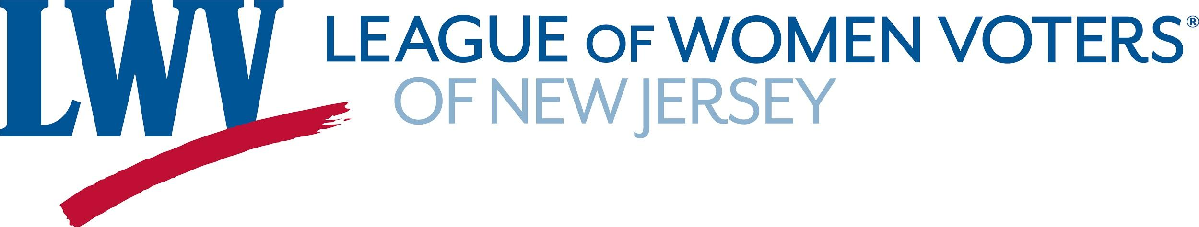

2020 Election Season Social Media Sample Posts

VOTER REGISTRATION
- The officials you vote into office determine policies on immigration reform, jobs, health care, education, and more. Voting is your chance to choose and to weigh in on the issues that matter most to you—take a moment to register to vote now! VOTE411.org/register
- We each have the power to increase voter turnout. Register to vote & help others register, too! VOTE411.org/register
- Not sure if you’re registered to vote? Visit VOTE411.org/check-registration to check your registration.
- Registering to vote is the first step to participating in our election. Interested in setting up a voter registration drive? Learn how in the League of Women Voter’s blog: http://bit.ly/2QkhlDe
- Help ensure all Americans have an opportunity to participate in the upcoming pivotal elections. Ask your friends and family if their voter registration is up to date, consider volunteering with your local League of Women Voters, and share VOTE411.org with your networks.
- Are you registered to vote? Make sure your voice is heard! Visit vote411.org/check-registration for more info.
- First-time voter? We've got you covered! Take a look at the @VOTE411 checklist: https://vote411.org/first-time-voter-checklist
- Take a 5-minute break today and make sure you’re all set to vote in the #2020Election. Head to VOTE411.org/check-registration to confirm your registration status—then tell your family and friends to check their status, too! Have more questions? 📞 866-OUR-VOTE. #ProtectOurVote

VOTER EDUCATION
- Our right to vote is one of our basic American freedoms. Have a plan for making your voice heard and casting your ballot. Will you: vote with a mail-in ballot or vote in person? Check New Jersey’s options and make a plan now: VOTE411.org #ProtectOurVote
- 2020 will be a historic election, with high rates of participation from all parts of the country, among all population groups. Have you made your plan? #2020election
- Wondering who will be on your ballot this Election Day? Visit VOTE411.org & enter your address to see the candidates and issues on your ballot.
- Who’s on your ballot? Where is your polling place? What do you need to bring with you on #ElectionDay? If you can’t answer one or more of these questions, we’ve got you covered! Head to VOTE411.org for all of your voting and election info.
- Getting the voting and #electionday info you need is easy. Go to VOTE411.org, enter your address, and we’ll do the rest.
- Get ready to vote! Don’t hit the polls uninformed, check out VOTE411.org to see your personalized ballot.
- Confused about election rules and regulations in New Jersey? VOTE411.org has the answers.
- Election Day is just around the corner! It's not too late to visit VOTE411.org to get ready to vote: find your local voting rules, polling place hours, and who will be on your ballot.

GET OUT THE VOTE
- The right to vote is a basic American freedom, but no one should have to choose between voting and protecting their health. #VoteByMail is one of the most secure ways to vote. Request your mail-in ballot today!
- You can apply NOW to vote by mail. Once you receive your ballot, fill it out and return it right away. #2020election
- Voting in-person? Check the hours of your polling location and arrive as early as possible, because wait times will be even longer this year. Follow the CDC’s guidelines by wearing a mask to protect yourself and others. #2020election
- Voting is your chance to take control of the future of your family and your community. Don't let anything keep you from voting—help make democracy work!
- Election Day is just [X] days away and, if you haven't cast your ballot, we have all the info you need to hit the polls! Spread the word to help make sure that your friends & family have everything they need to vote! VOTE411.org
- We're counting down, and #ElectionDay is just days away! Are you ready to vote? Visit VOTE411.org now to view your personalized voter guide, check your local polling hours & get all the information you need to vote on Tuesday!
- Every single vote matters. RT to remind your friends to vote on November 3rd.
- Voting is your chance to stand up for what matters most to you. Get all the info you need to vote at VOTE411.org

