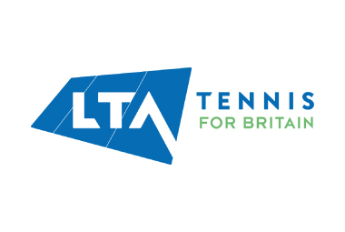





**U17s**

* A current parent, athlete, or coach participating regularly in regional or national level tennis.
* Be in the same parent, athlete, coach group for a minimum of 12 months.
* All members of the group must be willing to participate.

**U12s**

* A current parent, athlete, or coach participating regularly in county or regional level tennis.
* Be in the same parent, athlete, coach group for a minimum of 12 months.
* All members of the group must be willing to participate.

**U10s**

* A current parent, athlete, or coach participating regularly in mini-level tennis.
* Be in the same parent, athlete, coach group for a minimum of 6 months.
* All members of the group must be willing to participate.

**To be included in this study, participants should be:**

Participation in youth tennis can be a stressful experience not only for athletes, but for their parents and coaches. Research has shown that positive relationships between parents, athletes, and coaches can improve athletic experiences. However, there is limited research which has gathered the perspectives from all members and looked to understand the nature of these relationships. Ultimately, this research aims to improve the experiences that parents, athletes, and coaches have by facilitating positive relationships in youth tennis.

**RELATIONSHIPS IN YOUTH TENNIS**

**RESEARCH STUDY**

**If you believe you meet the criteria for this study and are interested in participating, please contact the lead investigator: Ella Williams | E.Williams3@lboro.ac.uk**

After completing the interview, participants will be asked to join a WhatsApp group with the lead investigator and other members of the group. Participants will be asked to use this as their method of communication with group members for two months.

Participants will be asked to attend an interview where they will be asked questions about their experiences regarding their relationships in youth tennis. The interview will last between approximately 60-90 minutes.

After reading the information sheet and completing a consent form, participants will be sent short materials to read and complete. Participants under the age of 18 will be required to sign an assent form and have a parent sign a consent form on their behalf.