Articles & Publications

2018 – Publications in English:

- World Trademark Review; feature article – Issue 71; published on January 2, 2018
“Protecting the looks of products in China” (Christopher Shen and Amy Hsiao)

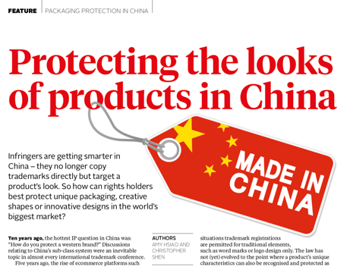

- Expert Analysis Section Law 360: “A Solution To China’s Counterfeiting Problem” by Amy Hsiao and Samuel Speed; published on 4/03//2018
- Multiple publications on LinkedIn Pulse, China Trademark Blog (www.lastweekinchina.com). Selective ones are outlined below:
- “Well-Known Trademark in China?!” (published: 02/18/2018)
- “East Meets West – A Trademark Practice in the US & China!” (published: 02/21/2018)
- “Significant changes to China’s entire governmental structure!” (published: 03/19/2018)
- “Key policy updates from Alibaba that benefit brand-owners” (published: 04/15/2018)
- “Expect your trademarks to move REALLY fast in China this year!” (published: 04/18/2018)
- “An Interesting Solution to China’s Counterfeiting Problem” (published: 05/01/2018)

2018 – Publications in Mandarin Chinese:
- 美国加征25%关税对中国企业的「三大影响」！ 知产力 2018-06-13

2017 – Publications in English:

- Book: “Landmark Trademark Cases in China” – published by Wolters Kluwer in May 2017 and is available on Amazon. The book is described as: “the single indispensable source on China”. Amazon link: https://www.amazon.com/Landmark-Trademark-Cases-China-depth/dp/9041168362

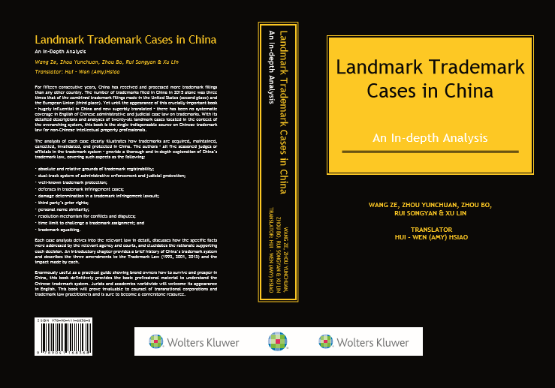

- “Takeaways from Trump’s Recent Trademark Victories in China” by Amy Hsiao; published on 4/3/2017 in Law 360 Expert Analysis Section
- “Takeaways from Ivanka Trump’s TM Approval in China” by Amy Hsiao; published on 5/12/2017 in Law 360
- “Regulations by China Supreme People’s Court Regarding the Administrative Trademark Litigations” by Amy Hsiao; published on 1/10/2017 in the EU Embassy website in China
- Multiple publications on LinkedIn Pulse, China Trademark Blog (www.lastweekinchina.com). Selective ones are outlined below:
- “Possible Punitive Damages against Trademark Infringement in China” (published: 03/21/2017)
- “Good News! Less Legal Expense in China” (published: 03/30/2017)
- “China’s New Credit System: Using Public Shaming to Deter Copycats & Serial Infringers” (04/04/2017)
- “Finally, Prison Time for Counterfeiters in China!” (04/11/2017)
- “How Fast is the Speed in China? 2000+ views in 24 hours!” (04/23/2017)
- “How to Know Whether Your China Experts are Indeed Experts or Simply People Who Travel to China in First Class (With Your Money)?” (4/26/2017)
- “Top 5 Cases Picked by China’s Authorities as A Roadmap to Its Trademark System” (4/27/2017)
- “How to Fight Counterfeits in China? What’s the Exact Dollar to Make a Case Criminal?” (05/07/2017)
- “What is the Real Breakthrough Regarding the Recent Criminal Trademark Cases in China?” (05/12/2017)
- “Where to Majority of China’s IP Criminal Cases Come From?” (05/19/2017)
- “Have You Received the Scam Email from China (yet)?” (06/06/2017)
- “What Are the Top Three Products China’s Infringers Favor?” (7/10/2017)

2017 – Publications in Mandarin Chinese:

- “Top Three Key Issues to Bear in Mind When Seeking Trademark Protection in the US” by Amy Hsiao; published on 2/26/2017 in Zhichanli (a leading online IP publication in China) (http://www.zhichanli.com/article/44007)
- “Top 10 Tips to Quickly Understand the Trademark System in the US” by Amy Hsiao; published on 4/21/2017 in Zhichanli (a leading online IP publication in China)
- “Three Most Frequently Asked Questions When Seeking Trademark Registrations in the US” by Amy Hsiao; published on 6/29/2017 in Zhichanli (a leading online IP publication in China)
- 《一位美国律师的来信：中国企业在美国申请商标的三大误区》 知产力 2016-12-09
- 《美国律师的第二封来信：企业须特别关注美国商标项目描述之三大原因》知产力 2017-01-20
- 《美国律师的第三封来信：10个重点帮您快速了解美国商标法》知产力 2017-04-21
- 《美国律师的第四封来信：美国商标制度下关于使用权的常见三大问题》 知产力 2017-06-29
- 《美国律师的第五封来信：美国商标制度下关于使用权有哪些问题》 (Ashley Zito and Amy Hsiao) 知产力 2017-10-30
- 《美国律师的第六封来信：英国脱欧影响中国企业商标的十大问题》(Carl Steele and Amy Hsiao) 知产力 2017-11-21
- 《美国知识产权诉讼不简单，这3大重点需注意》(Ashley Zito and Amy Hsiao) 知产力 2017-10-23

2016 – Publications in English:

- “Doing Good Business in China” by Amy Hsiao and Brett Heavener; published on 3/16/2016 in TBO Trademarks & Brands
- “Top Three Pitfalls Chinese Companies Make When Applying for TM in the US” by Amy Hsiao; published on 3/2/2016 in Zhichanli (http://www.zhichanli.com/; a leading online IP platform in China).
- “A Tale of Two Giants in China: Facebook and iPhone” by Amy Hsiao; published in the July/August 2016 edition of China-Britain Business Focus
- “China Judge’s View: Why Apple Lost and Facebook Won” written by Chen, Zhixing (a judge at the Beijing Intellectual Property Court) and translated by Amy Hsiao. This article was published on 6/24/2016 in Zhichanli
- “A $15.8 Million Dollar Question: Could you Be an Infringer of Your Own Brand in China?” by Amy Hsiao; published on 8/24 in Westlaw Journal Intellectual Property
- "How Michael Jordan Won Trademark Case in China Without Trademark Rights" by Amy Hsiao and Christopher
Shen published on January 24, 2017 in Law360
“3 Take-Aways from Michael Jordan’s Chinese Supreme Court Trademark Victories for Companies Doing Business in China” by Amy Hsiao Aaron Parker in Sporttechie

SPEECHES/WEBINARS/PRESENTATIONS:
2018:

- 08/30/2018 USPTO China IP Road Shows – Kansas City (August 2018) “Copyright in China”
- 08/28/2018 USPTO China IP Road Shows – Iowa City (August 2018) “Copyright in China”
- 07/25/2018 USPTO China IP Road Shows – Louisville (July 2018): “Copyright in China”
- 05/01/2018 USPTO China IP Road Shows – Phoenix and Las Vegas (May 2018): “3 Key Differences and Impacts to Business”

- 03/01/2018 TrademarkNow One-Hour Briefing (Live Webinar): “3 Keys to the Emperor’s Kingdom”

2017:

- 01/31/2018 PLI One-Hour Briefing (Live Webinar): “Well-Known Trademark in China: What is it, how to get it and how to protect it”
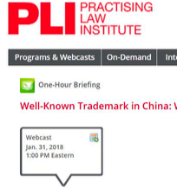

- 10/17/2017 Global Sourcing Summit (Live Presentations; Hong Kong): “Legal Strategies: 3 Differences Between US and Chinese Law and How They Impact Your Sourcing”

- 10/09/2017 IIPLA 2nd Annual Meeting (Live Presentations; Silicon Valley): Session 5 and Session 9 – China IP Strategies and Anti-Counterfeiting Program

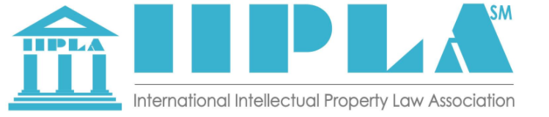

- 07/13/2017 PLI One-Hour Briefing (Live Webinar): “Top Trademark Cases in China: How These Decisions Impact Your Business and Brands”
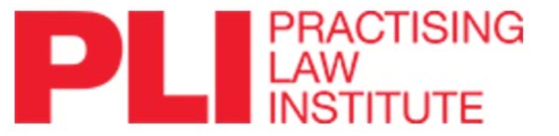

- 08/01/2017 Thomson Reuters Western Legal Ed Featured Program: “China’s Trademark, Branding & Social Media”
2016:

- 09/2016 – “Trademark Practice in Europe, the United States and China: Navigating These Three Important Jurisdictions” (Danny Awdeh, Clare Cornell and Amy Hsiao)(London, United Kingdom)
- 07/2016 -- Client Presentations and Onsite Training: “China Advertising Updates and Key Issues” (audience: global marketing team and in-house counsel) (Amy Hsiao; Atlanta, GA)
- 07/2016 – “Doing Business in China – Protecting Your Brand in One of the World’s Most Important and Challenging Jurisdictions” hosted by Georgia Bar Association (Amy Hsiao, Carolyn Dinberg, and Danny Awdeh)(Atlanta, GA)
- 04/2016 -- Finnegan Webinar “Cutting it off at the Source: Enforcing design rights against counterfeiters at the border” (Philip L. Cupitt, Elizabeth D. Ferrill, and Amy Hsiao)
- 02/2016 -- Finnegan Podcast “Cutting it off at the Source: Enforcing design rights against counterfeiters at the border” (Amy Hsiao & Beth Ferrill)

2015 & Before:

- 10/2015 -- Speaker at the 2015 China Trademark Festival hosted by China Trademark Association “Trademark Practice Differences between the US and China and key issues for Chinese companies to be aware of when launching brands abroad” (Amy Hsiao; China)
- 2012-2015: Represented western law firms and brand owners to the China Trademark Office, and China Appeal Board to voice concerns regarding IP issues. (Amy Hsiao; Shanghai/Beijing, China)
- 2012: Selected by Kilpatrick’s key client to accompany its global General Counsel to interview top 10 IP and Corporate law firms in China (Amy Hsiao; Shanghai/Beijing, China)

