Thank you for downloading the sample email text. Copy and paste the below into your email and use the logo as a header or footer before sending to your customers.
Don’t forget to add your own dates and to complete the missing details.
Thank you so much for your support.
Team Margot.

Team Margot’s ‘Pinkspiration Week’
We’re getting involved in the first ever ‘Pinkspiration Week’ on [DATE/S] and wanted to let you know what we’ve got lined up for you when you visit us – and why.
What’s Team Margot’s Pinkspiration Week?
It’s a charity awareness-raising week running in pubs, bars and restaurants across the country – but, unlike most of them, it’s not an appeal for money! So you can keep your wallet closed, but please keep your eyes open on this message and consider the request for a potentially life-saving action.
Pinkspiration Week is about awareness and action! It’s organised by Team Margot, a charity that campaigns for every individual who is eligible, particularly those of mixed heritage, to register as a stem cell and bone marrow donor.
In December this year, the Team Margot Atlantic Rowers, a team of four dads, will be rowing across the Atlantic in the Talisker Whisky Atlantic Challenge, with the aim of signing up 1.5 million people – the number of strokes it will take the team to complete the 3,000 mile challenge. If they achieve this level of new potential donors, then it will double the size of the UK registers and statistically up to 15,000 lives could potentially be saved.
There simply aren’t enough registered stem cell donors, especially from people of mixed heritage. Anyone aged 17-55 years of age and in general good health can register to go on standby to save a life and we want them to sign up via the links on: WeRowYouRegister.org
We wanted to support this awe-inspiring effort with our own awareness raising in our pub, which is why we’re getting behind Team Margot’s Pinkspiration Week.
So what can you expect?
[PUB TO COMPLETE DETAILS, DATES ETC]
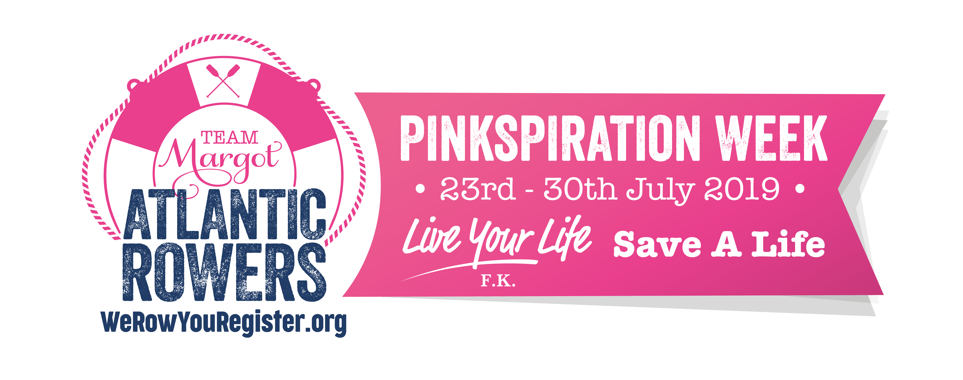
We look forward to seeing you in the pub on [DATE/S]. We’re proud to be supporting this worthy cause and hope you’ll feel able to add your name to the list of potential lifesavers on the stem cell and bone marrow registers.

