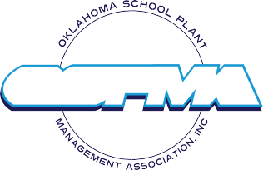
.
OKLAHOMA SCHOOL PLANT MANAGEMENT ASSOCIATION

2023 OSPMA Winter Training Core Certification Class

Module 3 - Environmental Health and Safety

8am-4pm February 22
Moore Norman Tech Penn Campus

Registration: $75.00 for each module

P.O. #___________ Date: _____________
Name _____________________________________________Position _____________________________________
Phone ________________________________email ___________________________________________________
School Dist./Technology/Higher Ed. __________________________________________________________________
Address: _______________________________ City_________________________________ State __Zip___________
OSPMA members can begin Core Certification at any time.

NOTE
Registrants for module 3 are not required to have completed modules 1 & 2

Make check or Purchase Order out to: Oklahoma School Plant Management Association
35718 West 251st Street South Bristow, Ok. 74010
Phone (918) 352-5454

Email completed Registration to: OSPMA at director@ospma.org
Or mail to
35718 S 251st Street W
Bristow, Ok. 74010
Phone (918) 352-5454

