Sunday Afternoon Wine Tasting

20th October, 4.00 pm to 6.00 pm
Anderweinig Weine und Weinshule, Hohe Straße 29 40213 Düsseldorf

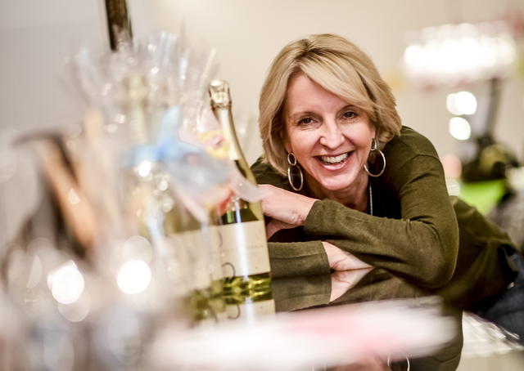

Dear Members and Guests

Please come and join for a fun and informal Sunday afternoon learning about and of course tasting wine at the lovely Weinshule Anderweinig in Hohe Strasse, Dusseldorf

You will be hosted by Birgit Felzmann, a wine expert with 25 years experience in the wine trade and now the owner of Anderweinig.

Members + 1 Guest €20pp and Non Members €22pp

The price includes 2 hours of fun and informative wine tasting accompanied by multiple cheeses and hams.

For reservations or more details please contact
justinecross@emea-channels.com and c.c. mackenzie@freenet.de

Your confirmation will include bank details and further key information about the event.

