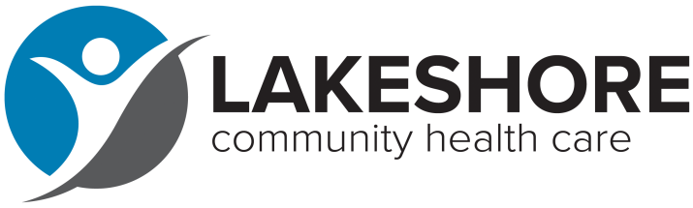
FOR IMMEDIATE RELEASE Contact: Noelle Boeldt
Marketing and Communications Manager
nboeldt@lakeshorechc.org
920-395-2978

Lakeshore Community Health Care Partners with Albrecht Free Clinic to Provide Dental Care

SHEBOYGAN - Lakeshore Community Health Care (LCHC) is excited to announce a new partnership with The Albrecht Free Clinic to increase access to dental care in a joint effort to serve more residents in need. With clinics in Manitowoc and Sheboygan, LCHC will serve Washington County’s growing Medicaid population, as well as its uninsured living at 200% or below the federal poverty level.

In 2016, Albrecht Free Clinic began offering dental care to vulnerable populations in response to an unfulfilled community need. The clinic has been successful in caring for this patient population since 2016. However, the need is great and growing, dental clinics are costly to operate, and provider availability is limited. LCHC will utilize Albrecht Free Clinic’s three dental chairs and operate the dental clinic 40 hours per week. The partnership will begin in September.

“Access to affordable dental care is one of the greatest needs we see in our communities. Over 9,000 patients receive dental services at our clinics in Manitowoc and Sheboygan,” explained Lakeshore Community Health Care’s CEO Kristin Stearns. “We look forward to working with the Albrecht Free Clinic to increase access to oral care in the community.”

“Put simply, working together we can serve more people on a consistent and sustainable basis,” said Albrecht Free Clinic’s Executive Director Ruth Henkle. “Our clinic has made great strides in improving oral health in Washington County over the last 6 years. That said, particularly since the pandemic, our volunteer-based dental clinic has been difficult to run, with staffing shortages affecting the entire dental industry. We’ve been exploring creative ways to increase our capacity, and a partnership with Lakeshore Community Health Care will allow more residents to get the dental care that they desperately need.”

Moving forward, the Albrecht Free Clinic will continue providing medical care for uninsured residents of Washington County at 200% or below the federal poverty level. While Lakeshore will be providing the direct dental care, the Albrecht Free Clinic will help underwrite the cost of care for its uninsured patients.

###

Lakeshore Community Health Care provides primary medical, dental, mental health, and pharmacy services for all, regardless of insurance status or income level. The non-profit’s mission is to provide access to high-quality, comprehensive health care and reduce health disparities for underserved people with a focus on serving low-income individuals and families, the uninsured and underinsured, and those enrolled in Medicaid (BadgerCare). For more information, visit lakeshorechc.org.

The Albrecht Free Clinic exists to meet the medical and dental needs of uninsured individuals living and working in Washington County. Founded in 1996 by Dr. James E. Albrecht. it is a volunteer-driven organization, made possible by professional and administrative support volunteers who give so generously of their time and talents. For more information, visit albrechtfreeclinic.org.

