To create a new LAKESHORE Health Connect account, please follow the instructions below:
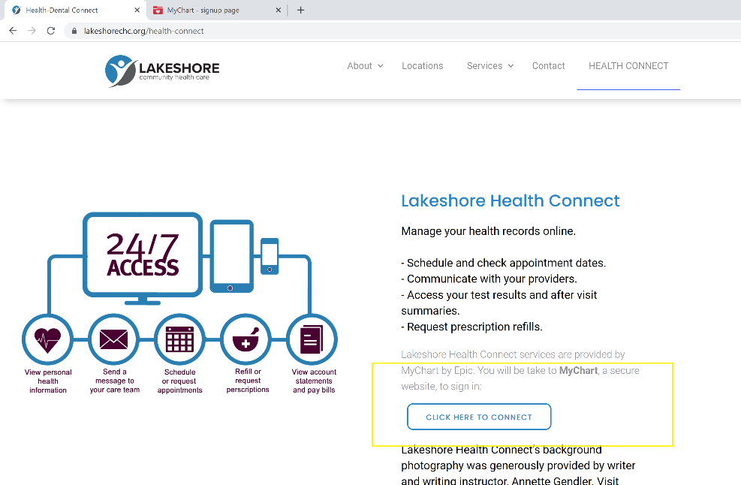

1. Go to the Health Connect page on LCHC’s website lakeshorechc.org/health-connect. Scroll past PAY YOUR BILL to LAKESHORE Health Connect. Click on:
“Click Here to Connect.”

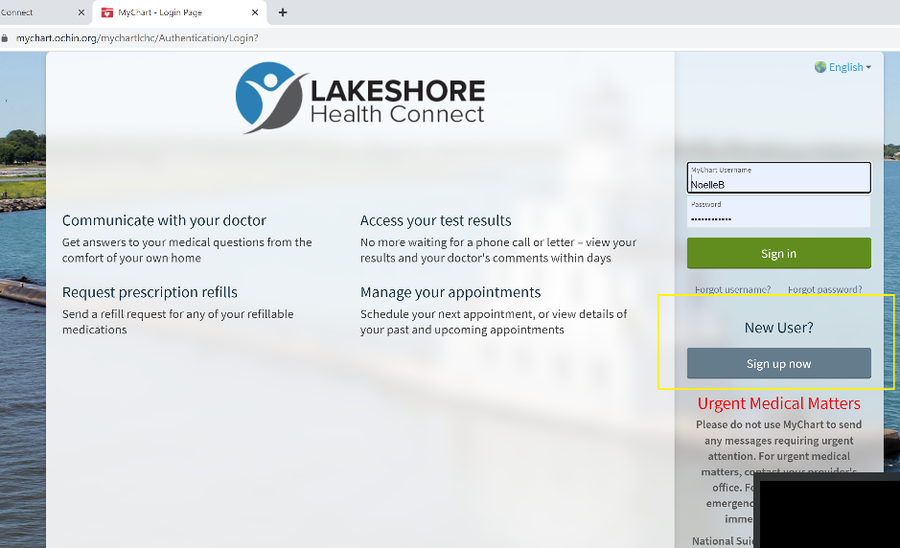

2. On the right side of the screen,
under New User?
Click Sign Up Now.

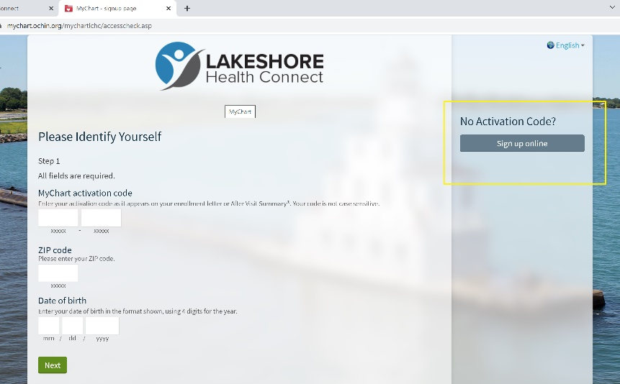

3. On the right side of the screen,
under No Activation Code?
Click Sign up online.

4. Complete the form to receive an activation code sent to your email address.
Follow the instructions provided in the email to create your account.
If you run into any issues, call 920-783-6633 to receive your activation code.

