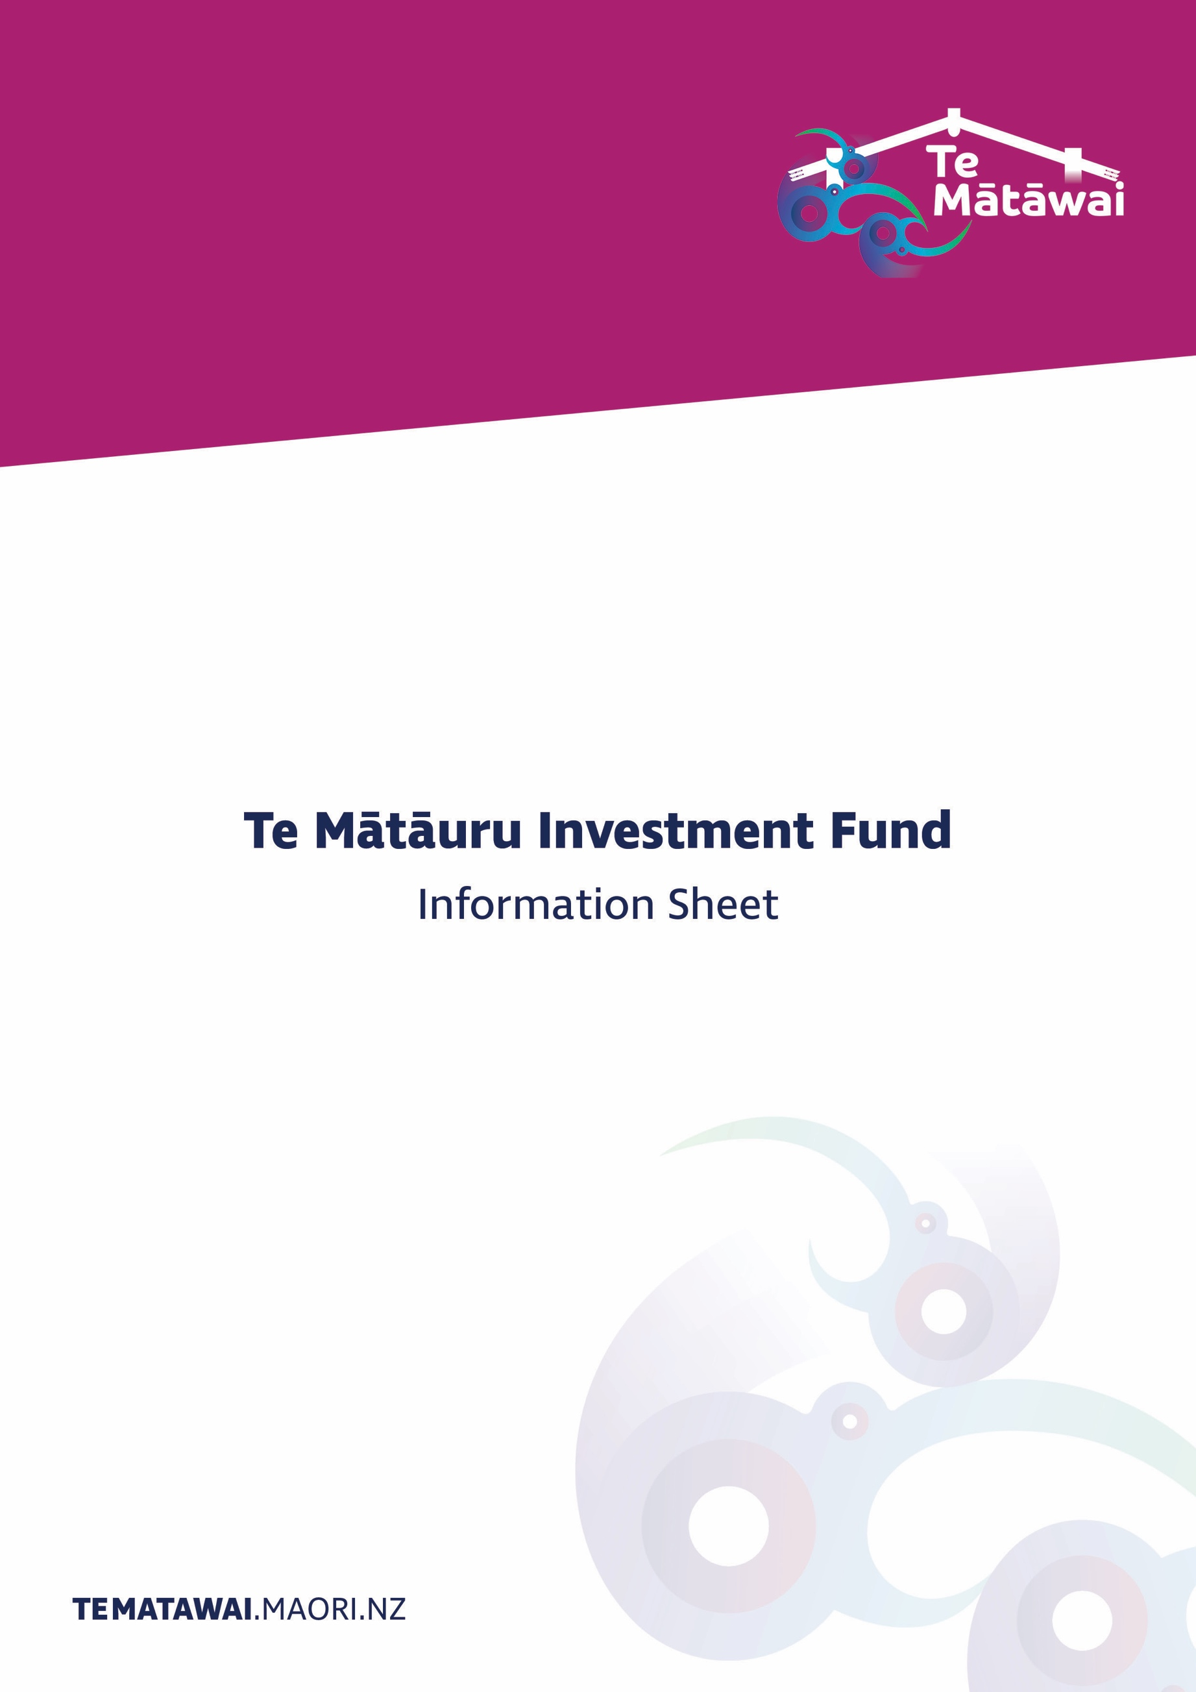

Te Mātāuru Investment Fund
Information Sheet

About the Te Mātāuru Investment Fund
Te Mātāuru is a contestable investment fund that targets home and community-based initiatives which contribute to revitalising te reo Māori as a nurturing first language. Te Mātāuru is driven by a cluster or Kāhui model that represents the interests of all iwi and sector groups listed in Te Ture mō Te Reo Māori 2016. Diagram One presents an overview of the people involved in the implementation of Te Mātāuru.
Te Mātāuru is underpinned by the following themes that serve as essential foundations for outcomes, indicators and the allocation of investment funding for a diverse range of initiatives:
• The importance of whānau leading initiatives which identify the importance of fostering te reo Māori in the home and wider community;
• The need for greater collaboration across activities, events, domains, groups, sectors, communities, whānau, hapū and iwi;
• Better promotion of te reo Māori across all sectors including government, whānau, and language sectors; and
• Easier access to investment, planning and resources by ensuring whānau and communities have access to the full range of opportunities available to them.
Two ways to access Te Mātāuru
Te Mātāuru has two categories through which funding support may be accessed:
- Kāhui ā-Iwi: a category based on iwi affiliation
- Kāhui ā-Reo Tukutuku: a sector specific category for Te Mātauranga, Te Pāpāho and Te Hapori projects and activities.
The points of difference between the two categories are presented in the following table.
Components | Kāhui ā-Iwi | Kāhui ā-Reo Tukutuku
Purpose | To support iwi affiliated initiatives. | To support sector specific projects that occur on a national and multi-region level.
Who can apply | Any person or organisation who affiliates to an iwi or hapū listed in Te Ture mō Te Reo Māori 2016 may apply for investment funding under Te Mātāuru Kāhui ā-Iwi Category.  Note that applicants do not have to be residing in their tribal areas.  Applicants must be a New Zealand citizen, permanent resident or an organisation based and delivering services in New Zealand. | Any person or organisation who affiliates any of the other Reo Tukutuku sector groups including:  Te Mātauranga  (a) ko Te Kōhanga Reo National Trust  (b) ko Te Rūnanga Nui o Ngā Kura Kaupapa Māori o Aotearoa  (c) ko Te Ringa Raupā o ngā Kura ā-Iwi  (d) ko Te Tauihu o Ngā Wānanga  Te Pāpāho  (e) ko Te Whakaruruhau o ngā Reo Irirangi Māori o Aotearoa  (f) ko Ngā Aho Whakaari  Te Hapori  (g) ko Te Rūnanga o Te Ātaarangi Trust:  (h) ko Te Rōpū Wāhine Māori Toko i te Ora  (i) ko Te Kaunihera Māori: Te Hunga Noho Tāone  (j) ko te National Urban Māori Authority.  Applicants must also be able to demonstrate existing or growing capability in these areas as well as an ability to deliver the initiatives or goods in te reo Māori.

How to apply
Diagram Two explains the application process. Ensure you read the relevant guidelines carefully and complete the application as fully as possible. If you need help, contact Te Mātāwai at info@tematawai.maori.nz.
When Te Mātāuru opens and closes
Te Mātāuru has eight investment rounds that occur annually as each Te Pae Motuhake is established. This means there will be one funding round for each Te Pae Motuhake.

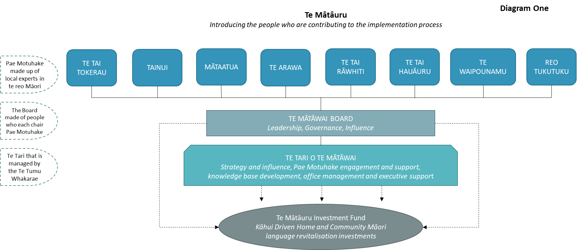

Diagram Two

