Census Outreach Templates:
Community Motivator

Welcome!

Getting the word out about the Community Motivator is essential in order for people to use it.

You can use these marketing templates to support your outreach. They include sample flyers, ads, social media templates, stickers (and more!).

Quickly and easily cut and paste these Word templates. Upload your logo, customize your colors and your Census tagline. Be creative and adapt them for the different formats that your reach your constituents and clients.

Remember: try different ways to reach people. Some people will see your flyers, while others will see your emails. In any public marketing campaign, it requires 7-10 exposures for people to take an action, and don’t forget to include translated materials to support your constituents.

Here’s to your successful complete count in the 2020 Census!

Content

- Instructions
- Sample Outbound Text Message
- Social Media Templates
- Email Template
- Stickers to Promote Text-in
- Sample Flyer & Ad

Instructions

- Use the Samples Provided

Sample Outbound Text Message
Do you have a list of clients who have provided you with permission to contact them? Reach out to your contact list by texting them the provided sample message. (Please contact your Community Motivator Administrator about how to do this within CommunityConnect Labs’ platform).

Social Media
Use images, videos, and your organization’s Census hashtags. Post regularly but vary the Census content. You can be more creative on social media than other mediums.

For Email Lists: Template Email
Customize the subject line and email to be most compelling for your department’s constituents/clients.

For envelopes, letters, and mailers: Stickers and Stamps
Does your department hand out or send out letters or mailers? Use these existing communications to get out the word about the Census!

- Stamp or add stickers on your print materials, or include a graphic In the print itself if your department can support it
- Stickers: You can use these templates for stickers and stamps on mailers and packages.
- Square stickers: Avery Template 60504 – UltraDuty GHS Labels, 4" x 4", 4 per Sheet, White.
- Round stickers: Avery Template 22830 – Print-to-the-Edge Round Labels, 2-1/2" diameter, 9 per Sheet, White

- Customize Your Marketing

- Enter your dedicated phone number and start word
- Insert your logo: right click on “Add Your Logo”, select “Change Picture”, then navigate to the logo location on your computer. Resize if necessary.
- Change text color, fonts and sizes if desired.

- Add images or videos

- Research shows that people are much more likely to pay attention to communications that have a photo or a video.
- Use photos and videos of your community
- Use free Census galleries such as http://www.creativesforthecount.org
Hi, it’s [ORG]. The 2020 Census is coming. Help your schools and hospitals get the funding they need. Would you like to take the Pledge to be Counted?

Msg&DataRatesMayApply

P Pledge
N No thanks

Sample Outbound Text Message

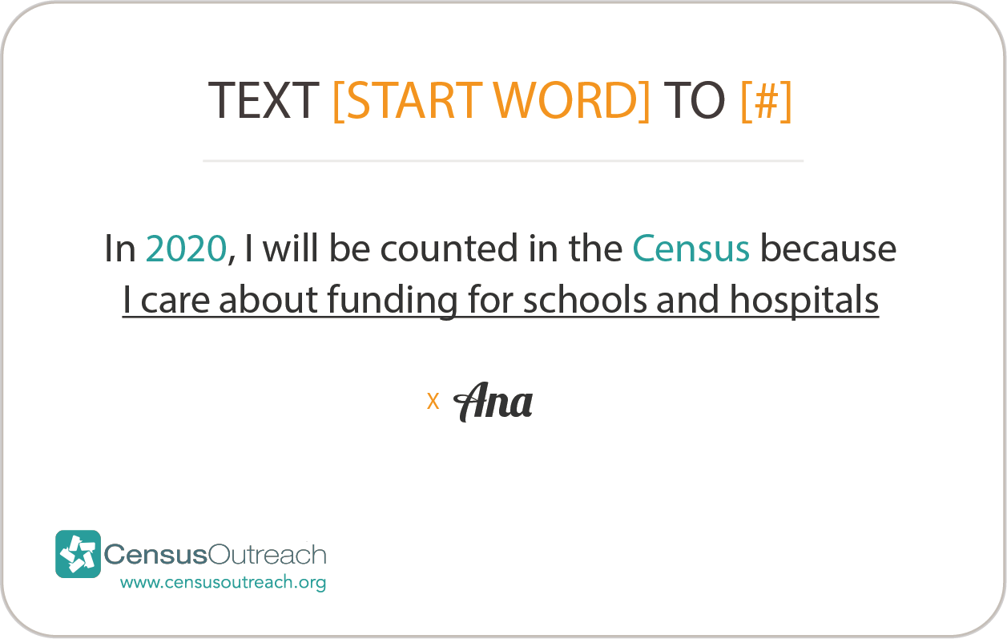
Help your schools and hospitals get the funding they need. Pledge to be Counted in the #2020Census. Text [INSERT START WORD] to [INSERT #] and take the pledge now. [INSERT YOUR ORGANIZATION’S PLEDGE CARD]

The #2020Census is coming. Help your schools and hospitals get the funding they need. Would you like to get a free digital Pledge to be Counted card? Text [INSERT START WORD] to [INSERT #] and take the pledge now #Icount
Social Media Templates

Make Your Social Media Posts Visual

Easily create more visual posts by selecting a Census related photo and placing a headline, the text-in call to action, and your logo over it. The more emotional the picture, the more compelling your post will be. Include any additional information and your Census hashtags in the caption!

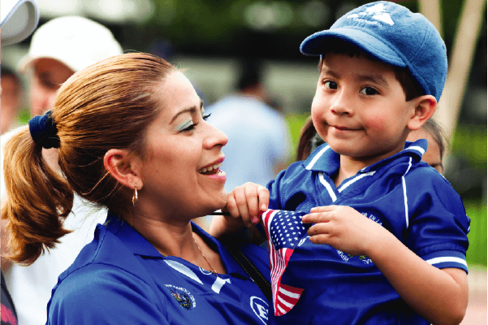
PLEDGE TO BE COUNTED
IN THE CENSUS
Text [Start Word] to
[ENTER #]

HELP YOUR SCHOOLS
AND HOSPITALS
Text [Start Word] to

[ENTER #]

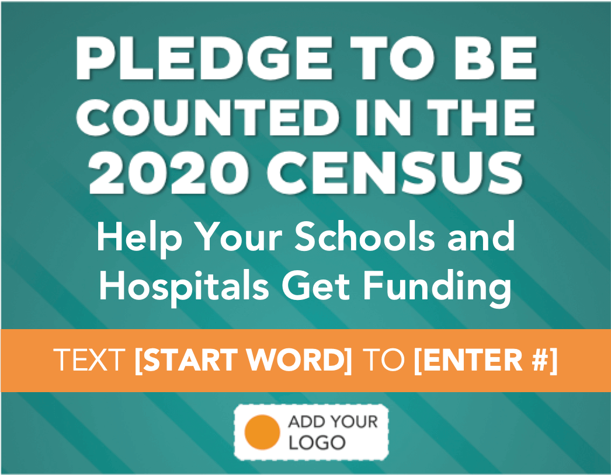
Email Template
[Subject line: “Don’t miss out on funding for your schools and hospitals”]

Dear [First name],

Every decade, we get one chance to collect accurate Census data to help make sure we have the funding for our schools, roads, hospitals, and more. Every single person is critical to helping achieve a full and accurate count.

Will you pledge with us to be counted in the Census this year? Join us and take the Pledge:

Text [INSERT START WORD] to [INSERT#]

Thank you for your participation!
[Your Organization]

Pledge to Be Counted in the 2020 Census
Text [START WORD] to
[ENTER#]

Pledge to Be Counted in the 2020 Census
Text [START WORD] to

[ENTER#]

Pledge to Be Counted in the 2020 Census
Text [START WORD] to

[ENTER#]

Pledge to Be Counted in the 2020 Census
Text [START WORD] to

[ENTER#]

Pledge to Be Counted in the 2020 Census
Text [START WORD] to

[ENTER#]

Pledge to Be Counted in the 2020 Census
Text [START WORD] to

[ENTER#]

Pledge to Be Counted in the 2020 Census
Text [START WORD] to

[ENTER#]

Pledge to Be Counted in the 2020 Census
Text [START WORD] to

[ENTER#]

Pledge to Be Counted

Text [START WORD] to
[ENTER #]

in the
2020 Census
Pledge to Be Counted

Text [START WORD] to

[ENTER #]

in the
2020 Census
Pledge to Be Counted

Text [START WORD] to

[ENTER #]

in the
2020 Census
Pledge to Be Counted

Text [START WORD] to

[ENTER #]

in the
2020 Census
Pledge to Be Counted

Text [START WORD] to

[ENTER #]

in the
2020 Census
Pledge to Be Counted

Text [START WORD] to

[ENTER #]

in the
2020 Census
Pledge to Be Counted

Text [START WORD] to

[ENTER #]

in the
2020 Census
Pledge to Be Counted

Text [START WORD] to

[ENTER #]

in the
2020 Census
Pledge to Be Counted

Text [START WORD] to

[ENTER #]

in the
2020 Census
Pledge to Be Counted

Text [START WORD] to

[ENTER #]

in the
2020 Census
Pledge to Be Counted

Text [START WORD] to

[ENTER #]

in the
2020 Census
Pledge to Be Counted

Text [START WORD] to

[ENTER #]

in the
2020 Census
Pledge to Be Counted

Text [START WORD] to

[ENTER #]

in the
2020 Census
Pledge to Be Counted

Text [START WORD] to

[ENTER #]

in the
2020 Census
Pledge to Be Counted

Text [START WORD] to

[ENTER #]

in the
2020 Census
Pledge to Be Counted

Text [START WORD] to

[ENTER #]

in the
2020 Census
Pledge to Be Counted

Text [START WORD] to

[ENTER #]

in the
2020 Census
Pledge to Be Counted

Text [START WORD] to

[ENTER #]

in the
2020 Census
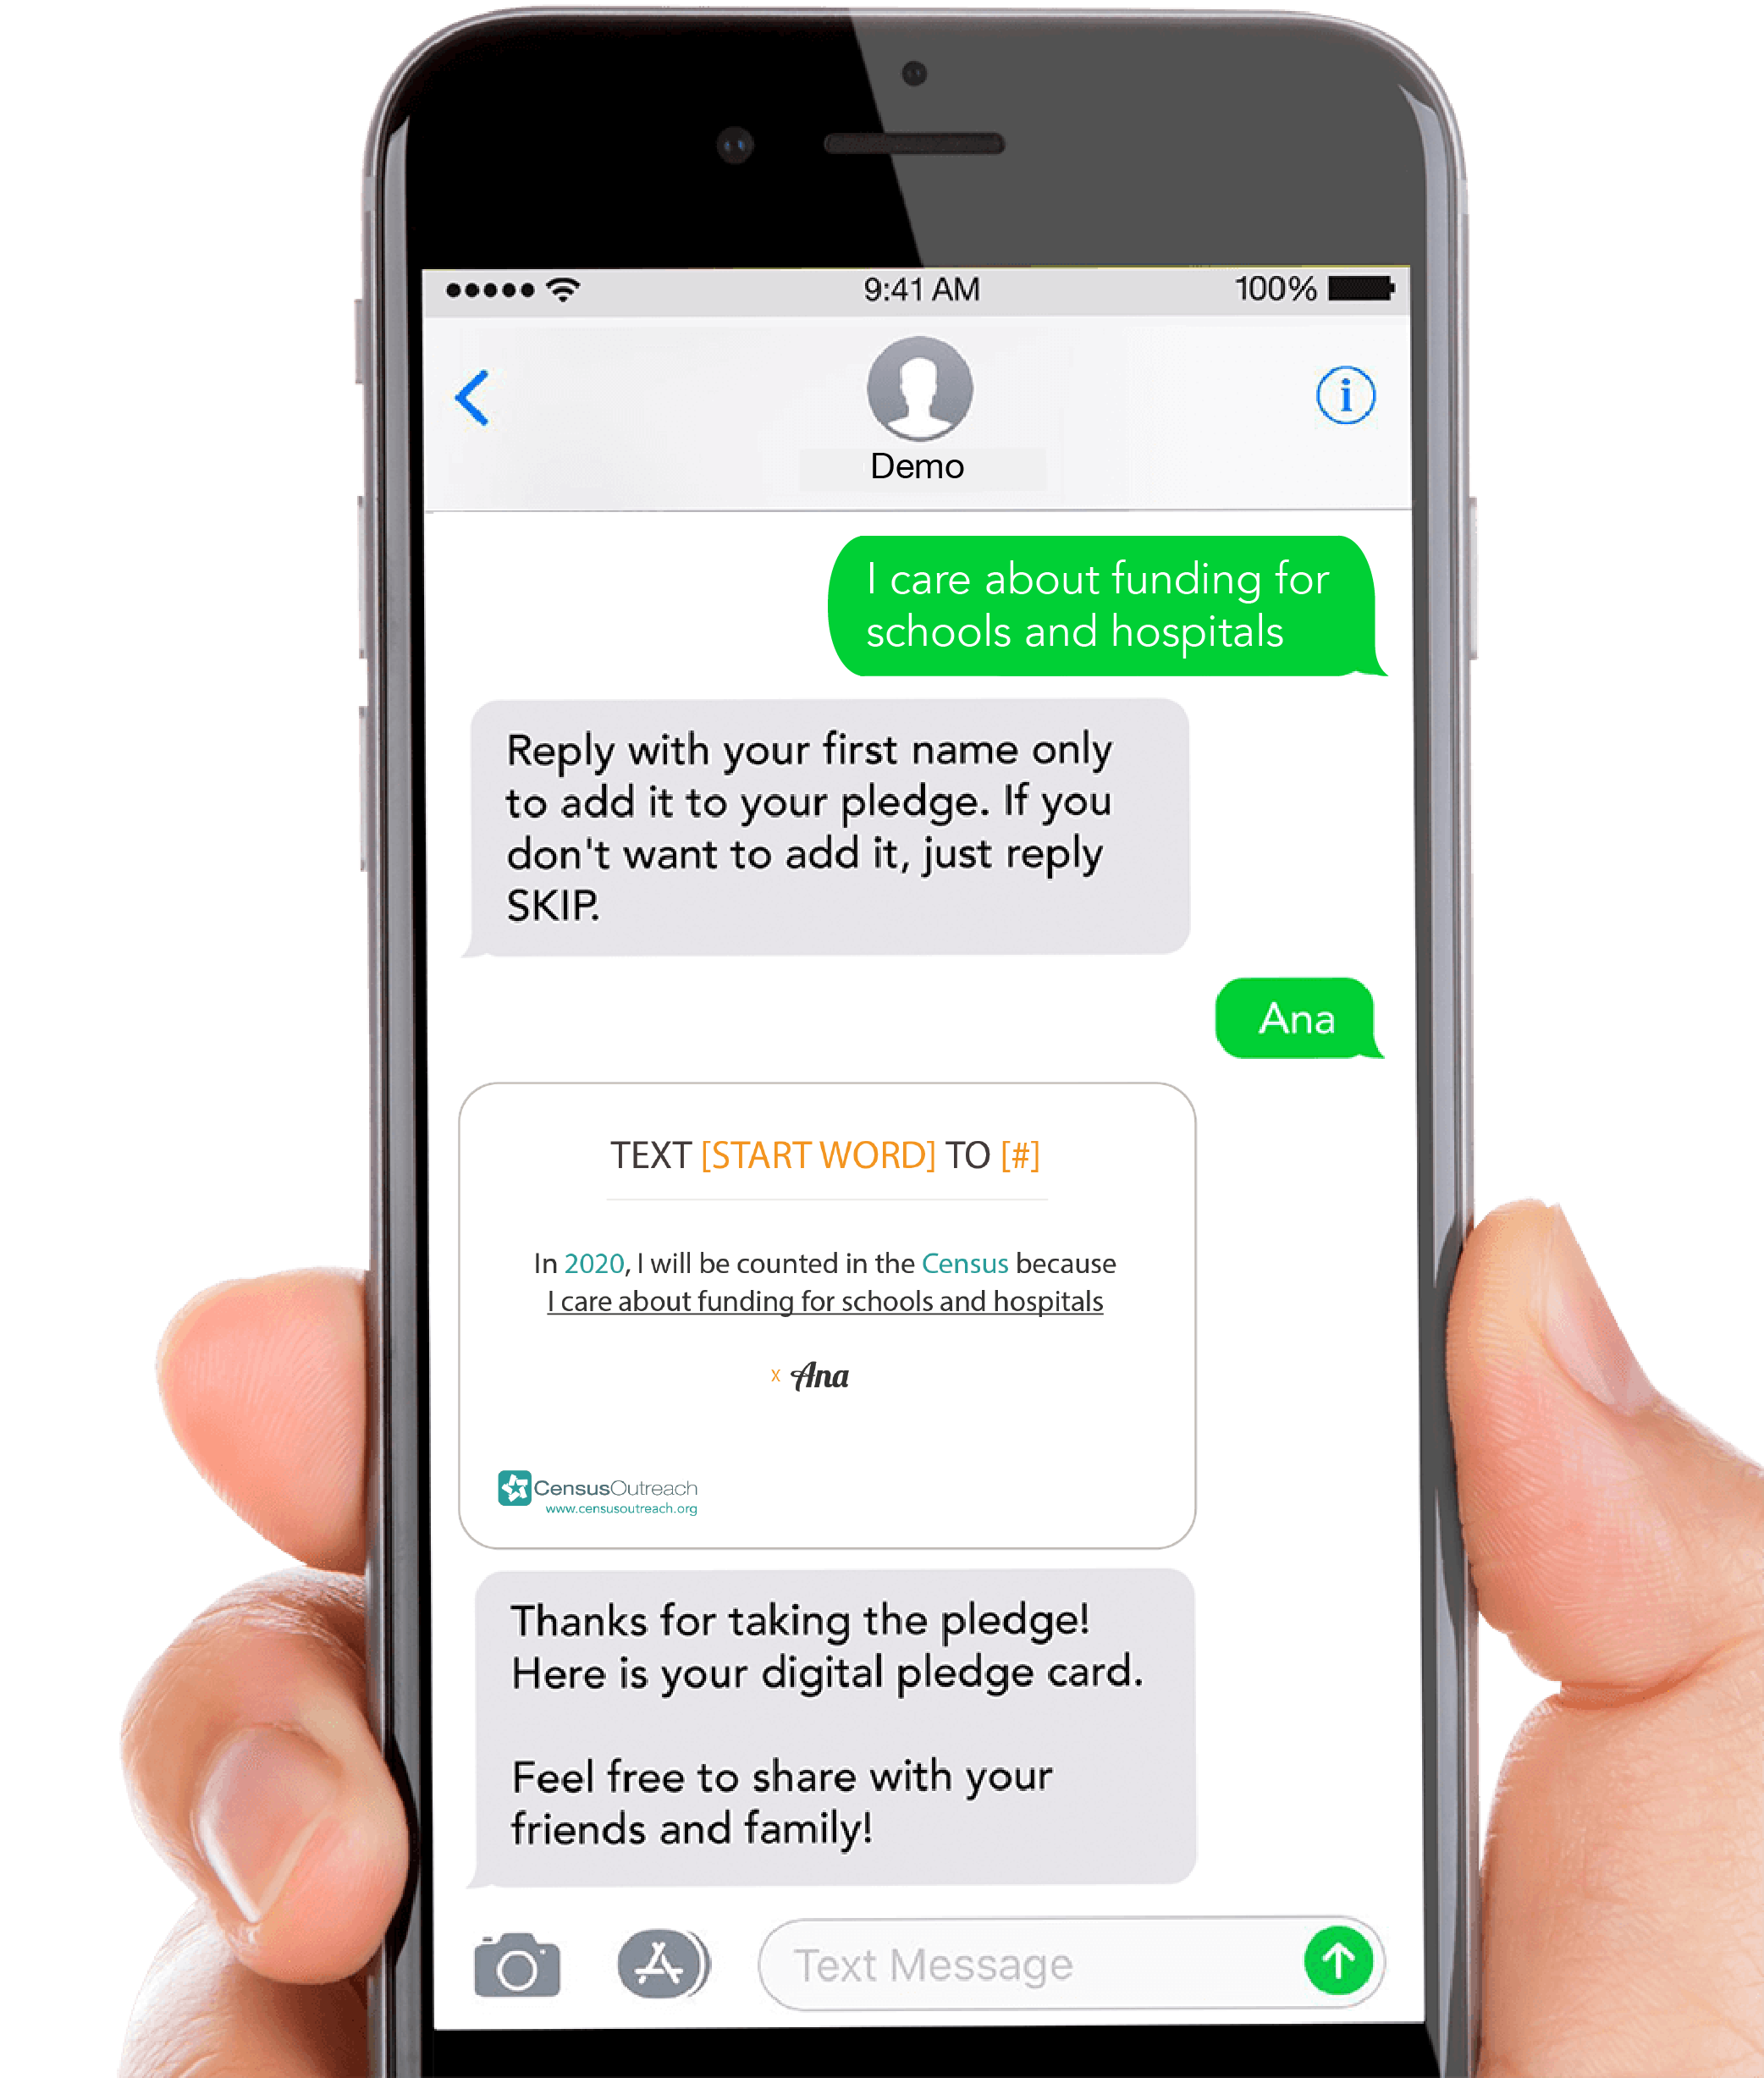
Help Your Schools and Hospitals Get Funding
PLEDGE TO BE COUNTED
IN THE 2020 CENSUS
*To stop receiving text messages from this number at any time text “EXIT” or “STOP”
*Standard message and data rates may apply
See: http://bit.ly/ccl-privacy for Privacy Policy
See: http://bit.ly/ccl-service for Terms of Service
TEXT [START WORD] TO

[ENTER #]

PLEDGE TO BE COUNTED IN THE 2020 CENSUS
Help Your Schools and Hospitals Get Funding

TEXT [START WORD] TO [ENTER #]

